**Game Design Document**

**Game Overview**

**Summary**

Shewolf is a game where the player gets to meet the fog of war style of gameplay in a platformer. Curcy is a girl who is lost in the wilder and is trying her best to find her way back to her clan and family. However, the way back home isn’t so easy because she is surrounded by rocky canyon thus there is no easy way back for her from all the rocks that are being obstacles. To make the matters worse she has been cursed with the power to turn into a wolf where she is unable to see when in this form. This is how she got lost in the first place and is her ticket back to climb the tall rocks that that are stopping her in her human form to jump over.

**Game Concept**

The concept of the game is to figure out the puzzle behind the each physics of the stone’s movement. We are trying to make a game where

**Hook**

-Shewolf is a game based on a puzzle platformer with the fog of war being the main attraction

-Player will experience the fun world within Shewolf by memorizing each steps that the player has to make by strategically memorizing the steps

**Features**

-Fog and clear sight gameplay

-wolf and human form dependence puzzle play

-Easy Visuals for gameplay

**Game Progression**

-The level will start out with easy positioned platforms

-The levels later will contain platform moving around where the accuracy will determine success (maybe juice)

-Timing will be also a relevant issue to beat the game (maybe juice)

Target Audience

-Players ranging from 10-20

**Gameplay and Mechanics**

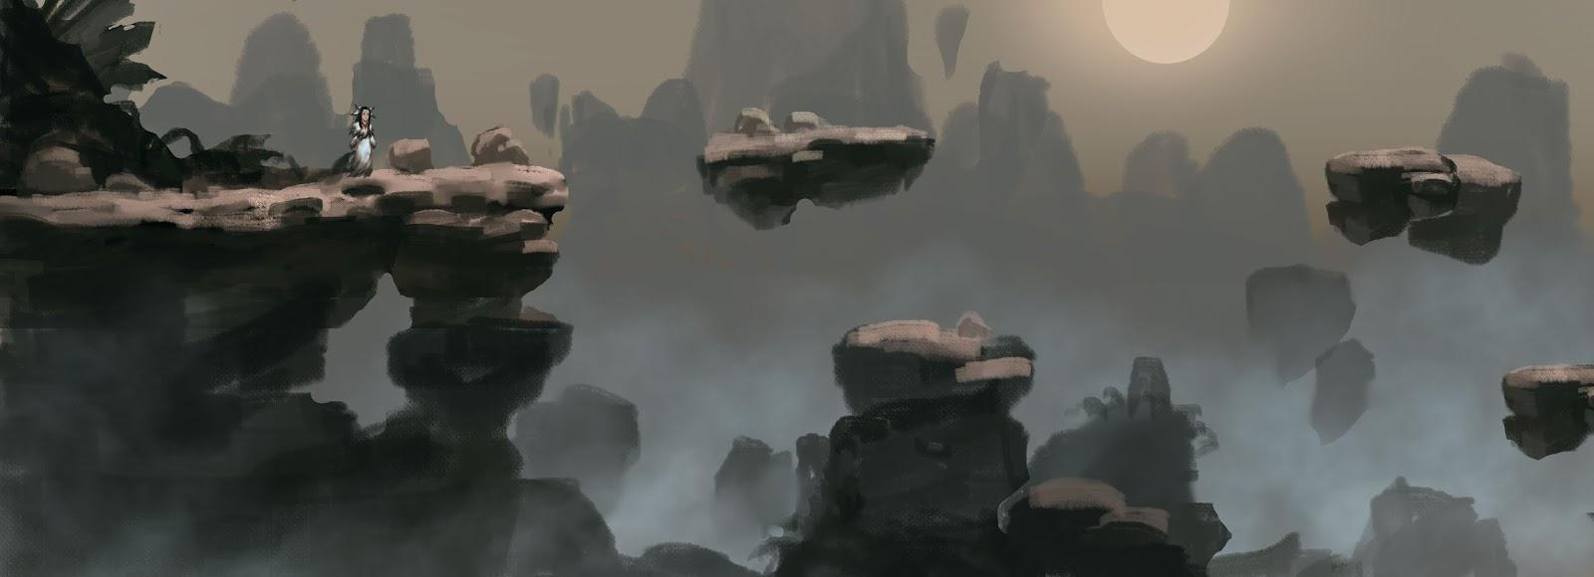

**Gameplay**

-Player will be moving the map by transforming into a wolf whenever it is necessary to jump over couple blocks

-The scene of the game will turn dark when she turns into a werewolf and will not be able to see anything that is around her

-Player will have to determine where to jump and how to jump it

-Some platforms will mysteriously move to make the game harder

**Mechanics**

-left and right arrow keys to move back and forth around the map

-space bar to jump in werewolf form

-f key to turn into wolf and the scene goes dark

**Objectives**

-To get to the end of the level by not falling and making it safely to the finish line

-Memorizing the rocks movements before you turn into werewolf to make the jump

-Make it to the other platform to get time extension item before the time runs out to beat the level(maybe juice)

-Avoid items that will reduce the time allowed to beat the level(maybe juice)

**Branding and Style Guide**

**Art Style**

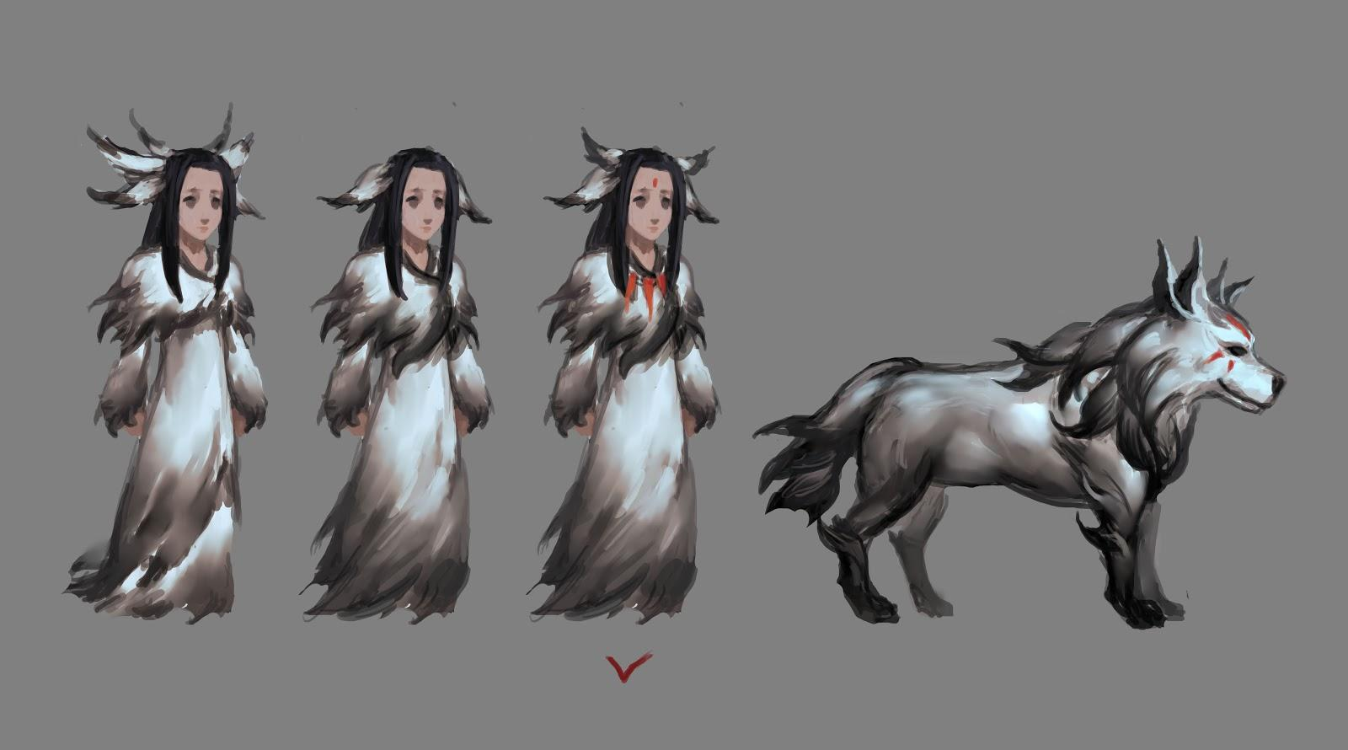

-Traditional Chinese influence

-Mixed with western comic style

-Saturated colors to make the environment for easy viewing

-Simple ink style

-Influences from many traditional asian folks and fairy tales

**UI**

10676280_10205096127670371_7474755283837909083_n.jpg

-Desaturated colors

-Mysterious feel