1. To print the pattern, as there are 5 rows, it is initialised by 5. Next,the for loop is used by the range from 0, followed by a nested loop with a new variable to iterate from the above variable, and as well as it has been incremented.Secondly, for the reverse pyramid,the axis in the ranged has been changed and udes the decrement in the nested loop. print("\r"), a carriange return is used to let the cursour move accordingly.

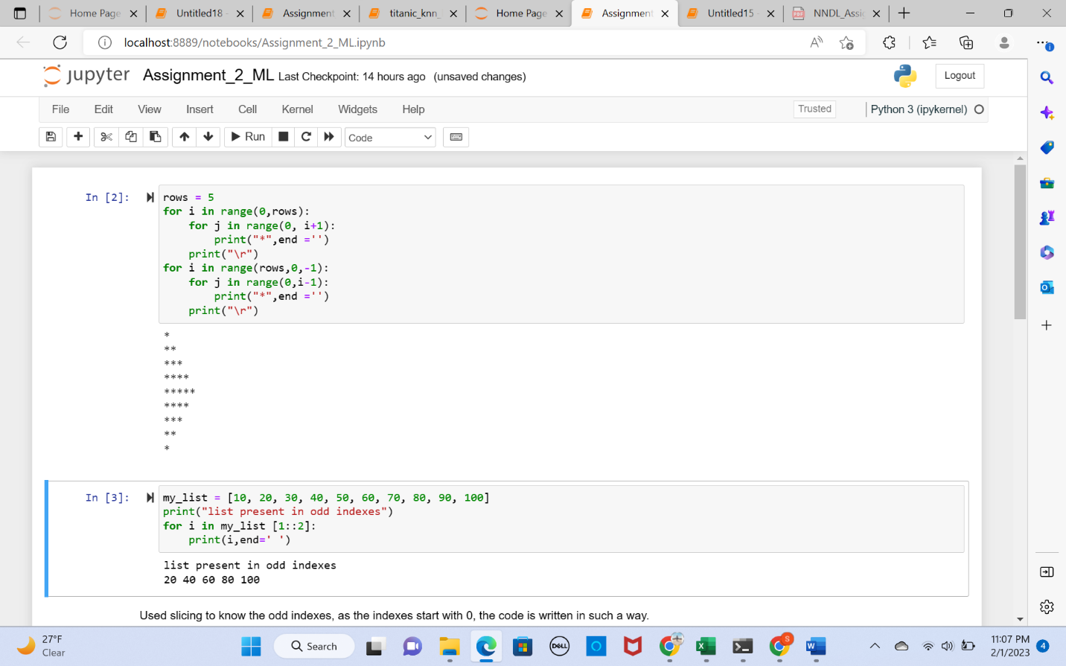

1. Used slicing to know the odd indexes, as the indexes start with 0, the code is written in such a way.

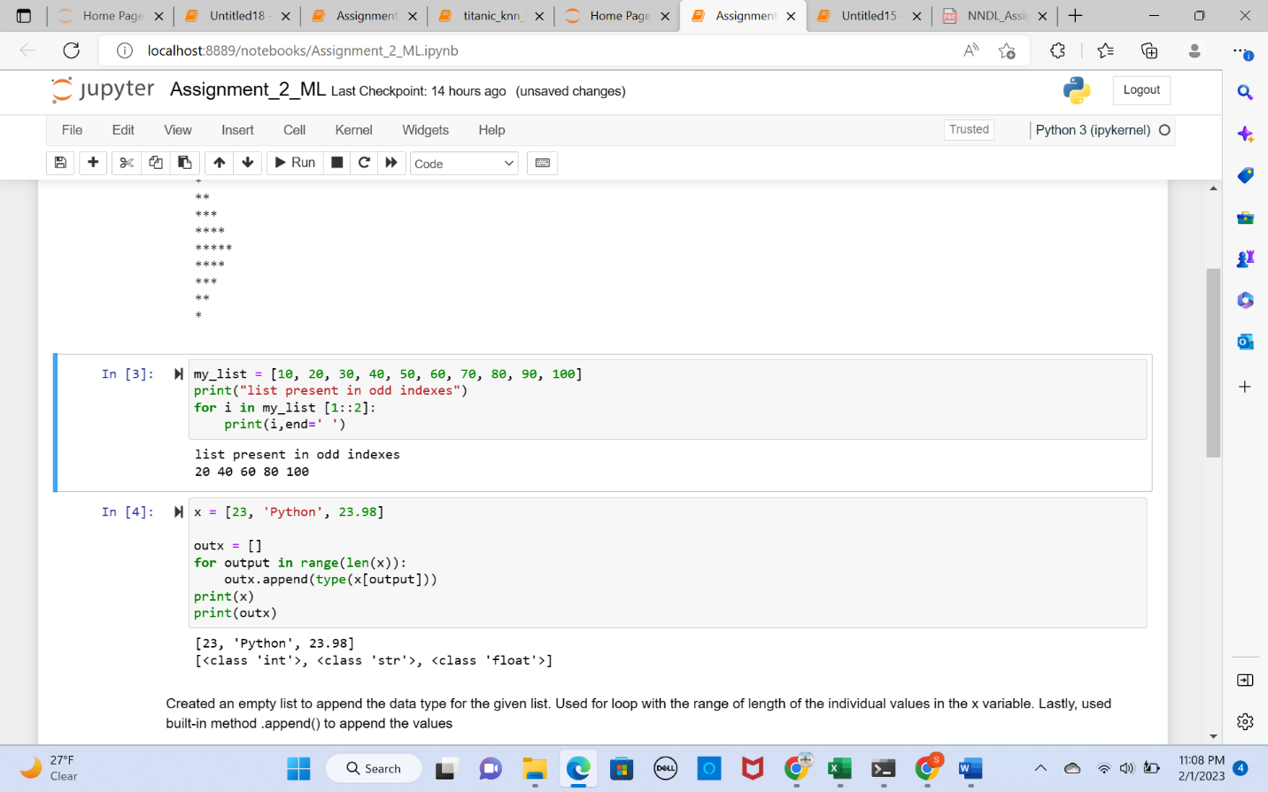

1. Created an empty list to append the data type for the given list. Used for loop with the range of length of the individual values in the x variable. Lastly, used built-in method .append() to append the values



1. As the question says to do with the function, def is how a function is called in the python. For loop is used with an if and then appended the values in the given empty list.

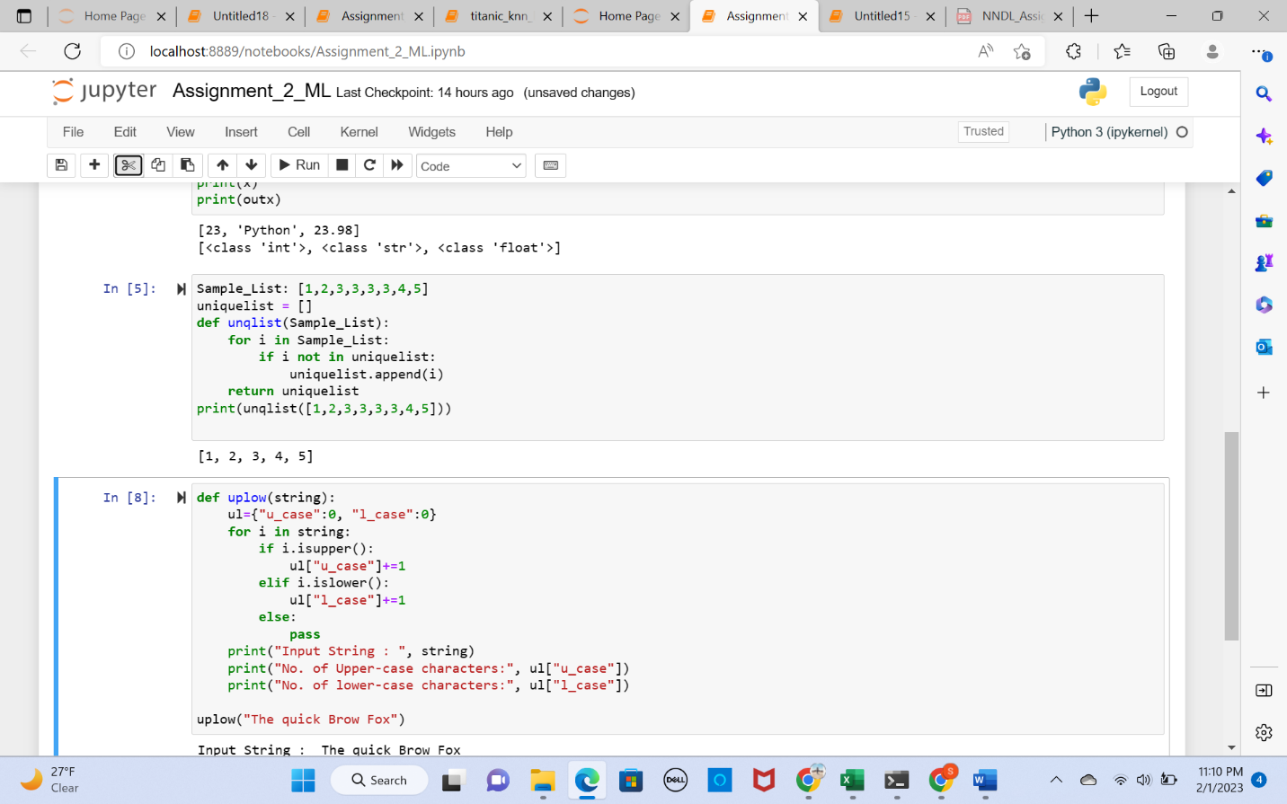

1. By using function, and the loops i.e.,for and if, by using inbuilt-methods .isupper(), and .islower() the above code has been excuted

