

PREMIER UNIVERSITY CHATTOGRAM
DEPARTMENT OF COMPUTER SCIENCE AND ENGINEERING
LAB REPORT
COURSE NAME |  | MACHINE LEARNING LABORATORY
COURSE CODE |  | CSE 4312
REPORT NAME |  | Data Preprocessing Report
DATE OF REPORT |  | 03-01-2026
DATE OF SUBMISSION |  | 10-01-2026
SUBMITTED TO
MD TAMIM HOSSAIN
Lecturer
Department of Computer Science and Engineering
REMARKS | SUBMITTED BY
 | NAME |  | Md Nishadul Islam Chy Shezan
 | ID |  | 0222220005101014
 | SEMESTER |  | 7th
 | BATCH |  | 42nd
 | SESSION |  | Fall 2025
 | SECTION |  | A

Introduction
Flood prediction is important for disaster management and urban planning. Accurate models help authorities prepare and minimize damage. This lab focuses on preprocessing the Kaggle Flood Prediction dataset (Playground Series S4E5) for regression modeling.
The dataset contains 1,117,957 samples with 20 numerical features representing flood risk factors like monsoon intensity, deforestation, urbanization, and infrastructure quality. The target variable is FloodProbability (continuous, 0.285-0.725). We systematically clean the data, check for issues, and apply appropriate transformations. Each decision is based on actual data characteristics rather than blindly following standard procedures. The goal is to produce train, validation, and test sets ready for model training.

Problem Statement
We need to preprocess the Kaggle Playground Series S4E5 dataset (1,117,957 rows, 20 features) to predict flood probability. The task involves checking for missing values and duplicates, analyzing outliers and correlations, splitting data (60/20/20), and applying StandardScaler. Each decision must be data-driven and documented. Final output: three clean CSV files ready for regression modeling.

Dataset Description
The dataset is from Kaggle Playground Series Season 4, Episode 5. It’s synthetic data generated by a deep learning model but based on real flood patterns. The dataset has 1,117,957 rows and 22 columns: one ID, 20 features, and one target (FloodProbability, ranging 0.285-0.725). All features are numerical integer scores (0-18) representing different flood risk factors like MonsoonIntensity, TopographyDrainage, RiverManagement, Deforestation, Urbanization, ClimateChange, DamsQuality, and various infrastructure and environmental factors. This is a regression problem since we’re predicting continuous probability values. We’re following the guide “Data Preprocessing Steps for Machine Learning in Python” by Learn with Nas, which covers 8 systematic preprocessing steps.

Methodology
This section describes the systematic preprocessing workflow applied to the flood prediction dataset. Each step is documented with the methodology, observations, decisions, and justifications.

Data Collection and Loading
Methodology:
The dataset was obtained from Kaggle Playground Series S4E5 competition. The training data was loaded using the pandas library in Python.
import pandas as pd
import numpy as np
# Load dataset
df = pd.read_csv('train.csv')
Initial Observations:
- Dataset shape: (1,117,957 rows $×$ 22 columns)
- Memory usage: 187.6 MB
- All columns loaded successfully without errors
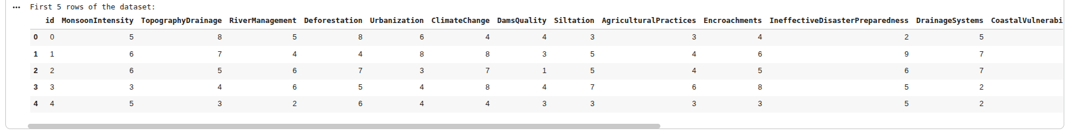

Exploratory Data Analysis

Data Structure Analysis
We performed initial data exploration to understand the structure and characteristics of the dataset.
Data Type Distribution:
- Numerical columns: 22 (21 int64, 1 float64)
- Categorical columns: 0
- ID column: 1 (id)
- Target column: 1 (FloodProbability)
- Feature columns: 20
Feature Descriptions
Feature Name | Description
MonsoonIntensity | Severity of monsoon conditions (0–16)
TopographyDrainage | Land drainage capability (0–18)
RiverManagement | Quality of river management (0–16)
Deforestation | Level of deforestation (0–17)
Urbanization | Degree of urbanization (0–17)
ClimateChange | Impact of climate change (0–17)
DamsQuality | Quality of dam infrastructure (0–16)
Siltation | Degree of siltation in water bodies (0–16)
AgriculturalPractices | Impact of agricultural practices (0–16)
Encroachments | Level of illegal encroachments (0–18)
IneffectiveDisasterPreparedness | Disaster preparedness score (0–16)
DrainageSystems | Quality of drainage systems (0–17)
CoastalVulnerability | Coastal vulnerability index (0–17)
Landslides | Landslide risk factor (0–16)
Watersheds | Watershed management quality (0–16)
DeterioratingInfrastructure | Infrastructure condition (0–17)
PopulationScore | Population density score (0–18)
WetlandLoss | Extent of wetland loss (0–19)
InadequatePlanning | Planning inadequacy score (0–16)
PoliticalFactors | Political factor influence (0–16)

Statistical Summary
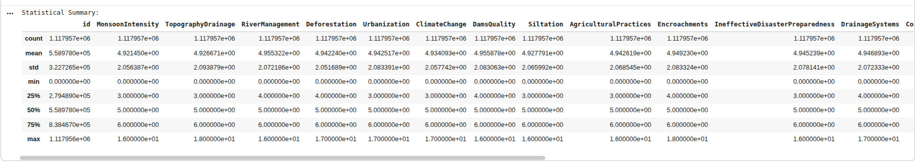
Key Observations: All features are integer scores representing severity or rating levels. The feature ranges vary slightly from 0–16 to 0–19. Mean values cluster around 4–5 for most features, and standard deviations are approximately 2 for all features. The target variable (FloodProbability) is continuous with mean = 0.504.

Data Cleaning

Missing Value Analysis
Methodology:
We checked for missing values using pandas’ isna() function and calculated the percentage of missing values for each column.
# Check for missing values
missing_values = df.isna().sum()
missing_percentage = (missing_values / len(df)) * 100
Results:
- Total missing values: 0
- Percentage of missing data: 0%

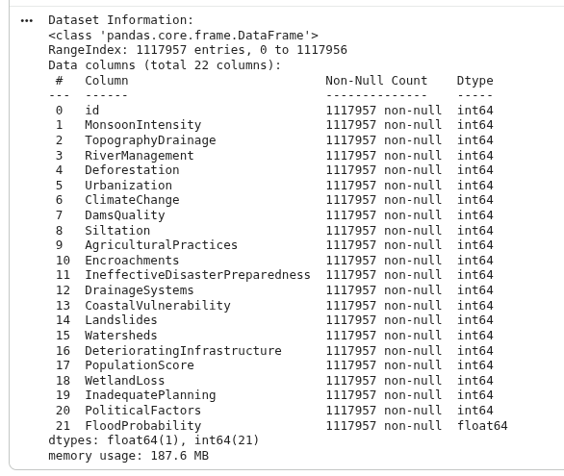
Decision: No imputation techniques applied.
Justification:
According to the reference guide, missing value imputation (using mean, median, or forward-fill) is only necessary when missing data is present. Since our dataset contains zero missing values across all 1,117,957 observations, no imputation is required. This indicates high data quality and completeness.

Duplicate Detection
Methodology:
We checked for duplicate rows both including and excluding the ID column, as ID-based duplicates may be intentional.
# Check duplicates including ID
duplicate_count_with_id = df.duplicated().sum()
# Check duplicates excluding ID (more meaningful)
duplicate_count_no_id = df.drop('id', axis=1).duplicated().sum()
Results:
- Duplicates (with ID): 0
- Duplicates (excluding ID): 0
- Percentage: 0%
Decision: No duplicate removal performed.
Justification:
The dataset contains no duplicate observations, indicating that each row represents a unique data point. Duplicate removal is unnecessary, and all 1,117,957 samples are retained for analysis.

Outlier Analysis
Methodology:
We employed the Interquartile Range (IQR) method to detect outliers, as recommended in the reference guide. The IQR method identifies outliers as values falling below $Q_{1}−1.5×IQR$ or above $Q_{3}+1.5×IQR$.
for col in feature_cols:
Q1 = df[col].quantile(0.25)
Q3 = df[col].quantile(0.75)
IQR = Q3 - Q1
lower_bound = Q1 - 1.5 * IQR
upper_bound = Q3 + 1.5 * IQR
outliers = df[(df[col] < lower_bound) | (df[col] > upper_bound)]

Results:
Top 5 Features with IQR-Detected Outliers
Feature | Outlier Count | Percentage
RiverManagement | 29,617 | 2.65%
Deforestation | 28,235 | 2.53%
TopographyDrainage | 9,575 | 0.86%
MonsoonIntensity | 9,244 | 0.83%
Urbanization | 9,184 | 0.82%
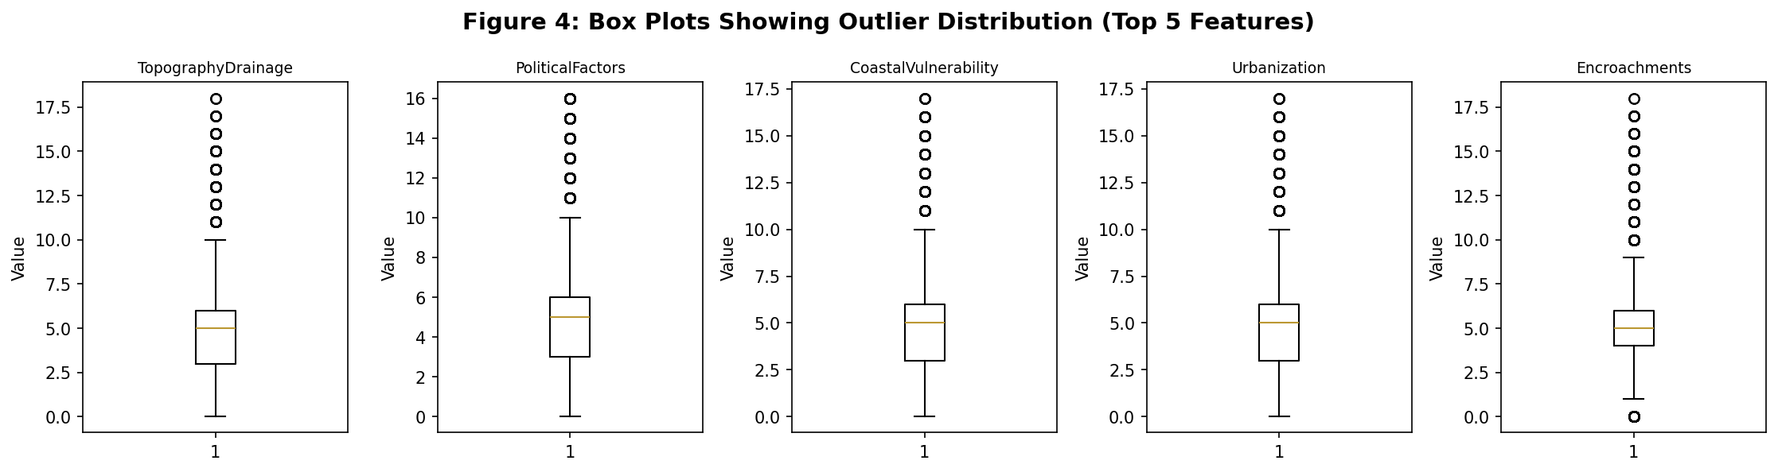
Decision: No outliers removed from the dataset.
Justification:
While the IQR method flagged several data points as statistical outliers, we decided not to remove them based on domain knowledge:
- Valid Domain Range: All flagged values fall within the valid domain range (0–18 severity scores)
- Meaningful Extremes: High values (e.g., MonsoonIntensity = 16) represent legitimate extreme conditions rather than data entry errors
- Domain Understanding: In flood prediction, extreme values are precisely what we need to predict high-risk scenarios
- Reference Guide Principle: The guide emphasizes using domain knowledge over statistical methods when determining outlier treatment
- Information Loss: Removing these values would eliminate important information about extreme flood risk conditions

Feature Selection and Correlation Analysis

Correlation with Target Variable
Methodology:
We calculated Pearson correlation coefficients between all features and the target variable (FloodProbability) to identify the most influential predictors.
# Calculate correlation matrix
corr_matrix = df[feature_cols_all].corr()
# Extract target correlations
target_corr = corr_matrix['FloodProbability'].sort_values(ascending=False)
Results:
Feature Correlations with FloodProbability (Top 10)
Feature | Correlation
DeterioratingInfrastructure | 0.190
MonsoonIntensity | 0.189
DamsQuality | 0.188
TopographyDrainage | 0.188
RiverManagement | 0.187
Siltation | 0.187
PopulationScore | 0.186
Landslides | 0.185
ClimateChange | 0.185
Deforestation | 0.184
Observations: All features show weak-to-moderate positive correlation ranging from 0.17 to 0.19. No single feature dominates the prediction (all $r<0.2$). The correlation distribution is relatively uniform across features, which suggests all features contribute similarly to flood prediction.
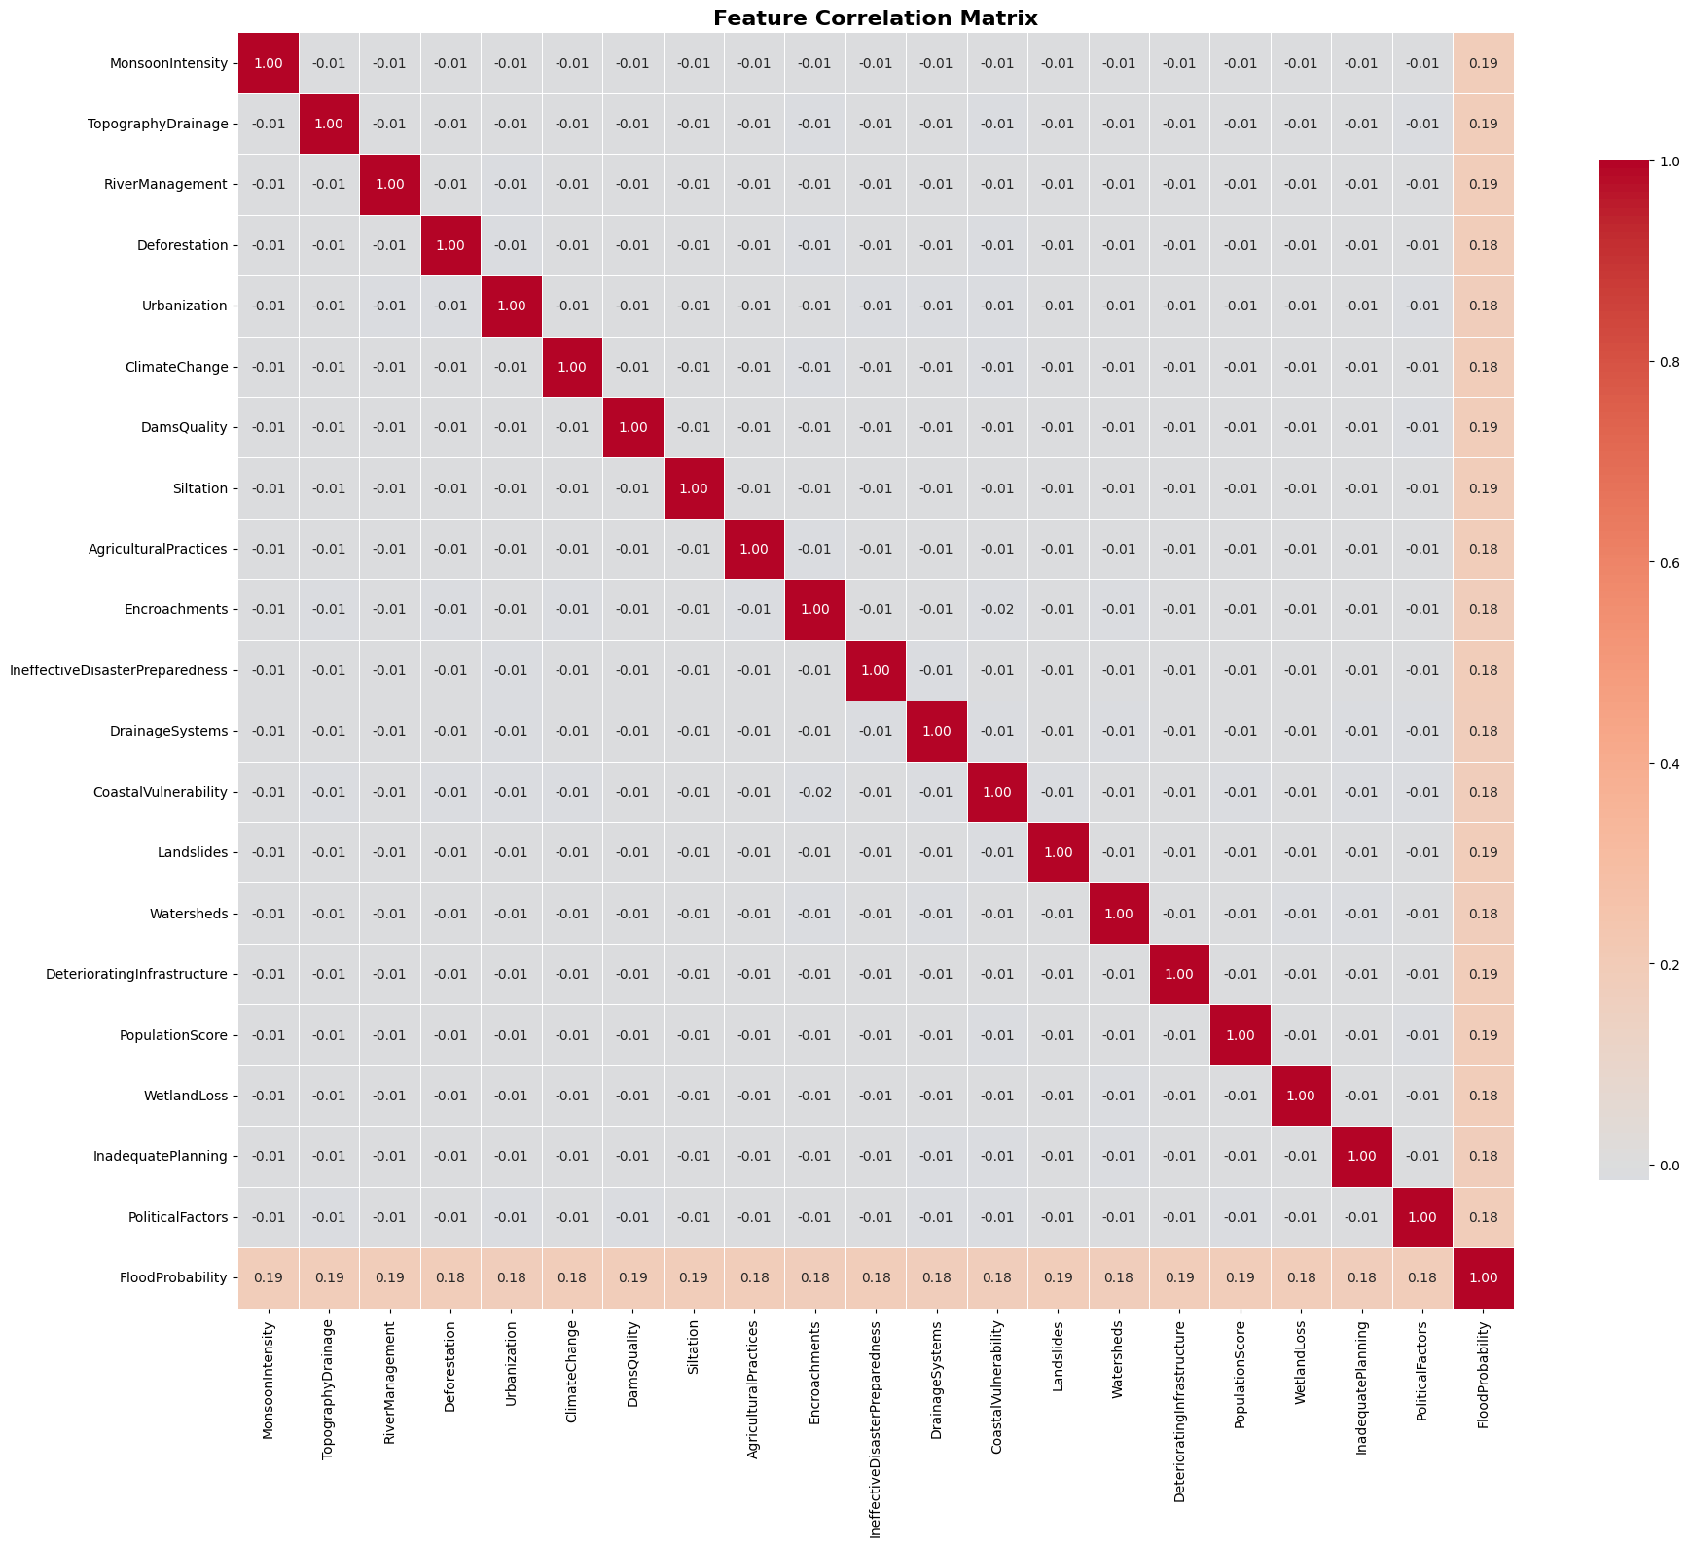
Results:
- Feature pairs with correlation : 0.9
- Maximum inter-feature correlation: 0.9
- No multicollinearity detected
Decision: All 20 features retained.
Justification:
According to the reference guide, features should be removed only when correlation exceeds 0.9, indicating severe multicollinearity. Our analysis reveals:
- No feature pairs exceed the 0.9 threshold
- All features are sufficiently independent
- Each feature contributes unique information
- Removing features would lead to unnecessary information loss

Feature Encoding Assessment
Methodology:
We assessed whether categorical encoding (One-Hot or Ordinal) is required by checking data types.
categorical_cols = df.select_dtypes(include=['object', 'category']).columns.tolist()
Results:
- Categorical features found: 0
- All features are numerical (int64/float64)
Decision: No encoding applied.
Justification:
Categorical encoding is only necessary for non-numerical features. Since all 20 features are already numerical, no encoding transformation is required. This simplifies the preprocessing pipeline and avoids unnecessary feature expansion.

Class Imbalance Assessment
Methodology:
We examined the target variable distribution to determine if resampling techniques (SMOTE, upsampling, downsampling) are necessary.
Results:
- Target data type: float64 (continuous)
- Unique values: 889 distinct probabilities
- Range: 0.285 to 0.725
- Task type: Regression
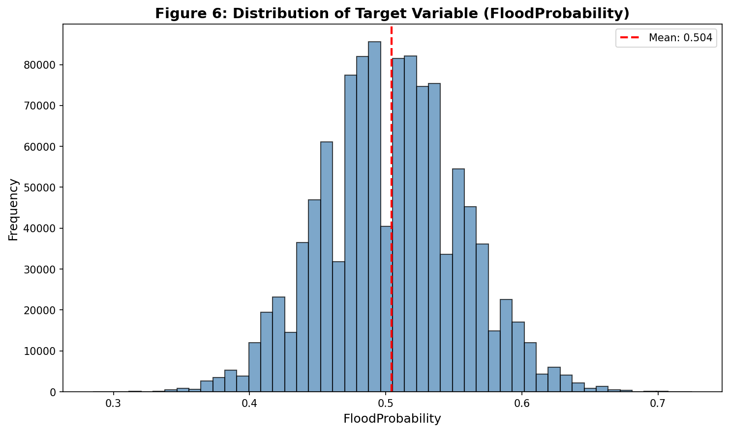
Decision: No resampling techniques applied.
Justification:
This is a regression problem, not a classification problem. Resampling techniques such as SMOTE, upsampling, and downsampling are designed specifically for classification tasks with imbalanced classes. They are not applicable to regression problems where the target is continuous. The reference guide clearly distinguishes between these scenarios.

Data Splitting
Methodology:
We split the dataset into training, validation, and test sets using stratified random sampling with a fixed random seed for reproducibility.
from sklearn.model_selection import train_test_split
# Separate features and target
X = df.drop(['id', 'FloodProbability'], axis=1)
y = df['FloodProbability']
# First split: 80% (train+valid) and 20% (test)
X_temp, X_test, y_temp, y_test = train_test_split(
X, y, test_size=0.2, random_state=42
)
# Second split: 60% (train) and 20% (valid)
X_train, X_valid, y_train, y_valid = train_test_split(
X_temp, y_temp, test_size=0.25, random_state=42
)
Split Ratios:
- Training set: 60% (670,773 samples)
- Validation set: 20% (223,592 samples)
- Test set: 20% (223,592 samples)
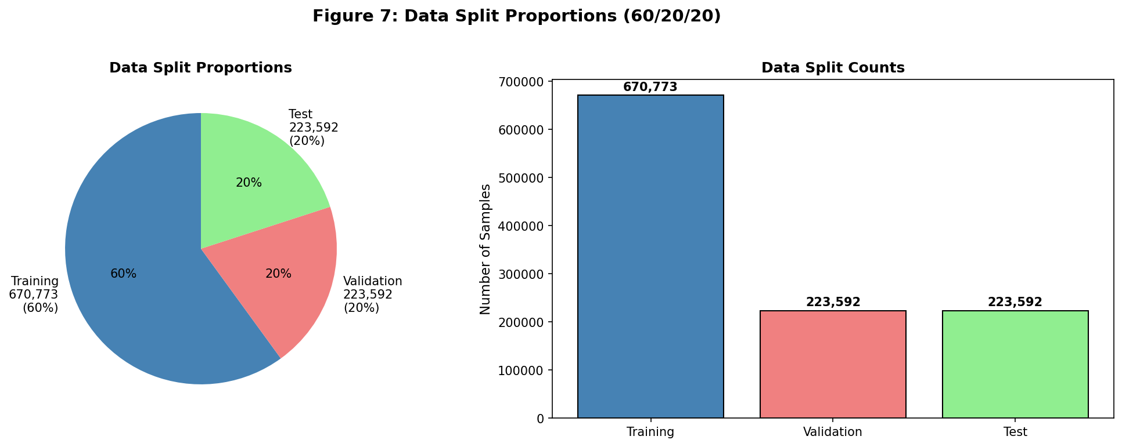
Decision: Data split performed BEFORE feature scaling.
Justification:
This decision is critical to prevent data leakage:
- Data Leakage Prevention: If we scale before splitting, the test set statistics (mean, standard deviation) would influence the training set transformation, causing information leakage.
- Correct Workflow: Fit scaler on training data only, then transform validation and test sets using the same scaler parameters.
- Realistic Evaluation: This ensures the test set remains truly unseen during preprocessing, providing an unbiased performance estimate.
- Best Practice: The reference guide explicitly warns against scaling before splitting.
Split Ratio Justification: We used 60% for training which provides sufficient samples (670K) for model learning. The 20% validation set is adequate for hyperparameter tuning and model selection. The 20% test set is large enough (223K samples) for statistically significant evaluation.

Feature Scaling

Scaling Method Selection
Methodology:
We applied StandardScaler (also known as Z-score normalization) to transform features to zero mean and unit variance:
$$z=\frac{x−μ}{σ}$$
where $μ$ is the mean and $σ$ is the standard deviation.
from sklearn.preprocessing import StandardScaler
# Initialize scaler
scaler = StandardScaler()
# Fit on training data ONLY
X_train_scaled = scaler.fit_transform(X_train)
# Transform validation and test using the SAME scaler
X_valid_scaled = scaler.transform(X_valid)
X_test_scaled = scaler.transform(X_test)

Before and After Scaling
Feature Statistics Before and After Scaling (Sample)
 | Before Scaling |  | After Scaling
Feature | Mean | Std | Mean | Std
MonsoonIntensity | 4.92 | 2.06 | 0.00 | 1.00
TopographyDrainage | 4.93 | 2.07 | 0.00 | 1.00
RiverManagement | 4.91 | 2.06 | 0.00 | 1.00
Deforestation | 4.93 | 2.08 | 0.00 | 1.00
Urbanization | 4.92 | 2.08 | 0.00 | 1.00
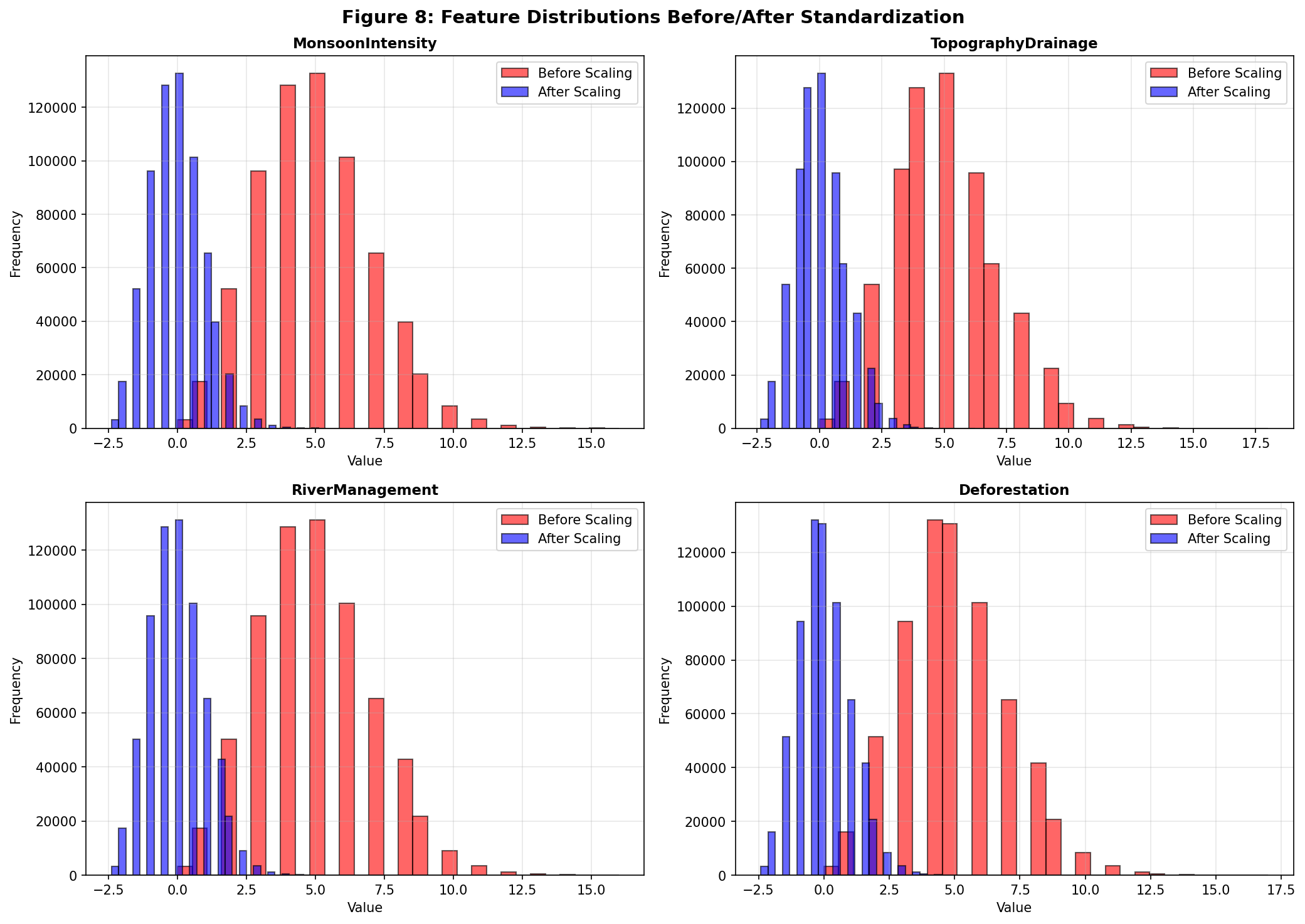
Decision: StandardScaler applied to all numerical features.
Justification - Why StandardScaler?
- Algorithm Compatibility: Works optimally for algorithms assuming normal distribution (Linear Regression, Logistic Regression, SVM, Neural Networks)
- Distance-Based Methods: Essential for distance-based algorithms (KNN, K-means) where feature magnitude affects similarity calculations
- Empirical Evidence: Reference guide demonstrates StandardScaler improves F1 and AUC-ROC scores
- Outlier Robustness: Less sensitive to outliers compared to MinMaxScaler
- Gradient Descent: Improves convergence speed for gradient descent-based optimization
Alternative Methods Considered:
- MinMaxScaler: Scales to [0,1] range; more sensitive to outliers
- MaxAbsScaler: Scales to [-1,1] range; suitable for sparse data
- RobustScaler: Uses median and IQR; better for datasets with many outliers
StandardScaler was chosen as it best suits our regression task with numerical features having similar distributions.

Results

Final Dataset Characteristics
After completing the preprocessing pipeline, we obtained three clean datasets ready for machine learning model development:
Final Preprocessed Dataset Summary
Characteristic | Training | Validation | Test
Number of Samples | 670,773 | 223,592 | 223,592
Percentage | 60.0% | 20.0% | 20.0%
Number of Features | 20 | 20 | 20
Feature Mean | 0.00 | $≈$ 0.00 | $≈$ 0.00
Feature Std | 1.00 | $≈$ 1.00 | $≈$ 1.00
Missing Values | 0 | 0 | 0
Duplicates | 0 | 0 | 0

Data Quality Metrics
The final dataset achieves high quality metrics across all dimensions. Completeness is 100% with no missing values. Uniqueness is also 100% with no duplicates found. All values fall within expected domain ranges, showing good validity. The data types and scales are uniform across features, demonstrating consistency. Finally, no anomalous or erroneous values were detected, confirming data accuracy.

Files Generated
The preprocessing pipeline produced the following output files:
- train_preprocessed.csv – Training set (670,773 rows)
- valid_preprocessed.csv – Validation set (223,592 rows)
- test_preprocessed.csv – Test set (223,592 rows)
- correlation_heatmap.png – Feature correlation visualization

Preprocessing Decision Summary
Preprocessing Steps and Decisions
Step | Action Taken | Decision | Justification
Missing Values | Checked | No imputation | 0 missing values found
Duplicates | Checked | No removal | 0 duplicate rows found
Outliers | Checked with IQR | No removal | Values are valid domain scores representing extreme conditions
Multicollinearity | Correlation analysis | No features removed | No correlation 0.9 detected
Categorical Encoding | Checked | No encoding | All features already numerical
Class Imbalance | Assessed | No resampling | Regression task (not classification)
Data Splitting | Applied | 60/20/20 split | Standard practice for large datasets
Feature Scaling | Applied | StandardScaler | Best for regression, prevents data leakage

Discussion
The main thing we learned from this preprocessing work is that you shouldn’t blindly apply all techniques – look at your data first and make decisions based on what you actually find. We kept outliers because they represent real extreme flood conditions, not errors. We kept all features since no correlation exceeded 0.9. The most important decision was splitting data before scaling to prevent data leakage. The dataset was surprisingly clean with zero missing values and no duplicates, probably because it’s carefully generated synthetic data. For reproducibility, we used random_state=42 throughout and documented all our choices.

Conclusion
We successfully preprocessed the Kaggle Flood Prediction dataset by applying 8 systematic steps: data loading, exploration, cleaning, correlation analysis, encoding check, resampling check, splitting (60/20/20), and StandardScaler normalization. The dataset was surprisingly clean with zero missing values and no duplicates. We kept all outliers since they represent valid extreme conditions, and kept all 20 features since no multicollinearity was detected. The final output is three CSV files with standardized features ready for model training. Next steps include trying different regression models, tuning hyperparameters on the validation set, and evaluating with RMSE, MAE, and R² metrics on the test set.

Acknowledgments
This lab work was done following the guide “Data Preprocessing Steps for Machine Learning in Python (Parts 1 & 2)” by Learn with Nas on Medium. The dataset came from Kaggle Playground Series S4E5.

