OFFICIAL WEBSITE USER & VISUAL GUIDANCE MANUAL
Ms.Porn Slushie
(ร้านมิสพร สเลอปี้ บุรีรัมย์)
Visual Step-by-Step Guide with Click Pointers & Content Management
Local Factory & Drink Shop • Buriram, Thailand
📌 QUICK FACTS & CORE REQUIREMENTS
• Shop Name: Ms.Porn Slushie (ร้านมิสพร สเลอปี้ - โรงงานผลิตและหน้าร้าน)
• Location: Buriram Province, Thailand (Daily 09:00 AM – 06:30 PM)
• Main Produce: Signature Fresh Orange Slushie (สเลอปี้ส้มสายน้ำผึ้งแท้ 100%)
• Full Flavors: Strawberry, Thai Tea, Green Tea, Cola, Coco Milk, Coconut Water
• Delivery Coverage: Within 20 km radius across Buriram (Thermal zero-melt packing)
• Customer Hotline: 086-557-8822 (One-tap calling & copy button ready)
• Local Live URL: http://localhost:8000

1. Website Overview & How to Run
The Ms.Porn Slushie website is an interactive single-page application crafted specifically to answer the three most important questions customers have: Where are we located? Where can we deliver? Where to contact? It features a clean, cozy, and refreshing visual aesthetic with warm vanilla backgrounds, fresh orange accents, and clear bilingual (English & Thai) labeling for Buriram residents and visitors alike.
How to View the Live Website:
1. Live Local URL: Open Chrome, Edge, or Safari and go to http://localhost:8000
2. Double-Click Open: You can also double-click index.html in the project folder to view it directly.
3. Free Online Publishing: Drag the project folder into Netlify (app.netlify.com/drop) to publish a live public web link in seconds!

2. Hero Section & Navigation Guide (Where to Click)
The top of the website greets visitors with your brand story, highlighting that Ms.Porn Slushie is a local Buriram factory craft. Look at the visual guide below with the numbered arrows pointing to each interactive control:
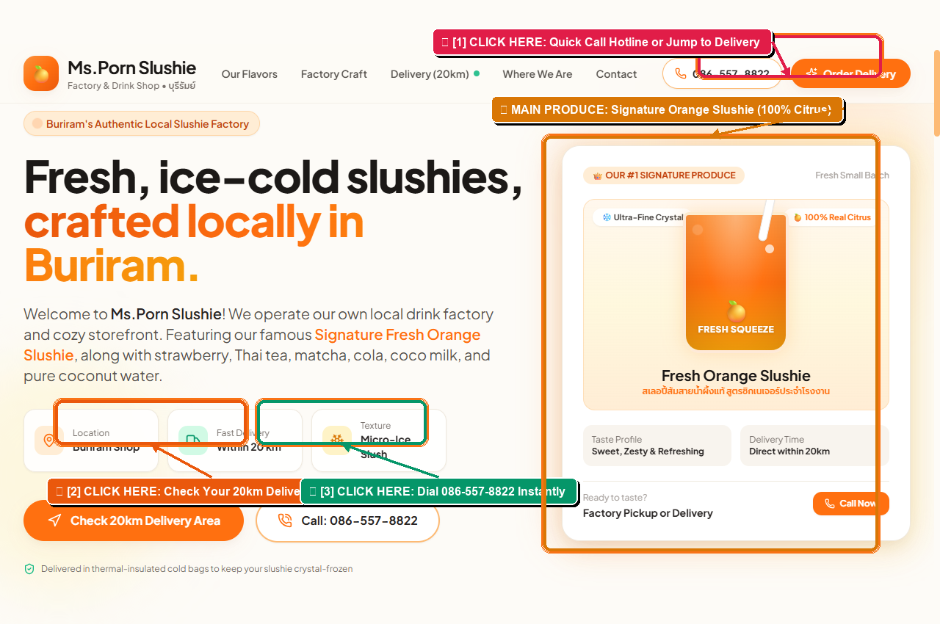
📸 Figure 1: Hero Section Click Guide — Header navigation, phone hotline, and 20km delivery check buttons.
Click Controls on this Screen:
👉 Arrow [1] - Top Header Actions: Located in the sticky navbar. Clicking the phone number (086-557-8822) opens the phone dialer immediately. Clicking 'Order Delivery' jumps down smoothly to the 20km delivery checker.
👉 Arrow [2] - 'Check 20km Delivery Area' CTA: The primary orange button in the hero banner. Clicking this takes the customer directly to the Buriram interactive distance tool.
👉 Arrow [3] - 'Call: 086-557-8822' CTA: A secondary high-visibility button allowing mobile and desktop users to dial the shop with one click.
👉 Arrow [4] - Signature Orange Slushie Showcase: Spotlights your #1 Main Produce with frost badges, taste profile notes, and direct order link.

3. Fresh Slushie Menu & Flavor Ordering
The menu presents all 7 flavors crafted at your factory, each with taste notes, Thai subtitles, and an interactive 'Order This' shortcut button:
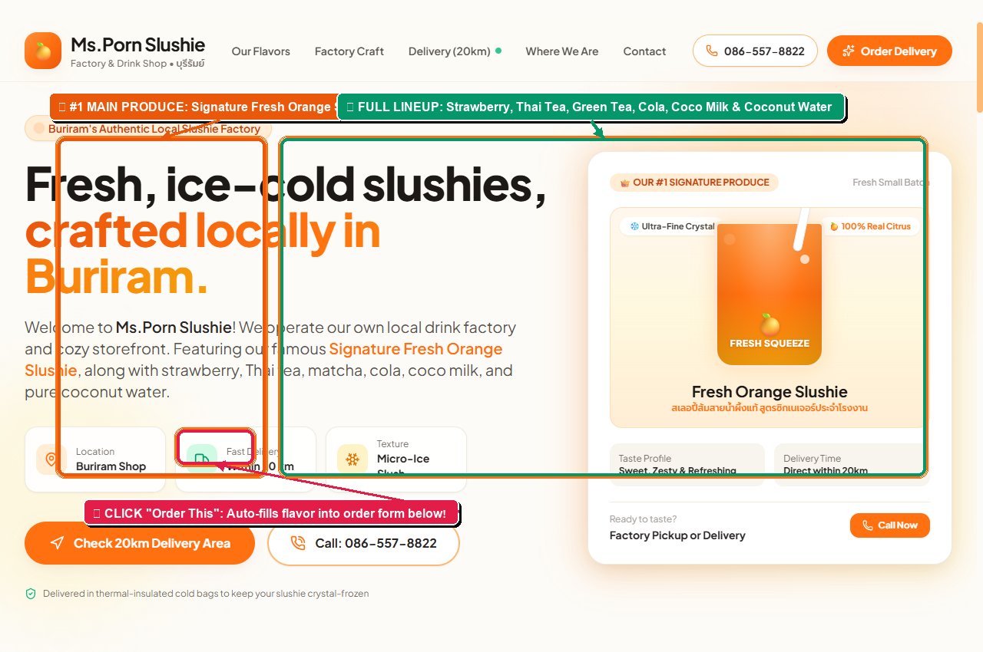
📸 Figure 2: Menu Showcase Guide — Highlighting Main Produce and interactive 'Order This' buttons.
• 🍊 Orange Slushie (สเลอปี้ส้มสด): Main signature produce made with 100% real citrus squeeze. Golden badge highlighted.
• 🍓 Strawberry Slushie (สเลอปี้สตรอว์เบอร์รี): Fruity, sweet, and fragrant red berry slushie.
• 🧋 Thai Tea Slushie (ชาไทยสเลอปี้): Deep brewed authentic Thai tea with creamy milk freeze.
• 🍵 Green Tea Slushie (ชาเขียวมัทฉะเกล็ดหิมะ): Soothing, aromatic matcha with crisp micro-crystals.
• 🥤 Cola Slushie (โคล่าสเลอปี้): Nostalgic fizzy cola micro-freeze.
• 🍫 Coco Milk (โกโก้นมสเลอปี้): Rich velvety chocolate cocoa blend.
• 🥥 Coconut Water (น้ำมะพร้าวสดเกล็ดหิมะ): 100% pure young coconut water, ultra-hydrating.
💡 How the 'Order This' Button Works: When a customer clicks the 'Order This' button on any flavor card (pointed by Arrow [2]), the page automatically scrolls down to the Order Form, selects that flavor in the dropdown menu, and places the cursor in the Buriram Address input field ready for typing!

4. 'Where Can We Deliver' (20km Delivery Zone)
One of your primary requirements is making sure customers know where you deliver. We built an interactive 20km delivery radius checker that lets customers test their address immediately:
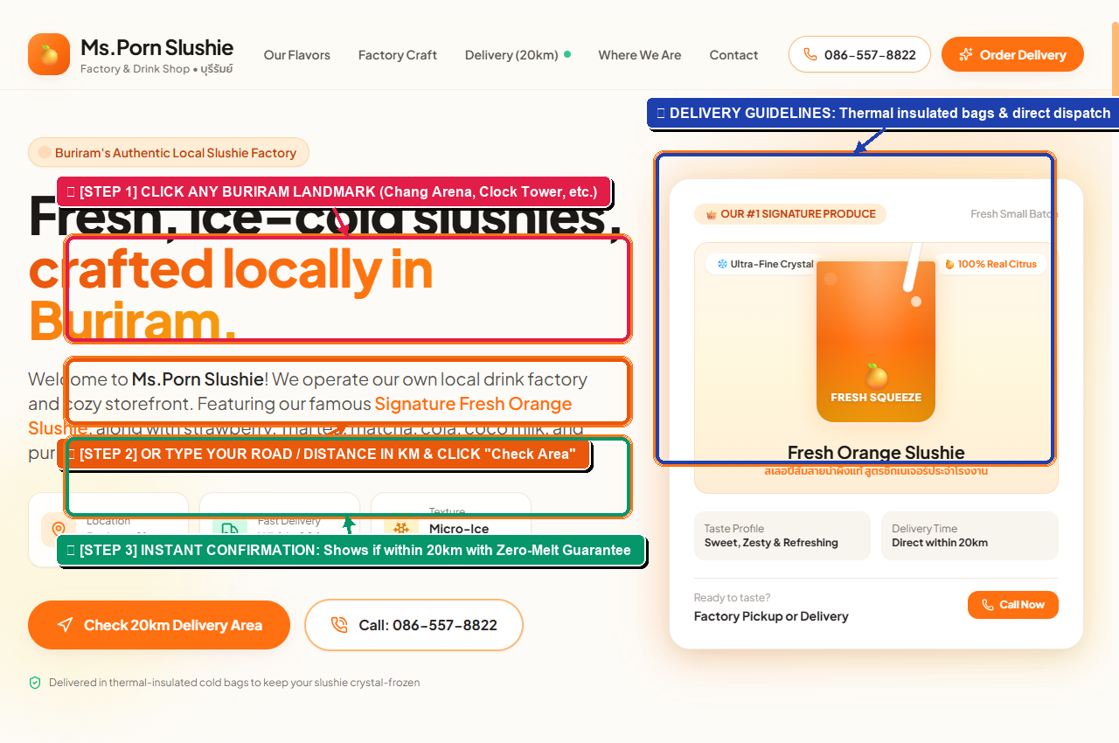
📸 Figure 3: Delivery Checker Guide — Landmark buttons, custom distance input, and confirmation badge.
✅ Step 1 (Red Arrow): Click Any Buriram Landmark Chip
Customers can tap common destinations such as Chang Arena (4.8 km), Buriram Clock Tower (2.5 km), Buriram Rajabhat University (3.2 km), Khao Kradong (8.5 km), Buriram Hospital (2.0 km), or Huai Chorakhe Mak (14.5 km).
✅ Step 2 (Orange Arrow): Or Type Custom Road / Kilometers
If their location isn't a landmark, they can type their subdistrict or estimated km (e.g. 'Isan subdistrict', '8 km') and click 'Check Area'.
✅ Step 3 (Green Arrow): Instant Delivery Eligibility Status
The system displays a green badge confirming they are within the 20km radius, details the thermal zero-melt packaging guarantee, and displays the direct hotline.

5. 'Where We Are' (Visit Buriram Shop & Map)
Customers looking to visit the shop and micro-factory in person can find complete physical details and directions:
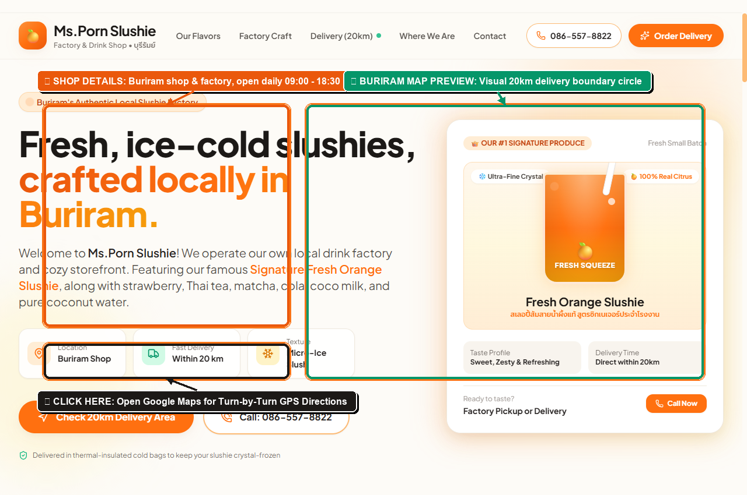
📸 Figure 4: Location & Map Guide — Shop hours, address, parking, and Google Maps GPS navigation.
📍 Physical Shop Location: Buriram Province, Thailand (อำเภอเมืองบุรีรัมย์ จ.บุรีรัมย์).
📍 Operating Hours: Monday – Sunday, 09:00 AM – 06:30 PM (Open daily with fresh morning batches).
📍 Open in Google Maps Button (Dark Arrow): One click opens Google Maps navigation with driving directions for motorbikes and cars.
📍 Parking & Pickup Convenience: Dedicated frontage parking allows customers to quickly stop and grab takeout cups without parking hassles.

6. 'Where to Contact' & Quick Order Guide
The contact section provides frictionless ways for customers to reach you immediately by phone, copy your number for messaging apps, or fill out a pre-order form:
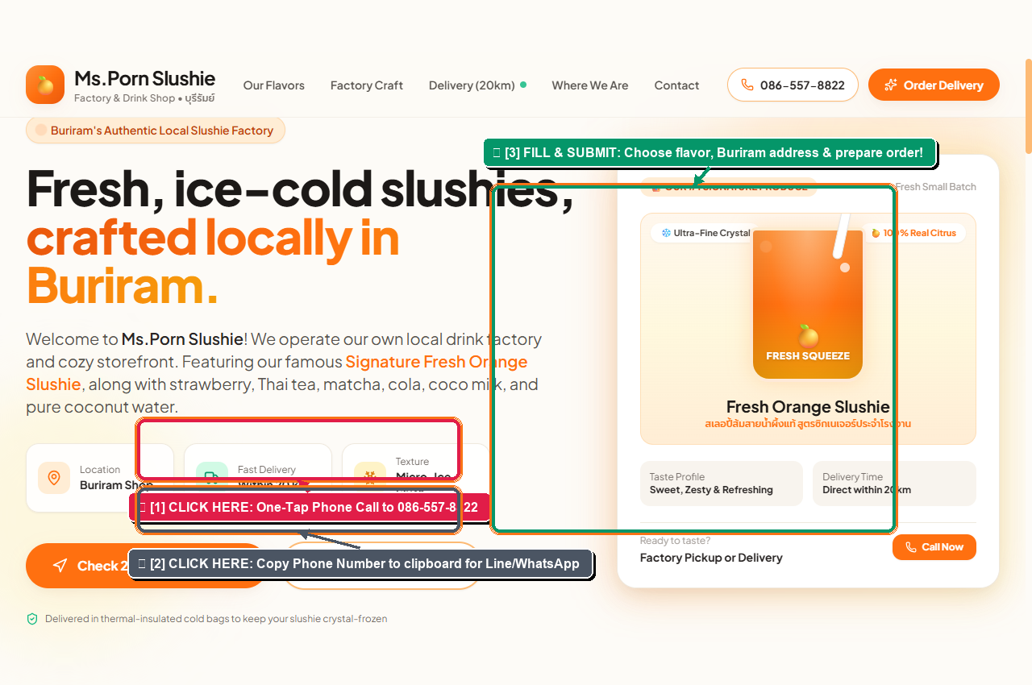
📸 Figure 5: Contact Guide — One-tap phone calling, number copy tool, and quick order submission.
📞 Arrow [1] - Big Call 086-557-8822 Button:
Tapping this button triggers a direct phone call. Best for immediate delivery dispatch and urgent orders.
📞 Arrow [2] - Copy Phone Number Button:
Copies '0865578822' directly to the user's clipboard and flashes 'Copied: 086-557-8822!'. Perfect for customers pasting into Line search or WhatsApp.
📞 Arrow [3] - Quick Order Submission Form:
Customers enter their name, phone number, choose their slushie flavor (Orange, Strawberry, etc.), and their Buriram address. Clicking submit prepares an order summary and offers an instant confirmation dial.

7. How to Update Content (Owner's Cheatsheet)
You can easily edit and customize any text or flavor on the website. Here is a quick reference table showing which file and line to edit:
Item to Change | File to Edit | What to Look For & Replace
Phone Number | index.html & script.js | Search for '086-557-8822' and '0865578822'. Replace with your new phone number.
Opening Hours | index.html | Search for '09:00 AM – 06:30 PM' and update your daily working hours.
Specific Street Address | index.html | Search for 'Buriram Province, Thailand' and insert your exact street name, subdistrict, or house number.
Delivery Distance | index.html & script.js | In index.html search '20km'. In script.js search 'if (distanceKm <= 20)' to adjust threshold.
New Drink Flavors | index.html | Duplicate any '<div class="flavor-card">' block, change emoji, flavor name, and description.

— End of Visual Guidance Manual —
Prepared for Ms.Porn Slushie • Buriram, Thailand • 2026

