**COLLEGE OF SCIENCES ELIBRARIUM: AN ONLINE**

**LIBRARY ACCESS FOR THE PALAWAN STATE**

**UNIVERSITY, QUEZON CAMPUS.**

A Capstone Project Presented to the

Faculty of the College of Sciences

Palawan State University

In Partial Fulfillment of the

Requirements for the Degree of

Bachelor of Science in Information Technology

By

Cuyos, Justine Paul I.

Dulman, Kent Daniel E.

Escalante, Jeanamae E.

Gualdrapa, Jamyca Jeielle J.

Layba, Maryjoy A.

Urdelas, Alyza O.

***(Date)***

**CHAPTER IV**

**METHODOLOGY**

**Locale**

The Elibrarium will be implemented in the Palawan State University of Quezon Campus and will be used by the students as extra educational resource.

**Population of the study**

The actual population of the University is 1,622 and 30+ Instructors but the study focused to the overall number of interview users or actual number of users who respond the questioner that researcher provided the collect data.

Total number of respondents – 20% per program

Total number of questions – 10

**Instrumentation**

Questioners - The Researches created questioners in hard copy for all students enrolled at Palawan State University Quezon Campus. Questioners are an overview of the questions that served as a guide during the interview.

**Conceptual Framework** Based on the objectives of the study and the literature review, the following conceptual model was developed to outline the structure and process of creating the elibrarium.

**INPUT PROCESS OUTPUT**

**COLLEGE OF SCIENCES ELIBRARIUM:**

**AN ONLINE**

**LIBRARY ACCESS FOR THE PALAWAN STATE**

**UNIVERSITY, QUEZON CAMPUS.**

Effectiveness:

“”

1. Data Gathering
2. Analysis & planning
3. GUI Designing
4. Coding
5. Testing
6. Implementation
7. maintenance
8. **KNOWLEDGE REQUIREMENTS**

* Email

1. **USER’S NEEDS**

* Internet
* Browser

1. **SOFTWARE REQUIREMENTS**

* Windows 10

1. **HARDWARE REQUIREMENTS**

* Intel core i3 11th Gen processor

**Evalution and Performance Test**

**Figure 1.** Conceptual Framework

**Requirements Analysis**

**Use Case**



**Admin**

**Figure 2.** Admin Use Case

An admin in elebrarium system is responsible for managing users, content, and overall system to secure smooth operations. They handle tasks such as editing user account, assigning roles and permissions and monitoring user for security and compliance. The admin can also manage the elibrarium content by updating digital resources.



**User**

**Figure 3.** User Use case

The user can explore the elibrarium using view content details, then access the material online without the option to download. Their reading progress Is saved in their account, allowing them to the content at any time as long as they remain connected to the platform.

**User Stories**

1. Accessibility: Elibrarium are accessible from anywhere with an internet connection, allowing users to access materials at any time, removing the need for physical travel to a traditional library.
2. Wide Range of Resources: Traditional libraries often provide a wide range of multimedia resources, including e-books, and academics books the learning experience.
3. Convenience: users can quickly search for, access, and download resources with the click a button making the process of finding information much faster.

**Software Requirements Specification**

**Purpose**

A digital library platform aimed at providing users to access to a wide range of electronics resources, including ebooks, academic e-books that are hidden and cannot be seen or used.

**Scope**

The system will serve different user roles, such as students and faculty. For managing the library’s collection and user accounts is that Librarian.

**Elibrarium**

A digital library platform for managing and accessing digital content such as e-books and academic e-books.

**Users**

A person using the eibrarium website is a students, faculty and staff.

**Requirements Documentation**

This document is to define the functional requirements for the development of an elibrarium system for Palawan State University Quezon Palawan. This system will serve as a digital platform that enables Students and Faculty to access ebooks academic resources of the library management process.

The elibrarium system will include the following features:

* Online catalog of books, Research papers and other resources.
* User authentication and access control for students and faculty.
* Reporting tools for library staff usage statistics, inventory management.

**Stakeholders**

* Students: End users who will access resources.
* Faculty: Users with special access for academic resources.
* Library personnel: Administrators managing the elibrarium content and inventory.

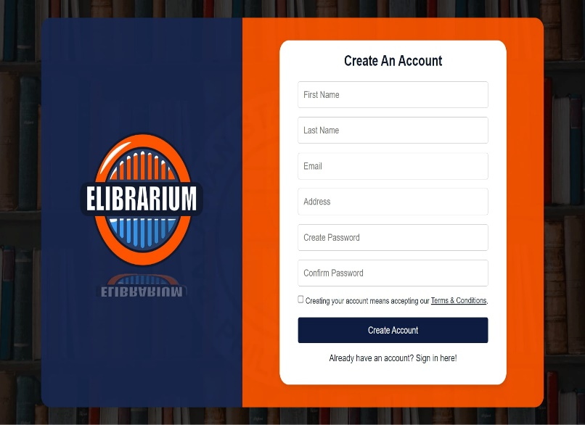**Design of Software, System, Product and/or Processes**

**Figure 5.** Design of Software to Create Account

**Create Account**

1. Visit the Website: Go to the official website.
2. Find sign-up or Register button: look for a “Create account”, button typically at the top-right corner of the page.
3. Provide Details: Enter your personal information like name, email and password. Some platforms might ask for a phone number or other details.
4. Verify email/phone: Check your email or phone for a verification link or code to confirm your account.
5. Complete Setup: After verification, log in to your new account and complete any additional steps.

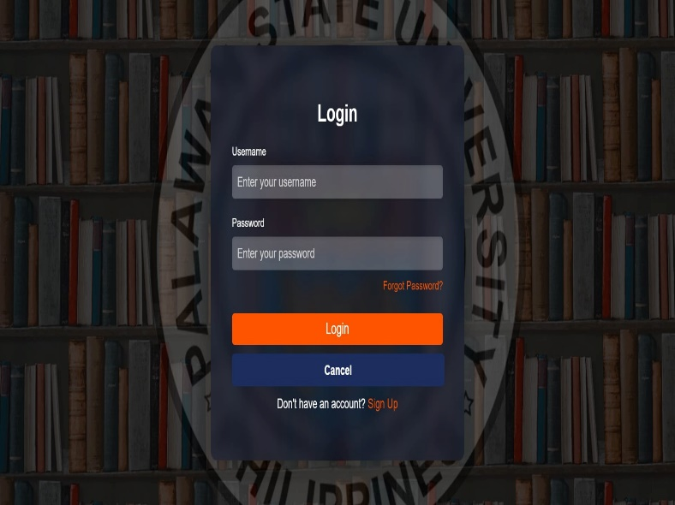

**Figure 6.** Design of Software to Login

**Log-in**

1. Email/ Username: A text box where users input their registered email or username.
2. Password: A password box where users enter their account password.
3. Submit Button: A button to a log in after entering credentials.
4. Forgot Password: A link to recover or reset the password.

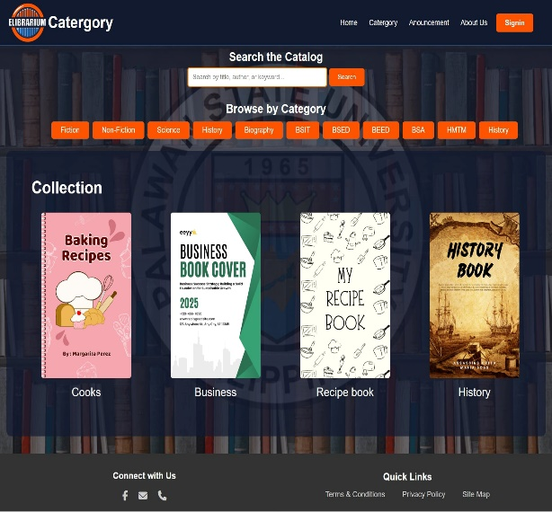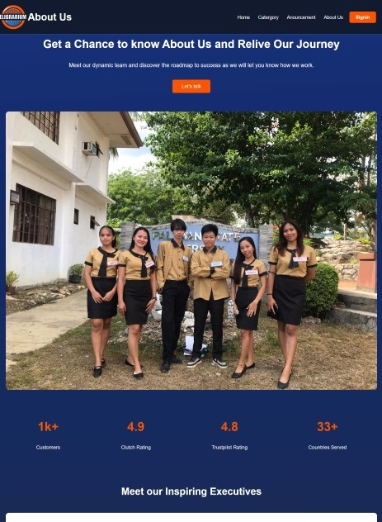

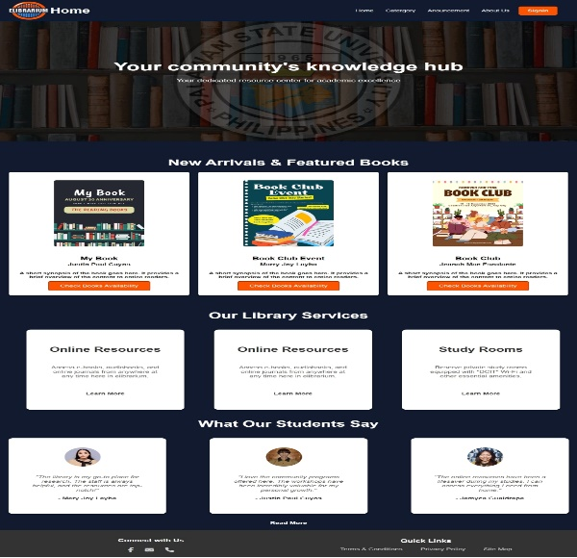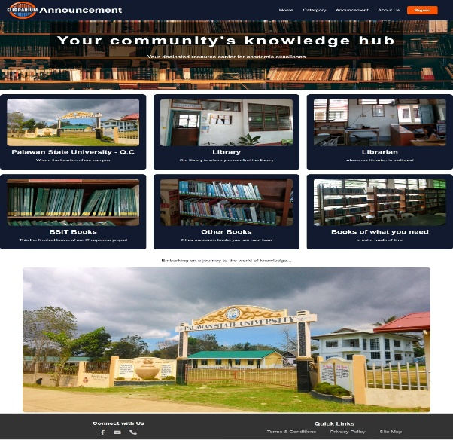

**Figure 7.** Design of Software to Access the Website

Once you log-in, you’ll have access to the website and can explore our elibrarium, which offers a variety of ebooks and academic ebooks for free download.

**Data flow Diagram**

Here’s a more detailed data flow for an elibrarium system, covering various interactions from user request to content delivery:

|  |  |
| --- | --- |
| 1. User request | * Login/Authentication: * The user initiates a session by logging into the elibrarium platform * Search or Browse: * After authentication the user searches for resources by inputting keyboards, Author, Categories or browses through available categories or collection. |
| 1. Search Engine Processing | * Search query sent: * The search terms are processed by the search engine. * Query Database: * The search engine queries the backend database (or index) for matching resources. * Search results Compilation: * The database retrieves result, including metadata like titles, Authors, summaries and content link. |
| 1. Database Access | * Metadata Repository: * The search engine accesses the metadata repository, which contains information about the digital resources (ebooks files). * Digital content Repository: * The system identifies the locations of the actual content (ebooks files) either stored locally or on a cloud server. |
| 1. Data storage and Management | * Content management System: * Admins can manage digital collections, add new content, and update resources metadata. * Back up and Maintenance: * The system regularly back up the digital content and metadata to prevent data loss. |

**Table 1.** Data flow Diagram

This is a typical data flow for how an elibrarium system functions from a user’s search request to delivering the digital content.

**Entity Relationship Diagram**

**Network Topology and Architecture**

**Bus Topology**

elibrarium

User

Internet

**Figure 4.** Network Topology and Architecture

In a bus topology, devices are connected to a single communication line or backbone and data is sent over this shared medium. For a user to interact with online resources, such as a website like elibrarium, certain steps when setting up an account or accessing restricted services.

1. Internet Requirement: The device needs to be connected to the internet to communicate with external websites. In a Bus topology, all devices share the same network. This means the connection to the internet must be active and the data being sent to and from the user’s device travels though this shared to reach the website.
2. Website Interaction: When a user wants to log in or create account on a website, website generally requires specific information to be entered. This step is important to verify the identity of the user and ensure secure access to the system. On the elibrarium website, before the user can gain access or sign in the system will ask them to fill in necessary details.
3. Filling in Required Information: the website typically requests the user to complete a form with essential information such as name, email, password and other required credentials. This data collection process is crucial for creating a unique profile for the user on the platform. Every time the user signs up for a new this information before proceeding.
4. Account Creation on elibrarium: once the user provides all the necessary information the website processes the data, verifies credentials and creates a new account for the user. Only after completing this step can the user gain access to the website’s features and services. The user has a unique identity and secure access to the system.