A Project Progress Report

On

**Quality analysis and classification of Rice Grains**

BACHELOR OF TECHNOLOGY

IN

COMPUTER SCIENCE AND ENGINEERING

Submitted by:

**Shipra Kumari (University Roll No-125000119183)**

**Soni Kashyap (University Roll No-125000119188)**

Under the guidance of

Guide Name

(Designation, CSE)



**DEPT. OF COMPUTER SCIENCE & ENGG.**

**BENGAL COLLEGE OF ENGINEERING AND TECHNOLOGY**

Durgapur

Date: 14Nov 2022

**DECLARATION**

We Shipra kumari and Soni kashyap final year student of B.Tech. in the department of Electronics and Communication Engineering, hereby declare that the project work entitled **Quality Analysis and Classifications of rice grain** is carried out by we and submitted in partial fulfilment of the requirements for the award of **Bachelor of Technology in Computer Science and Engineering ,** under the guidance of Animesh samanta, Bengal college of technology , Durgapur and has not been submitted to any other university for the award of any kind of degree.

**Date: 14Nov 2022**

**Durgapur** **Shipra kumari And Soni kashyap**

**ACKNOWLEDGEMENT**

We would like to express our gratitude to Bengal college of Engineering and Technology for granting me the oppurtunity of carrying out the project during the 7th semester.

We would like to express my gratitude to my faculty Animesh samanta for her invaluable guidance and advice during the ongoing of the project and for always being available whenever we needed help.

We would like to express gratitude towards Bengal college of Engineering and Technology and all the fellow students in our class there who all made the learning very fruitful. We was able to learn new concepts and gained the exposure to implement the concepts in the real world.

We also express gratitude towards all those who have directly or indirectly contributed to the successful completion of the project.

Place : DURGAPUR

Date : 14.11.22

**ABSTRACT**

Rice Grain Classification becomes very important as there are multiple rice grain types available in the market today. Classifying rice grains as per rice types manually is not feasible nor efficient. Classification can be a really tedious task when it comes to doing it manually instead of automatically. This would consume a lot of efforts as well as a lot of time would be wasted. There is a need for an intelligent and smart system which can overcome this difficulty by automating this process. It should be able to identify and classify individual rice grains according to the respective type automatically. The collection of data set should be the primary process. This includes extraction of various parameters of individual rice grains like major axis, minor axis, eccentricity, length, breadth, just to name a few. The system will utilize this information to train the computer. Each rice grain or image would be allocated to its respective class. Classes used in this project are jasmine, Arborio, Basmati and so on. Any rice sample that has been encountered in the system will be first classified and then will be segregated into its respective class. This would keep the entire system organized and segregated. Managing and keeping a track of different rice types is important and its proper classification in an industrial environment becomes crucial. Automating the system would encourage the industry to have future scope for its implementation according to the changes required as per the industry requirements.

1. **EXECUTIVE SUMMARY**

In this project, we take processing, enhancement and analysis of digital images as a way to determine the quality of different rice samples. Image is processed in spatial domain. Image reduction, image enhancement, and image increment, object recognition in spatial domain is applied on grain by grain of different samples of rice to determine its size, colour and quality as whole to grade the grain of rice. Grain quality evaluation is done manually but it is relative, time consuming, may be varying the results costly. The evaluation of the rice grains on the basic grain size and shape using image processing edge detection algorithm is used to find the region of boundaries in each grain. We find the endpoints of each grains and after we measure the length and breadth of rice grains. The performance of Image Processing reduces the time of operation.

**TABLE OF CONTENTS**

|  |  |  |
| --- | --- | --- |
| **CHAPTER NO.** | **TITLE** | **PAGE NO.** |
|  | **CHAPTERS** |  |
| **1.** | **Executive Summary** | 5 |
| **2.** | **Introduction** | 7 |
|  | **2.1 Objective** | 7 |
|  | **2.2 Motivation** | 8 |
|  | **2.3 Background** | 8 |
| **3.** | **Literature Review** | 10 |
| **4.** | **Proposed Method (Algorithm & Flowchart)**  **4.1 Design Approach,** | 15 |
| **5.** | **DFD, Use case Diagram** | 17 |
|  | **5.1 Flow Diagram** | 18 |
|  | **5.2 Codes and Standards** | 19 |
| **6.** | **Project Demonstration** | 38 |
| **7.** | **Cost Analysis** | 41 |
| **8.** | **Results and Discussion** | 42 |
| **9.** | **Future Plan** | 49 |
| **10.** | **Conclusion** | 49 |
|  |  |  |

1. **INTRODUCTION**

Rice is favourable and high consumed cereal grain in Asian countries. It can be easily found all over the world. Many values added products are produced by using rice for human beings. In the rice market, key determinant of milled rice is quality. The quality measurement becomes more important with the import and export trade. Rice samples contain different dispensable objects like paddy, chaff, damaged grains, weed seeds, stones etc. Rice quality is varying according to these impurity content.

The main purpose of the proposed method is, to offer an alternative way for quality control and analysis which reduce the required effort, cost and time. Image processing is significant and advanced technological area where important developments have been made.

In agricultural and farming production quality control and analysis of manufactured goods is vital. Quality of grain is analyse visually by veteran person and technician. But the effect of such measurement is changing in results and prolonged. The excellence and quality also influenced by the mood and atmosphere of technician; so to overcome the shortcoming occurred due to conventional methods advanced technique i.e. Image processing technique is projected, to Maintaining the Integrity of the Specifications.

Image processing manipulates image for performing some operations on targeted image to get an improved and desirable image. And extort some valuable information from input image. Nowadays, image processing is hastily growing technologies. All types of data have to go through three general phases while using DIP technique which are pre-processing, enhancement, and display, information extraction.

* 1. **OBJECTIVE**

Use of image processing algorithms to analyse grains quality by its size. To analysis and classify the quality of rice grains.

* 1. **MOTIVATION**

In this study, the image processing algorithms are developed to segment and identify rice grains. use of image processing algorithm is an efficient method to analyze grains quality by its size. The paper presents a solution of grading and evaluation of rice grains on the basis of grain size and shape using image processing techniques. Specifically, edge detection algorithm is used to find out the region of boundaries of each grain. In this technique we find the endpoints of each grain and after using caliper we can measure the length and breadth of rice. This method requires minimum time and it is low in cost.

The conventional methods used for grain shape and size measurement are grain shape tester, dial micro meter and graphical method, but these methods are very lengthy. In above equipment we can measure breadth and length of one grain at a time. The result of this methods is also lengthy and costly and higher possibility of human errors, so it requires high accuracy to assure customers need as well as to conquer restrictions of manual.

Many studies that consider the morphological features of grains such as its area, shape etc. have already been performed. However, the shapes and sizes of the different varieties are too varied to generalize a common formula for the classification of all varieties of rice. In this paper, Fourier features are also extracted from grain images in addition to the spatial features to arrive at an improved accuracy for classification.

* 1. **BACKGROUND**

The Agricultural industry on the whole is very vast and ancient. Quality assessment of grains is a very big challenge since time immemorial. The project presents a solution for quality evaluation and grading of rice grains using image processing techniques. Commercially the grading of rice is done according to the size of the grain (full, half or broken). The food grains quality is rapidly assessed through visual inspection by human inspectors. The decision-making capabilities of human-inspectors are subjected to external influences such as fatigue, vengeance, bias etc. With the help of image processing techniques, we can overcome that and which are also a non-destructive and cost-effective techniques. Here we also discuss the procedure used to obtain the percentage quality of rice grains. Rice quality is nothing but the combination of physical and chemical characteristics. Grain size and shape, chalkiness, whiteness, milling degree, bulk density and moisture content are some physical characteristics, gelatinization temperature and gel consistency are chemical characteristics of rice.

1. **LITERATURE REVIEW**

|  |  |  |  |  |  |  |  |
| --- | --- | --- | --- | --- | --- | --- | --- |
| ***SL.NO*** | ***Title of Paper*** | ***Authors*** | ***Year of Publication*** | ***Dataset Used*** | ***Methodology Proposed*** | ***Pros and Cons*** | ***Future work possible*** |
| 1 | Rice Quality Analysis Based on Physical Attributes  Using Image Processing Technique . | Namita Patel,Hardik Jayswal,Amit Thakkar | 2017 2nd IEEE International Conference On Recent Trends In Electronics Information Communication Technology, May 19-20, 2017, India | RGB IMAGE | Classifying rice grains into three categories small seed, medium seed and long seed based on the parameters: area, major axis length,minor axis length;eccentricity.Methodology consists of preprocessing of image(conversion from rgb to grayscale and then to binary),morphological operations(dilation and erosion),edge detection,object measurement, classification of rice grains | **Pros**:Canny edge detection is used which gives better results than prewitt and sobel edge detections.**Cons**:But the quality analysis of the rice grains is not done. The amout of dust which can also be present in the rice grains is also not considered.Noticing the  precise quality is  difficult. | A future extension to this work is to apply different  classification techniques for better classification of seeds. Possibility of  adding more parameters for better classification. |
| 2 | Identification And Quality Testing Of Rice Grains Using Image Processing And Neural network | Mr. V.S.Kolkure,Ms. B.N.Shaikh | International Journal of Recent Trends in Engineering & Research (IJRTER) (2017). | 640 x 480 JPEG image | A model of quality grade testing and identification is built which is based on  appearance features such as area, major axis length, minor axis length, aspect ratio, the  morphological and color with technology of computer image processing and neural network.The work process system consists of image preprocessing,image segementation, image feature extraction(color, area, major axis,minor axis length,aspect ratio),neural network | **Pros**:Unknown rice grain features can be known using the image processing model combined with neural networks.**Cons:**Explicity the rice grains have not been classified into categories to distingush them based on the features extracted using the model.Noticing the  precise quality is  difficult. | Explicitly categorizing the rice grains quality by classifiying them into groups.Also rice grains can contain dust which has its own features.Dust can also be used for classification. |
| 3 | Rice  Sample Segmentation  and Classification  Using Image  Processing and Support "Rice  Sample Segmentation  and Classification  Using Image  Processing and Support | Nagoda, Nadeesha, and Lochandaka Ranathunga | 2018 IEEE 13th  International  Conference on  Industrial and  Information Systems  (ICIIS), pp. 179-184.  IEEE, 2018. | 3966 x 2976 two images. One is the rice grains image with background. Second image is the background image. | Rice sample  is a combination of full rice, broken rice, damaged rice, paddy,  stones and foreign objects.. A rice sample need to classify in to  these six groups in order to identify rice quality. This paper  provides an approach to separate and classify objects of rice  sample based on color and texture features with the help of  image processing and machine learning techniques. The methodology consists of Gray  scale conversion, noise reduction, binarization, morphological  operations are applied on the acquired images. Contours of the  objects are estimated by using contour detection. | **Pros:**The proposed method provides better results than manual and traditional methods. Because it is accurate and cost effective. This approach requires less time than manual process and also it gives better algorithmic efficiency because of light weighted algorithms and feature vectors utilized. **Cons:**But the stone object identification gives less accuracy. | For further research, stone identification accuracy can be improved by specially designing further validation step in the approach. |
| 4 | Assessment of quality of rice grain using optical and image processing technique. | Parveen, Zahida, Muhammad Anzar Alam, and Hina Shakir. | 2017 International  Conference on  Communication,  Computing and Digital  Systems (C-CODE),pp. 265-270. IEEE,  2017. | d rice grain images from HP Scan jet G2410 with black background. Then saved in JPEG format. | Image processing algorithm to grade the rice on the basis of length, width, area and area of chalky and also worked on the color detection on the rice grain.Methodology consists of image acquisition , image preprocessing, edge detection, color and chalky detection ,classification. | **Pros**:It is concluded that some rice are better on the basis of their length, some are better on the basis of their width while some can be termed good in quality on the basis of their area and area of the chalky**.Cons**:It is not essential that all features can be present in the rice grain . | For further research, the moisture content in the rice grain can also be added to grade the overall quality of the rice grain. |
| 5 | Low Cost Solution for Rice quality analysis using Morphological parameters and its comparison with Standard measurements | Ali, Syed Farooq, Halima Jamil, Razia Jamil, Iqra Torij, and Saira Naz. | 2017 International Multi-topic Conference (INMIC), pp. 1-6. IEEE, 2017. | 103 rice grains were scanned using HP Scanjet G3110 scanner with a resolution of 300 dpi.It contains total of 8 images obtained by placing the rice grains on the scanner. | Rice quality is determined by different parameters including width, length, area, number of large, medium, small and broken rice. In recent years, there has been an increasing trend in automation of rice quality parameters. State of Art Software named Satake RSQI10A Grain Scanner is being used in this regard in various rice mills in Pakistan including Amir Rice Mill. The main aim of this paper is to provide a low cost software product that mimics all the features and functionalities of this state of art software. | **Pros:**Software provides a low cost solution for rice  industry by imitating the state of art Satake RSQI10A Grain  Scanner that is being extensively used in rice industry of  Pakistan including Amir Rice Mill Sheikhupura. The  accurate results and low cost of our software add more  confidence in its future use as a replacement of  SatakeRSQI10A Grain Scanner.**Cons:** Does not consider any other impuritiespresent. | The future directions could be to apply machine learning algorithms and techniques to intelligently classify different types (nations) of rice including Basmati, Kernel and Super Kernel. |
|  |  |  |  |  |  |  |  |

1. **PROPOSED METHOD (Algorithm )**

**4.1 DESIGN APPROACH**

The image processing technique is used for counting the number of rice seeds and classifies them on the basis of length, breadth and length - breadth ratio. Length is the average length of rice grain while breadth is the average breadth of rice grain and length-breadth ratio is calculated as: L/B = [(Average length of rice grain)/(average breadth of rice)]*10. In first pre-processing step image registration takes place and noise is removed from the image by using filter. Shrinkage algorithm used for segmenting the touching kernels which is second step. In third step we perform edge detection to find out the region of boundaries. In fourth step rice seed measurement is done and in the same step length, breadth and length-breadth is also measured. In the fifth step of the algorithm rice is classified according to its size and shape.

**METHODS:**

* Image pre-processing –

Filter is applied to remove noise which occurs during the acquisition of image. Filter also sharpens the image. Threshold algorithm is used to segment the rice grains from the black background.

* Shrinkage morphological operation-

Erosion is applied to separate the touching features of rice grains without losing the integrity of single feature. Dilation process follows erosion process. The goal of dilation is to grow the eroded features to their original shape without re-joining the separated features.

* Edge detection

Edge detection helps to find out the region of boundaries of rice grains. We use canny algorithm to detect the edges.

* Object measurement

Measurement indicates the count of rice grains. After getting the count of rice grains, edge detection algorithms applied on the image and outcome of the applied algorithm is we get endpoint values of each grain. We use calliper to join the endpoints and measure the value of length and breadth of each grain. After getting the value of length and breadth we can calculate length-breadth ratio.

* Object classification

Classification requires all standard, measured and calculated results. The standard database for rice size and shape measurement is referred from laboratory manual on rice grain quality, Directorate of Rice Research, Rajendra nagar, Hyderabad. The classification of rice grains as per the standard database is shown in following tables. Table below indicates classification of rice grains on the basis of length and length- breadth ratio:

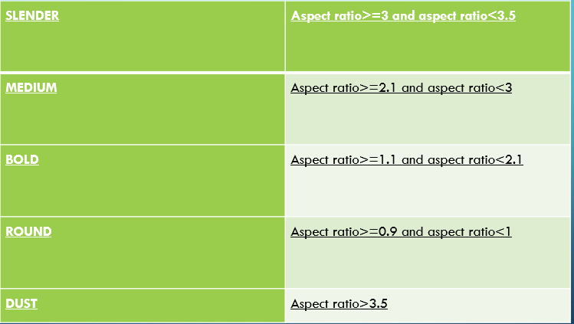

**5.1 SYSTEM ARCHITECTURE DESIGN & Flowdiagram**

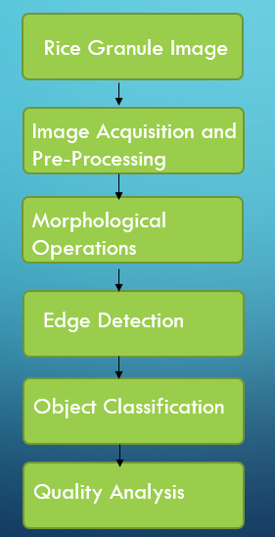

**5.2 CODES AND STANDARDS**

#RICE_QUALITY_DETECTION_USING_IMAGE_PROCESSING AND DATA VIZUALIZATION

#IMPORTING DATASETS

import dash

import dash_core_components as dcc

import dash_html_components as html

import plotly.graph_objects as go

from plotly import subplots

import pandas as pd

import plotly.express as px

import numpy as np

from dash.dependencies import Input, Output, State

import cv2

import PIL.Image as image

from io import BytesIO

import base64

from matplotlib import pyplot as plt

app = dash.Dash(__name__)

#project explanation

text1="""

Rice is favorable and high consumed cereal grain in Asian countries.

It can be easily found all over the world. Many value added products are produced by using rice for human beings .

In the rice market, key determinant of milled rice is quality. The quality measurement becomes more important with

the import and export trade. Rice samples contain different dispensable objects like paddy, chaff, damaged grains, weed seeds, stones etc.

Rice quality is varying according to these impurity content.

"""

text2="""

The main purpose of the proposed method is, to offer an alternative way for quality control and analysis which reduce the required effort,

cost and time. Image processing is significant and advanced technological area where important developments have been made.

"""

text3="""

In agricultural and farming production quality control and analysis of manufactured goods is vital.

Quality of grain is analyzed visually by veteran person and technician. But the effect of such measurement is changing in results and prolonged.

The excellence and quality also influenced by the mood and atmosphere of technician; so to overcome the shortcoming occurred due to conventional methods advanced technique i.e.

Image processing technique is projected, to Maintaining the Integrity of the Specifications.

"""

text4="""

Image processing manipulates image for performing some operations on targeted image to get an improved and desirable image.

And extort some valuable information from input image. Nowadays, image processing is hastily growing technologies.

All types of data have to go through three general phases while using digital image processing technique which are pre-processing, enhancement, and display, information extraction.

"""

text5="""

The Agricultural industry on the whole is very vast and ancient. Quality assessment of grains is a very big challenge since time immemorial.

The project presents a solution for quality evaluation and grading of rice grains using image processing techniques.

Commercially the grading of rice is done according to the size of the grain (full, half or broken). The food grains quality are rapidly assessed through visual inspection by human inspectors.

The decision making capabilities of human-inspectors are subjected to external influences such as fatigue, vengeance, bias etc.

With the help of image processing techniques we can overcome that and which are also a non-destructive and cost-effective techniques.

Here we also discuss the procedure used to obtain the percentage quality of rice grains. Rice quality is nothing but the combination of physical and chemical characteristics.

Grain size and shape, chalkiness, whiteness, milling degree, bulk density and moisture content are some physical characteristics, gelatinization temperature and gel consistency are chemical characteristics of rice.

"""

text6="""

Many studies that consider the morphological features of grains such as its area, shape etc. have already been performed.

However, the shapes and sizes of the different varieties are too varied to generalize a common formula for the classification of all varieties of rice.

"""

#classification of rice particals

def get_classification(ratio):

ratio =round(ratio,1)

toret=""

if(ratio>=3 and ratio<3.5):

toret="Slender"

elif(ratio>=2.1 and ratio<3):

toret="Medium"

elif(ratio>=1.1 and ratio<2.1):

toret="Bold"

elif(ratio>0.9 and ratio<=1):

toret="Round"

else:

toret="Dust"

return toret

#initialisig the values

classification = {"Slender":0, "Medium":0, "Bold":0, "Round":0, "Dust":0}

avg = {"Slender":0, "Medium":0, "Bold":0, "Round":0, "Dust":0}

#load in greyscale mode

from IPython.display import display, Image

img = cv2.imread("rice.png",0)

display(Image(filename='rice.png'))

#histogram part of the image

import cv2

import numpy as np

from matplotlib import pyplot as plt

img = cv2.imread('rice.png',0)

hist,bins = np.histogram(img.flatten(),256,[0,256])

cdf = hist.cumsum()

cdf_normalized = cdf * hist.max()/ cdf.max()

plt.plot(cdf_normalized, color = 'b')

plt.hist(img.flatten(),256,[0,256], color = 'r')

plt.xlim([0,256])

plt.legend(('cdf','histogram'), loc = 'upper left')

#plt.show()

#convert into binary

# 160 - threshold, 255 - value to assign, THRESH_BINARY_INV - Inverse binary

ret,binary = cv2.threshold(img,160,255,cv2.THRESH_BINARY)

#averaging filter

kernel = np.ones((5,5),np.float32)/9

dst = cv2.filter2D(binary,-1,kernel)

# -1 : depth of the destination image

kernel2 = cv2.getStructuringElement(cv2.MORPH_ELLIPSE,(3,3))

#erosion

erosion = cv2.erode(dst,kernel2,iterations = 1)

#dilation

dilation = cv2.dilate(erosion,kernel2,iterations = 1)

#edge detection

edges = cv2.Canny(dilation,100,200)

#size detection

contours, hierarchy = cv2.findContours(erosion, cv2.RETR_EXTERNAL, cv2.CHAIN_APPROX_SIMPLE)

print("No. of rice grains=",len(contours))

total_ar=0

#counting impurities

for cnt in contours:

x,y,w,h = cv2.boundingRect(cnt)

aspect_ratio = float(w)/h

if(aspect_ratio<1):

aspect_ratio=1/aspect_ratio

#print(round(aspect_ratio,2),get_classification(aspect_ratio))

classification[get_classification(aspect_ratio)] += 1

if get_classification(aspect_ratio) != "Dust":

total_ar+=aspect_ratio

if get_classification(aspect_ratio) != "Dust":

avg[get_classification(aspect_ratio)] += aspect_ratio

#getting the average value

avg_ar=total_ar/len(contours)

#setting the values for classification of rice

if classification['Slender']!=0:

avg['Slender'] = avg['Slender']/classification['Slender']

if classification['Medium']!=0:

avg['Medium'] = avg['Medium']/classification['Medium']

if classification['Bold']!=0:

avg['Bold'] = avg['Bold']/classification['Bold']

if classification['Round']!=0:

avg['Round'] = avg['Round']/classification['Round']

#saving different types of images

cv2.imwrite("img.jpg", img)

cv2.imwrite("binary.jpg", binary)

cv2.imwrite("dst.jpg", dst)

cv2.imwrite("erosion.jpg", erosion)

cv2.imwrite("dilation.jpg", dilation)

cv2.imwrite("edges.jpg", edges)

#histogram part for the edge part of the image

import cv2

import numpy as np

from matplotlib import pyplot as plt

img = cv2.imread('edges.jpg',0)

hist,bins = np.histogram(img.flatten(),256,[0,256])

cdf = hist.cumsum()

cdf_normalized = cdf * hist.max()/ cdf.max()

plt.plot(cdf_normalized, color = 'b')

plt.hist(img.flatten(),256,[0,256], color = 'r')

plt.xlim([0,256])

plt.legend(('cdf','histogram'), loc = 'upper left')

#plt.show()

#converting rgb to bgr

def readb64(base64_string):

sbuf = BytesIO()

sbuf.write(base64.b64decode(base64_string))

pimg = image.open(sbuf)

return cv2.cvtColor(np.array(pimg), cv2.COLOR_RGB2BGR)

#updating the image

def update_image(pic):

img = readb64(pic)

img = cv2.cvtColor(img, cv2.COLOR_BGR2GRAY)

classification1 = {"Slender":0, "Medium":0, "Bold":0, "Round":0, "Dust":0}

avg1 = {"Slender":0, "Medium":0, "Bold":0, "Round":0, "Dust":0}

#convert into binary

ret,binary = cv2.threshold(img,160,255,cv2.THRESH_BINARY)# 160 - threshold, 255 - value to assign, THRESH_BINARY_INV - Inverse binary

#averaging filter

kernel = np.ones((5,5),np.float32)/9

dst = cv2.filter2D(binary,-1,kernel)# -1 : depth of the destination image

kernel2 = cv2.getStructuringElement(cv2.MORPH_ELLIPSE,(3,3))

#erosion

erosion = cv2.erode(dst,kernel2,iterations = 1)

#dilation

dilation = cv2.dilate(erosion,kernel2,iterations = 1)

#edge detection

edges = cv2.Canny(dilation,100,200)

### Size detection

contours, hierarchy = cv2.findContours(erosion, cv2.RETR_EXTERNAL, cv2.CHAIN_APPROX_SIMPLE)

#print("No. of rice grains=",len(contours))

total_ar1=0

for cnt in contours:

x,y,w,h = cv2.boundingRect(cnt)

aspect_ratio = float(w)/h

if(aspect_ratio<1):

aspect_ratio=1/aspect_ratio

print(round(aspect_ratio,2),get_classification(aspect_ratio))

classification1[get_classification(aspect_ratio)] += 1

if get_classification(aspect_ratio) != "Dust":

total_ar1+=aspect_ratio

if get_classification(aspect_ratio) != "Dust":

avg1[get_classification(aspect_ratio)] += aspect_ratio

avg_ar1=total_ar1/len(contours)

if classification1['Slender']!=0:

avg1['Slender'] = avg1['Slender']/classification1['Slender']

if classification1['Medium']!=0:

avg1['Medium'] = avg1['Medium']/classification1['Medium']

if classification1['Bold']!=0:

avg1['Bold'] = avg1['Bold']/classification1['Bold']

if classification1['Round']!=0:

avg1['Round'] = avg1['Round']/classification1['Round']

cv2.imwrite("img1.jpg", img)

cv2.imwrite("binary1.jpg", binary)

cv2.imwrite("dst1.jpg", dst)

cv2.imwrite("erosion1.jpg", erosion)

cv2.imwrite("dilation1.jpg", dilation)

cv2.imwrite("edges1.jpg", edges)

return classification1,avg1,avg_ar1

#displaying image

def get_image(path):

img=image.open(path)

# Constants

img_width = 710

img_height = 550

scale_factor = 0.5

fig = go.Figure()

fig.add_trace(

go.Scatter(

x=[0, img_width * scale_factor],

y=[0, img_height * scale_factor],

mode="markers",

marker_opacity=0

)

)

fig.update_xaxes(

visible=False,

range=[0, img_width * scale_factor]

)

fig.update_yaxes(

visible=False,

range=[0, img_height * scale_factor],

scaleanchor="x"

)

fig.add_layout_image(

dict(

x=0,

sizex=img_width * scale_factor,

y=img_height * scale_factor,

sizey=img_height * scale_factor,

xref="x",

yref="y",

opacity=1.0,

layer="below",

sizing="stretch",

source=img)

)

fig.update_layout(

width=img_width * scale_factor,

height=img_height * scale_factor,

margin={"l": 0, "r": 0, "t": 0, "b": 0},

)

fig.show(config={'doubleClick': 'reset'})

return fig

#average aspect vs classification plot

def get_plot1(classification = classification, avg = avg, avg_ar = avg_ar):

fig = subplots.make_subplots(rows=1,cols=1,specs=[[{"type":"bar"}]], shared_xaxes=True)

print(list(classification.keys()))

print(list(classification.values()))

plot1 = go.Bar(x=list(classification.keys()), y=list(classification.values()), name="Particles")

plot2 = go.Bar(x=list(avg.keys()), y=list(avg.values()), name="Avg. Aspect Ratio")

fig.add_trace(plot1,1,1)

fig.add_trace(plot2,1,1)

fig.add_shape(

type="line",

x0=0,

y0=round(avg_ar,2),

x1=5,

y1=round(avg_ar,2),

line=dict(

color="LightSeaGreen",

width=4,

dash="dashdot",

),

)

fig.update_layout(

width = 600,

height = 350,

margin = {"l": 5, "r": 5, "t": 30, "b": 5},

title = "Average Aspect Ratio Vs Classification",

template = "plotly_dark"

)

return fig

#quality annalysis

def get_plot2(classification = classification):

fig = subplots.make_subplots(rows=1,cols=1,specs=[[{"type":"pie"}]])

rice = sum(list(classification.values())) - classification['Dust']

dust = classification['Dust']

values = [rice, dust]

labels = ["Rice", "Dust"]

plot1 = go.Pie(labels=labels, values=values, hole=.3)

fig.add_trace(plot1,1,1)

fig.update_layout(

width = 600,

height = 350,

margin = {"l": 65, "r": 5, "t": 60, "b": 50},

title = "Quality Analysis",

template = "plotly_dark"

)

return fig

#

app.layout = html.Div([

html.Div([

html.Div([

html.Img(

src="logo.jpg",

style={"height" : "40px", "width" : "40px", "border-radius":"20px"}

)

],style={"float":"left","padding" : "5px 0 5px 50px"}),

html.Div(

children="Classification and Quality Analysis of Rice",

style={"float":"left","padding" : "10px 0 10px 10px","font-size": "17px", "font-weight" :"600"}

),

html.Div([

html.Div([html.A("Home",href="#home")], style={"float":"left","padding":"0 10px 0 10px","align-items": "center","font-size": "15px", "font-weight" :"600"}),

html.Div([html.A("About Project",href="#about-project")], style={"float":"left","padding":"0 10px 0 10px","align-items": "center","font-size": "15px", "font-weight" :"600"}),

html.Div([html.A("About Us",href="#about-us")], style={"float":"left","padding":"0 10px 0 10px","align-items": "center","font-size": "15px", "font-weight" :"600"}),

html.Div([html.A("Source Code",href="#bottom")], style={"float":"left","padding":"0 10px 0 10px","align-items": "center","font-size": "15px", "font-weight" :"600"}),

],style={"float":"right", "padding": "10px 50px 10px 0px"})

],className="nav"),

html.Div([],style={"height":"50px"},id="home"),

html.Div([

html.H1(children="Visualisation of Results", style={"text-align":"center", "margin":"0", "padding-bottom" : "20px", "color" : "whitesmoke"}),

html.Div([

html.Div([

dcc.Graph(figure=get_plot1(),id="graph1"),

html.P("Original Image", style={"margin":"0","padding-bottom":"10px"})

], style = {"display": "block", "justify-content": "center", "align-items": "center", "padding":"0 20px 0 20px"}),

html.Div([

dcc.Graph(figure=get_plot2(),id="graph2"),

html.P("Binary Image", style={"margin":"0","padding-bottom":"10px"})

], style = {"display": "block", "justify-content": "center", "align-items": "center", "padding":"0 20px 0 20px"}),

], style = {"display": "flex", "justify-content": "center", "align-items": "center", "text-align":"center"}),

html.Div([]),

html.Div([

html.Div([

dcc.Upload([

'Drag and Drop or ',

html.A('Select a File')

],

style={

'width': '100%',

'height': '60px',

'lineHeight': '60px',

'borderWidth': '1px',

'borderStyle': 'dashed',

'borderRadius': '5px',

'textAlign': 'center'

}, id="upload-image"),

], style = {"display": "block", "justify-content": "center", "align-items": "center", "padding":"0 20px 0 20px"}),

], style = {"display": "flex", "justify-content": "center", "align-items": "center", "text-align":"center", "width" : "100%"})

],style = {"color":"black", "padding" : "20px 0 20px 0", "color" : "whitesmoke"},id='plots'),

html.Div([

html.H1(children="Images", style={"text-align":"center", "margin":"0", "padding-bottom" : "20px"}),

html.Div([

html.Div([

dcc.Graph(figure=get_image("img.jpg"),id="img"),

html.P("Original Image", style={"margin":"0","padding-bottom":"10px"})

], style = {"display": "block", "justify-content": "center", "align-items": "center", "padding":"0 20px 0 20px"}),

html.Div([

dcc.Graph(figure=get_image("binary.jpg"),id="binary"),

html.P("Binary Image", style={"margin":"0","padding-bottom":"10px"})

], style = {"display": "block", "justify-content": "center", "align-items": "center", "padding":"0 20px 0 20px"}),

html.Div([

dcc.Graph(figure=get_image("dst.jpg"),id="dst"),

html.P("Dust Image", style={"margin":"0","padding-bottom":"10px"})

], style = {"display": "block", "justify-content": "center", "align-items": "center", "padding":"0 20px 0 20px"})

], style = {"display": "flex", "justify-content": "center", "align-items": "center", "text-align":"center"}),

html.Div([]),

html.Div([

html.Div([

dcc.Graph(figure=get_image("erosion.jpg"),id="erosion"),

html.P("Erosion", style={"margin":"0","padding-bottom":"10px"})

], style = {"display": "block", "justify-content": "center", "align-items": "center", "padding":"0 20px 0 20px"}),

html.Div([

dcc.Graph(figure=get_image("dilation.jpg"),id="dilation"),

html.P("Dilation", style={"margin":"0","padding-bottom":"10px"})

], style = {"display": "block", "justify-content": "center", "align-items": "center", "padding":"0 20px 0 20px"}),

html.Div([

dcc.Graph(figure=get_image("edges.jpg"),id="edges"),

html.P("Edge Detection", style={"margin":"0","padding-bottom":"10px"})

], style = {"display": "block", "justify-content": "center", "align-items": "center", "padding":"0 20px 0 20px"})

], style = {"display": "flex", "justify-content": "center", "align-items": "center", "text-align":"center"})

],style = {"color":"black", "background-color" : "lightsteelblue", "border-radius":"40px 40px 40px 40px", "padding" : "20px 0 20px 0"},id='images'),

html.Div([

html.H1(children="About Project", style={"text-align":"center"}),

html.P(children=text1),

html.P(children=text2),

html.P(children=text3),

html.P(children=text4),

html.P(children=text5),

html.P(children=text6),

],style = {"color":"white", "padding":"10px 50px 10px 50px"},id="about-project")

])

#app callback

@app.callback([Output('img', 'figure'),

Output('binary', 'figure'),

Output('dst', 'figure'),

Output('erosion', 'figure'),

Output('dilation', 'figure'),

Output('edges', 'figure'),

Output('graph1', 'figure'),

Output('graph2', 'figure')],

[Input('upload-image', 'contents')])

#updating the outputs

def update_output(list_of_contents):

if list_of_contents is not None:

ind = str(list_of_contents).find(",")

cla,av,av_ar = update_image(list_of_contents[ind:])

return get_image("img1.jpg"), get_image("binary1.jpg"), get_image("dst1.jpg"), get_image("erosion1.jpg"), get_image("dilation1.jpg"), get_image("edges1.jpg"), get_plot1(cla, av, av_ar), get_plot2(cla)

else:

return get_image("img.jpg"), get_image("binary.jpg"), get_image("dst.jpg"), get_image("erosion.jpg"), get_image("dilation.jpg"), get_image("edges.jpg"), get_plot1(), get_plot2()

#hosting the website

if __name__ == '__main__':app.run_server(debug=False)

1. **PROJECT DEMONSTRATION**

INPUT IMAGE

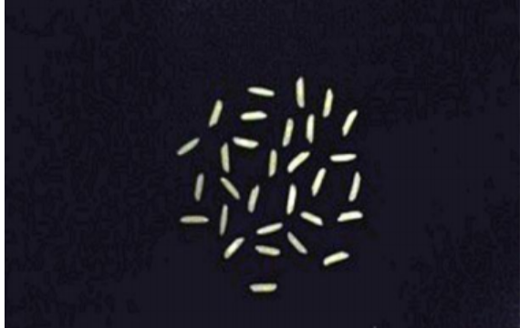

HISTOGRAM BEFORE PROCESSING

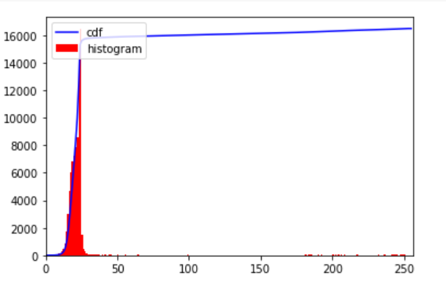

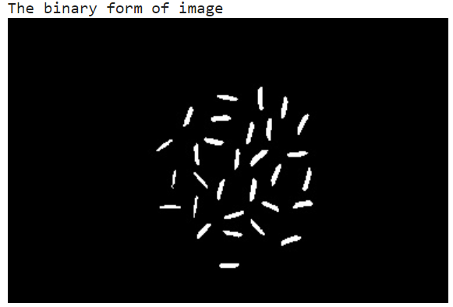

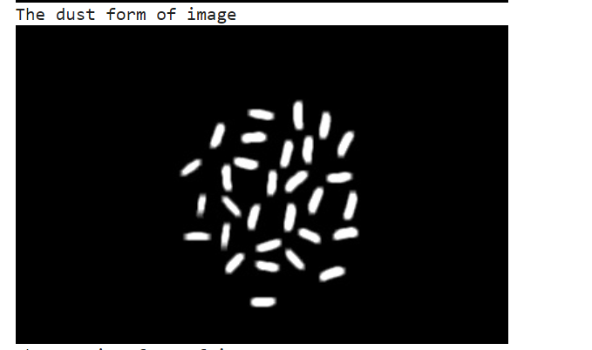

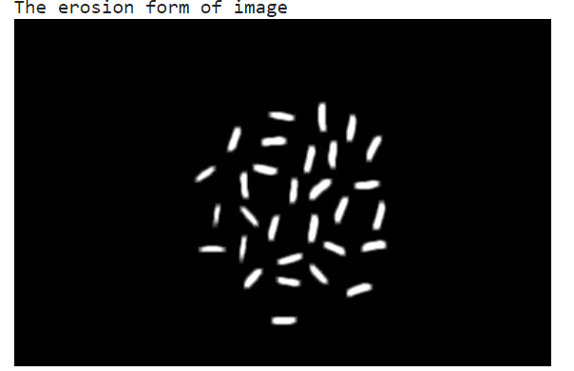

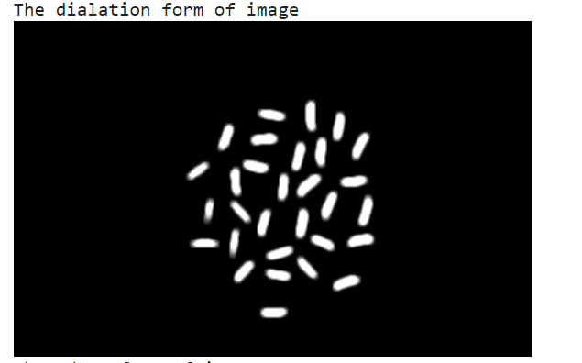

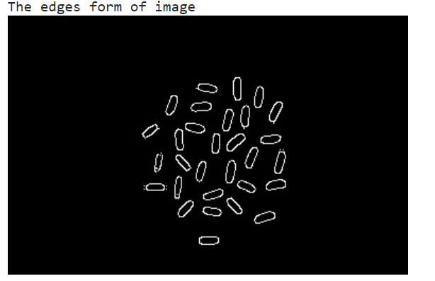

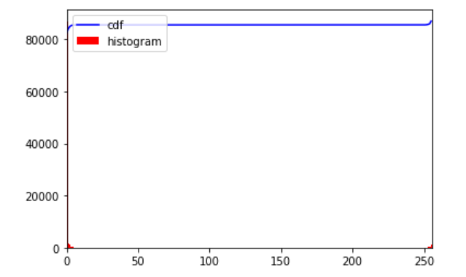

1. **PROJECT COST ANALYSIS**

This project aims in reducing the total amount of physical labour required to classify rice grains and to analyse the rice grains based on their quality. Machine Learning and Python Flask have been used to achieve the objectives of this project.

At the end of the project we are successful in developing a website which can take input in the form of rice images and classify the rice grains and as well as determine the quality of the rice grains.

This is an efficient approach and as well as a cost-efficient approach.

1. **RESULTS AND DISCUSSION**

|  |  |  |
| --- | --- | --- |
| S.NO | INPUT | OUTPUT |
| 1 |  |  |
| 2 |  |  |
| 3 |  |  |
| 4 |  |  |
| 5 |  |  |
| 6 |  |  |

Grouped Bar chart – Used for Classification purpose

• Blue Bar indicates the Number of Rice grains.

• Red Bar indicates Average Aspect Ratio.

Pie chart – Used for Quality Analysis purpose

• Blue Section indicates percentage of Rice grains in the given sample.

• Red Section indicates percentage of Dust in the given sample.

**8.Future Plan**

In future work, we will hybrid the transfer learning or combine the two different machine learning algorithms or combine the two different deep learning algorithms for better performance or efficiency.

**9.Conclusion**

In this project, we are classifying the rice grain sample taken into various categories and also analysing its quality based on its aspect ratio, so it is not possible to compare with other works. Existing works only detect the rice grains, or calculate number of rice grains in the given sample but our work helps to analyse the quality of rice sample and classify them into particular category.

Quality of grains in the samples should be nearly 100% accurate and it should be suitable to grade large quality of grains efficiently, which otherwise will consume lot of time in manual analysis, this feature will be able to save lot of time & human effort

The image analysis algorithms are applied on image in which rice grains are randomly placed and spread in one layer. If the error occurs like touching kernels shrinkage operation works efficiently for separating the connecting part from point touching kernels. Edge detection is performed to find out the region of boundaries and endpoints of each grain; and then after that using calliper length and breadth can be measured. After getting the values for length and breadth, length-breadth ratio is to be calculated. In this study, the image processing algorithms are developed to segment and identify rice grains. use of image processing algorithm is an efficient method to analyse grains quality by its size. The main benefit of proposed method is it requires minimum time; cost is less and gives better results compared with manual results or traditional methods. We have successfully executed all the steps proposed. Last two steps include calculating the size of the grains and then classifying them according to the Table provided.