**Steps to create and upload files to GitHub**

1. Signup on “github.com” using Email Id

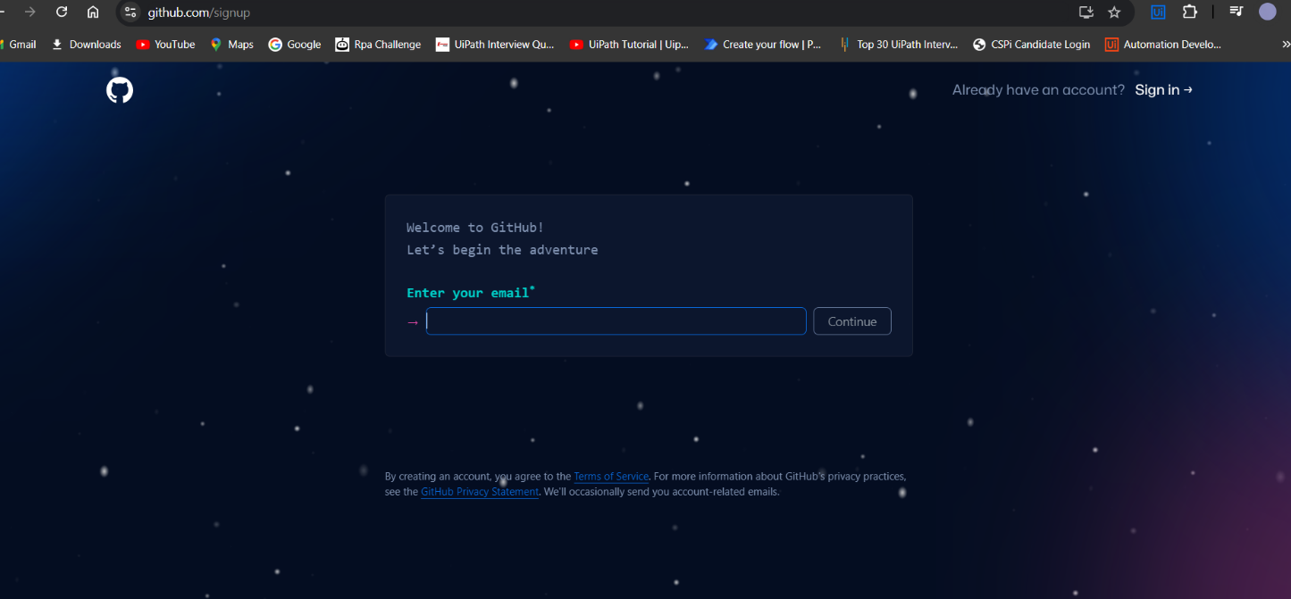

1. Select Free version



1. On your profile create a Public Repository

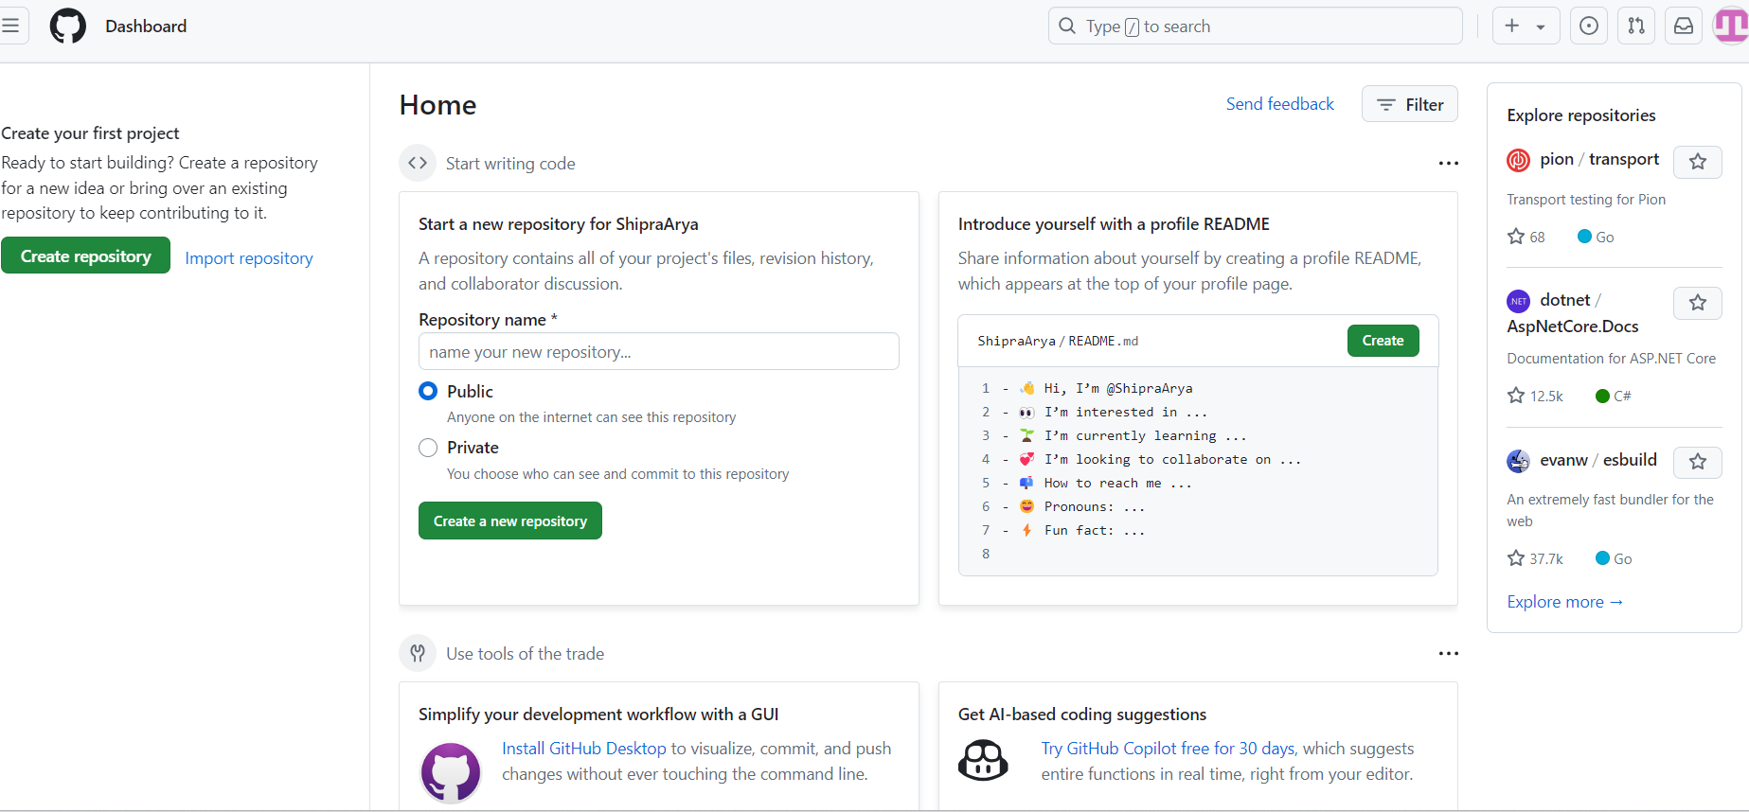

1. Enter Repository name and description, and add project file

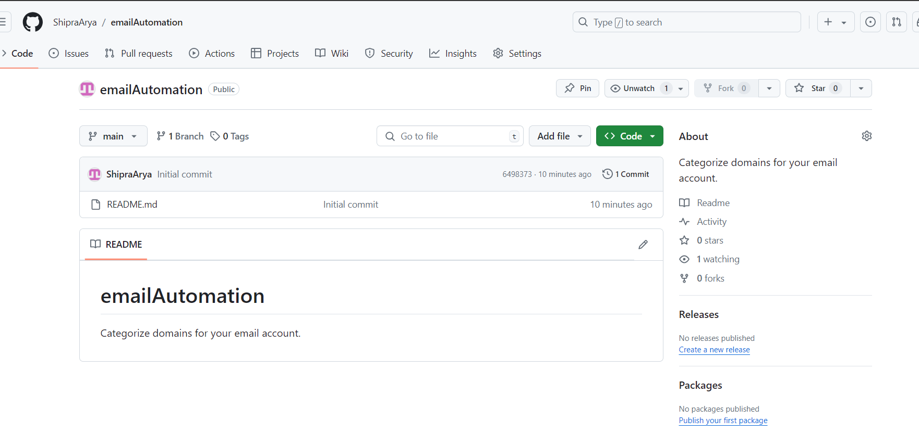

1. Upload the attached file

