WEEK-6 Hands-On

1.
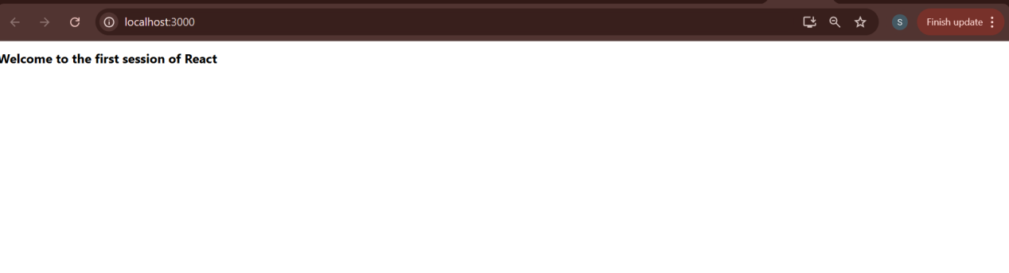
2.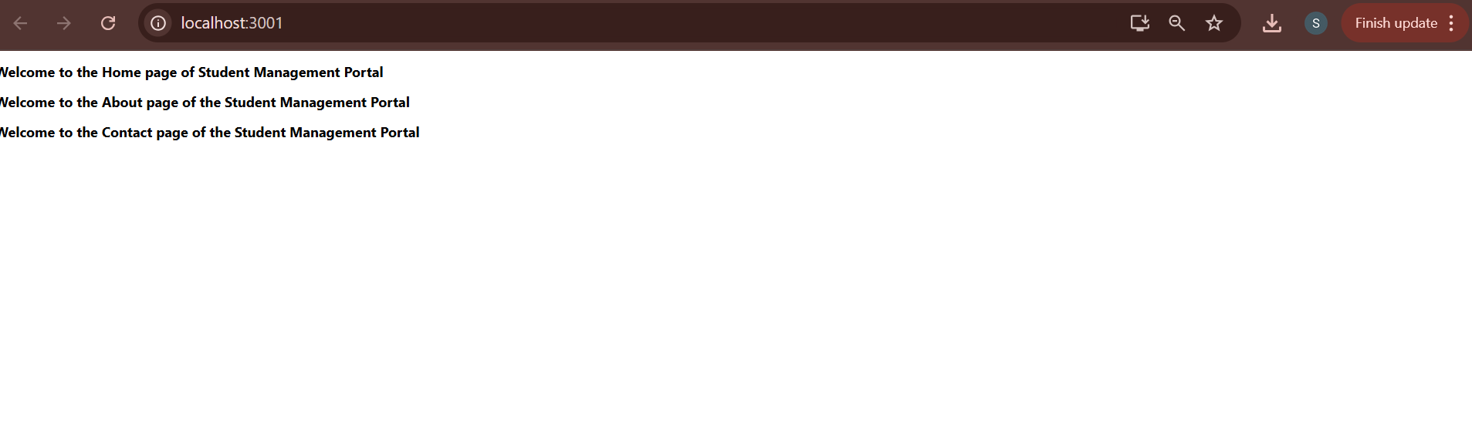

3.
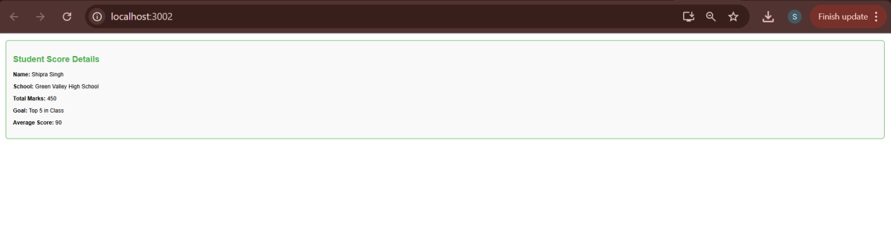

4.
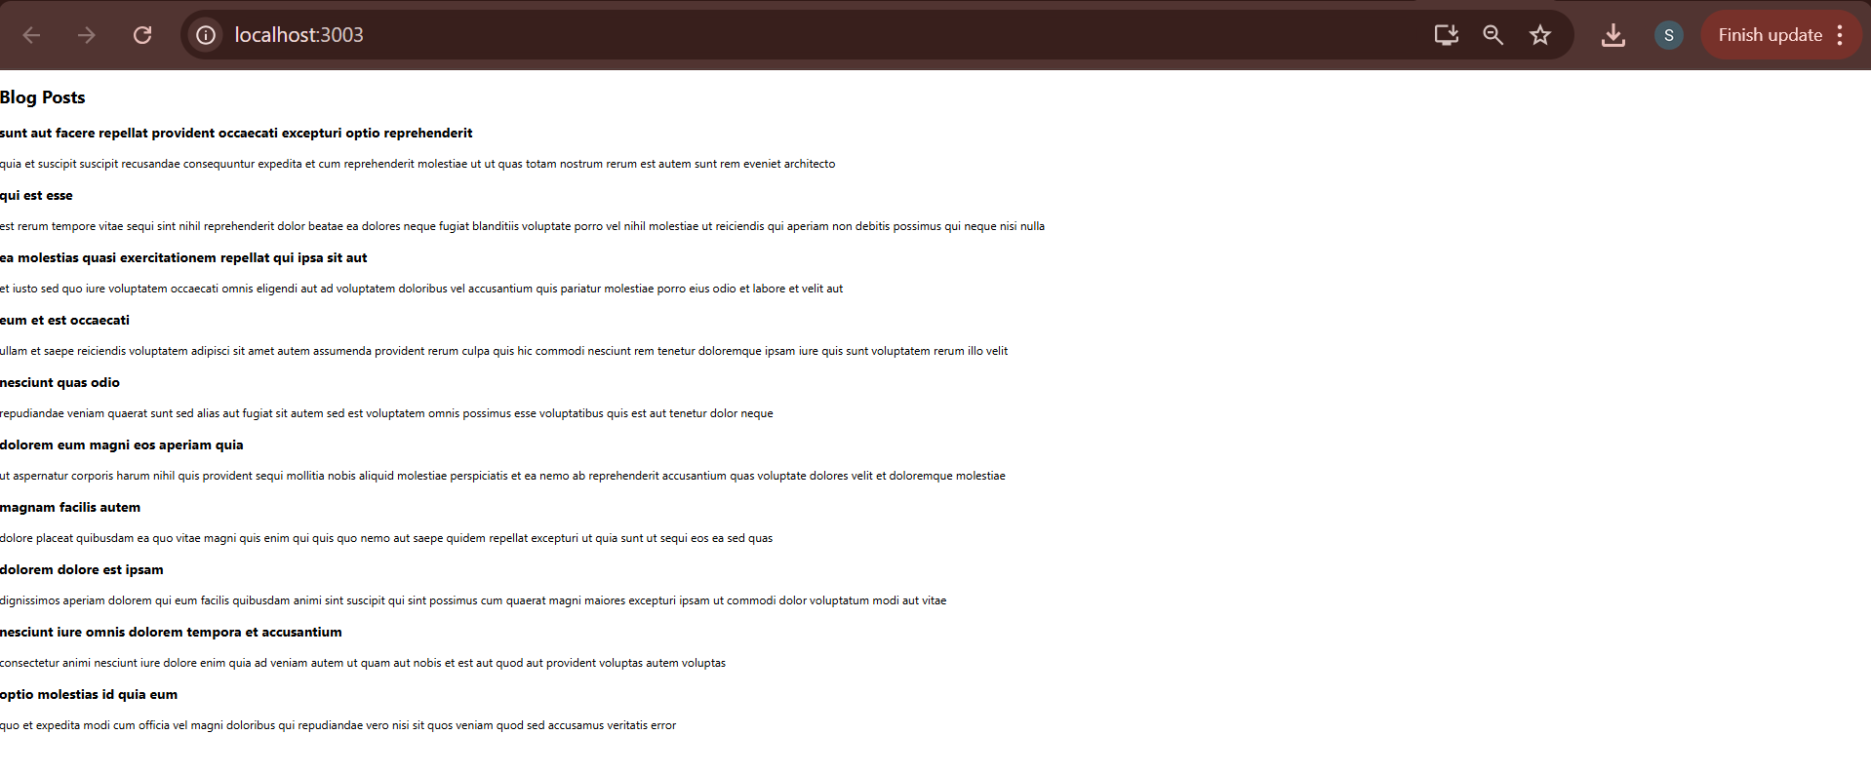

5.
