**WEEK 1 : DESIGN PRINCIPLES AND PATTERNS**

**Exercise 1: Implementing the Singleton Pattern**

**Code:**

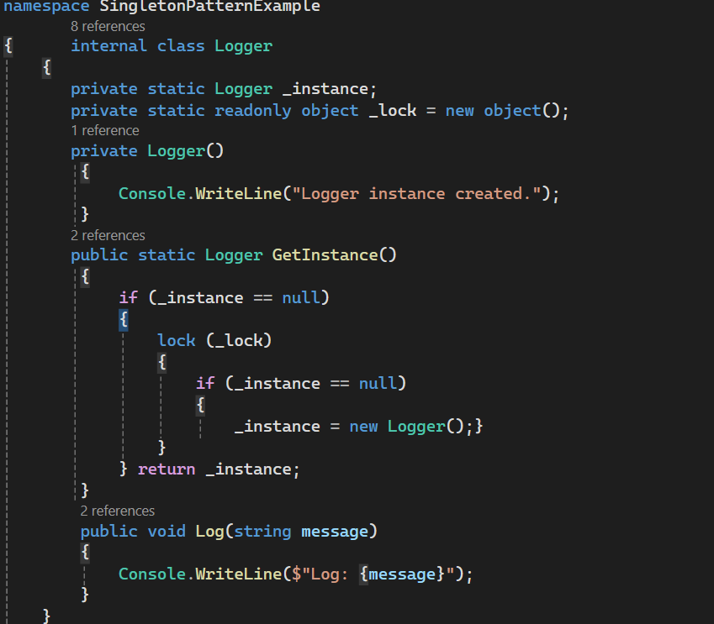

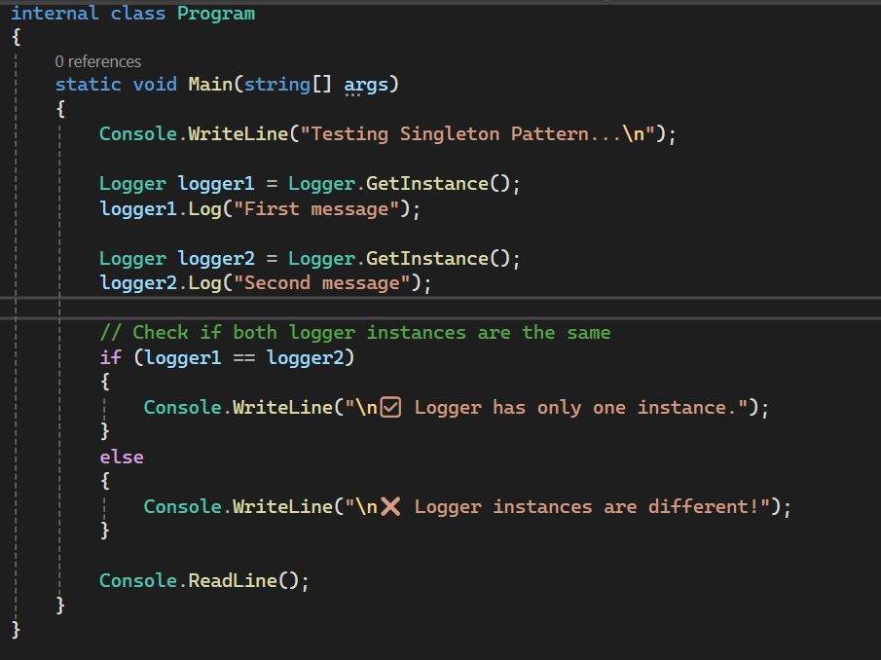

**OUTPUT:**

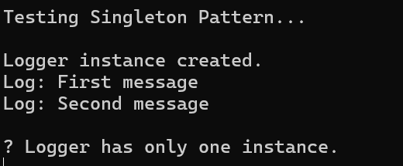

**Exercise 2: FactoryMethodPatternExample**

**Code:**

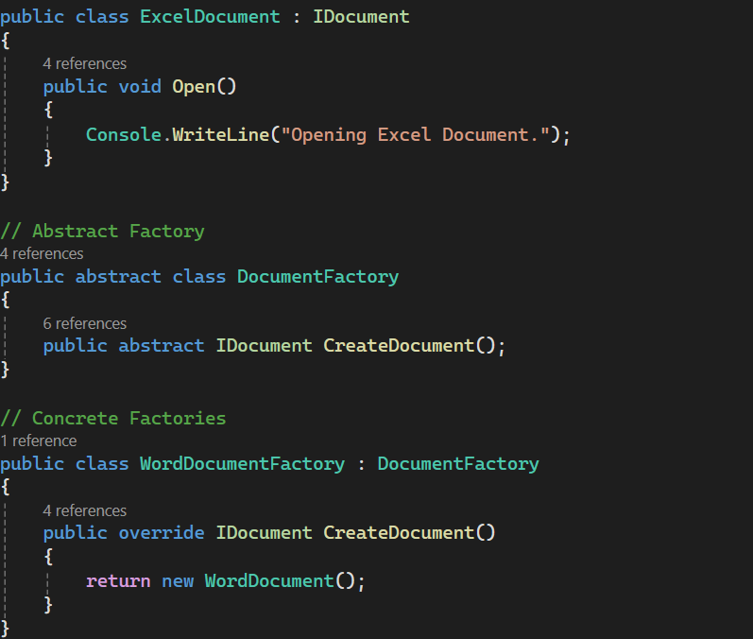

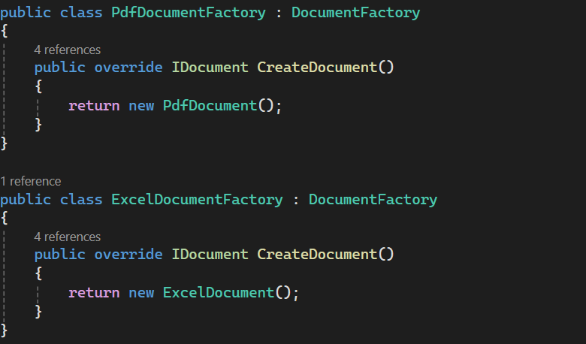

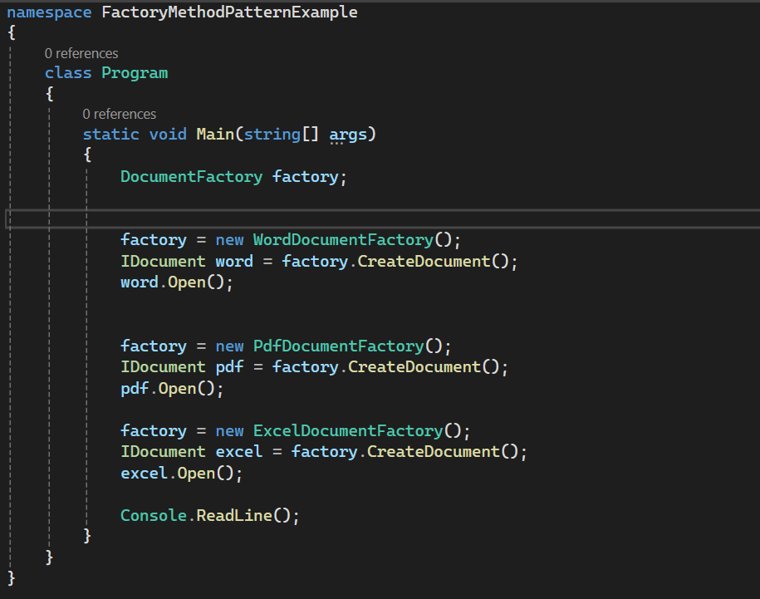

**OUTPUT:**

