Supporting Information
Unlocking Sequence Distribution in Ethylene/Vinylcyclohexane Copolymers by ¹³C NMR: From Microstructure to Thermal Properties
Roberta Cipullo^{a,*}, Lucrezia Ricciardiª, Viviana Loscialeª, Andrea Pucciarelli^{b}, Antonio Vittoriaª, Vincenzo Busicoª
ª Dipartimento di Scienze Chimiche, Università di Napoli Federico II, 80126 Napoli, Italy.
^{b} Scuola Superiore Meridionale, Largo San Marcellino, Naples, Italy

Table S1. Experimental conditions for Samples 1-3
Sample | Catalyst | nmol_{Hf} | V_{V}, mL | t_{p}, s | Yield, mg
1 | C1 | 6 | 1.0 | 520 | 149
2 | C2 | 6 | 2.0 | 1800 | 100
3 | C2 | 1 | 0.75 | 2300 | 82
Other experimental conditions: T_{p}=80°C; p_{E} = 80 psi; Cocatalyst, MAO/BHT (1:0.4)

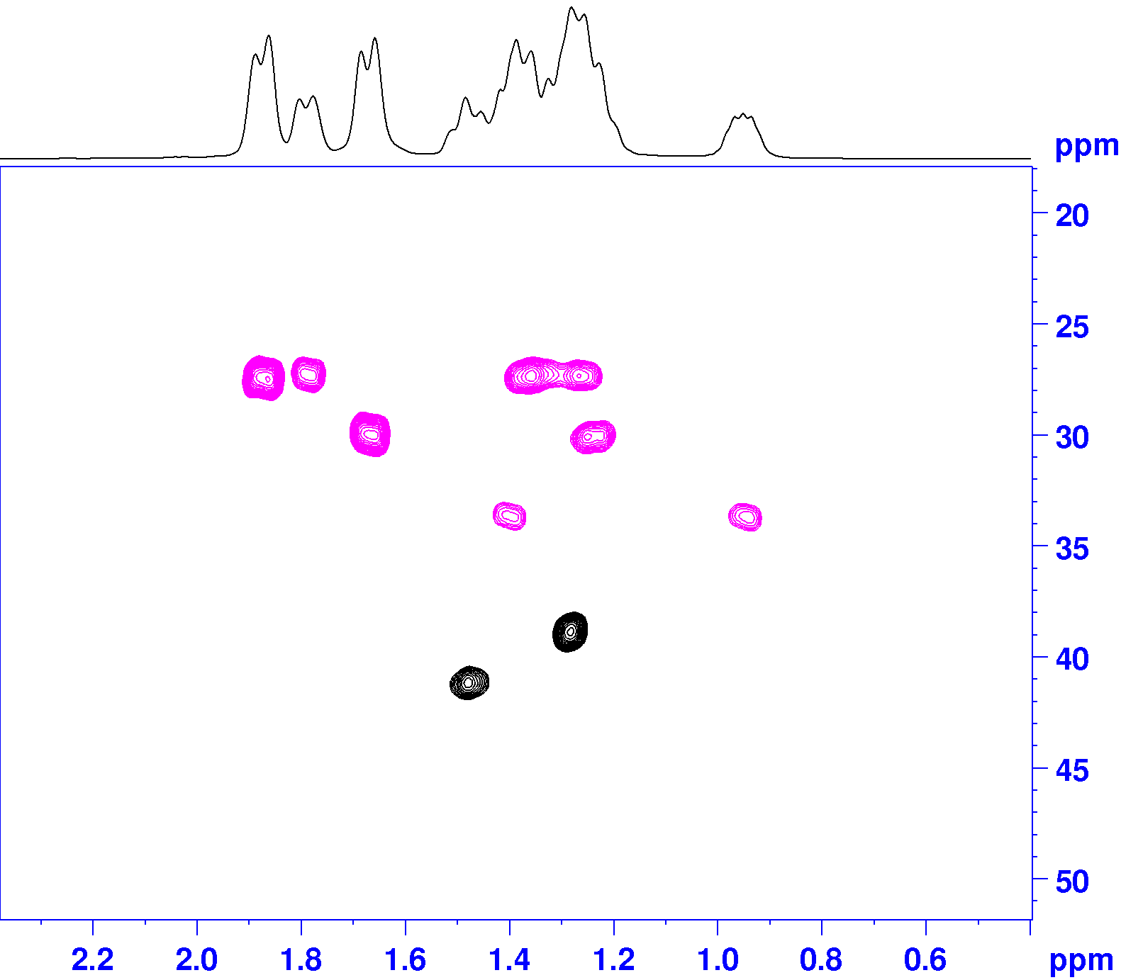

Figure S1. 2D HSQC-DEPT spectrum of a typical polyvinylcylohexane prepared with catalyst C2. The resonance of the methylene of the main chain at δ(¹³C) =33.7 ppm is largely split in two spots along the ¹H axis, at δ(¹H) ~ 0.9 and 1.4 ppm, as is typical of CH₂ groups in isotactic (m) dyads [1].

Relationship used to determine dyad and triad distribution in E/V copolymers [2].

[VV] = k I(S_{αα})
[EV] = k [I(S_{αγ} + S_{αδ})] (Eq.1)
[EE] = k [0.5×I(S_{βδ} + S_{δδ}) + 0.25×I(S_{γδ})]

[VVV] = k’ I(T_{ββ})
[VVE] = k’ I(T_{βδ})
[EVE] = k’ I(T_{δδ}) (Eq. 2)
[VEV] = k’ I(S_{ββ}) = k’ 0.5×I(S_{αγ})
[VEE] = k’ I(S_{αδ}) = k’ Ι(S_{βδ})
[EEE] = k’ [0.5×I(S_{δδ}) + 0.25×I(S_{γδ})]

where [XY] and [XYZ] denote the normalized fractional abundances of dyads and triads, respectively, I = Integral; k, k’ = normalization constants chosen such that the sum of all dyads and triads equals unity, respectively.

The necessary peak integrations are made according to Figure S1 and Table 1.

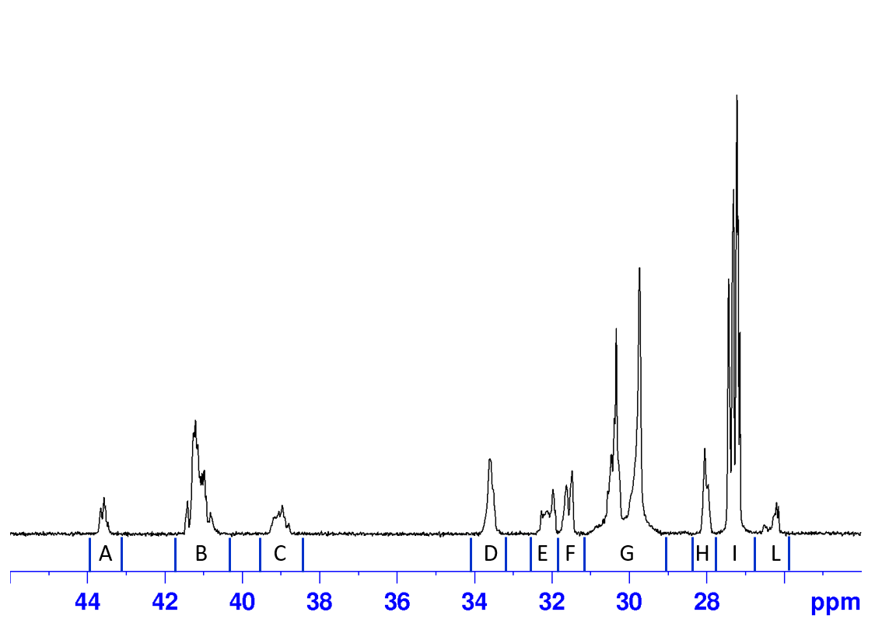
Figure S2. ¹³C-NMR spectrum of Sample 2, with indication of spectral regions for quantitative determination of dyad and triad distributions according to Eqs. 1 and 2.
Despite partial overlap of some resonances, the values of I(S_{δδ}) and I(T_{βδ}) in Eq.2 can be estimated as follows:
I(T_{βδ}) = I(B) - 1/3×I(I)
I(S_{δδ}) = I(G) – [2/3×I(I)] - I(H)

Determination of copolymer composition by means ¹H NMR spectroscopy.

A single-pulse ¹H-NMR spectrum of Samples 1-3 are shown in Figures S2-S4. In the methylene region (δ = 0.8-2.0 ppm downfield of the TMS reference), the signal of the five equatorial protons of the cyclohexyl cycle in the V units (δ = 1.58-1.95 ppm) is well separated from that cumulatively arising from the E units and the five axial protons of the cyclohexyl cycle (δ = 0.80-1.57 ppm).

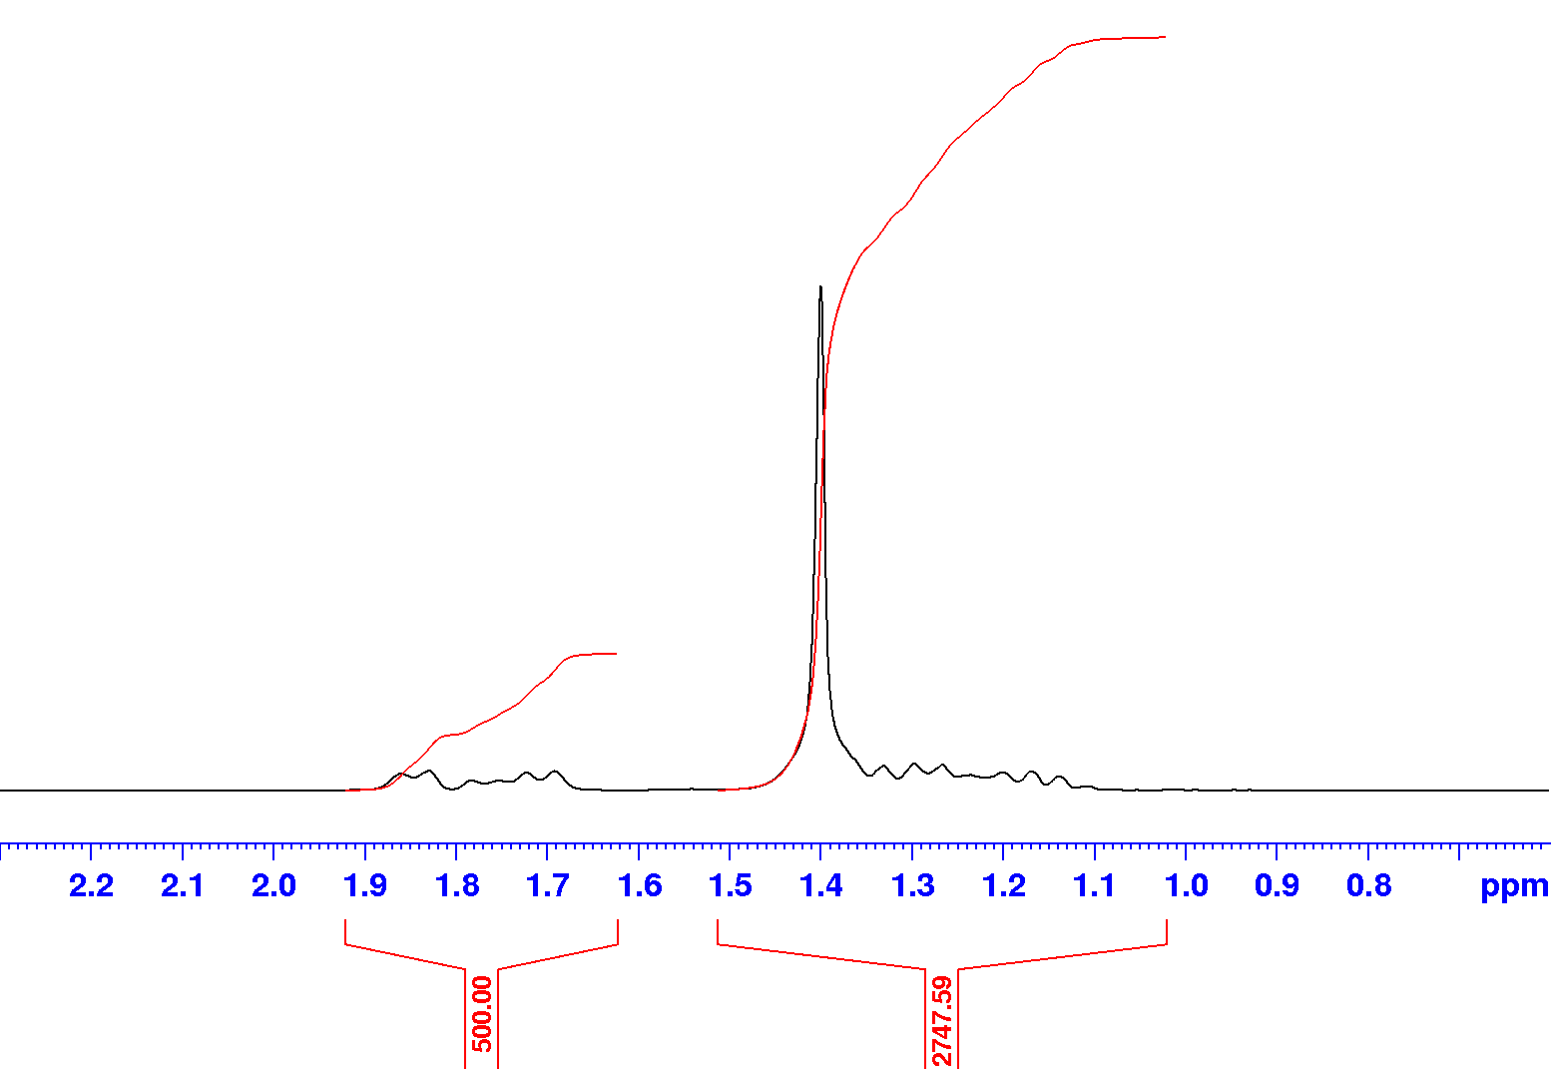
Figure S3. ¹H NMR spectrum of Sample 1

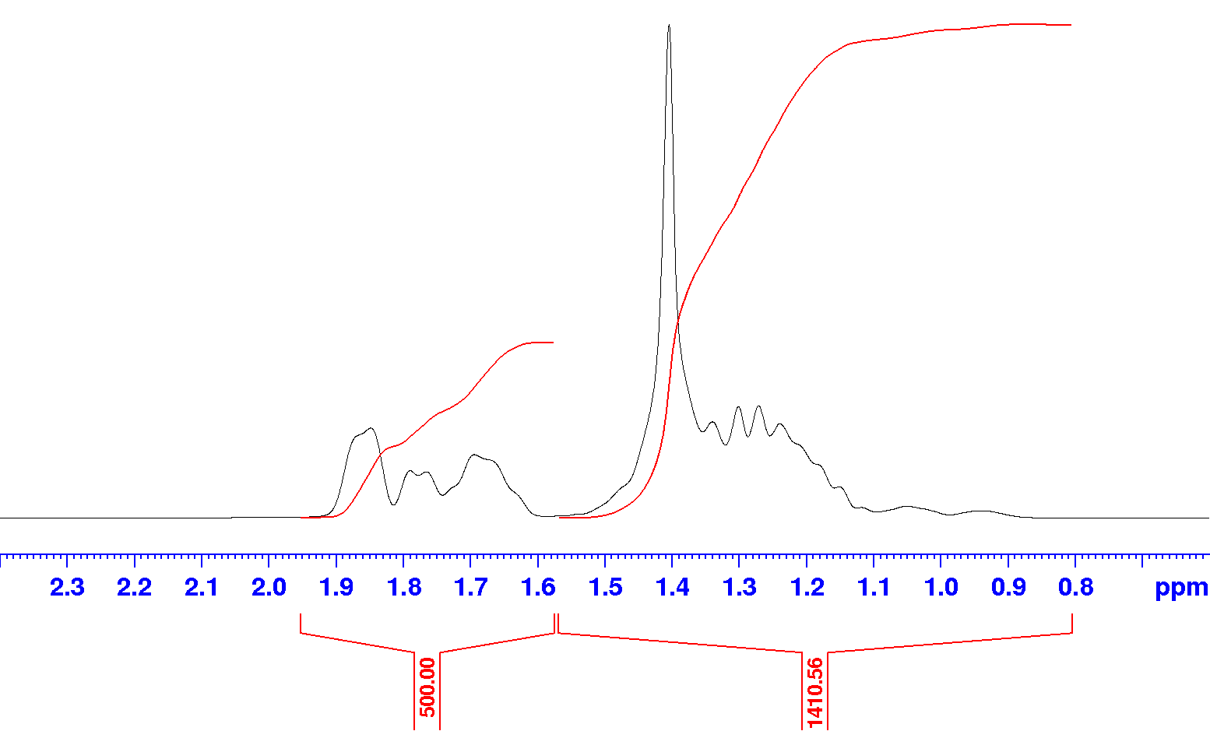
Figure S4. ¹H NMR spectrum of Sample 2
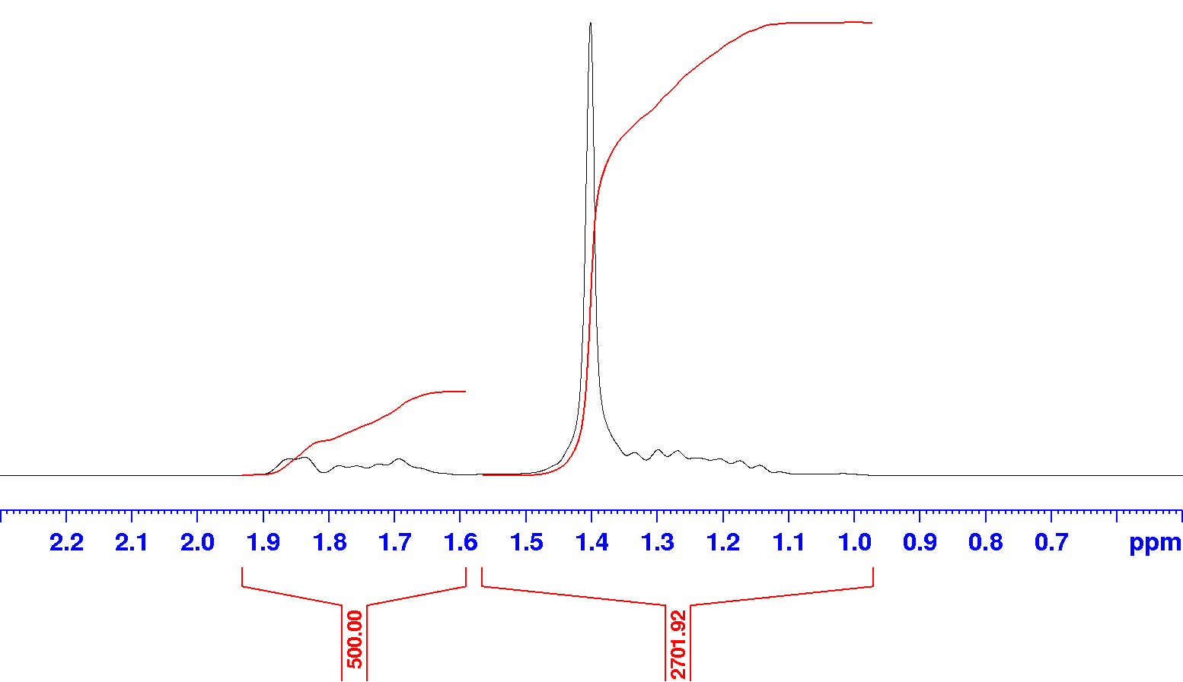
Figure S5. ¹H NMR spectrum of Sample 3

From the integrals of the two regions, the mol fraction of V units can be determined according to the following relationship:
$$x_{V}=\frac{\frac{I\left(A\right)}{5}}{\frac{I\left(A\right)}{5}+\frac{I\left(B\right)- \frac{9}{5} I\left(A\right)}{4}}$$

Determination of monomer reactivity ratios r_{E} and r_{V} from ${\text{p}}_{\text{EE}}$and ${\text{p}}_{\text{VV}}$ [1].

$${\text{r}}_{\text{E}}\text{ = }\frac{{\text{p}}_{\text{EE}}}{{\text{p}}_{\text{VE}}}\text{ ∙ }\frac{\text{[V]}}{\text{[E]}}\text{ = }\frac{{\text{p}}_{\text{EE}}}{\text{1 } {\text{p}}_{\text{EE}}}\text{ ∙ }\frac{\text{[V]}}{\text{[E]}}$$
$${\text{r}}_{\text{V}}\text{ = }\frac{{\text{p}}_{\text{VV}}}{{\text{p}}_{\text{EV}}}\text{ ∙ }\frac{\text{[E]}}{\text{[V]}}\text{ = }\frac{{\text{p}}_{\text{VV}}}{\text{1 }{\text{ P}}_{\text{VV}}}\text{ ∙ }\frac{\text{[E]}}{\text{[V]}}$$

Table S2. Experimental ¹³C-NMR dyad and triad distributions for E/H sample prepared with C2, and best-fit calculated ones assuming a first-order Markov copolymerization statistics (see main text)^{(a)}
Sequenceª | Exp., % | Calc., %
[EE] | 69.1 (3) | 69.39
[EH] | 25.7 (3) | 25.56
[HH] | 5.2 (3) | 5.05
[EEE] | 58.8 (4) | 58.60
[EEH] | 20.5 (4) | 21.58
[HEH] | 2.6 (4) | 1.99
[EHE] | 9.6 (4) | 9.16
[EHH] | 6.6 (4) | 7.24
[HHH] | 1.9 (4) | 1.43
 |  | p_{EE} = 0.844
 |  | P_{HH} = 0.283
 |  | χ_{r}² = 2.1
- p_{XY} = conditional probability of inserting comonomer Y after comonomer X (X and Y = E or V).

Table S3. Sequence parameters for E/H copolymer
Sample | Precatalyst | n_{E} | n_{V} | B
1 | C2 | 6.39 | 1.40 | 0.9

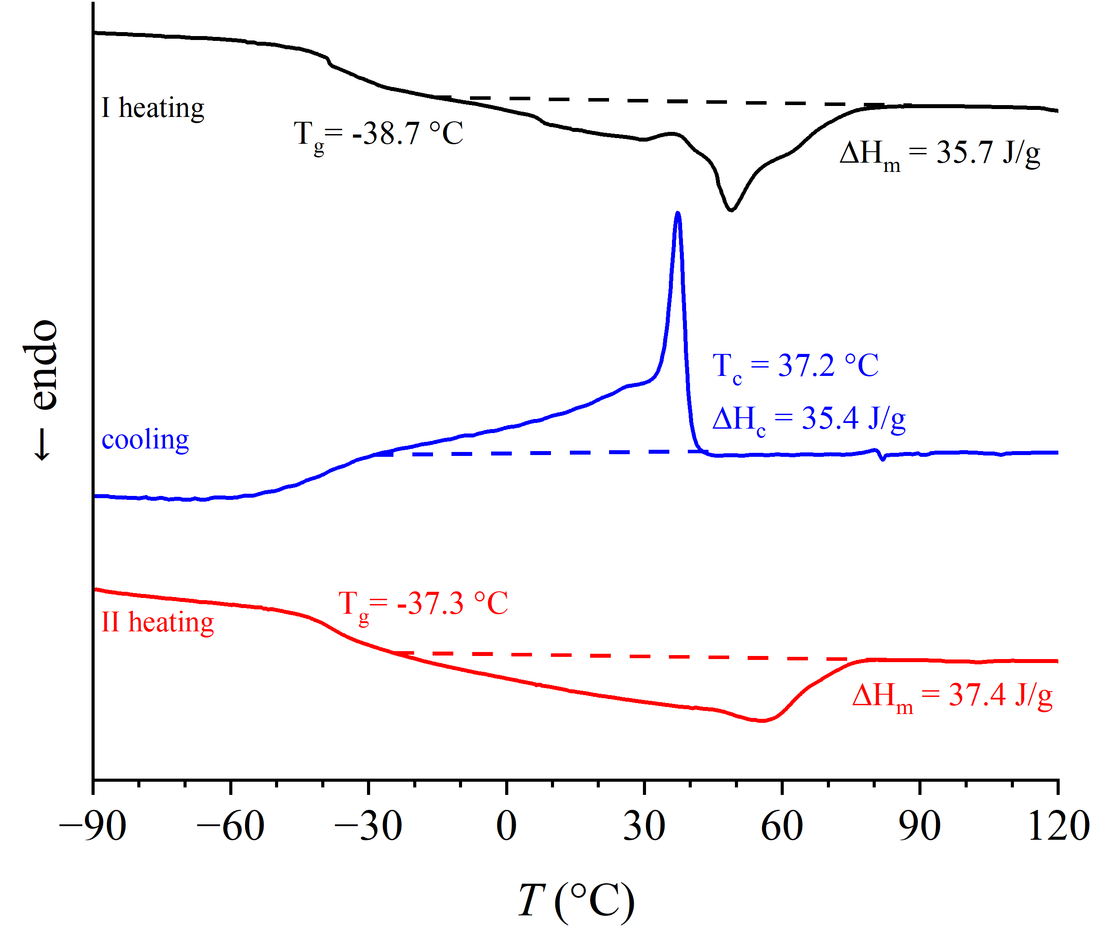
Figure S6. Thermal profile of E/H copolymer with similar sequence descriptors of Sample 3.

Reference
[1] H.N. Cheng, G.H.Lee, Two-dimensional NMR studies of polypropylene tacticity, Polym. Bull. 13 (1985) 549-556.
[2] M. Kakugo, Y. Naito, K. Mizunuma, T. Miyatake, ¹³C NMR Determination of Monomer Sequence Distribution in Ethylene-Propylene Copolymers Prepared with δ-TiCl₃/Al(C₂H₅)₂Cl, Macromolecules 15 (1982) 1150–1152. https://doi.org/10.1021/ma00232a037.

