EuPPollNet: A European database of plant-pollinator networks

Abstract
Motivation: Pollinators play a crucial role in maintaining Earth’s terrestrial biodiversity. However, rapid human-induced environmental changes are compromising the long-term persistence of plant-pollinator interactions. Unfortunately, we lack robust generalisable data capturing how plant-pollinator communities are structured across space and time. Here, we present the EuPPollNet (European Plant-Pollinator Networks) database, a fully open European-level database containing harmonised taxonomic data on plant-pollinator interactions referenced in both space and time, along with other ecological variables of interest. In addition, we evaluate the taxonomic and sampling coverage of EuPPollNet, and summarise key structural properties in plant-pollinator networks. We believe EuPPollNet will stimulate research to address data gaps in plant-pollinator interactions and guide future efforts in conservation planning.
Main Types of Variables Included: EuPPollNet contains 1,162,109 interactions between plants and pollinators from 1,864 distinct networks, which belong to 52 different studies distributed across 23 European countries. Information about sampling methodology, habitat type, biogeographic region, and additional taxonomic rank information (i.e., order, family, genus, and species) is also provided.
Spatial location and grain: The database contains 1,214 different sampling locations from 13 different natural and anthropogenic habitats that fall in 7 different biogeographic regions. All records are geo-referenced and presented in the World Geodetic System 1984 (WGS84).
Time period and grain: Species interaction data was collected between 2004 and 2021.
Major taxa and level of measurement: The database contains interaction data at the species level for 94% of the records, including a total of 1,411 plant and 2,223 pollinator species. The database includes data on 6% of the European species of flowering plants, 34% of bees, 26% of butterflies, and 33% of syrphid species at the European level.
Software format: The database was built with R and is stored in “.rds” and “.csv” formats. Its construction is fully reproducible and can be accessed at: https://doi.org/10.5281/zenodo.14747448.
KEYWORDS
Angiosperms, connectance, flowering plants, nestedness, plant-pollinator networks, pollinators, species interactions

INTRODUCTION
Plant-pollinator interactions involve a great diversity of species, largely attributed to their coevolutionary history (Ollerton, 2017), and are critically important for terrestrial biodiversity and economic productivity. The synergistic effects of climate change with other global change pressures are threatening worldwide biodiversity (Bellard et al., 2014; Sala et al., 2000), including plant and pollinator species as well as their interactions (Eichenberg et al., 2021; Goulson et al., 2015; Settele et al., 2016). Under this scenario, the increasing availability of biodiversity data plays a major role in our ecological understanding of species status, trends, and conservation (Heberling et al., 2021; Zattara & Aizen, 2021). However, our knowledge of plant and pollinator species and their network of interactions still exhibits major temporal, spatial and taxonomic biases (Archer et al., 2014; Marshall et al., 2024; Poisot et al., 2021; Troia & McManamay, 2016), limiting our ability to effectively protect their biodiversity.
The interactions between different plant and pollinator species within a community form complex networks. Macro-ecological analyses of the topology of these networks have revealed common properties, such as truncated power-law degree distributions (Jordano et al., 2003) or modularity (Olesen et al., 2007). Large-scale analyses across multiple studies can quantify patterns across geographic regions (Olesen & Jordano, 2002; Traveset et al., 2016) or environmental gradients (Ramos-Jiliberto et al., 2010; Rech et al., 2016; Saunders et al., 2023) that cannot be examined in a single study. Although macro-ecological approaches that use ecological interactions make significant contributions to knowledge on plant-pollinator networks (Windsor et al., 2023), such synthesis work must consider variation across studies in the spatio-temporal nature of the data (Burkle & Alarcón, 2011; CaraDonna et al., 2021; Garcı́a et al., 2024). For instance, plant-pollinator studies tend to differ in sampling effort and methodology which affect the structure of the resulting plant-pollinator networks (Gibson et al., 2011; Jordano, 2016; Schwarz et al., 2020). Most plant-pollinator networks have unobserved interactions (Chacoff et al., 2012; Olesen et al., 2011). Therefore, research attempting to synthesise findings across studies must have access to raw data on interactions to statistically account for sampling effort and completeness within well-described taxonomic groups. This emphasizes the importance of providing data in its rawest possible form in datasets that will be utilised for synthesis and macro-ecological studies.
Europe is one of the continents with a larger amount of available biodiversity data (Proença et al., 2017), yet still exhibits major gaps (Bennett et al., 2018; Wetzel et al., 2018). While species checklists need to be treated carefully, especially at a macro-ecological scale (Grenié et al., 2023), the growing number of European plant and pollinator checklists (Reverté et al., 2023), along with occurrence data (Zattara & Aizen, 2021), is setting a foundation for the conservation of its flora and their pollinators. However, species richness is just one component of biodiversity and documenting the interaction between plants and pollinators is essential for understanding biodiversity change (Jordano, 2016). Numerous works have studied plant-pollinator interactions in the last decades, generating thousands of plant-pollinator interaction networks worldwide. Several initiatives have tried to integrate plant-pollinator interaction data into databases such as Mangal (Poisot et al., 2016) or GloBI (Poelen et al., 2014), resulting in numerous large scale comparative analyses that have enhanced our understanding of the ecology of plants and pollinators (e.g., European wild bee data trends; Marshall et al., 2024). Despite all these resources, Europe lacks accessible harmonised plant-pollinator interaction data that allow researchers to evaluate plant-pollinator interactions at a European level. For example, only over a dozen of European plant-pollinator networks are included in Mangal, while GloBI focuses on pairwise interactions disconnected from the community context. Assembling and curating the existing information on EU plant-pollinator networks will guide research efforts, conservation planning and will set a foundation for future global change research.
Here, we present the European Plant-Pollinator Networks database (EuPPollNet), which contains harmonised information on plant-pollinator interactions at the European level. The database includes the animal pollinators that visit and pollinate flowering plants in Europe, with these European pollinators predominantly consisting of insect species. Although the database contains data on a diverse range of pollinator taxonomic groups (e.g., 17 pollinator orders), this study explores only patterns for the insects orders Hymenoptera, Diptera, Lepidoptera and Coleoptera, which accounts for almost the totality of recorded interactions in EuPPollNet (99%). To understand the scope of the database, we examined the taxonomic and sampling coverage of the different plant and pollinator species at the European level with the help of the most up-to-date species checklists and rarefaction analyses. In addition, for bees and plants, we evaluated if there is a phylogenetic signal in the presence-absence of interaction data.
To contextualise the general structural patterns that characterise EuPPollNet and set expectations for potential users of the database, we provide an exploration of widely used network indices. For example, despite the large theoretical literature on the meaning of a nested structure in plant-pollinator networks (Bascompte & Jordano, 2007; Guimaraes, 2020), where specialists species interact only with subsets of generalists species, this pattern has only been empirically evaluated with a relatively small number of networks (Bascompte et al., 2003; Payrató-Borras et al., 2019; Staniczenko et al., 2013), and is still debated how structural metrics such as connectance and nestedness change across latitudes and biogeographic regions (Olesen & Jordano, 2002; Song et al., 2017; Trøjelsgaard & Olesen, 2013).
Overall, EuPPollNet aims to cover a wide range of taxonomic groups and habitats, while also providing other variables of interest that define the ecological context and sampling methods of the study. In addition, EuPPollNet offers a transparent and accessible workflow of its data management and species harmonization that allows the database to be reused and to expand over time. This database provides a large number of community-level networks with curated and harmonised data, distinguishing it from other currently available resources that contain plant-pollinator interactions. We expect that EuPPollNet can be used to evaluate macro-ecological processes in plant-pollinator networks, guide conservation planning, and set a baseline for global change research.

METHODS

Data acquisition
The EuPPollNet database includes published and unpublished studies compiled initially by a wide number of researchers and institutions within the European continent as defined by the European Environment Agency (Stanners & Bourdeau, 1995). As this database is the result of one of the work packages of the European project Safeguard (Safeguarding European wild pollinators; https://doi.org/10.3030/101003476), first, data was directly requested from members of the Safeguard project in May 2022. Second, the request was extended to data owners outside of the project, with data collection concluding in August 2024. These other data owners were identified by direct communication with colleagues suggested by Safeguard members and by directly searching for studies on Google Scholar of under-represented regions within the database. While Google Scholar lacks reproducibility (Gusenbauer & Haddaway, 2020), it still remains the most comprehensive search engine to date (Gusenbauer, 2019). This approach maximised the potential number of studies that could be incorporated in this database. The search strings used were ‘plant-pollinator interactions’ and ‘plant-pollinator networks’. To maintain high quality standards that will support robust future ecological research, we only included studies that met the following criteria: 1) studies containing time- and geo-referenced records of plant-pollinator interactions; and 2) studies that quantify interactions by documenting the contact between a floral visitor - referred to as a ‘pollinator’ throughout the manuscript, even though pollination efficiency is not evaluated - and the reproductive structure of a specific sampled plant (i.e., phyto-centric networks).

Dataset description
The database contains 52 independent published and unpublished studies conducted during the time period 2004 - 2021 in 23 different countries (Figure 1a and Figure 1b; see Figure S1 for exact locations). Most of the studies in EuPPollNet are conducted in mainland Europe (78%), while 22% are on continental islands, including the Balearic Islands, Greek islands, Great Britain, and Ireland. The studies differ in sampling effort and methodology, and thus documenting sampling methods and sampling effort is an important feature of EuPPollNet. Most studies took place within a single flowering season (68%), sampled a given location for an average of 6 days, and exclusively sampled diurnal plant-pollinator interactions, with transects being the most common sampling method (64%). All the studies documented interactions with Hymenopterans (with 50% considering all Hymenopterans, 46% only wild bees and 3% only bumblebees), 92% documented interactions with Dipterans (with 46% considering all Dipterans, 46% only syrphids and 5% recorded syrphids plus bombylids or tachinid flies), 63% with Lepidopterans, and 32% with Coleopterans. The database includes a total of 1,162,109 distinct interactions. Most of the pollinator species belong to the orders Hymenoptera, Diptera, Lepidoptera and Coleoptera (89%), which account for nearly all interactions in this database (99%). Species from other orders (11%) are also included in the database but they represent a minor fraction of the total interactions (1%). Hymenoptera and Diptera contain the highest number of species, with each comprising approximately 1,000 species in the database. However, the majority of plant-pollinator interactions are from Hymenoptera species (90%; Figure 1c). Notably, the western honey bee, Apis mellifera, represents 69% of the total interaction records from the database and an average of 30% of the total interactions per network.

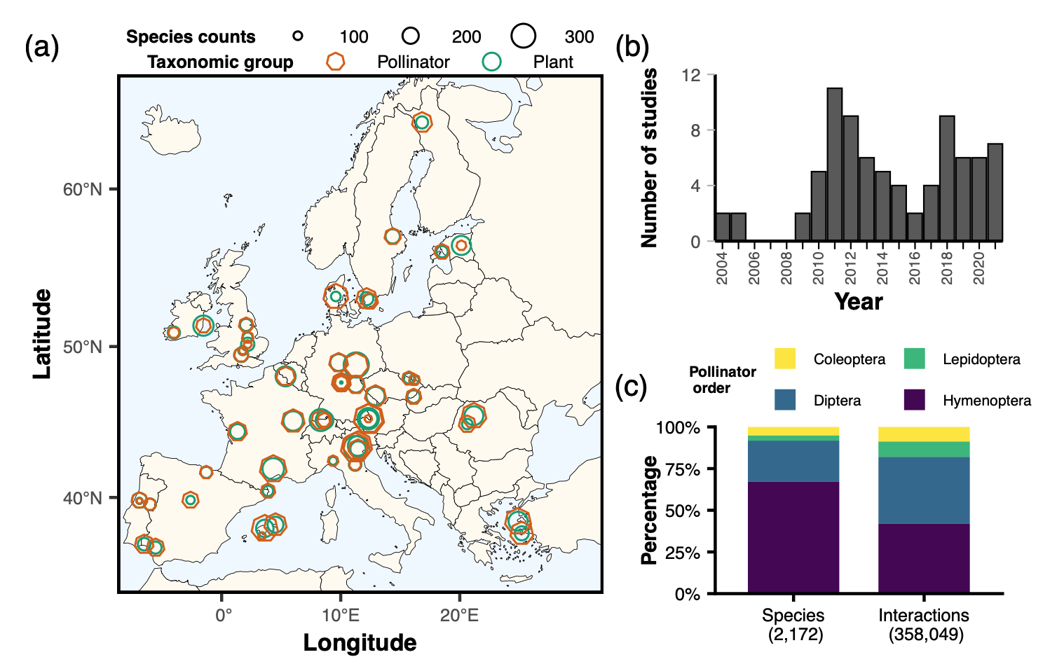
Figure 1. (a) Locations of the studies in EuPPollNet across the European continent, showing the total number of pollinator (i.e., orange heptagon) and plant (i.e., green circles) species per study. The sizes of these shapes are proportional to the respective species counts. For visualization purposes, we have selected only a single location per study. (b) Number of studies by year in EuPPollNet. (c) Proportion of species and interactions across the four main pollinator orders in EuPPollNet, excluding interactions from Apis mellifera. The total number of species and interactions is indicated in parentheses at the bottom.

Data structure
The EuPPollNet database is available in both .csv and .rds formats and contains a total of 30 columns (Table 1), where each row represents a single interaction between a plant and a pollinator species. These columns include information about the study and network identifiers (columns 1 and 2), sampling method (3), habitat type as described by the author, and a unified habitat classification across studies (4 and 5), biogeographic region where the network is located (6), country, locality, and latitude-longitude coordinates (7 to 10), date of the interaction (11), number of interactions (12), taxonomic information about plants (13 to 20), taxonomic information about pollinators (21 to 28), and information about the availability of floral count data (29). Although the database contains 52 studies, there are 54 study identifiers because one study was divided into three separate identifiers (i.e., identifiers 23, 24, and 25), as they focused on comparing three distinct habitat types. The flower count data is provided in a separate file (.csv or .rds) and can be merged with the interaction data through the “Flower_data_merger” column (30). Note that although two-thirds of studies include information on floral abundance, the methods and units vary greatly across studies. To construct a plant-pollinator network matrix within a single flowering season at the site level, users should group interactions by plant and pollinator species, site, study, and year (see a detailed example in the README file at https://github.com/JoseBSL/EuPPollNet). Finally, metadata at the study level is provided in a separate file, including information about the authors, digital object identifier (if available), sampling time, and taxonomic coverage of the main pollinator groups for each study.
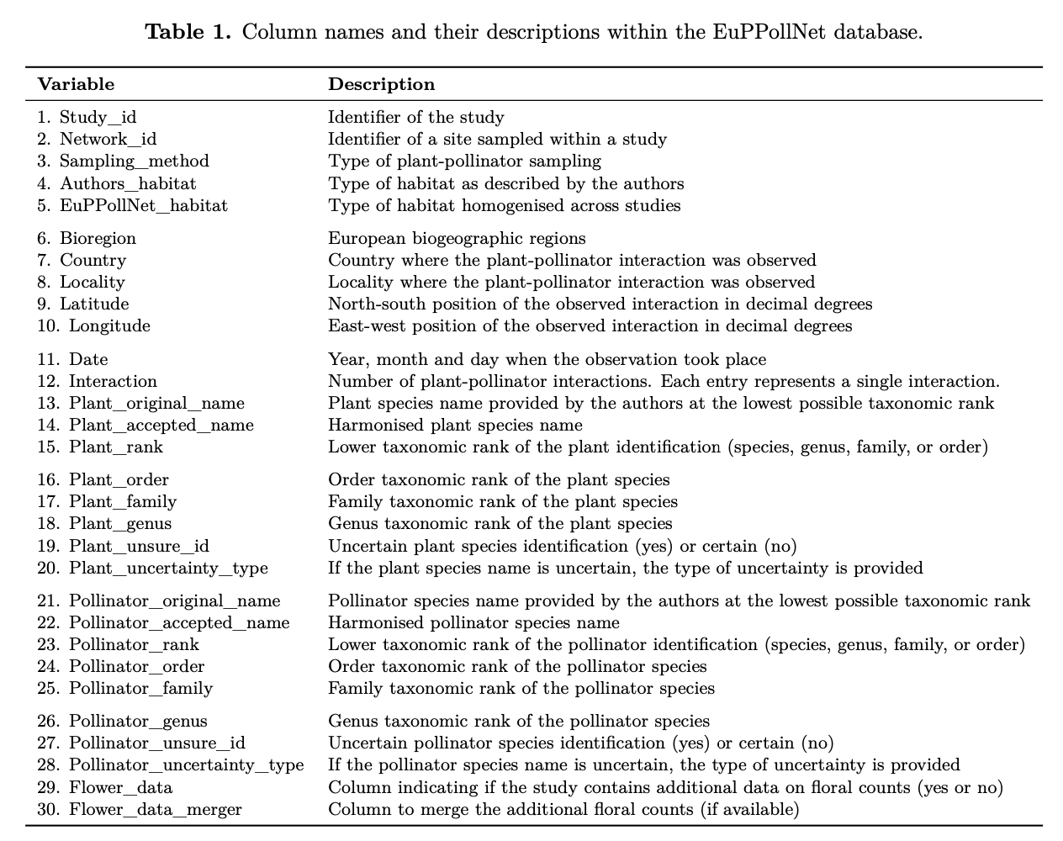

Taxonomic harmonization
All plant and pollinator species names were checked and harmonised in R using rgbif (Chamberlain et al., 2022). The protocol for plants and pollinators is similar but slightly different given the availability of the different taxonomic resources. For transparency, we have included in the database the original species name or the lowest taxonomic rank provided by the authors, the new assigned name, and, if the name of the species is uncertain (e.g., species complex or species alike). In addition, taxonomic information at genus, family and order level was downloaded for each species.
For plants: (i) we initially verified the exact matches against the GBIF species checklist; (ii) we selected unmatched cases and fixed orthographic errors; (iii) we retrieved again taxonomic information for those unmatched cases, evaluated accuracy of fuzzy matching and manually fixed records that are still not found; (iv) finally, we used the World Flora Taxonomic Backbone (Govaerts et al., 2021; WFO, July 7, 2022) as the ultimate filter for taxonomic information as we used it to calculate the plant taxonomic coverage of our database.
For pollinators: (i) we first created a checklist of species names for the most representative pollinator groups at the European level by combining the most up to date published checklists of bees and syrphids (Reverté et al., 2023), and butterflies (Wiemers et al., 2018); (ii) we compared pollinator species names against the checklist and recovered some unmatched cases with restrictive fuzzy matching by using stringdist package (Van der Loo et al., 2014); (iii) we fixed unmatched records when necessary and retrieved the taxonomic information for all species from GBIF; (iv) we fixed the non-found cases in the GBIF checklist and made sure that all species names from bees, syrphids and butterflies were named according to their respective species checklists. Coleoptera species names were only checked against the GBIF checklist.

Taxonomic coverage
To assess the completeness of plant and pollinator species in the EuPPollNet database at the European level, we used the aforementioned checklists for plants and pollinators. Specifically for plants, we refined the checklist to include only those species occurring in Europe and excluded taxonomic groups associated exclusively with wind pollination (see Culley et al., 2002) to better reflect the number of plants that benefit from pollinators at the European level. Additionally, we manually included exotic species and added unresolved species names that were not present in the accepted names of the checklist at the current version of usage. For pollinators, we only evaluated the taxonomic coverage of groups with species checklists available in Europe (i.e., bees, syrphids and butterflies). To provide an approximate number of potential pollinators in Europe, we summed the total number of species of bees, syrphids, and butterflies from the checklists, along with the extrapolated number of species from other taxonomic groups. The potential number of non-bee, non-syrphid, and non-butterfly species in Europe was extrapolated from their rarefied accumulation curve across networks using the iNEXT package (Hsieh & Chao, 2016). The maximum extrapolated number of species and the respective sampling coverage at that number provided by iNEXT were used to calculate the potential number of species at 100% sampling coverage. Only species-level identifications were considered.
Finally, to evaluate if the presence-absence of interaction records for bees and flowering plants follows a phylogenetic pattern within the database, we calculated its phylogenetic signal at genus and family level, respectively. The phylogenetic signal was calculated by using the phylosig function from the phytools package (Revell, 2012). We extracted the phylogenetic information for bees from a genus level phylogeny (Hedtke et al., 2013) and processed it using the packages ape (Paradis et al., 2019), MCMCglmm (Hadfield, 2010) and phytools. For plants, the phylogenetic tree was obtained from a species level plant phylogeny (Smith & Brown, 2018) with the help of the rtree package (Li, 2023). Only bees were considered from all pollinator groups, as they constitute the majority of the interaction records in the database (89%).

Sampling coverage
The completeness of the EuPPollNet database was evaluated by exploring the rarefied accumulation curves of plant and pollinator species and their interactions across the different networks. In addition, we computed the accumulation curve of pollinator species with an increasing number of plant species as an indicator for how many pollinator species are likely responsible for the pollination of flowering plants (e.g., Kleijn et al., 2015 for crops). The rarefied and extrapolated sampling curves were obtained using the iNEXT package. The different rarefied curves were complemented with 100 bootstrapped accumulation curves.

Habitat type and biogeographic region
We describe the habitat type for each site using information from Corine Land Cover (CLC, version 2018) extracted using the Terra package (Hijmans et al., 2022), visual inspection of Google Earth imagery and the habitat classification from the authors. These different habitat categories (see definitions in supplementary text) allow a quick comparison and understanding of the habitat types from the database. Moreover, Europe is characterised by a great variety of environmental conditions that harbor different biota. Thus, to allow authors to explore the set of studies that share similar environmental conditions and species, we assigned a biogeographic region to each site. The biogeographic regions were downloaded from the European Environment Agency (version 2016) and were matched to the different sites using a spatial joint from the sf package (Pebesma et al., 2018).

Network analyses
To provide a general overview of the structure of plant-pollinator networks in EuPPollNet, we quantified connectance and nestedness for each network and examined how these network metrics change across different latitudes and biogeographic regions in Europe. We selected these two network metrics because they are commonly evaluated in plant-pollinator studies and summarise features of network structure with potential ecological relevance. We implemented ‘standardised’ versions of connectance and nestedness to account for the effect of sampling effort on network metrics. As connectance is negatively associated with network size (Jordano, 1987), we evaluated how network connectance was associated with the number of species (i.e., log of geometric mean of plants and pollinators) and extracted the residuals from this association (i.e., residual connectance) as a measurement of corrected connectance. The relationship between residual connectance and species richness was investigated using a beta regression. This approach was chosen because connectance displays a non-normal distribution with continuous values bounded between 0 and 1. The model was implemented using the betareg package (Cribari-Neto & Zeileis, 2010). We used NODFc to compare nestedness across networks, as it corrects by connectance and the number of species in comparison to other nestedness metrics that change with network size (Song et al., 2017). This metric was calculated using the maxnodf package (Hoeppke & Simmons, 2021). Both residual connectance and NODFc were used as dependent variables to evaluate their association with latitude. In addition, to quantify how connectance and nestedness change with network size, we determined their association with the number of species per network using the Kendall rank correlation coefficient.
Finally, to compare if networks are more or less nested than expected by chance, we employed the traditional z-score approach with the widely used nestedness metric (NODF) from Almeida-Neto et al. (2008). The z-score approach only compares each unique network against their randomised versions, avoiding the influence of network size. As NODF is a metric computed from binary matrices, we calculated 100 null models for the binarised version of each network using the ‘curveball’ algorithm (Strona et al., 2014). This algorithm implements the configuration model (i.e. random rewiring of all links, without self-links or double links) and thus keeps the exact number of connections per species (i.e., realised degree). Since null model selection can significantly influence statistical results (Kaiser, 2015), we also implemented a null model that reorganizes the quantitative networks before binarising them. To that end, we used the ‘quasiswap_count’ algorithm, which is a non-sequential algorithm for quantitative networks that maintains constant connectance and the number of connections per species. Each empirical network was randomised 100 times using each method. These null models were implemented with the vegan package (Oksanen et al., 2013). Both connectance and nestedness (NODF) were estimated for each network using the function networklevel from the bipartite package (Dormann et al., 2008).

RESULTS

Taxonomic coverage
Europe hosts approximately over 5,000 species of pollinators, including 2,138 bee species 913 syrphid species, 496 butterfly species, and about 1,400 species from other taxonomic groups. These represent a total of 13 taxonomic orders, which account for less than 1% of the total interactions within the database (e.g., the taxonomic orders with the most interactions include Hemiptera, Thysanoptera, Squamata, and Orthoptera). Additionally, there are around 25,000 species of plants that benefit from animal pollination when excluding wind pollinated species. EuPPollNet contains a total of 2,223 pollinators and 1,411 plant species. The coverage of the main pollinator groups occurring in Europe is 34% for bees, 33% for syrphids and 26% for butterflies (see Figure S2 for coverage at the family level for bees and butterflies, and at the subfamily level for syrphids). Bees (i.e., Anthophila) constitute 89% of the interactions in EuPPollNet, and 77% of the interactions when excluding honey bees. Within the database, 83% of bee genera have at least one species with interaction records, and the average coverage of species at the bee genus level is 36% (Figure 2). The presence or absence of interaction records for bees does not follow a phylogenetic pattern ($λ$ = 0.07; P = 0.65). The database coverage of all flowering plant species occurring in Europe is around 6% (Figure 3), with an average coverage of 9% at the plant family level. Approximately, half of the plant families have at least one species with interaction records (52%), and the presence or absence of interaction data for the different plant species also does not follow a statistically relevant phylogenetic pattern ($λ$ = 0.26; P = 0.07).

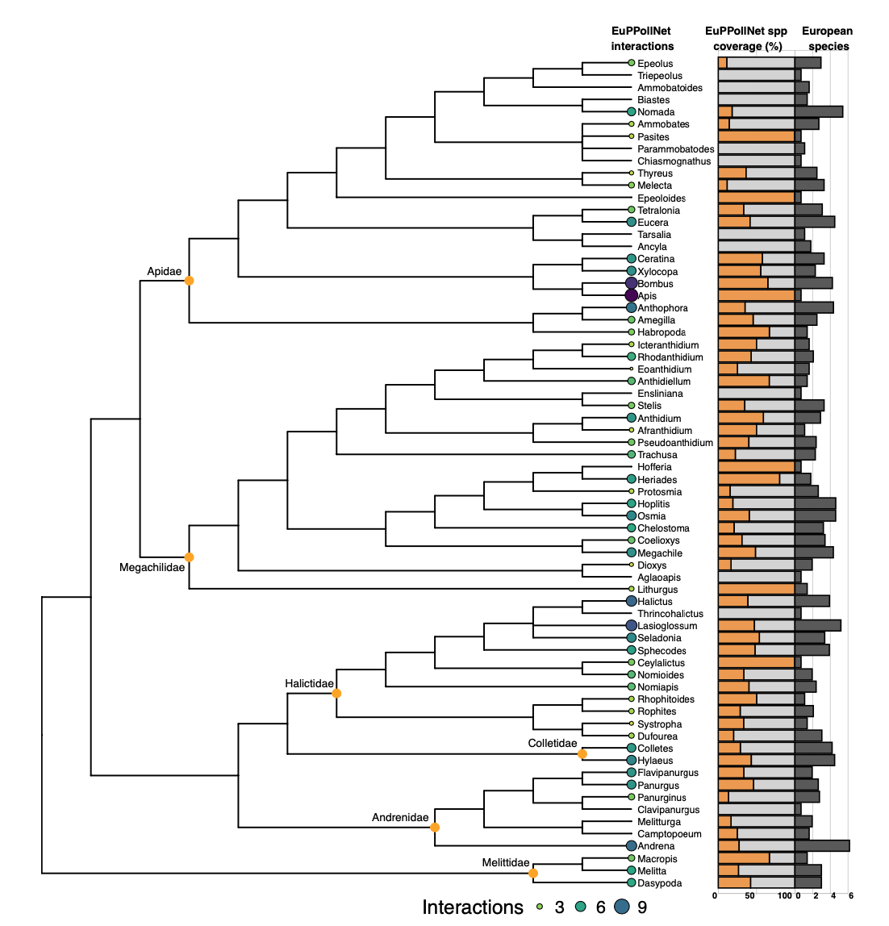
Figure 2. Phylogenetic and taxonomic coverage of bee genera at European level. The number of interactions recorded per genus in the database is illustrated using circles, with their sizes proportional to the number of interactions on a logarithmic scale, complemented by a gradient of colors ranging from yellow to dark purple. Additionally, the coverage of species recorded in EuPPollNet for each genus is depicted using two types of bars: orange bars representing the percentage of species included in the database and light grey bars indicating the percentage of species not included in the database, out of the total number of bee species in Europe. Dark grey bars represent the total number of species per genus on a logarithmic scale at European level.

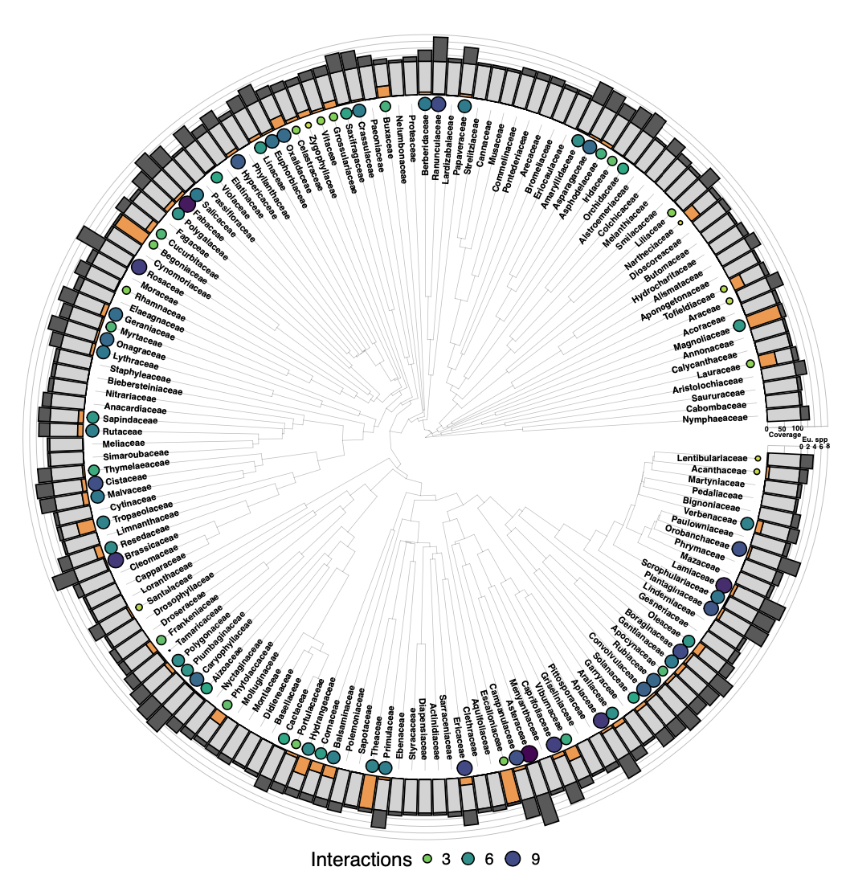
Figure 3. Phylogenetic and taxonomic coverage of the plant families at European level. The number of interactions recorded per family in the database is illustrated using circles, with their sizes proportional to the number of interactions on a logarithmic scale, complemented by a gradient of colors ranging from yellow to dark purple. Additionally, the coverage of species recorded in EuPPollNet for each family is depicted using two types of bars: orange bars representing the percentage of species included in the database and light grey bars indicating the percentage of species not included in the database out of the total number of bee species per family in Europe. Dark grey bars represent the total number of species per family on a logarithmic scale at European level.

Sampling coverage
The estimated sampling coverage of plant and pollinator species within EuPPollNet across the different networks is approximately 97% for both taxonomic groups. The rarefied accumulation curves indicate incomplete sampling, as both plant and pollinator species exhibit an exponential trend without reaching full saturation or a plateau (Figure 4a-4b). The predicted observed species richness by doubling the sampling effort on the already sampled habitat types within the database will only increase pollinator richness by 23% and plant richness by 21%. However, the sampling coverage of interactions is 74%, and by doubling the sampling effort, the predicted number of unique interactions recorded will have approximately a twofold increase (53%; Figure 4c). When we consider the accumulated pollinator richness across sampled plant species, this curve also shows an exponential growth that does not reach full saturation with a sampling coverage value of 96%. The predicted recorded pollinator species by doubling the number of plants sampled is expected to increase by 22% (Figure 4d). We find that a small portion of plant species and pollinator species are shared across a broad range of networks and that most plant (85%) and pollinator (87%) species are exclusively found in less than 1% of networks (Figures 4e-4f). The most common plant (Trifolium pratense) and pollinator (Bombus pascuorum when excluding Apis mellifera) species are found in 36% and 62% of networks, respectively.
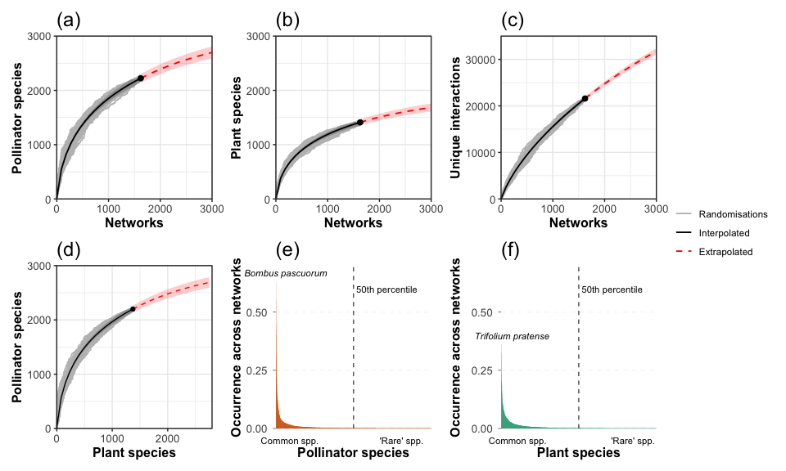
Figure 4. Graphs (a-b-c) indicate the accumulation curves for pollinators, plants, and the number of unique pairwise interactions across networks. Grey solid lines represent 100 randomised accumulation curves, the black solid lines represent the interpolated curve (i.e., the mean across curves), and the red dashed lines illustrate the extrapolated curve for approximately 3000 networks. The solid black points indicate the number of species and interactions contained in the database. Graph (d) shows the accumulation curve of pollinator species across an increasing number of plant species. This last graph uses the same color and shape structure as the ones in the top panel. Graphs (e-f) indicate the percentage of occurrence (i.e., incidence) of plant and pollinator species across networks. Species on the left (i.e., common) are found in many networks, while species on the right (i.e., rare) are found in few or only a single network. Note that Apis mellifera is the most common pollinator but was excluded from this visualization.

Habitat type and biogeographic region
The proportion of species from the major pollinator orders within the database differed across habitats and biogeographic regions (Figure 5). Hymenoptera was the main taxonomic order in the majority of habitats, exceeded only by Diptera for the habitat categories of riparian vegetation and moors and heathland. Overall, the proportions of flower visitors from Lepidoptera and Coleoptera were low across all habitats but Coleopteran flower visitors were notably more abundant in sclerophyllous vegetation and beaches, dunes and sands habitat categories. Similar patterns were observed when exploring the pollinator proportions by biogeographic region. Hymenopterans were abundant across all biogeographic regions and Dipterans were particularly abundant in the Boreal, Alpine and Atlantic regions. Lepidopterans had low proportions across all biogeographic regions and Coleopterans were only relevant in the Mediterranean region at European level. Notably, the number of studies (Figure 5) and sampling sites (Figure S3) also differed across habitats and biogeographic regions. The habitats sampled by a higher number of studies in the database were intensive grasslands (26), semi-natural grasslands (15) and sclerophyllous vegetation (10). However, the habitats that contain a higher number of sampling sites were intensive grasslands (601), agricultural margins (432) and agricultural land (141). The biogeographic regions with a higher number of studies were Continental (24), Atlantic (13) and Mediterranean (13); and those that contain a higher number of sampling sites were Continental (490), Atlantic (459) and Boreal (439).
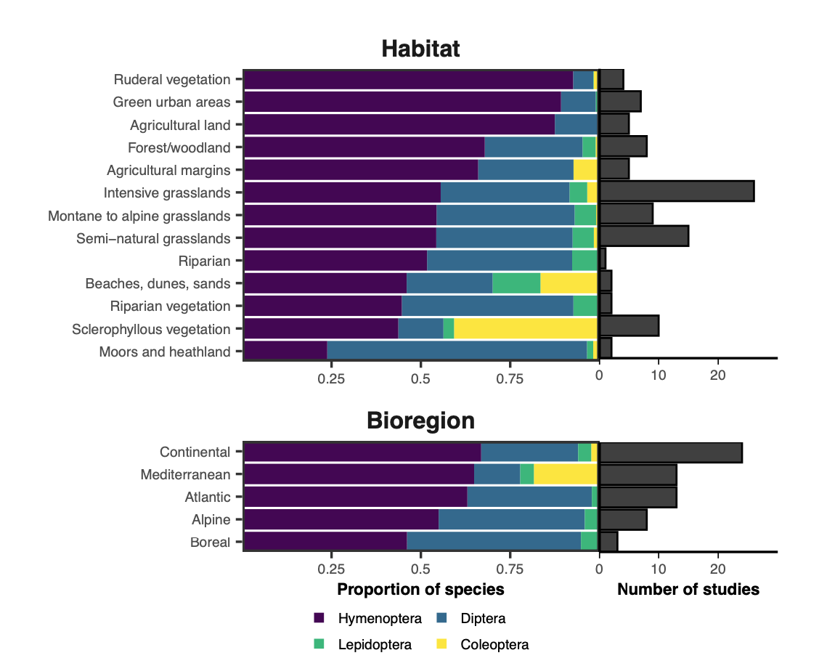
Figure 5. Proportion of species from the major pollinator orders by habitat types and biogeographic regions in the EuPPollNet database. The orders, from left to right, include Hymenoptera, Diptera, Lepidoptera and Coleoptera. The horizontal bar plot on the right indicates the number of studies that were conducted on each habitat type or biogeographic region. Note that a single study can contribute to more than one habitat or biogeographic region. Areas with a greater number of studies are more likely to depict accurate proportions of the different pollinator orders in those systems. The Pannonian and Steppic bioregions were excluded from this visualization because they contain only few networks from a single sampling day and site.

Network properties
Connectance values ranged between 0.03 to 0.4 ($\overset{‾}{x}$ = 0.14) and followed a negative exponential relationship with the number of species per network (Kendall $τ$ = -0.75, P < 0.01; Figure 6a). Nestedness values (NODFc) ranged between 1.34 to 8.63 ($\overset{‾}{x}$ = 2.87), and, as expected, were not strongly dependent on the mean number of species (Kendall $τ$ = -0.05, P = 0.08; Figure S4). Although latitude had a significant impact on residual connectance, it explained a small portion of the observed variability in both residual connectance and nestedness across networks (connectance: R$​^{2}$ = 0.02, P < 0.01, Figure 6c; NODFc: R$​^{2}$ $≈$ 0, P = 0.83, Figure 6d). In general, networks at higher latitudes tended to have lower residual connectance but similar nestedness compared to those at lower latitudes. Note that residual connectance and normalised nestedness showed a moderate significant negative correlation (Kendall $τ$ = -0.43, P < 0.01). Empirical networks did not show statistically different nestedness (NODF) to the simulated ones (Figure 6b and Figure S5). The ‘curveball’ method for binary networks resulted in 12.4% of networks statistically less nested than null expectations, 86% showing no difference, and 1.6% being more nested. The ‘quasiswap_count’ algorithm for quantitative networks resulted in 11.4% of networks being less nested, 88.1% showing no difference and 0.5% being more nested. Note that in both cases, NODF is calculated on binarised matrices.
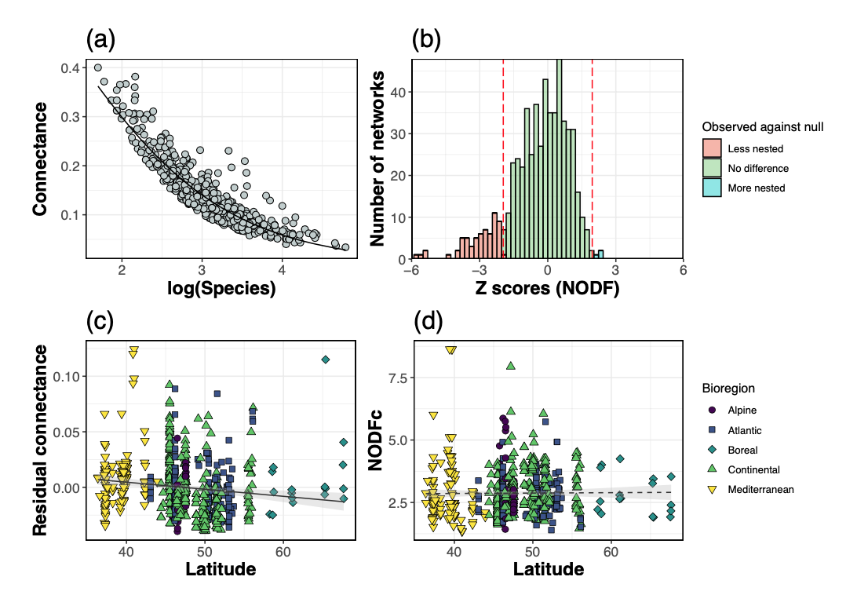
Figure 6. Graph (a) shows the association between network connectance and the geometric mean of plant and pollinator species per network on a log-scale with the respective fitted line from a Beta regression. Graph (b) shows the distribution of z-scores when comparing the nestedness from the empirical networks with their randomised counterparts (100 null models for each network with the curveball algorithm). The vertical red dashed lines represent the z critical value for a two tailed test with alpha = 0.05. Z-scores to the left of the first vertical red dashed line indicate that networks are less nested than expected by chance (red), those between the two dashed lines indicate no statistical difference from random expectations (green), and those to the right indicate that networks are more nested than expected by chance (blue). Graphs (c-d) show the fitted regression of residual connectance and nestedness across the latitudinal range of the studies from the database. The solid fitted line indicates a significant association, while the dashed lines indicate a non-significant association. The biogeographic region of each network is indicated with points of different shapes and colours.

DISCUSSION
EuPPollNet offers the largest set of plant-pollinator studies and networks compiled to date at European level. The database contains 1,411 plant and 2,223 pollinator species with over a million interaction records. While the overall sampling coverage of species and interactions is relatively high across the sampled sites, the taxonomic coverage of plants and the main pollinator groups at the European level is still relatively low (i.e., 6% for flowering plants and 34% for bee species). This likely reflects that most plant and pollinator species are rare and geographically restricted; however, rarity may also be driven by existing sampling biases. For example, given that most of the plant-pollinator networks from the database are sampled on intensive grasslands, and habitat heterogeneity is a crucial factor in understanding pollinator diversity at European level (Hass et al., 2018; Kleijn et al., 2015; Martı́nez-Núñez et al., 2022), adding studies on other habitat types is likely to result in a rapid increase of the coverage of plant and pollinator species and their interactions. Indeed, plant and pollinator species were rarely shared across multiple sites, indicating that there are few ‘common’ species and many ‘rare’ ones at the metaweb or continental level. This high number of ‘rare’ species results in an upward slope of the species or interaction accumulation curves (Thompson & Withers, 2003). In other words, minimal sampling efforts are capturing a substantial number of species and interactions, but achieving a comprehensive inventory will require numerous sampling events within and across habitats, particularly for plant-pollinator interactions.
Bees are responsible for the majority of the sampled interactions at the metaweb level. Since not all surveys included all pollinator groups, this result may be partly influenced by the taxonomic groups sampled across studies, which could reflect potential taxonomic biases. However, the relevance of bees and other pollinator orders for network topology changed across habitats and biogeographic regions in accordance to the literature. For instance, plant-pollinator communities in the Mediterranean were dominated by bees, while communities in Alpine or Boreal regions were fly species rich or fly-dominated. These patterns are consistent with our current understanding of bee diversity, which peaks in dry or temperate areas (Leclercq et al., 2023; Orr et al., 2021); and with the fact that colder environments (i.e., altitude and latitude wise) harbor a larger fraction of fly pollinators compared to other taxa (Elberling & Olesen, 1999; Lefebvre et al., 2018). In addition, beetles were only commonly documented as floral visitors in the Mediterranean region. This study cannot determine whether pollination ecologists traditionally document flower-beetle interactions only in the Mediterranean, or if there are fewer flower visitations by beetles outside this region. Nevertheless, the high proportion of beetles as floral visitors provides further support for their potential role as pollinators in the Mediterranean (Herrera, 2019; León-Osper & Narbona, 2022). The number of butterfly species and interactions were relatively low compared to the other taxa. While Europe contains fewer butterfly species than other regions of the world (Ollerton, 2017), their relevance as pollinators is likely underestimated within this database. This is because a large fraction of studies (~40%) did not sample butterflies, and conventional sampling methods for monitoring other insect pollinators (e.g., bees or flies) may be inadequate for sampling plant-butterfly interactions (Isaac et al., 2011). Honey bees were present in 87% of networks and conducted on average a third of the total interactions per network. The proportion of honey bees in networks across Europe is higher than in natural communities (i.e., large unmanaged assemblages of plant species) across the world (~13%; Hung et al., 2018). This potentially reflects the dominance of intensive grassland habitats in EuPPollNet and their widespread distribution across European landscapes (Isselstein et al., 2005), the highly generalised nature of honey bees, their native status and above all, the widespread practice of beekeeping in Europe (Herrera, 2020; Magrach et al., 2017; Steffan-Dewenter & Tscharntke, 2000).
Although Europe contains a much larger number of flowering plants than pollinator species (~5 to 1 ratio according to our extrapolation from checklists), the observed number of pollinator species in the database was almost double that of the plants. This could be explained by the fact that all networks are phytocentric, resulting in sampling bias towards pollinator species (Jordano, 2016; Vizentin-Bugoni et al., 2018). While animal-centered sampling is likely to increase the plant-pollinator species ratio (e.g., Bosch et al., 2009), the spatial scale and environmental context of the sampled communities will also influence their observed diversity, especially given the ability to move of pollinators and the sessile nature of plants. In addition, we found that the accumulation curve of pollinators per plant species does not saturate, which indicates low redundancy of pollinators and that many are regionally ‘rare’. Rare pollinators can be functionally important for plant species at the landscape level (Simpson et al., 2022; Winfree et al., 2018), highlighting the need to conduct further sampling events to identify these rare species across different regions and to effectively understand and protect plant-pollinator biodiversity.
Consistent with Olesen & Jordano (2002), we found that residual connectance (i.e., the deviation from the expected connectance for a given network size) was lower at higher latitudes. Networks at lower latitudes in Europe are exposed to higher temperatures, which can result in higher visitation rates (Arroyo et al., 1985; Classen et al., 2015; Herrera, 2019), and the overall level of pollinator generalization is known to be higher at lower latitudes (Schleuning et al., 2012). These factors should increase the number of possible connections that can be established between plants and pollinators for a given network size, resulting in more connected networks at lower latitudes in Europe. However, our results cannot be extrapolated to lower latitudes outside Europe, as tropical systems might behave differently. Moreover, most empirical networks showed a non-nested structure (~85%), confirming previous evidence highlighting the non-nested structure in plant-pollinator networks when evaluated against restrictive null models that conserve the observed species degree (Payrató-Borras et al., 2019; Figure S6). Note that while species degree distributions are sufficient to explain the emergence of nestedness, this does not preclude nestedness from being a useful metric for comparison across networks. For example, plant-pollinator networks are more nested than plant-herbivore networks precisely because these two network types differ in their composition of generalist and specialist species (Thébault & Fontaine, 2010). Novel analytical methods considering compound topologies as described in Pinheiro et al. (2022) could provide further insights of the role and prevalence of nestedness in plant-pollinator networks.
Although this database covers a wide range of habitats across 23 countries, it contains temporal and geographical biases that can impact our understanding of plant-pollinator communities (Hughes et al., 2021). For instance, none of the studies in this database sampled nocturnal pollinators, which can impact our view of network structure (Garcı́a et al., 2024), and most studies were conducted during a single flowering season, limiting our ability to evaluate temporal trends of plant-pollinator communities in the face of environmental changes (Alarcón et al., 2008; Chacoff et al., 2018). In addition, most plant-pollinator networks are sampled from central Europe, while Eastern Europe, the Mediterranean region and European islands are underrepresented. This is consistent with previous studies which also report lack of plant-pollinator data for those regions (Bennett et al., 2018; Marshall et al., 2024; Traveset & Navarro, 2018), highlighting that this database shows existing patterns in data availability despite the absence of a systematic search for studies. The lack of data for Eastern Europe, which contains vast landscapes with semi-natural grasslands experiencing rapid land use change (Sutcliffe et al., 2015), and for the Mediterranean region, which is severely impacted by climate change (Duchenne et al., 2020; Jaworski et al., 2022; Pareja-Bonilla et al., 2023), is particularly concerning. These areas are well known for their rich pollinator diversity (Miličić et al., 2018; Reverté et al., 2023), and their under-representation is likely contributing to the low taxonomic coverage of this database at the European level. Although some of the most well studied countries in Europe (e.g., Belgium, The Netherlands) have already experienced land use change and biodiversity loss at the end of the 20th century (Carvalheiro et al., 2013), plant-pollinator communities in Europe and across the globe still face current and future threats from climate change (Bartomeus et al., 2011; Duchenne et al., 2020), land use change (Batáry et al., 2015; Reidsma et al., 2006), and the introduction of alien species (Vanbergen et al., 2018; Vilà et al., 2009). Therefore, continuous monitoring programs are needed in order to evaluate spatio-temporal changes of species and their interactions across different European habitats and regions. This will allow local and large scale analyses of the status and trends of plant-pollinator communities, effectively informing management and conservation actions.
In conclusion, the EuPPollNet database enables researchers to explore spatial, taxonomic and structural properties of plant-pollinator networks within Europe. In contrast to previous databases, EuPPollNet provides interaction data along with sampling information that could help researchers to better control for sampling effort and completeness and to select the most suitable networks for their research questions. Here, we have shown how connectance and nestedness change across their latitudinal range, and that plant-pollinator networks are as nested as expected given plant and pollinator generalist levels. These analyses aim to highlight the variability present across Europe in the structure of plant-pollinator networks and illustrate the opportunities available to develop and test questions about spatio-temporal network change using EuPPollNet. The reproducible workflow allows researchers to adapt and reuse this database, enabling the continuous addition of new networks to better evaluate the status and trends of plant-pollinator communities. Finally, we hope this database becomes an iterative resource that keeps growing and improving over time to better understand and conserve European biodiversity.

REFERENCES
Alarcón, R., Waser, N. M., & Ollerton, J. (2008). Year-to-year variation in the topology of a plant–pollinator interaction network. Oikos, 117(12), 1796–1807.
Almeida-Neto, M., Guimaraes, P., Guimaraes Jr, P. R., Loyola, R. D., & Ulrich, W. (2008). A consistent metric for nestedness analysis in ecological systems: Reconciling concept and measurement. Oikos, 117(8), 1227–1239.
Archer, C. R., Pirk, C. W. W., Carvalheiro, L. G., & Nicolson, S. W. (2014). Economic and ecological implications of geographic bias in pollinator ecology in the light of pollinator declines. Oikos, 123(4), 401–407.
Arroyo, M. T. K., Armesto, J. J., & Primack, R. B. (1985). Community studies in pollination ecology in the high temperate Andes of central Chile II. Effect of temperature on visitation rates and pollination possibilities. Plant Systematics and Evolution, 149(3–4), 187–203.
Bartomeus, I., Ascher, J. S., Wagner, D., Danforth, B. N., Colla, S., Kornbluth, S., & Winfree, R. (2011). Climate-associated phenological advances in bee pollinators and bee-pollinated plants. Proceedings of the National Academy of Sciences, 108(51), 20645–20649.
Bascompte, J., & Jordano, P. (2007). Plant-animal mutualistic networks: The architecture of biodiversity. Annu. Rev. Ecol. Evol. Syst., 38, 567–593.
Bascompte, J., Jordano, P., Melián, C. J., & Olesen, J. M. (2003). The nested assembly of plant–animal mutualistic networks. Proceedings of the National Academy of Sciences, 100(16), 9383–9387.
Batáry, P., Dicks, L. V., Kleijn, D., & Sutherland, W. J. (2015). The role of agri-environment schemes in conservation and environmental management. Conservation Biology, 29(4), 1006–1016.
Bellard, C., Leclerc, C., Leroy, B., Bakkenes, M., Veloz, S., Thuiller, W., & Courchamp, F. (2014). Vulnerability of biodiversity hotspots to global change. Global Ecology and Biogeography, 23(12), 1376–1386.
Bennett, J. M., Thompson, A., Goia, I., Feldmann, R., Ştefan, V., Bogdan, A., Rakosy, D., Beloiu, M., Biro, I.-B., Bluemel, S., et al. (2018). A review of European studies on pollination networks and pollen limitation, and a case study designed to fill in a gap. AoB Plants, 10(6), ply068.
Bosch, J., Martı́n González, A. M., Rodrigo, A., & Navarro, D. (2009). Plant–pollinator networks: Adding the pollinator’s perspective. Ecology Letters, 12(5), 409–419.
Burkle, L. A., & Alarcón, R. (2011). The future of plant–pollinator diversity: Understanding interaction networks across time, space, and global change. American Journal of Botany, 98(3), 528–538.
CaraDonna, P. J., Burkle, L. A., Schwarz, B., Resasco, J., Knight, T. M., Benadi, G., Blüthgen, N., Dormann, C. F., Fang, Q., Fründ, J., et al. (2021). Seeing through the static: The temporal dimension of plant–animal mutualistic interactions. Ecology Letters, 24(1), 149–161.
Carvalheiro, L. G., Kunin, W. E., Keil, P., Aguirre-Gutiérrez, J., Ellis, W. N., Fox, R., Groom, Q., Hennekens, S., Van Landuyt, W., Maes, D., et al. (2013). Species richness declines and biotic homogenisation have slowed down for NW-European pollinators and plants. Ecology Letters, 16(7), 870–878.
Chacoff, N. P., Resasco, J., & Vázquez, D. P. (2018). Interaction frequency, network position, and the temporal persistence of interactions in a plant–pollinator network. Ecology, 99(1), 21–28.
Chacoff, N. P., Vázquez, D. P., Lomáscolo, S. B., Stevani, E. L., Dorado, J., & Padrón, B. (2012). Evaluating sampling completeness in a desert plant–pollinator network. Journal of Animal Ecology, 81(1), 190–200.
Chamberlain, S., Oldoni, D., & Waller, J. (2022). Rgbif: Interface to the global biodiversity information facility API. http://www-cs-faculty.stanford.edu/~uno/abcde.html
Classen, A., Peters, M. K., Kindeketa, W. J., Appelhans, T., Eardley, C. D., Gikungu, M. W., Hemp, A., Nauss, T., & Steffan-Dewenter, I. (2015). Temperature versus resource constraints: Which factors determine bee diversity on Mount Kilimanjaro, Tanzania? Global Ecology and Biogeography, 24(6), 642–652.
Cribari-Neto, F., & Zeileis, A. (2010). Beta regression in R. Journal of Statistical Software, 34, 1–24.
Culley, T. M., Weller, S. G., & Sakai, A. K. (2002). The evolution of wind pollination in angiosperms. Trends in Ecology & Evolution, 17(8), 361–369.
Dormann, C. F., Gruber, B., & Fründ, J. (2008). Introducing the bipartite package: Analysing ecological networks. Interaction, 1(0.2413793), 8–11.
Duchenne, F., Thébault, E., Michez, D., Elias, M., Drake, M., Persson, M., Rousseau-Piot, J., Pollet, M., Vanormelingen, P., & Fontaine, C. (2020). Phenological shifts alter the seasonal structure of pollinator assemblages in Europe. Nature Ecology & Evolution, 4(1), 115–121.
Eichenberg, D., Bowler, D. E., Bonn, A., Bruelheide, H., Grescho, V., Harter, D., Jandt, U., May, R., Winter, M., & Jansen, F. (2021). Widespread decline in Central European plant diversity across six decades. Global Change Biology, 27(5), 1097–1110.
Elberling, H., & Olesen, J. M. (1999). The structure of a high latitude plant-flower visitor system: The dominance of flies. Ecography, 22(3), 314–323.
Garcı́a, Y., Giménez-Benavides, L., Iriondo, J. M., Lara-Romero, C., Méndez, M., Morente-López, J., & Santamarı́a, S. (2024). Addition of nocturnal pollinators modifies the structure of pollination networks. Scientific Reports, 14(1), 1226.
Gibson, R. H., Knott, B., Eberlein, T., & Memmott, J. (2011). Sampling method influences the structure of plant–pollinator networks. Oikos, 120(6), 822–831.
Goulson, D., Nicholls, E., Botı́as, C., & Rotheray, E. L. (2015). Bee declines driven by combined stress from parasites, pesticides, and lack of flowers. Science, 347(6229), 1255957.
Govaerts, R., Nic Lughadha, E., Black, N., Turner, R., & Paton, A. (2021). The World Checklist of Vascular Plants, a continuously updated resource for exploring global plant diversity. Scientific Data, 8(1), 215.
Grenié, M., Berti, E., Carvajal-Quintero, J., Dädlow, G. M. L., Sagouis, A., & Winter, M. (2023). Harmonizing taxon names in biodiversity data: A review of tools, databases and best practices. Methods in Ecology and Evolution, 14(1), 12–25.
Guimaraes, P. R. (2020). The structure of ecological networks across levels of organization. Annual Review of Ecology, Evolution, and Systematics, 51, 433–460.
Gusenbauer, M. (2019). Google Scholar to overshadow them all? Comparing the sizes of 12 academic search engines and bibliographic databases. Scientometrics, 118(1), 177–214.
Gusenbauer, M., & Haddaway, N. R. (2020). Which academic search systems are suitable for systematic reviews or meta-analyses? Evaluating retrieval qualities of Google Scholar, PubMed, and 26 other resources. Research Synthesis Methods, 11(2), 181–217.
Hadfield, J. D. (2010). MCMC methods for multi-response generalized linear mixed models: The MCMCglmm R package. Journal of Statistical Software, 33, 1–22.
Hass, A. L., Kormann, U. G., Tscharntke, T., Clough, Y., Baillod, A. B., Sirami, C., Fahrig, L., Martin, J.-L., Baudry, J., Bertrand, C., et al. (2018). Landscape configurational heterogeneity by small-scale agriculture, not crop diversity, maintains pollinators and plant reproduction in western Europe. Proceedings of the Royal Society B: Biological Sciences, 285(1872), 20172242.
Heberling, J. M., Miller, J. T., Noesgaard, D., Weingart, S. B., & Schigel, D. (2021). Data integration enables global biodiversity synthesis. Proceedings of the National Academy of Sciences, 118(6), e2018093118.
Hedtke, S. M., Patiny, S., & Danforth, B. N. (2013). The bee tree of life: A supermatrix approach to apoid phylogeny and biogeography. BMC Evolutionary Biology, 13, 1–13.
Herrera, C. M. (2019). Complex long-term dynamics of pollinator abundance in undisturbed Mediterranean montane habitats over two decades. Ecological Monographs, 89(1), e01338.
Herrera, C. M. (2020). Gradual replacement of wild bees by honeybees in flowers of the Mediterranean Basin over the last 50 years. Proceedings of the Royal Society B, 287(1921), 20192657.
Hijmans, R. J., Bivand, R., Forner, K., Ooms, J., Pebesma, E., & Sumner, M. D. (2022). Package “terra”.
Hoeppke, C., & Simmons, B. I. (2021). Maxnodf: An R package for fair and fast comparisons of nestedness between networks. Methods in Ecology and Evolution, 12(4), 580–585.
Hsieh, T., & Chao, A. (2016). iNEXT: An R package for rarefaction and extrapolation of species diversity (Hill numbers). Methods in Ecology and Evolution, 7(12), 1451–1456.
Hughes, A. C., Orr, M. C., Ma, K., Costello, M. J., Waller, J., Provoost, P., Yang, Q., Zhu, C., & Qiao, H. (2021). Sampling biases shape our view of the natural world. Ecography, 44(9), 1259–1269.
Hung, K.-L. J., Kingston, J. M., Albrecht, M., Holway, D. A., & Kohn, J. R. (2018). The worldwide importance of honey bees as pollinators in natural habitats. Proceedings of the Royal Society B: Biological Sciences, 285(1870), 20172140.
Isaac, N. J., Cruickshanks, K. L., Weddle, A. M., Marcus Rowcliffe, J., Brereton, T. M., Dennis, R. L., Shuker, D. M., & Thomas, C. D. (2011). Distance sampling and the challenge of monitoring butterfly populations. Methods in Ecology and Evolution, 2(6), 585–594.
Isselstein, J., Jeangros, B., & Pavlu, V. (2005). Agronomic aspects of biodiversity targeted management of temperate grasslands in Europe–a review. Agronomy Research, 3(2), 139–151.
Jaworski, C. C., Geslin, B., Zakardjian, M., Lecareux, C., Caillault, P., Nève, G., Meunier, J.-Y., Dupouyet, S., Sweeney, A. C., Lewis, O. T., et al. (2022). Long-term experimental drought alters floral scent and pollinator visits in a Mediterranean plant community despite overall limited impacts on plant phenotype and reproduction. Journal of Ecology, 110(11), 2628–2648.
Jordano, P. (1987). Patterns of mutualistic interactions in pollination and seed dispersal: Connectance, dependence asymmetries, and coevolution. The American Naturalist, 129(5), 657–677.
Jordano, P. (2016). Sampling networks of ecological interactions. Functional Ecology, 30(12), 1883–1893.
Jordano, P., Bascompte, J., & Olesen, J. M. (2003). Invariant properties in coevolutionary networks of plant–animal interactions. Ecology Letters, 6(1), 69–81.
Kaiser, L. (2015). Nestedness and null models in ecology. Bachelor’s Thesis, Freiburg, Germany: Albert-Ludwigs-University Freiburg.
Kleijn, D., Winfree, R., Bartomeus, I., Carvalheiro, L. G., Henry, M., Isaacs, R., Klein, A.-M., Kremen, C., M’gonigle, L. K., Rader, R., et al. (2015). Delivery of crop pollination services is an insufficient argument for wild pollinator conservation. Nature Communications, 6(1), 7414.
Leclercq, N., Marshall, L., Caruso, G., Schiel, K., Weekers, T., Carvalheiro, L. G., Dathe, H. H., Kuhlmann, M., Michez, D., Potts, S. G., et al. (2023). European bee diversity: Taxonomic and phylogenetic patterns. Journal of Biogeography, 50(7), 1244–1256.
Lefebvre, V., Villemant, C., Fontaine, C., & Daugeron, C. (2018). Altitudinal, temporal and trophic partitioning of flower-visitors in Alpine communities. Scientific Reports, 8(1), 4706.
León-Osper, M., & Narbona, E. (2022). Unravelling the mystery of red flowers in the Mediterranean Basin: How to be conspicuous in a place dominated by hymenopteran pollinators. Functional Ecology, 36(11), 2774–2790.
Li, D. (2023). Rtrees: An R package to assemble phylogenetic trees from megatrees. Ecography, 2023(7), e06643.
Magrach, A., González-Varo, J. P., Boiffier, M., Vilà, M., & Bartomeus, I. (2017). Honeybee spillover reshuffles pollinator diets and affects plant reproductive success. Nature Ecology & Evolution, 1(9), 1299–1307.
Marshall, L., Leclercq, N., Carvalheiro, L. G., Dathe, H. H., Jacobi, B., Kuhlmann, M., Potts, S. G., Rasmont, P., Roberts, S. P., & Vereecken, N. J. (2024). Understanding and addressing shortfalls in European wild bee data. Biological Conservation, 290, 110455.
Martı́nez-Núñez, C., Kleijn, D., Ganuza, C., Heupink, D., Raemakers, I., Vertommen, W., & Fijen, T. P. (2022). Temporal and spatial heterogeneity of semi-natural habitat, but not crop diversity, is correlated with landscape pollinator richness. Journal of Applied Ecology, 59(5), 1258–1267.
Miličić, M., Vujić, A., & Cardoso, P. (2018). Effects of climate change on the distribution of hoverfly species (Diptera: Syrphidae) in Southeast Europe. Biodiversity and Conservation, 27, 1173–1187.
Oksanen, J., Blanchet, F. G., Kindt, R., Legendre, P., Minchin, P. R., O’hara, R., Simpson, G. L., Solymos, P., Stevens, M. H. H., Wagner, H., et al. (2013). Package “vegan.” Community Ecology Package, Version, 2(9), 1–295.
Olesen, J. M., Bascompte, J., Dupont, Y. L., Elberling, H., Rasmussen, C., & Jordano, P. (2011). Missing and forbidden links in mutualistic networks. Proceedings of the Royal Society B: Biological Sciences, 278(1706), 725–732.
Olesen, J. M., Bascompte, J., Dupont, Y. L., & Jordano, P. (2007). The modularity of pollination networks. Proceedings of the National Academy of Sciences, 104(50), 19891–19896.
Olesen, J. M., & Jordano, P. (2002). Geographic patterns in plant–pollinator mutualistic networks. Ecology, 83(9), 2416–2424.
Ollerton, J. (2017). Pollinator diversity: Distribution, ecological function, and conservation. Annual Review of Ecology, Evolution, and Systematics, 48, 353–376.
Orr, M. C., Hughes, A. C., Chesters, D., Pickering, J., Zhu, C.-D., & Ascher, J. S. (2021). Global patterns and drivers of bee distribution. Current Biology, 31(3), 451–458.
Paradis, E., Blomberg, S., Bolker, B., Brown, J., Claude, J., Cuong, H. S., Desper, R., & Didier, G. (2019). Package “ape.” Analyses of Phylogenetics and Evolution, Version, 2(4), 47.
Pareja-Bonilla, D., Arista, M., Morellato, L. P. C., & Ortiz, P. L. (2023). Better soon than never: Climate change induces strong phenological reassembly in the flowering of a Mediterranean shrub community. Annals of Botany, mcad193.
Payrató-Borras, C., Hernández, L., & Moreno, Y. (2019). Breaking the spell of nestedness: The entropic origin of nestedness in mutualistic systems. Physical Review X, 9(3), 031024.
Pebesma, E. J. et al. (2018). Simple features for R: Standardized support for spatial vector data. R J., 10(1), 439.
Pinheiro, R. B., Felix, G. M., & Lewinsohn, T. M. (2022). Hierarchical compound topology uncovers complex structure of species interaction networks. Journal of Animal Ecology, 91(11), 2248–2260.
Poelen, J. H., Simons, J. D., & Mungall, C. J. (2014). Global biotic interactions: An open infrastructure to share and analyze species-interaction datasets. Ecological Informatics, 24, 148–159.
Poisot, T., Baiser, B., Dunne, J. A., Kéfi, S., Massol, F., Mouquet, N., Romanuk, T. N., Stouffer, D. B., Wood, S. A., & Gravel, D. (2016). Mangal–making ecological network analysis simple. Ecography, 39(4), 384–390.
Poisot, T., Bergeron, G., Cazelles, K., Dallas, T., Gravel, D., MacDonald, A., Mercier, B., Violet, C., & Vissault, S. (2021). Global knowledge gaps in species interaction networks data. Journal of Biogeography, 48(7), 1552–1563.
Proença, V., Martin, L. J., Pereira, H. M., Fernandez, M., McRae, L., Belnap, J., Böhm, M., Brummitt, N., Garcı́a-Moreno, J., Gregory, R. D., et al. (2017). Global biodiversity monitoring: From data sources to essential biodiversity variables. Biological Conservation, 213, 256–263.
Ramos-Jiliberto, R., Domı́nguez, D., Espinoza, C., Lopez, G., Valdovinos, F. S., Bustamante, R. O., & Medel, R. (2010). Topological change of Andean plant–pollinator networks along an altitudinal gradient. Ecological Complexity, 7(1), 86–90.
Rech, A. R., Dalsgaard, B., Sandel, B., Sonne, J., Svenning, J.-C., Holmes, N., & Ollerton, J. (2016). The macroecology of animal versus wind pollination: Ecological factors are more important than historical climate stability. Plant Ecology & Diversity, 9(3), 253–262.
Reidsma, P., Tekelenburg, T., Van den Berg, M., & Alkemade, R. (2006). Impacts of land-use change on biodiversity: An assessment of agricultural biodiversity in the European Union. Agriculture, Ecosystems & Environment, 114(1), 86–102.
Revell, L. J. (2012). Phytools: An R package for phylogenetic comparative biology (and other things). Methods in Ecology and Evolution, 2, 217–223.
Reverté, S., Miličić, M., Ačanski, J., Andrić, A., Aracil, A., Aubert, M., Balzan, M. V., Bartomeus, I., Bogusch, P., Bosch, J., et al. (2023). National records of 3000 European bee and hoverfly species: A contribution to pollinator conservation. Insect Conservation and Diversity, 16(6), 758–775.
Sala, O. E., Stuart Chapin, F., Armesto, J. J., Berlow, E., Bloomfield, J., Dirzo, R., Huber-Sanwald, E., Huenneke, L. F., Jackson, R. B., Kinzig, A., et al. (2000). Global biodiversity scenarios for the year 2100. Science, 287(5459), 1770–1774.
Saunders, M. E., Kendall, L. K., Lanuza, J. B., Hall, M. A., Rader, R., & Stavert, J. R. (2023). Climate mediates roles of pollinator species in plant–pollinator networks. Global Ecology and Biogeography, 32(4), 511–518.
Schleuning, M., Fründ, J., Klein, A.-M., Abrahamczyk, S., Alarcón, R., Albrecht, M., Andersson, G. K., Bazarian, S., Böhning-Gaese, K., Bommarco, R., et al. (2012). Specialization of mutualistic interaction networks decreases toward tropical latitudes. Current Biology, 22(20), 1925–1931.
Schwarz, B., Vázquez, D. P., CaraDonna, P. J., Knight, T. M., Benadi, G., Dormann, C. F., Gauzens, B., Motivans, E., Resasco, J., Blüthgen, N., et al. (2020). Temporal scale-dependence of plant–pollinator networks. Oikos, 129(9), 1289–1302.
Settele, J., Bishop, J., & Potts, S. G. (2016). Climate change impacts on pollination. Nature Plants, 2(7), 1–3.
Simpson, D. T., Weinman, L. R., Genung, M. A., Roswell, M., MacLeod, M., & Winfree, R. (2022). Many bee species, including rare species, are important for function of entire plant–pollinator networks. Proceedings of the Royal Society B, 289(1972), 20212689.
Smith, S. A., & Brown, J. W. (2018). Constructing a broadly inclusive seed plant phylogeny. American Journal of Botany, 105(3), 302–314.
Song, C., Rohr, R. P., & Saavedra, S. (2017). Why are some plant–pollinator networks more nested than others? Journal of Animal Ecology, 86(6), 1417–1424.
Staniczenko, P., Kopp, J. C., & Allesina, S. (2013). The ghost of nestedness in ecological networks. Nature Communications, 4(1), 1–6.
Stanners, D., & Bourdeau, P. (1995). Europe’s environment: The dobřı́š assessment. Office for Official Publications of the European Community.
Steffan-Dewenter, I., & Tscharntke, T. (2000). Resource overlap and possible competition between honey bees and wild bees in central Europe. Oecologia, 122, 288–296.
Strona, G., Nappo, D., Boccacci, F., Fattorini, S., & San-Miguel-Ayanz, J. (2014). A fast and unbiased procedure to randomize ecological binary matrices with fixed row and column totals. Nature Communications, 5(1), 4114.
Sutcliffe, L. M., Batáry, P., Kormann, U., Báldi, A., Dicks, L. V., Herzon, I., Kleijn, D., Tryjanowski, P., Apostolova, I., Arlettaz, R., et al. (2015). Harnessing the biodiversity value of Central and Eastern European farmland. Diversity and Distributions, 21(6), 722–730.
Thébault, E., & Fontaine, C. (2010). Stability of ecological communities and the architecture of mutualistic and trophic networks. Science, 329(5993), 853–856.
Thompson, G. G., & Withers, P. C. (2003). Effect of species richness and relative abundance on the shape of the species accumulation curve. Austral Ecology, 28(4), 355–360.
Traveset, A., & Navarro, L. (2018). Plant reproductive ecology and evolution in the Mediterranean islands: State of the art. Plant Biology, 20, 63–77.
Traveset, A., Tur, C., Trøjelsgaard, K., Heleno, R., Castro-Urgal, R., & Olesen, J. M. (2016). Global patterns of mainland and insular pollination networks. Global Ecology and Biogeography, 25(7), 880–890.
Troia, M. J., & McManamay, R. A. (2016). Filling in the GAPS: Evaluating completeness and coverage of open-access biodiversity databases in the united states. Ecology and Evolution, 6(14), 4654–4669.
Trøjelsgaard, K., & Olesen, J. M. (2013). Macroecology of pollination networks. Global Ecology and Biogeography, 22(2), 149–162.
Van der Loo, M. P. et al. (2014). The stringdist package for approximate string matching. The R Journal, 6(1), 111.
Vanbergen, A. J., Espı́ndola, A., & Aizen, M. A. (2018). Risks to pollinators and pollination from invasive alien species. Nature Ecology & Evolution, 2(1), 16–25.
Vilà, M., Bartomeus, I., Dietzsch, A. C., Petanidou, T., Steffan-Dewenter, I., Stout, J. C., & Tscheulin, T. (2009). Invasive plant integration into native plant–pollinator networks across Europe. Proceedings of the Royal Society B: Biological Sciences, 276(1674), 3887–3893.
Vizentin-Bugoni, J., Maruyama, P. K., Souza, C. S. de, Ollerton, J., Rech, A. R., & Sazima, M. (2018). Plant-pollinator networks in the tropics: A review. In W. Dáttilo & V. Rico-Gray (Eds.), Ecological networks in the tropics: An integrative overview of species interactions from some of the most species-rich habitats on earth (pp. 73–91). Springer.
Wetzel, F. T., Bingham, H. C., Groom, Q., Haase, P., Kõljalg, U., Kuhlmann, M., Martin, C. S., Penev, L., Robertson, T., Saarenmaa, H., et al. (2018). Unlocking biodiversity data: Prioritization and filling the gaps in biodiversity observation data in Europe. Biological Conservation, 221, 78–85.
Wiemers, M., Balletto, E., Dincă, V., Fric, Z. F., Lamas, G., Lukhtanov, V., Munguira, M. L., Swaay, C. A. van, Vila, R., Vliegenthart, A., et al. (2018). An updated checklist of the European butterflies (Lepidoptera, Papilionoidea). ZooKeys, 811, 9.
Windsor, F. M., Hoogen, J. van den, Crowther, T. W., & Evans, D. M. (2023). Using ecological networks to answer questions in global biogeography and ecology. Journal of Biogeography, 50(1), 57–69.
Winfree, R., Reilly, J. R., Bartomeus, I., Cariveau, D. P., Williams, N. M., & Gibbs, J. (2018). Species turnover promotes the importance of bee diversity for crop pollination at regional scales. Science, 359(6377), 791–793.
Zattara, E. E., & Aizen, M. A. (2021). Worldwide occurrence records suggest a global decline in bee species richness. One Earth, 4(1), 114–123.

DATA AVAILABILITY
All data and code to produce this database and manuscript are available at Zenodo (https://doi.org/10.5281/zenodo.14747448).

