Lab section 13, TA: Stephane, Mentor: Wilson, Casey, Terry & Tyler.

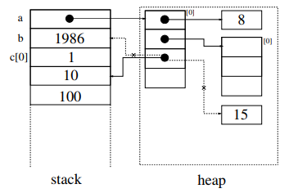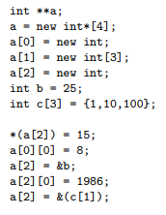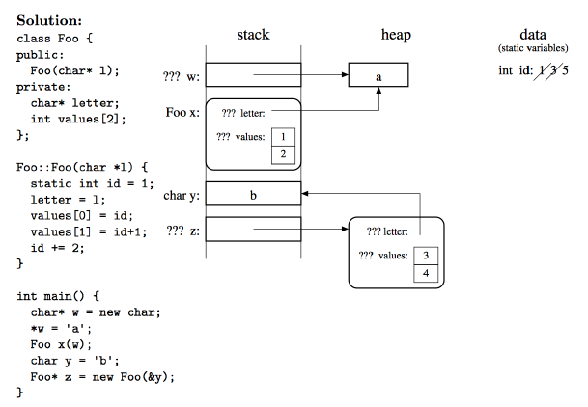

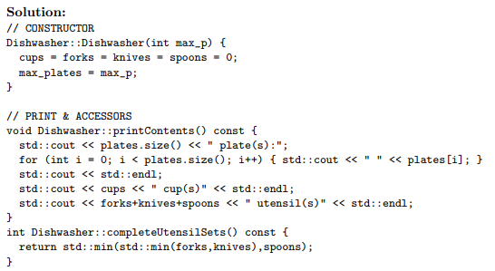

-If using members in the class, u have to use

Dishawasher:: before the function.

Otherwise writ it outside private and public.

- When passing in vecters, strings, should use &

Since vectors and strings take more memories,

we don’t want to make extra copies of them

int *p;

declares a pointer p points to NULL.

int *p = new int;

new creates a spot in heap

For ***classes***, DO NOT forget the “;” after

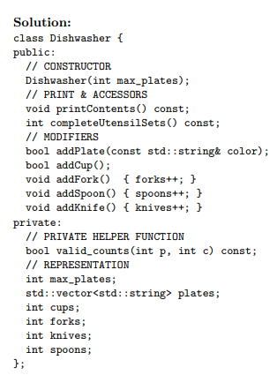declaring the class

The header file, file.h, contains the class declaration

The implementation file,

file.cpp, contains the member function definitions.

(Remember to #include “file.h” )

To use a **default constructor**,

simply assign the variable without ()

Ex. Name() ;

* 1. o **const type& foo():** has to use with the type& => not going to change the return
  2. variable
  3. o **foo() const:** cannot change the private variable of the class
  4. (only used when as a member function in the class)
  5. o **foo(const type& val):** Cannot change the val that is passed in.

* 1. **Read / Write** file from arguments:
  2. o std::ifstream inFile(argv[#]) / std::ofstream outFile(argv[#])
  3. o if (!inFile) {std::cerr << “ERROR!!” << std::endl;}
  4. If a is an array. By simply writing a means the address of a[0].

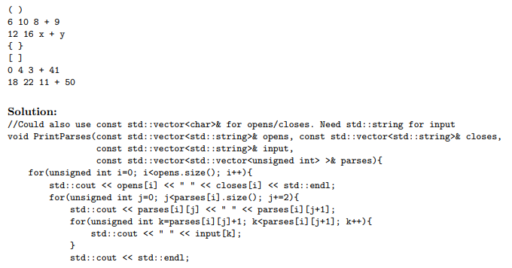

While deleting pointers:

Delete [] a represents deleting

array a.

Delete [] a[1] represents deleting

Whatever is a[1] points to.

Delete a only deletes first value in

array a.

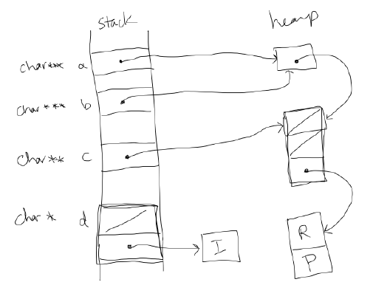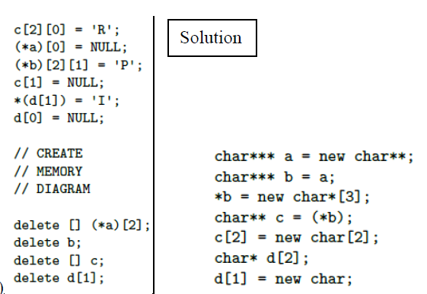

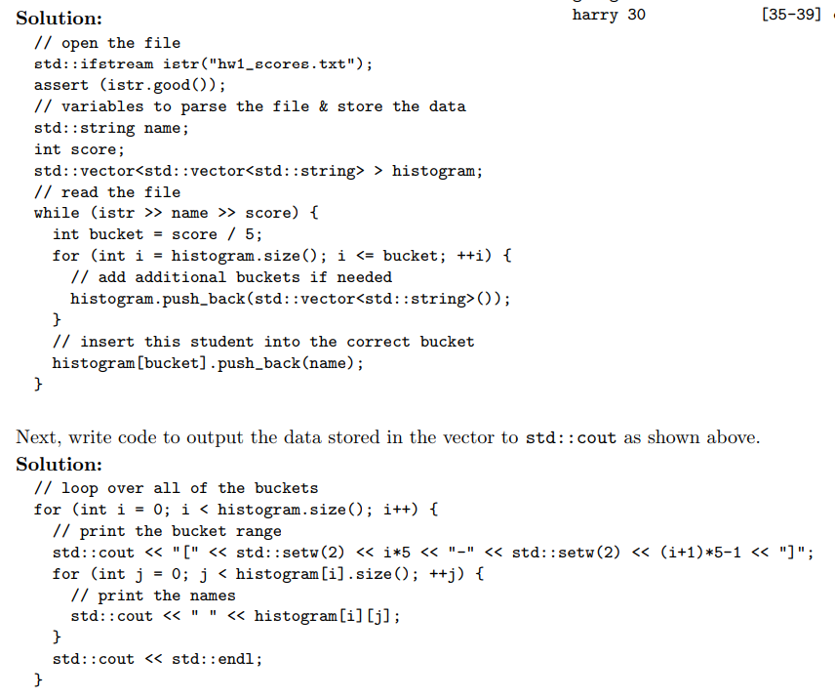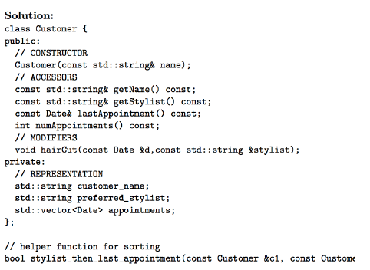

.h file 里 private 用来声明 class 里可使用的member variables

.cpp file里的Class::Class(){}初始化，把东西赋值给

Private里的的变量供class来使用