7.4(c)

$A_{0}=1;{ A}_{1}$ = 2; $A_{n}=2A_{n-1}-A_{n-2}+2 for n≥2;$

|  |  |  |  |  |  |  |
| --- | --- | --- | --- | --- | --- | --- |
|  | 2 | 3 | 4 | 5 | 6 | 7 |
| A(n) | 5 | 10 | 17 | 26 | 37 | 50 |
| A’(n) | / | 5 | 7 | 9 | 11 | 13 |
| A’’(n) | / | / | 2 | 2 | 2 | 2 |

We guess that the formula is $A_{n}=n^{2}+1$ from above table

Base case: $n=2$

$A_{n}=n^{2}+1=4+1=5$, $A_{n}=2A_{n-1}-A_{n-2}+2 =4-1+2=5,$ formula is true

Now prove $P\left(2\right)∧P\left(3\right)∧P\left(4\right)… ∧P\left(n\right) →P(n+1)$

Assume $P\left(2\right)∧P\left(3\right)∧P\left(4\right)… ∧P\left(n\right)$ is true

$$P\left(n\right)= 2A_{n-1}-A_{n-2}+2 , thus P\left(n+1\right)= 2A_{n}-A_{n-1}+2$$

Prove: $2A_{n}-A_{n-1}+2={(n+1)}^{2}+1$

$$LHS: 2A_{n}-A_{n-1}+2$$

$$=2*n^{2}+2-{\left(n-1\right)}^{2}-1+2$$

$$=2n^{2}+3-n^{2}+2n-1$$

$$=n^{2}+2n+2$$

$${RHS: \left(n+1\right)}^{2}+1$$

$$=n^{2}+2n+2$$

LHS = RHS

$$P\left(2\right)∧P\left(3\right)∧P\left(4\right)… ∧P\left(n\right) →P\left(n+1\right) is true$$

Prove by strong induction, $A_{n}=n^{2}+1$ is a correct formula for $A_{n}=2A_{n-1}-A_{n-2}+2$

7.56(a)

$$M\left(0,k\right) is the minmun drops needed at floor 0 with k eggs to determine the highest floor$$

$$which yuo can drop an egg without egg breaking.$$

**The result for M(0,k) is zero.**

$$M\left(n,1\right) is the minmun drops needed at floor n with only one egg to determine the highest$$

$$floor which you can drop an egg without egg breaking.$$

**The result for M(n,1) is n,**

$$M\left(n,k\right)=k, n<2^{k}$$

(b)

We know that the algorithm is a log function, we just need to find the maximum height we have to try in the worst case.

(i)If the egg breaks, we don’t need to search anything above x.

$$\log_{2}{x}$$

(ii)if the egg survives, we have to search higher floor until we find the highest floor that egg can survive.

$$\log_{2}{n-x}$$

(c)

M(7,3) = 3

M(8,3) = 4

M(9,3) = 4

8.6

(a)

$$1 ⊆A$$

$a ⊆A →2*a$ $⊆ A$

Proof:

Since 1 ($2^{0}$) and is in set $A;$ $a ⊆A →2*a$ $⊆ A$

Base case P(1) is true, now we want to prove $P\left(n\right) →P\left(n+1\right)$

First recursion, we get $2*1=2$

Second recursion, we get $2^{1+1}$

…

We can conclude that every time we do a recursion, we will get P(n+1) = 2*P(n) = $2^{n+1}$

$2*1 is 2^{0}$, so all the numbers in the set are in range of $2^{0}$ to $2^{n+1}$, which either one of them is always a non-negative power of 2 since we are multiplying them by 2 every recursion.

Proved by induction, everything in the set is a non-negative power of 2.

(b)

Proof:

Assume y = $2^{n}$ is a smallest non-negative number that is not in the set

X = ${\frac{y}{2}=2}^{n-1}$ must be in the set since y is not in the set to satisfy the smallest value requirement.

From the second definition, we know that if a is in the set, a*2 must be in the set.

So if x is in the set, y must also be in the set.

Contradiction is found

By using contradiction, we prove that every non-negative power of 2 must be in the set.

8.18

(a)

For both RBT and RFBT, we start with a single root. Vertices = 1 in this case.

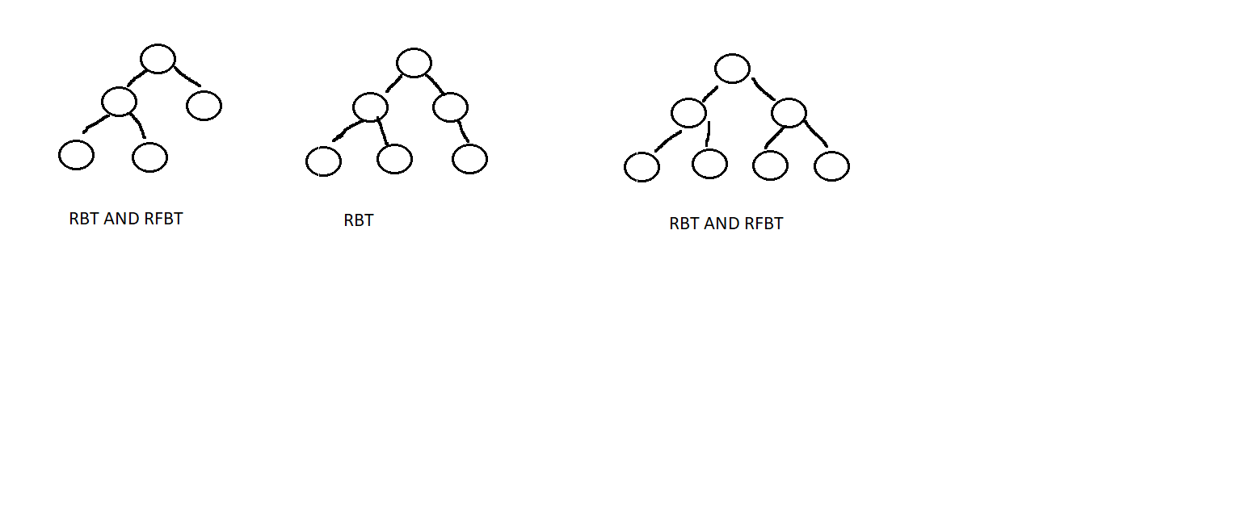

RBT: 5,6,7

As long as it follows the property that each node could have no more than 2 children, than it is a RBT.

RFBT: 5,7

The property of RFBT tells us that the node either has both children or no child. Starting from the root, every time we would have to add 2 in order to follow the property, 1 + 2 + 2 + 2 + 2….

5 and 7 fits the property.

(b)

The set initially only contain a single root, which is the smallest RFBT.

Base case: P(1) when there is only one node in the RFBT

It is true because vertices = 1, and it satisfies the property of RFBT. (it has no children in this case)

Prove: RFBT has odd number of vertices.

1. A single node can either have two children or no child (property of RFBT)
2. At base case, we have no children. If we want to add any nodes, we have to add two.
3. Now a new RFBT is formed, it has three vertices. (it still has an odd number of vertices)
4. Since the total number of vertices start with an odd number of 1. And whenever we increment it, we have to add a multiple of 2. Odd + even = Odd. (**P(2n +1) is always odd**)
5. In this case, if we follow the property of RFBT, as long as it is a RFBT, we will always get an odd number of vertices

9.3(b)

$$\sum_{i=1}^{n}{\sum_{j=1}^{i}{(i+j)}} \\ =\sum_{i=1}^{n}{i^{2}+\frac{1}{2}i(i+1)}$$

$$=\sum_{i=1}^{n}{\frac{3}{2}i^{2}+\frac{1}{2}}i$$

$$=\frac{3}{2}*\frac{1}{6}*n\left(n+1\right)\left(2n+1\right)+\frac{1}{4}*n(n+1)$$

$$=\frac{1}{2}n^{3}+n^{2}+\frac{1}{2}n$$

(e)

$$\sum_{i=0}^{n}{\sum_{j=0}^{m}{2^{i+j}}}$$

$$=\sum_{i=0}^{n}{\sum_{j=0}^{m}{2^{i}*2^{j}}}$$

$$=\sum_{i=0}^{n}{\sum_{j=0}^{m}{2^{i}*2^{j}}}$$

$$=\sum_{i=0}^{n}{2^{i}*\sum_{j=0}^{m}{2^{j}}}$$

$$=\sum_{i=0}^{n}{2^{i}*{(2}^{m+1}-1)}$$

$$={(2}^{m+1}-1)*\sum_{i=0}^{n}{2^{i}}$$

$$={(2}^{m+1}-1)*{(2}^{n+1}-1)$$

9.37

(a)

(i) $\lim_{n→∞}{\frac{n^{3}}{n^{2}*{(log}_{2}{n)^2}}=∞}$ $g∈O(f)$

(ii) $\lim_{n→∞}{\frac{n^{3}}{n^{3}+n^{2}}=1}$ $both$

(iii) $\lim_{n→∞}{\frac{n^{3}}{n^{3.5}}=0}$ $f∈O\left(g\right)$

(iv) $\lim_{n→∞}{\frac{n^{3}}{2^{3\log_{2}{n+2}}}=\frac{n^{3}}{n^{3}}}$ $both$

(v) $\lim_{n→∞}{\frac{n^{3}}{2^{(log{n})^2}}=\log{n}}$ $g∈O(f)$

(b)

(i) $\lim_{n→∞}{\frac{2^{n}}{3^{n}}=0}$ $f∈O(g)$

(ii) $\lim_{n→∞}{\frac{2^{n}}{2^{\sqrt{n}}}=∞}$ $g∈O\left(f\right)$

(iii) $\lim_{n→∞}{\frac{2^{n}}{2^{2n}}=0}$ $f∈O(g)$

(iv) $\lim_{n→∞}{\frac{2^{n}}{2^{\log_{2}{n+n}}}=0}$ $f∈O(g)$

(v) $\lim_{n→∞}{\frac{2^{n}}{2^{\sqrt{n}}+2^{n+4}}=0}$ $f∈O(g)$

(c)

(i) $\lim_{n→∞}{\frac{n!}{n^{n}}=0}$ $f∈O\left(g\right)$

(ii) $\lim_{n→∞}{\frac{n!}{n^{\frac{n}{2}}}=∞}$ $g∈O\left(f\right)$

(iii) $\lim_{n→∞}{\frac{n!}{\left(n+1\right)!}=0}$ $f∈O\left(g\right)$

(iv) $\lim_{n→∞}{\frac{n^{3}}{2^{n(log{n})}}=0}$ $g∈O\left(gf\right)$

(v) $\lim_{n→∞}{\frac{n!}{2^{n^{2}}}=0}$ $g∈O\left(f\right)$

(d)

(i) $∞$ $g∈O\left(f\right)$

(ii) $∞$ $g∈O\left(f\right)$

(iii) $\frac{1}{3}$ both

(iv) $∞$ $g∈O\left(f\right)$

(v)1 both

(e)

(i) $∞$ $g∈O\left(f\right)$

(ii)4 both

(iii)0 $f∈O\left(g\right)$

(iv)0 $f∈O\left(g\right)$

(v)top is bigger than bottom $g∈O\left(f\right)$

(f)

(i) $∞$ $g∈O\left(f\right)$

(ii) $∞$ $g∈O\left(f\right)$

(iii)sin() will either be 1 or 0 neither

(iv) $∞$ $g∈O\left(f\right)$

(v)0 $f∈O\left(g\right)$

9.44(a)

$$\sum_{i=1}^{n}{\frac{i^{2}}{i^{3}+1}}= \frac{i^{2}}{i^{3}+1}di$$

Integrate it

$$\int{\frac{i^{2}}{i^{3}+1}di}=\frac{1}{3}ln⁡(i^{3}+1)$$

$$\int_{0}^{n}{\frac{x^{2}}{x^{3}+1}dx≥S\left(n\right)≥\int_{1}^{n+1}{\frac{x^{2}}{x^{3}+1}dx} }$$

$\frac{\left(ln\left|{\left(n+1\right)}^{3}+1\right|\right)-ln2)}{3}≤ S\left(n\right)≤\frac{(\ln\left|n^{3}+1\right|-ln|1|)}{3}$

Big theta is $θ(\ln{|n^{3}|})$