22.2

Yes and No are both wrong

1. If we answer yes: then the statement is true, and according to the statement, the answer to this question is No, yes and no contradicts, thus yes is not the right answer.
2. If we answer no: then the statement is false, and according to the statement, the answer to this question is yes, yes and no contradicts, thus no is also not the right answer.

In conclusion, both yes and no are wrong. The statement is a paradox.

22.9

(a)

Not injective, not one-to-one mapped, for example, we can get a 3 from 1\*6/2 or 2\*3/2.

(b)

Surjective, all number has been mapped and some numbers have been mapped more than 1 time.

(c)

Not bijective, not one-to-one mapped, for example, we can get a 3 from 1\*6/2 or 2\*3/2.

22.25

(a)

$|\{0,1\}→N|=|N^{2}|=|N|$

There are $N^{2}$ possibilities, and all possible solutions can be mapped one-to-one and onto to $N$. From the book, we have proved $N$ is countable, thus, $N^{2}$ is also countable.

(b)

$$\left|{\left\{0,1\right\}}^{N}\right|=2^{N}=R$$

$$R is uncountable, so 2^{N} is also uncountable$$

Thus, the function is uncountable

23.33

(b)

(i)

$$L=\overline{{\left\{{\left\{1\right\}}^{*}⋅\left\{0\right\}⋅{\left\{1\right\}}^{*}⋅\left\{0\right\}⋅{\left\{1\right\}}^{*}⋅\left\{0\right\}⋅{\left\{1\right\}}^{*}⋅\left\{0\right\}⋅{\left\{1\right\}}^{*}\right\}}^{*}}∪\overline{\{ℇ\}}∪\overline{\{1^{*}\}}$$

(ii)

$$L={\{\left\{{\left\{1\right\}}^{*}⋅\left\{0\right\}⋅{\left\{1\right\}}^{*}⋅\left\{0\right\}⋅{\left\{1\right\}}^{*}⋅\left\{0\right\}⋅{\left\{1\right\}}^{*}⋅\left\{0\right\}⋅{\left\{1\right\}}^{*}\right\}}^{*}⋅\{1^{*}⋅{0⋅1}^{*}\}\}$$

$$∪{\left\{{\left\{1\right\}}^{*}⋅\left\{0\right\}⋅{\left\{1\right\}}^{*}⋅\left\{0\right\}⋅{\left\{1\right\}}^{*}⋅\left\{0\right\}⋅{\left\{1\right\}}^{*}⋅\left\{0\right\}⋅{\left\{1\right\}}^{*}\right\}}^{*}⋅\{1^{*}⋅{0⋅1}^{*}⋅{0⋅1}^{*}\}\}$$

$$∪{\left\{{\left\{1\right\}}^{*}⋅\left\{0\right\}⋅{\left\{1\right\}}^{*}⋅\left\{0\right\}⋅{\left\{1\right\}}^{*}⋅\left\{0\right\}⋅{\left\{1\right\}}^{*}⋅\left\{0\right\}⋅{\left\{1\right\}}^{*}\right\}}^{*}⋅\{1^{*}⋅{0⋅1}^{*}⋅{0⋅1}^{*}⋅{0⋅1}^{*}\}\}\}$$

24.3

(d)

$$L=\overline{{\left\{{\left\{0\right\}}^{*}⋅\left\{1\right\}⋅{\left\{0\right\}}^{*}⋅\left\{1\right\}⋅{\left\{0\right\}}^{*}⋅\left\{1\right\}⋅{\left\{0\right\}}^{*}\right\}}^{*}} ∪\overline{\{ℇ\}}∪\overline{\{0^{*}\}}$$

Strings whose number of 1s is not divisible by 3

24.11(z)

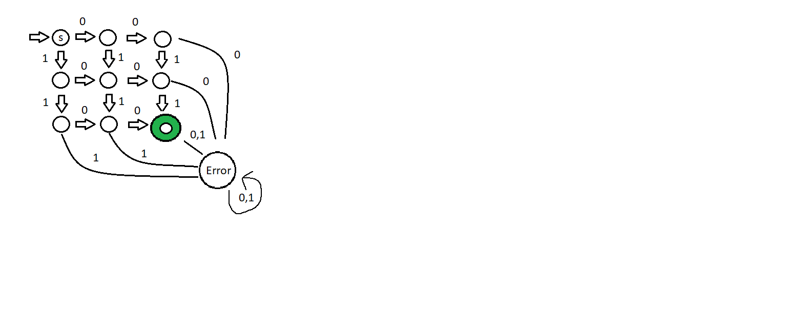

24.51

(b)

First equation:

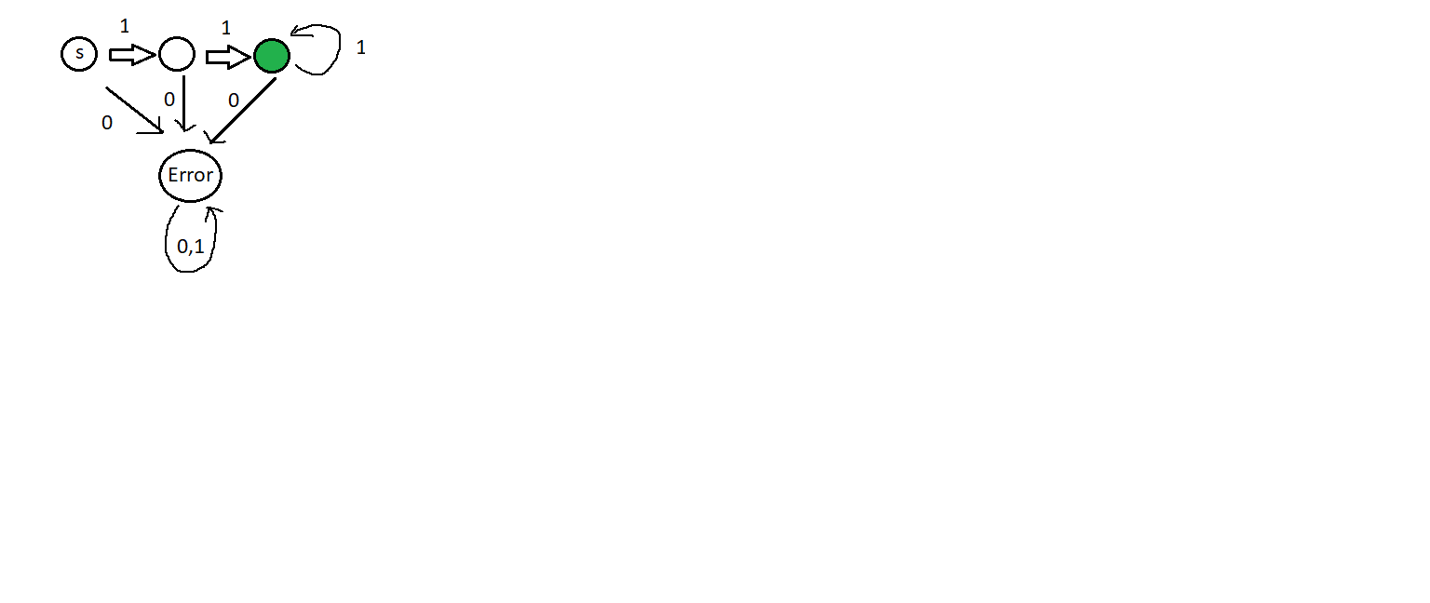

Second equation:

Not possible to make because w has to have fewer 1s, and it is not possible for us to compare n and w since we cannot count the number of 1s they have.