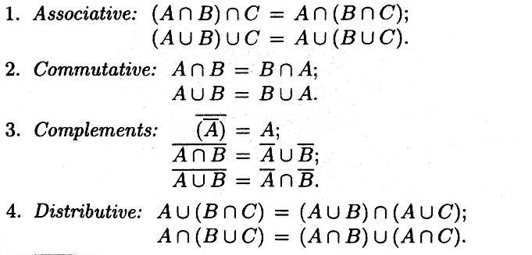Proof p -> q: Set

1 direct: assume p is true, show q is true

2: contraposition: assume q is false, show p is false

3: if and only if: first prove p -> q, then prove q -> p

4: contradiction: assume p is false, find a contradiction

that must be false, so p is true

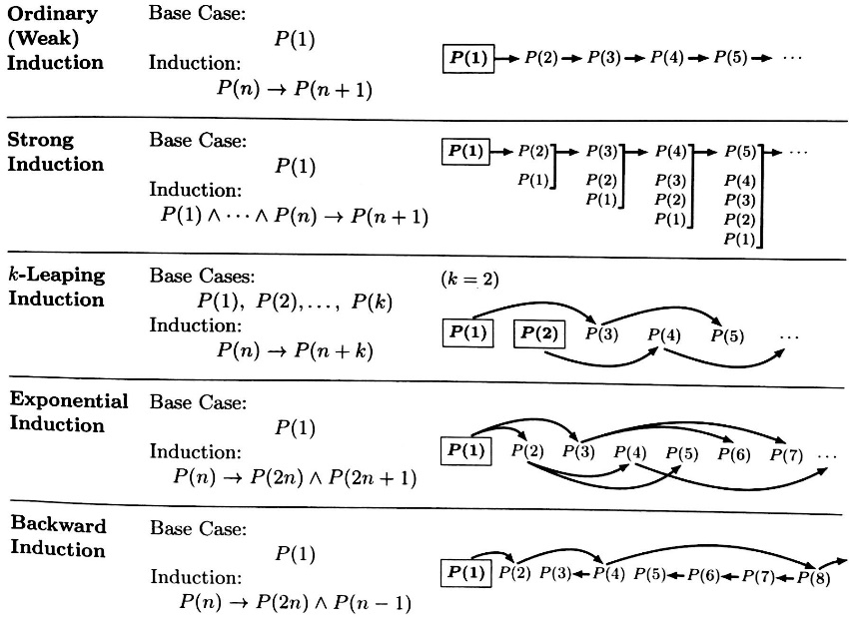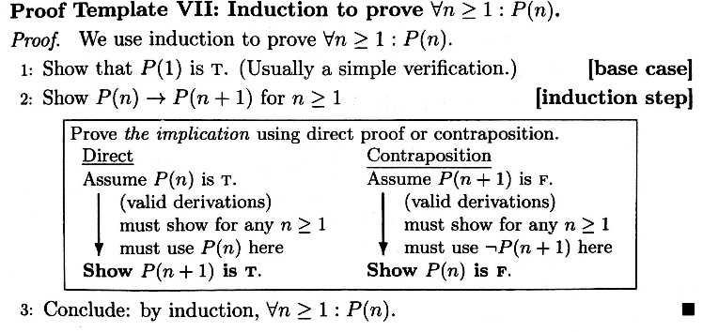Proof by induction:

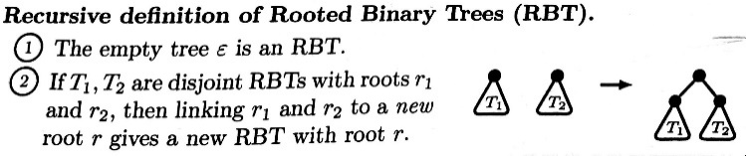

\

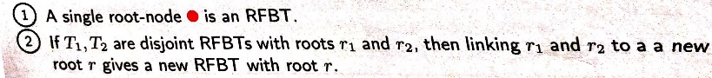

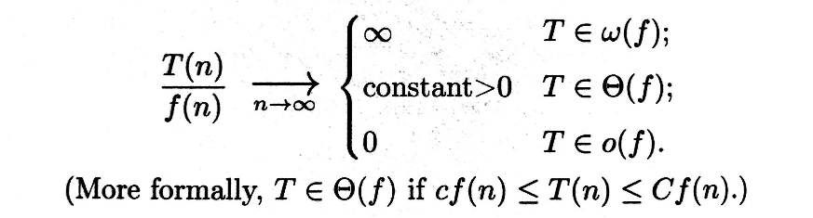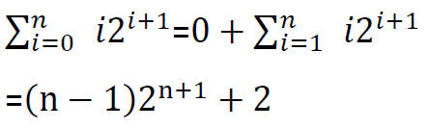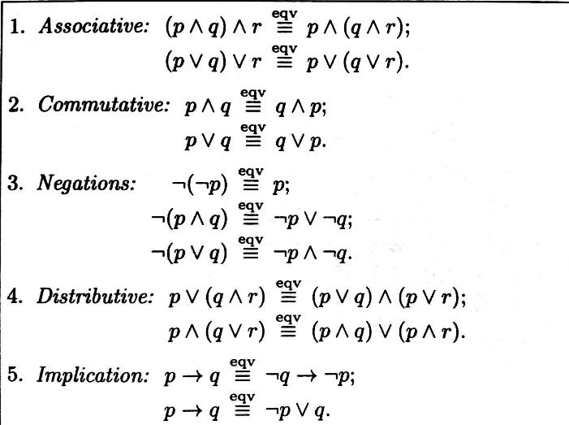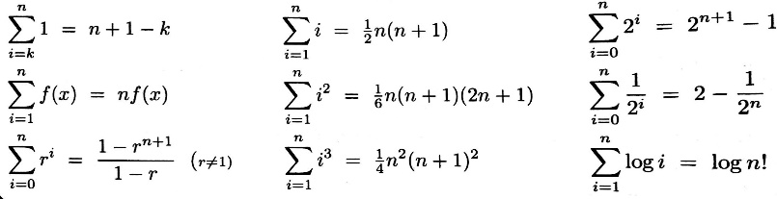Sum calculation:

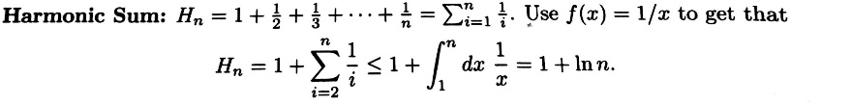

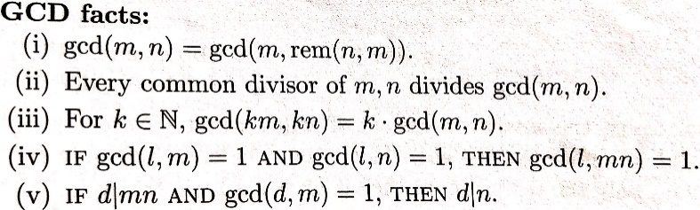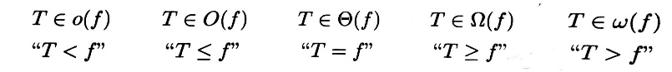

Approximation via Integration

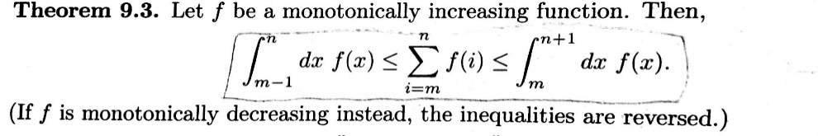

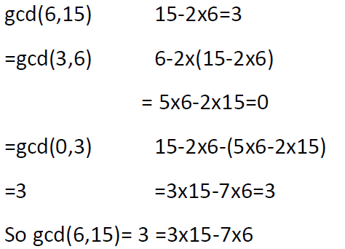 Modular Equivalence Properties:

the inverse of **k** exists modulo **d** if and only **gcd(k,d)=1**

Big Q is all rational numbers

Big N is all positive integers

Big Z is all integers

E is all positive evens

R is all real numbers

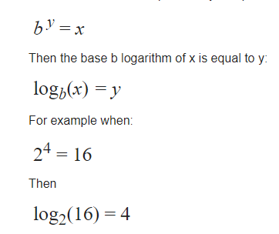

|  |  |  |
| --- | --- | --- |
|  | No repetition | With repetition |
| K sequence (order matters) | N!/(n-k)! | N^k |
| K subset (order does not matter) |  |  |

