**HW4 Query 3**

**SELECT DISTINCT**

**m.title**

**, md.director**

**FROM**

**movies m**

**, moviesdirectors md**

**, moviesgenres mg**

**, movieslanguages ml**

**, movieslanguages ml2**

**WHERE**

**m.movieid = md.movieid**

**and m.movieid = mg.movieid**

**and m.movieid = ml.movieid**

**and m.movieid = ml2.movieid**

**and m.imdbrating >= 8**

**and mg.genre in ('Action', 'Sci-Fi', 'Adventure', 'Drama')**

**and ml.language = 'English'**

**and ml2.language <> 'English'**

**ORDER BY**

**title**

**, director ;**

**Before**

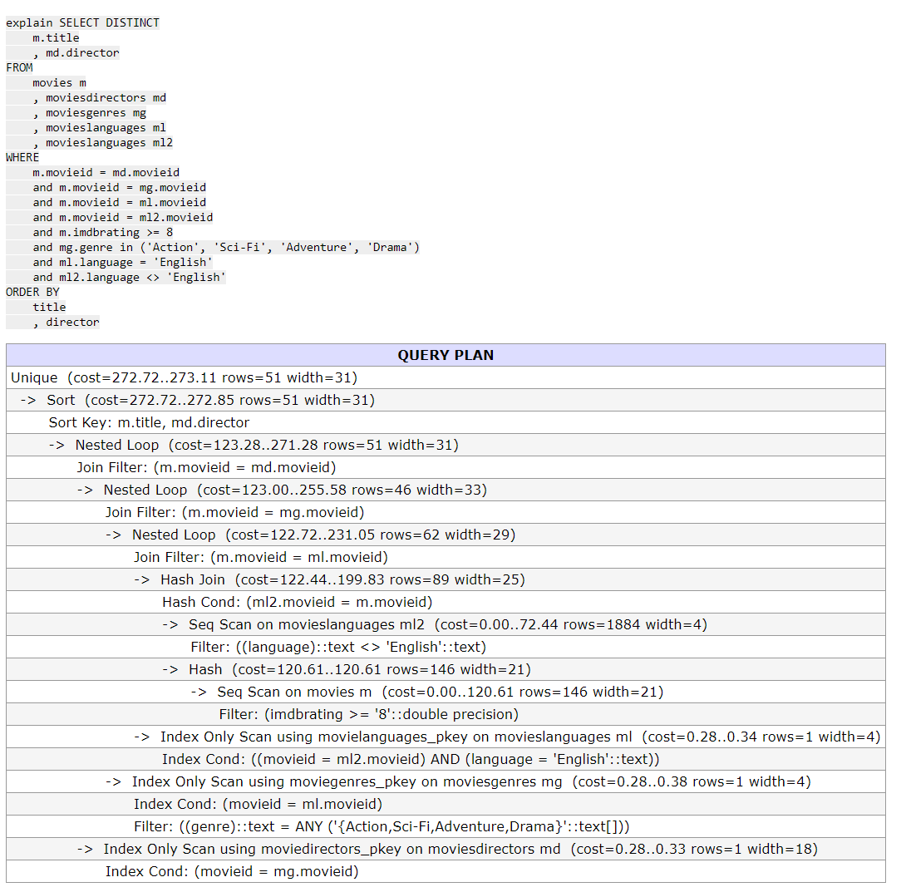

create index movie_index on movies(imdbrating, movieid, title);

create index language_index on movieslanguages(language, movieid);

After

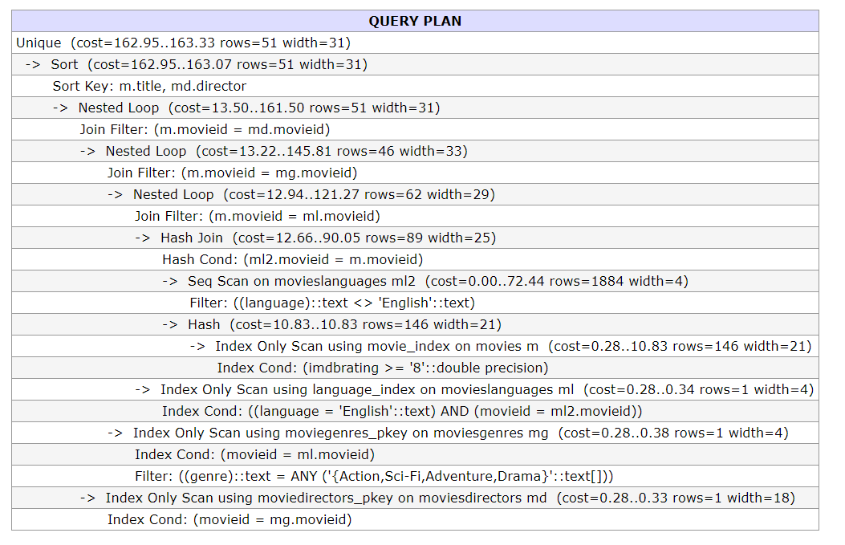

HW5 Query 6

**SELECT**

**sc.country**

**, s.title**

**, s.imdbrating**

**FROM**

**seriescountry sc**

**, series s**

**WHERE**

**s.seriesid = sc.seriesid**

**and s.imdbrating >= 7.5**

**and sc.country in ('Turkey','France','China','India','Thailand','Japan')**

**and not exists (SELECT 1**

**FROM seriescountry sc2**

**WHERE sc2.seriesid = s.seriesid**

**AND sc2.country <> sc.country)**

**ORDER BY**

**sc.country**

**, s.imdbrating**

**, s.title;**

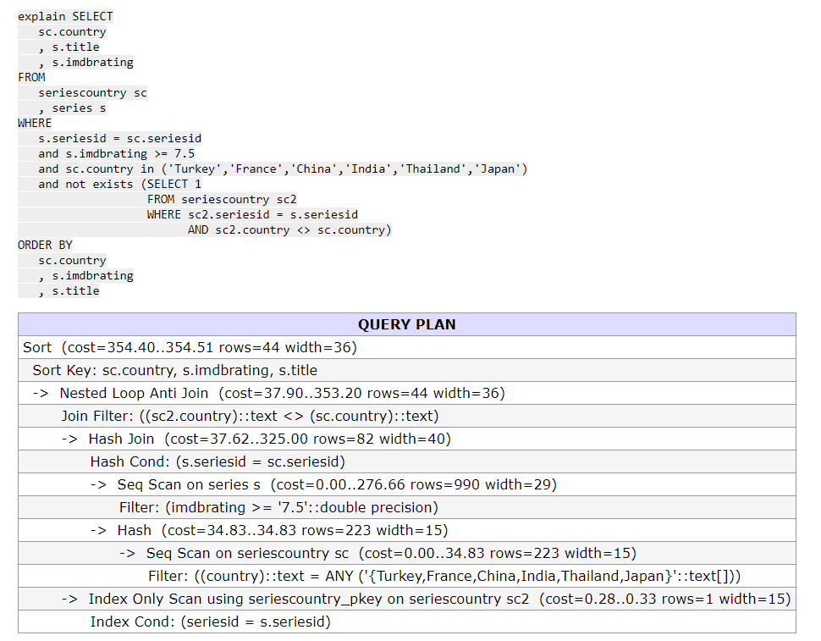

create index series_index on series(imdbrating, seriesid, title);

create index seriescountry_index on seriescountry(country, seriesid);

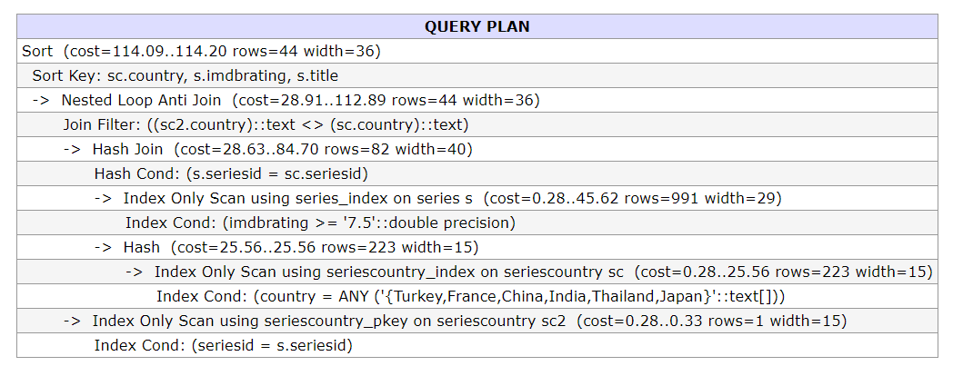

Q2

CONFLICT:

r1(x) --- w3(x) r2(z) --- w3(z) w2(z) --- r3(z), w3(z) w2(w) --- r1(w)

sl1(x) sl2(z) sl1(y) **r1(x) r2(z) r1(y)** xl2(w) xl2(z) **w2(w) w2(z)** ul2(z) sl3(z) **r3(z)**

--- T2 is in the shrinking phase

ul2(w) sl1(w) xl1(y) ul1(x) xl3 (x) xl3 (z) **w3(x) r1(w) w1(y) w3(z)** --- T1 is in the shrinking phase

CONFLICT:

r1(x) --- w3(x) r3(z) --- w2(z) w2(w) --- r1(w)

sl1(x) sl1(y) sl2(z) sl3(z) sl3(x) **r1(x) r1(y) r2(z) r3(z) r3(x)**

**w3(x) w2(w) w2(z) r1(w) w1(y)**

For **w3(x)** in here, we need to **ul(x)** first or we can put **r1(w) w1(y**) in front of T2 and T3. By the first way, if we do **ul(x), T1 is in the shrinking phase now, we cannot add any more lock then such as r1(w) w1(y)** and it fails. By the second case, if we put **r1(w) w1(y**) lock first and then do **ul(x),** we can find transaction order in there is wrong: we need do **w2(w)** in front of **r1(w),**

Q3

a)

**Redo**

103 T3 update P1

105 T1 update P4

**Undo**

107 abort T1 105

108 undo 105 100

109 undo 100 –

110 T1 end

b) NO force is used, because when T3 is committed, the last update on P1 should be 103, but in data pages entry it is 101.

c) Steal is used, because when T1 is not committed, the update of T1 on any page should not be recorded. But “100 T1 update P2” is showed on data pages, so it is steal.