Name: Linghao Shi

RIN: 661954958

CSCI: 4390

Part1:

We need **6** dimensions to capture alpha = 0.975 fraction of total variance.

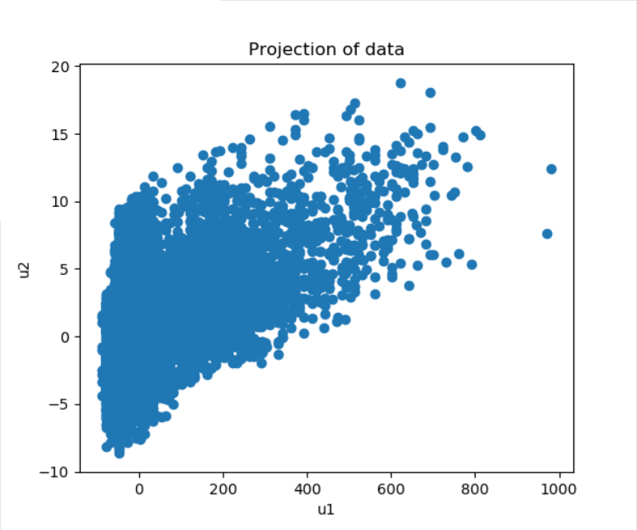Mean Squared Error is **603.439296**.

Part2:

10 Dimensions:

Minimum value is: **1.2074182697257333e-06**

Maximum value is: **179.99999879258172**

Value range is: **179.99999758516344**

Mean is: **90.00938717659825**, Variance is: **372.77407092024026**

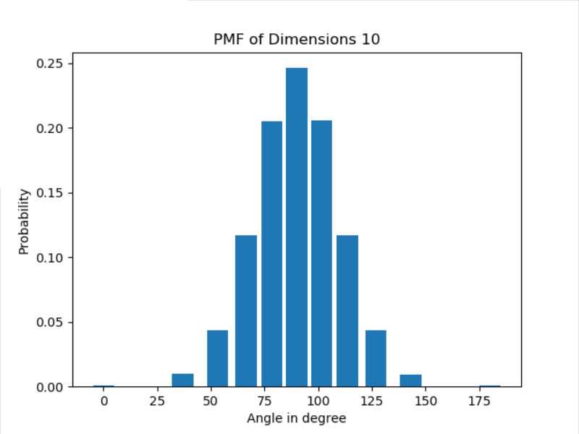

100 Dimensions:

Minimum value is: **63.8961188626601**

Maximum value is: **114.83458748970159**

Value range is: **50.93846862704149**

Mean is: **90.00967688634027**, Variance is: **33.19767061553111**

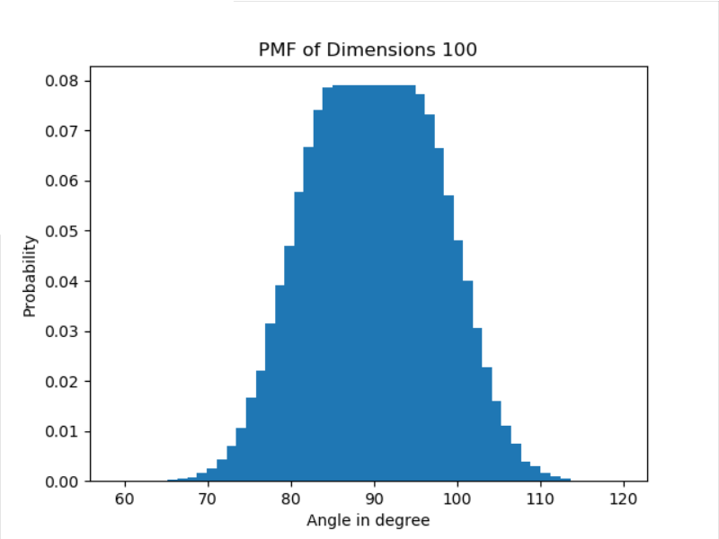

1000 Dimensions:

Minimum value is: **81.02520243060472**

Maximum value is: **98.16359419578697**

Value range is: **17.13839176518225**

Mean is: **89.99914326205678**, Variance is: **3.2731604745001404**

