**Shireen Kachroo**

**23103078**

**B3**

Q2.

#include <stdio.h>

int main() {

    int n, i;

    float sum = 0, average;

    printf("Enter the number of elements: ");

    scanf("%d", &n);

    int arr[n];

    printf("Enter %d integers:\n", n);

    for (i = 0; i < n; i++) {

        scanf("%d", &arr[i]);

        sum += arr[i];

    }

    average = sum / n;

    printf("Average = %.2f\n", average);

    return 0;

}

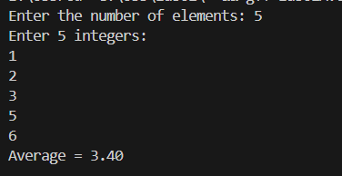

Q3.

#include <stdio.h>

#include <string.h>

int main() {

    char str[100];

    printf("Enter a string: ");

    fgets(str, sizeof(str), stdin);

    // Remove newline character if present

    str[strcspn(str, "\n")] = '\0';

    int len = strlen(str);

    printf("Reversed string: ");

    for (int i = len - 1; i >= 0; i--) {

        putchar(str[i]);

    }

    printf("\n");

    return 0;

}

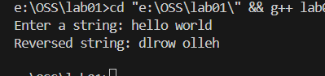

Q4.

git clone https://github.com/DaveGamble/cJSON.git

cd cJSON