**ASSIGNMENT 9**

**1. Get employees who have the highest salary**

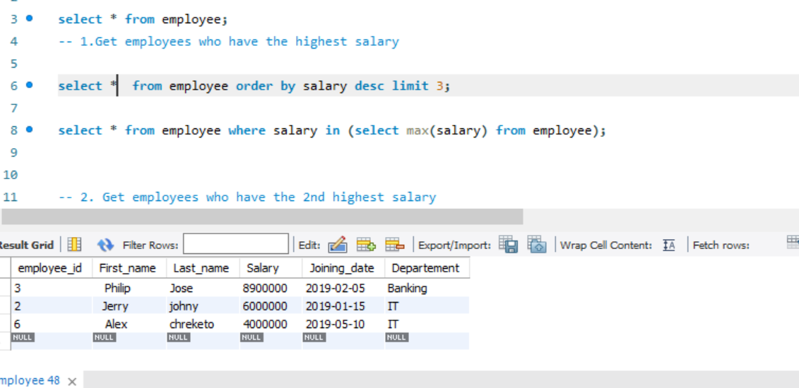

**2. Get employees who have the 2nd highest salary**

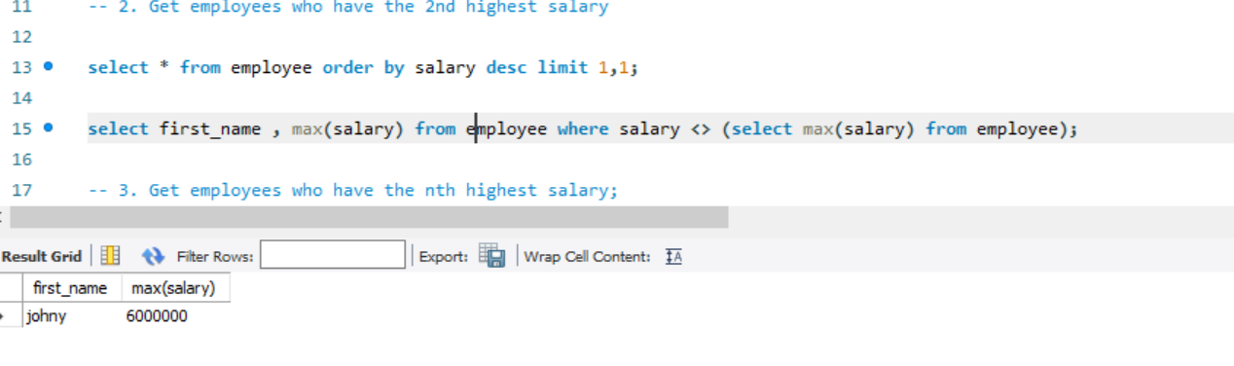

**3. Get employees who have the nth highest salary**

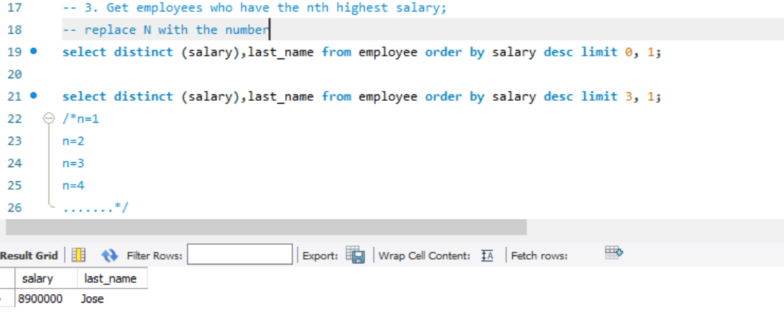

**5. Categorize employees into three groups based on their salaries (less than 30M-low,30M to 60M-medium, greater than 60M-h**

