**‘1. Write a procedure to fetch employee earning less than average salary**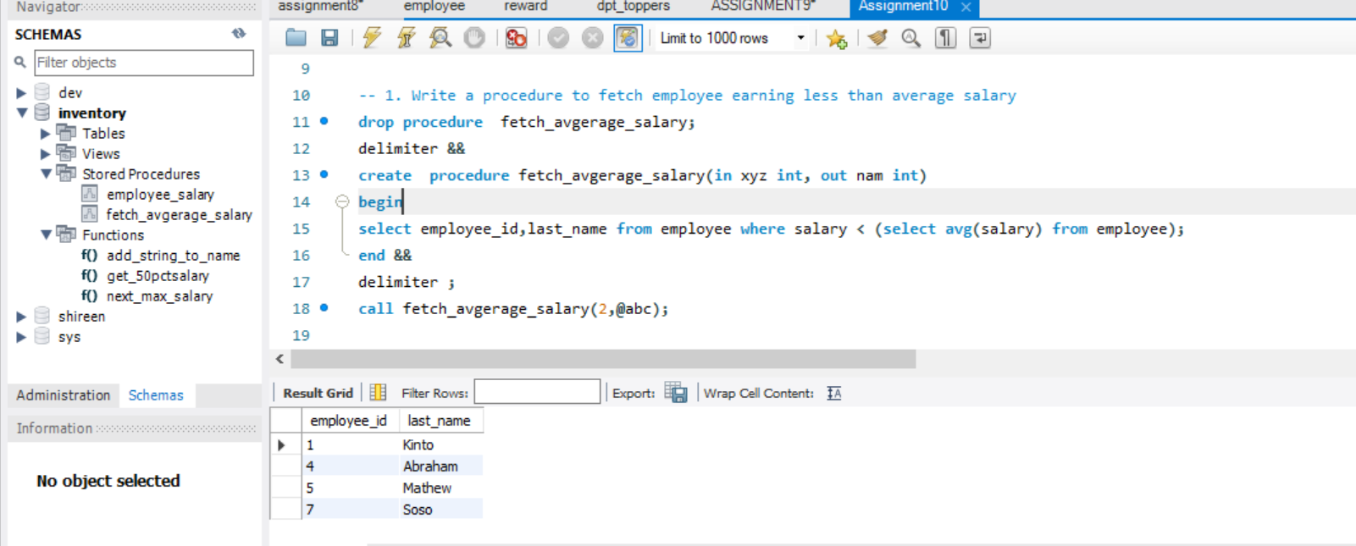

**2. Write a procedure to fetch salary of the employee id passed as input**

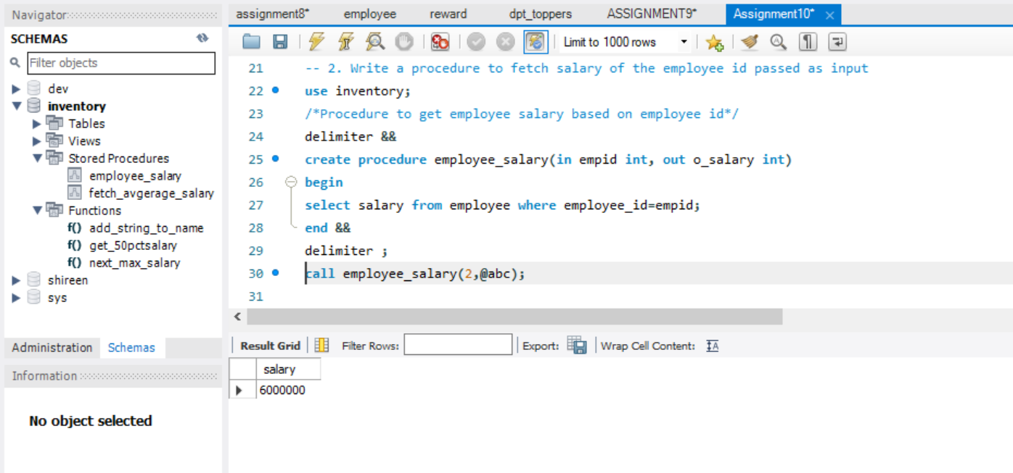

**3. Write a function to fetch 50% of salary**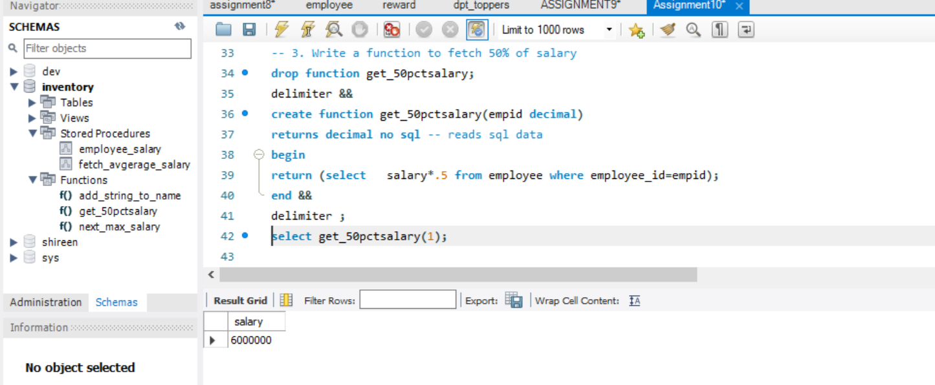

**4. Write a function to add a string to the passed name**

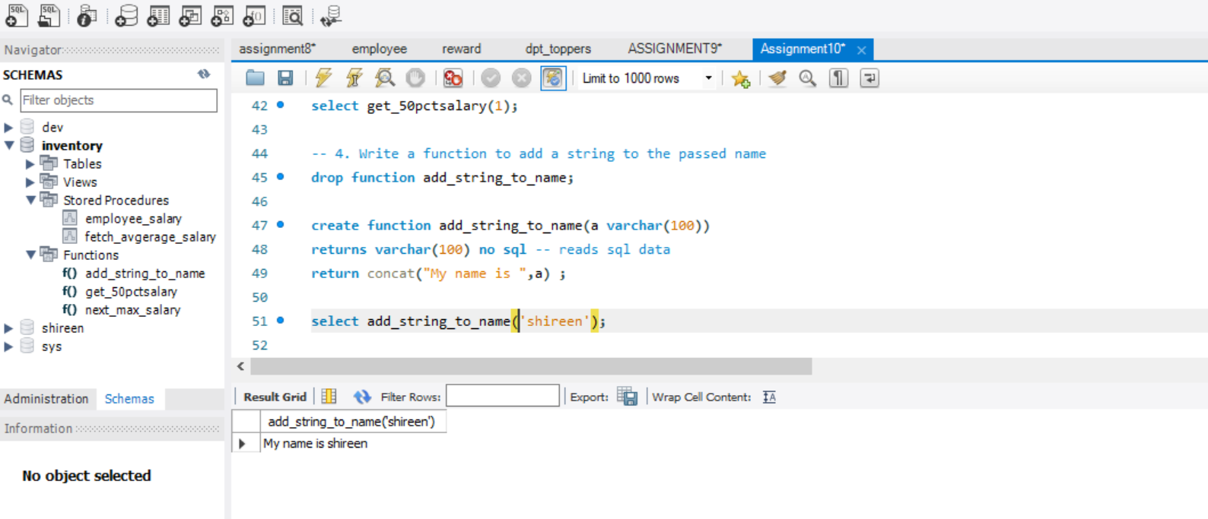

**-- 5 Write a function to fetch the next maximum salary to the input number passed**