**Assignment11**

**1. Create a table as same as employee table with true condition (but no columns used)**

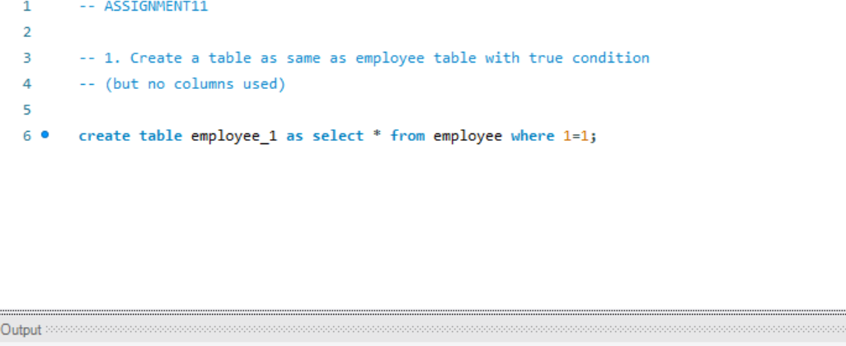

**2. Create a table as same as employee table with true condition (but columns used)**

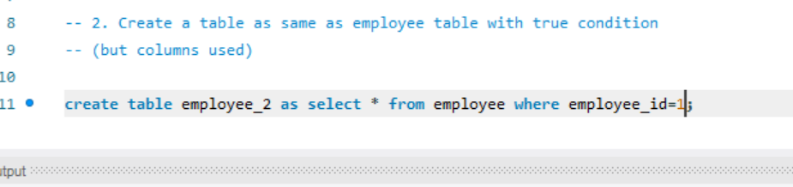

**3. Create a table as same as employee table with false condition (but columns used)**

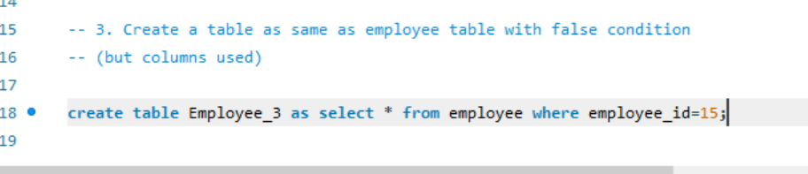

**4. Create a table as same as employee table with false condition (but no columns used)**

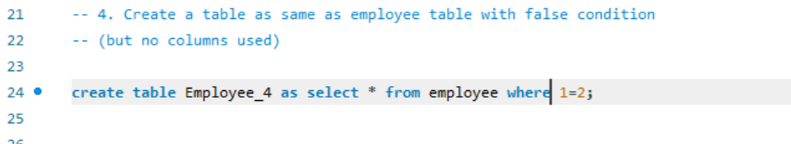

**5. Write a trigger to convert negative salary to 0 before any insertion into employee Table**

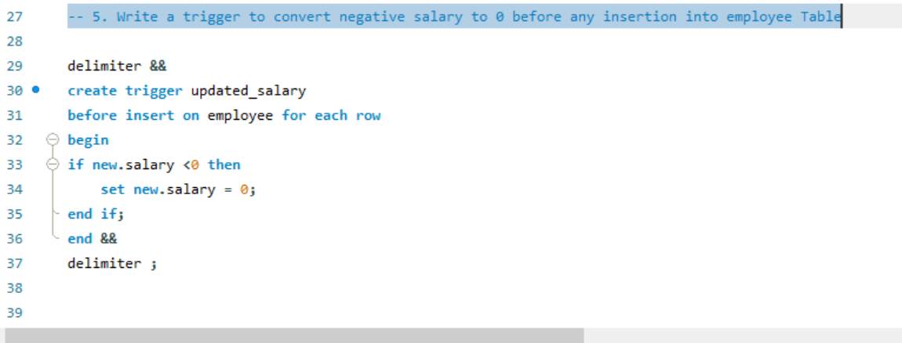

**6. Write a trigger to insert an entry into new table after any insertion into employee Table**

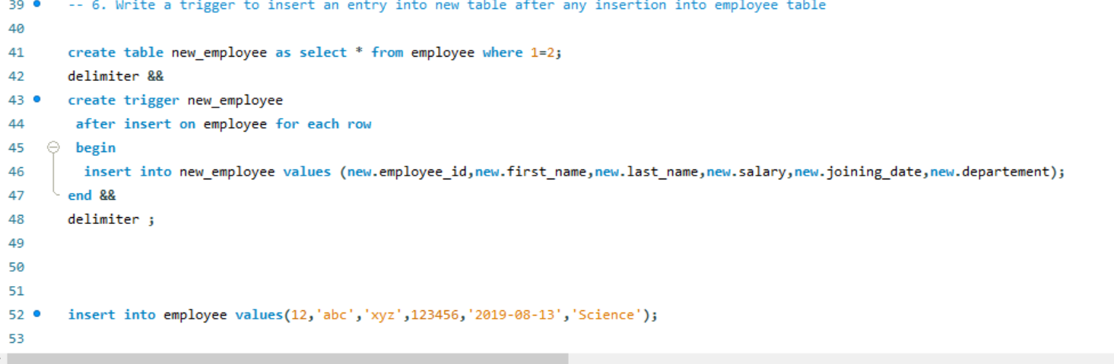

**7. Write a trigger to delete entry from new table after any deletion into employee table**

