**ASSIGNMENT 6 – SHIREEN**

1. **Get the employee’s first name and last name in separate rows.**

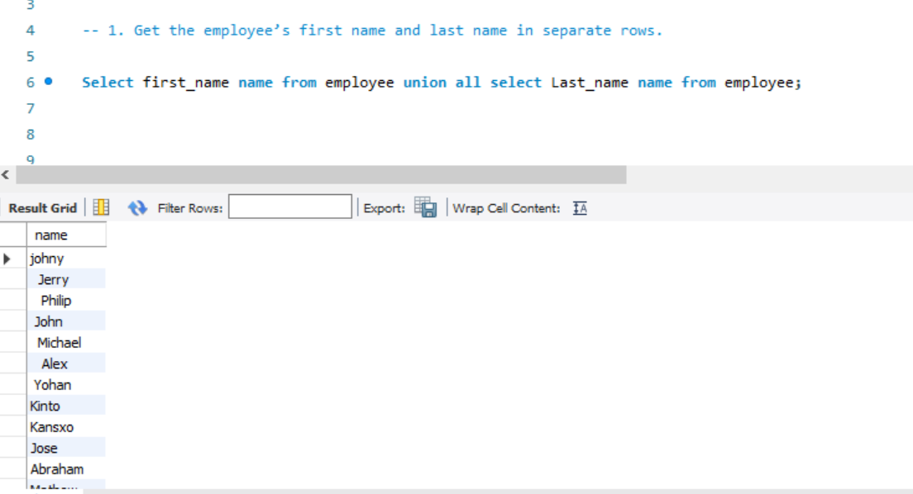

**2. Get the employee’s first name and last name in separate rows without duplicates.**

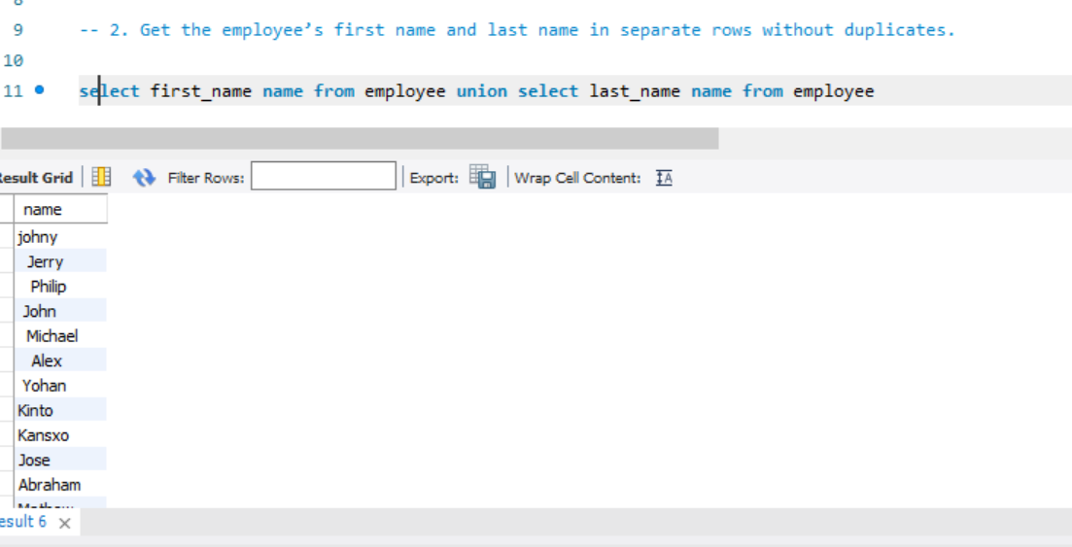

**3.Get the employee’s first name, each reward amount for employees who have rewards.**

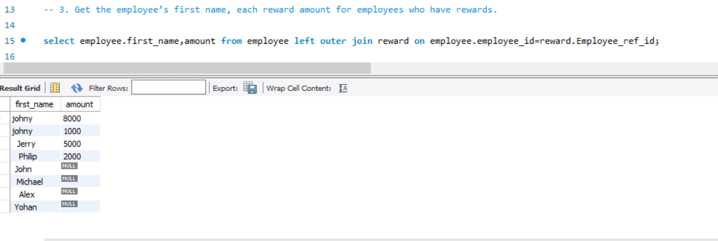

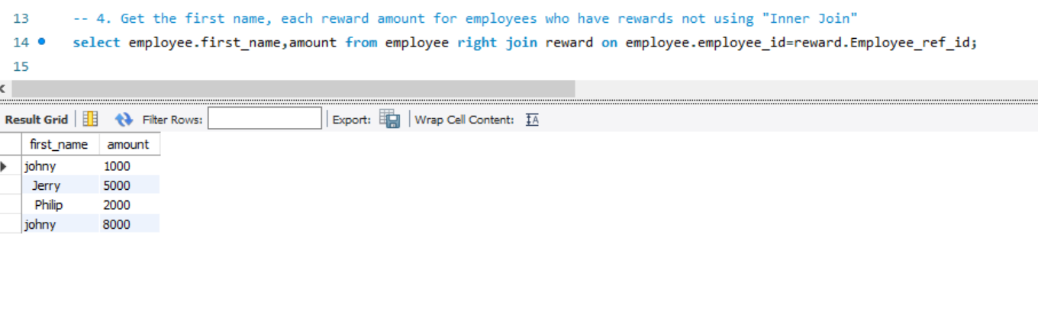

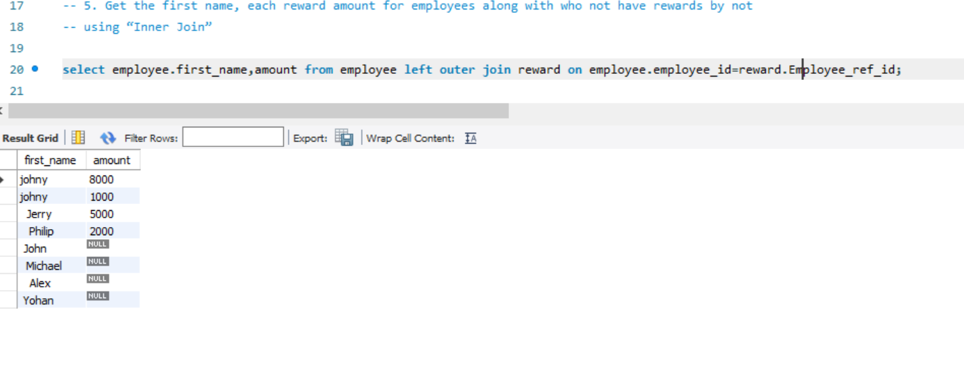

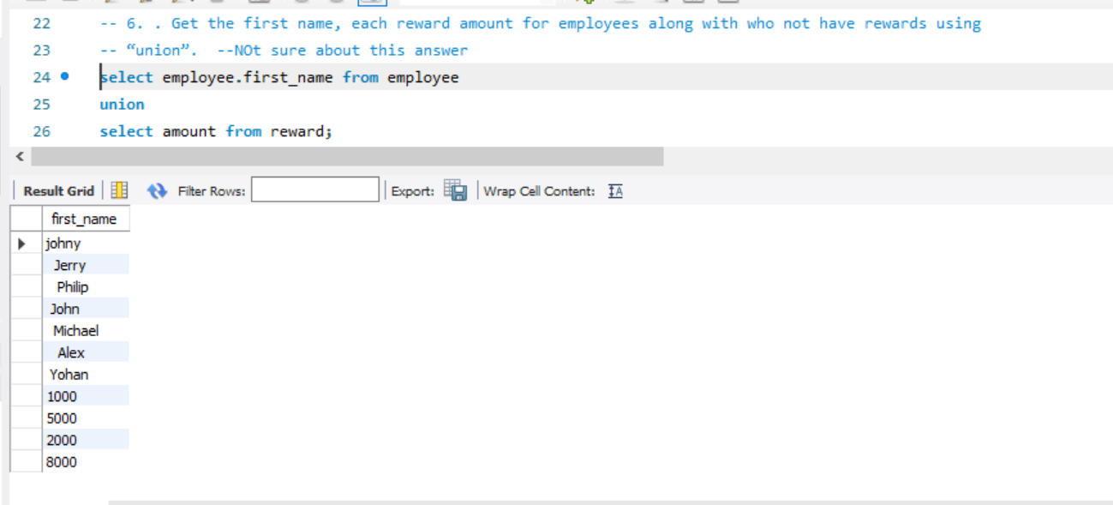

**7. .Get count of employees having last name same as first name of other employees**

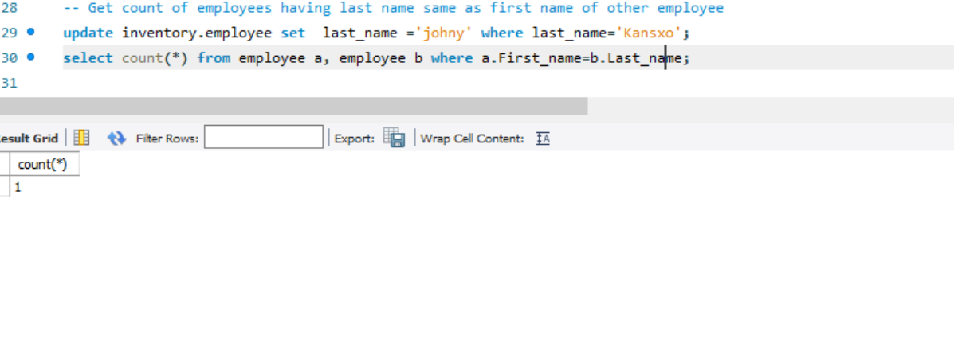

**8. List employees having last name same as first name of other employees** 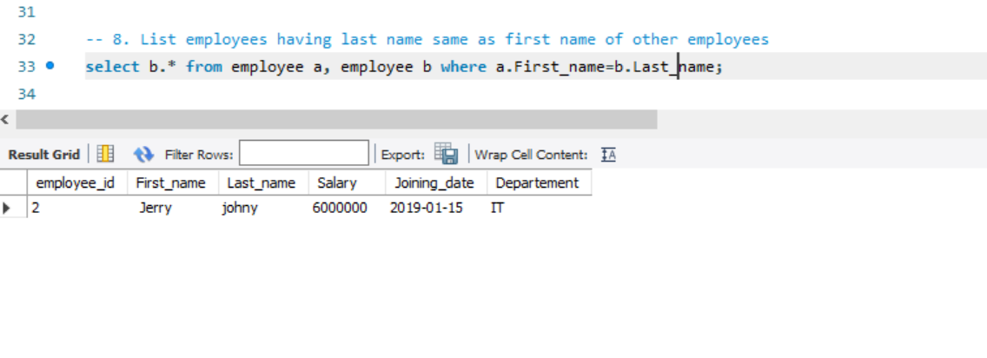

**I should get count as ‘6’**

**9. Get count of employees not having last name same as first name of other employees**

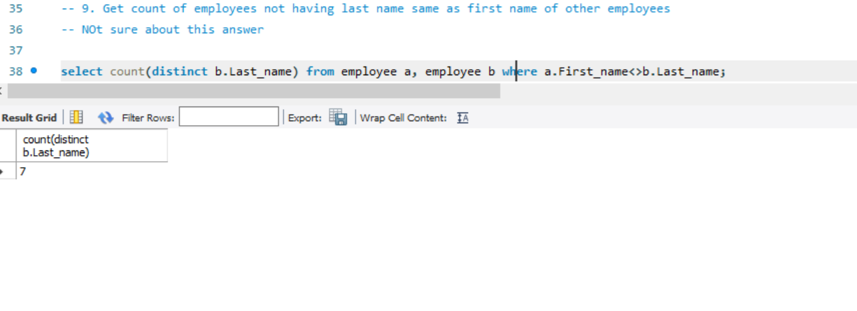

**10. List FName, LName, rewardamount of employees having last name same as first name of other employees or vice-versa, with each**

