**Assignment8 1. Get first 3 employees who were the earliest to join**

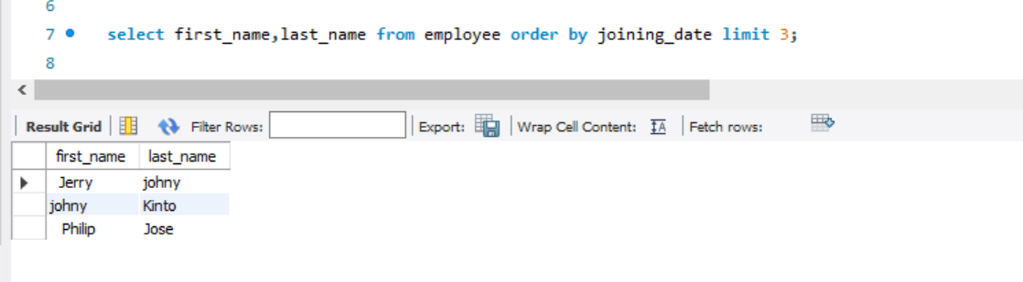

**2. Get first 3 employees who were the latest to join**

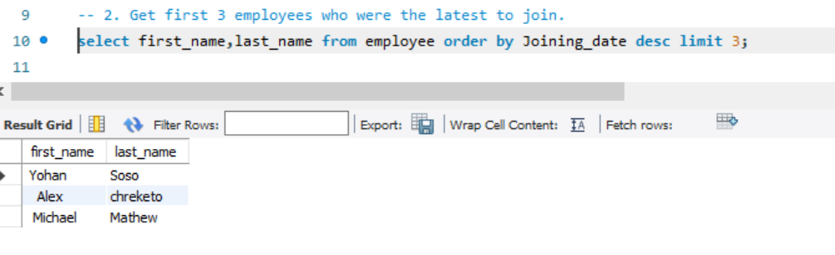

**3. Get details of the employees who were neither the first joinee nor last joinee**

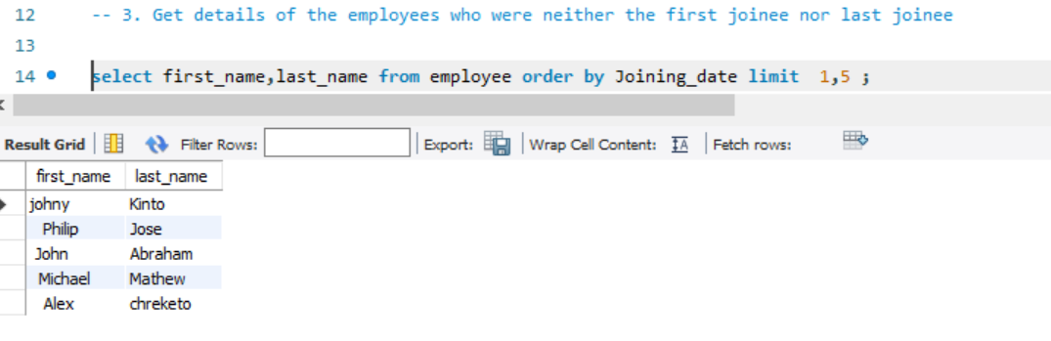

**4. Create a table dpt_toppers containing employees from each department earning highest salary**

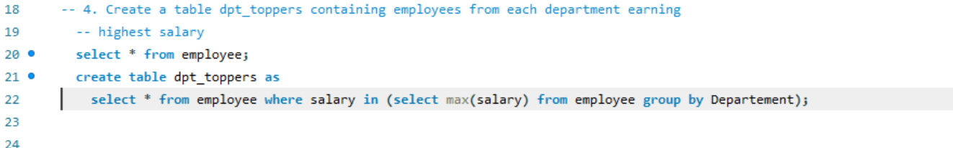

**5. Get top salary using max**

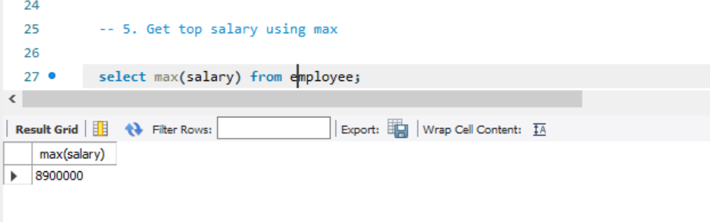

**6. Get top salary using limit**

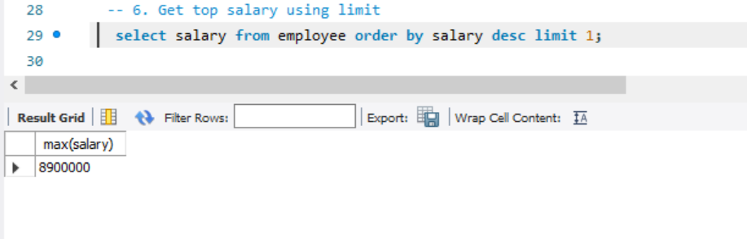

**7. Get top salary using sub query**

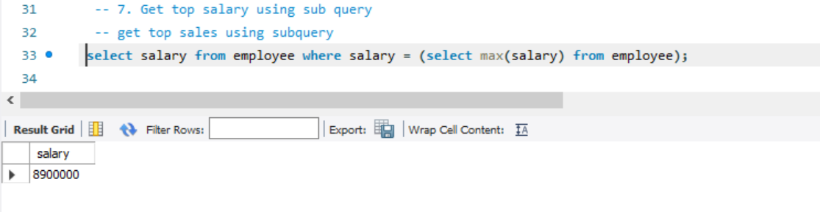

**8. Include comments column in dpt_toppers stating to 'give 10% bonus' for those employees who have not received any reward**

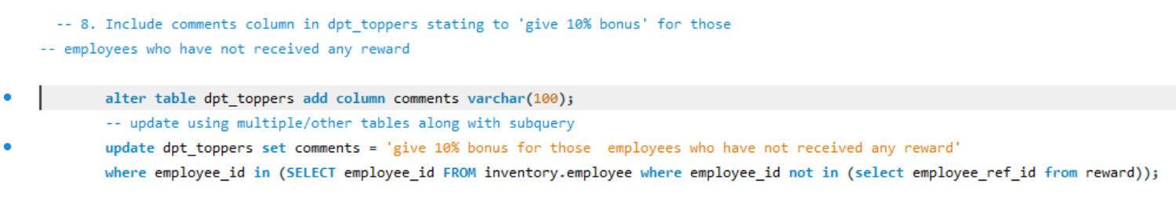

**9. Create a view vw_facilitated who have recieved rewards being a top salary earner of their department**

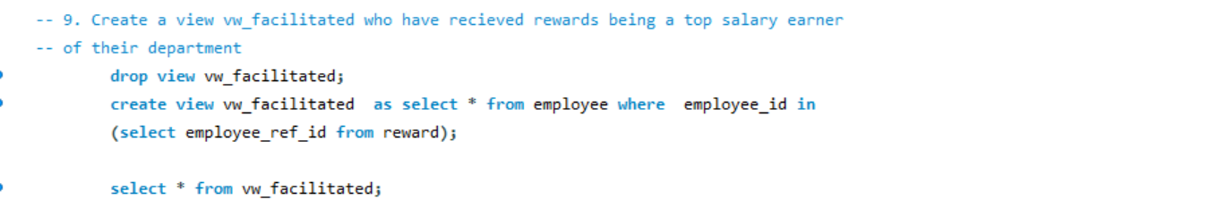

**10. Delete those employees from dpt_toppers who have received rewards already**

