**SRS for FactEcho – News System**

|  |  |
| --- | --- |
| System Analysis | Course Name: |
| Engineer: Ahmed Kord | Instructor Name: |

|  |  |  |
| --- | --- | --- |
| Section no. | Students Name (Arabic) | Student no. |
| 4 | شريف محمد محمد عبدالرازق | 1 |
| 4 | عبدالله محمد محى الدين ابوالفتوح | 2 |
| 4 | طارق السعيد محمد السعيد مصطفى | 3 |
| 4 | عبدالله ابراهيم السيد محمد توفيق | 4 |
| 6 | محمد على محمد على النجدى | 5 |
|  |  |  |
|  |  |  |

Table of Contents

1. Introduction 1

1.1 Overview 3

1.2 Features and Experience 3

2. Specific Requirements 4

2.1. Swot Analysis 4

2.2. Business Model 5

3. System interfaces 1

4. Model 1

4.1. Structured analysis Models 1

4.1.1 DFD Model 1

4.2 UML Analysis Models 1

4.2.1 Use Case diagrams 10

4.2.2 Activity diagrams 14

4.2.3 Sequence diagrams 21

References 1

## Overview

FactEcho is a news application that provides users with up-to-date news across various fields, emphasizing truth, transparency. Initially, FactEcho will be available as a website, with a mobile app and community engagement planned for future versions.

## Features and Experience

### Authentication and Authorization

* **User Registration:** Users can register using their email and a unique username, followed by email verification.
* **Login:** Users can log in with their email and password.
* **Password Reset:** Users can reset their password through a secure method.
* **Security:** Passwords will be encrypted, and JWT will be implemented for secure authentication.
* **OAuth:** User can register and login by OAuth like Google, X, Facebook.

### User Profile and Settings

* **Profile Management:** Users can update their profile information, including username, password and profile picture.
* **Account Deletion:** Options for users to delete their accounts if desired.
* **Multi Roles:** Roles for admins, authors and users.
* **Author Public Profile:** Users can see author articles and its profile.

### News Categories

* **Categorized News:** A dedicated section for various news categories (e.g., politics, sports, technology).

### 

### News Articles

* **Various Articles:** Light size articles contains images and embedded media frames.
* **Article Search:** Users can search for news articles and access individual article pages.
* **Article Page:** Page for each article.
* **Article Quires:** Suggested random article, trend articles, latest articles.
* **Interactions with Article:** In the future, Users maybe can like, save and comment on articles, we can allow users to follow specific authors, Also we can allow users to add their articles too.

### Admin Dashboard

* **Users Permissions Controls:** Set users as authors and set authors Permissions.
* **Categories Controls:** Admin can create, update and delete various categories.
* **Articles Controls:** Admin can create, update and delete various Articles.
* **Ads Controls:** In the future, Admin can create ads for a specific places in the app like some ads in slider in home and categories pages another ads slider in articles and search pages.
* **Email News Letter:** In the future, we can allow admin to send news letter to users who subscribe in this service.
* **Statistics View:** In the future, we can add statistics for admin about the system.

### Author Dashboard

* **Author Articles:** Author can create, update and delete its articles depending on his permissions.

### Premium Features

* **Subscription Options:** In the future, Future plans to offer premium subscriptions for an ad-free experience and exclusive content.

### Installation

* In the future, Instructions on how to set up and run the application.

### Usage

* In the future, Guidelines on how to use the app effectively.

### Contributing

* In the future, Information on how to contribute to the project.

### License

* In the future, Details about the project license.

## SWOT Analysis

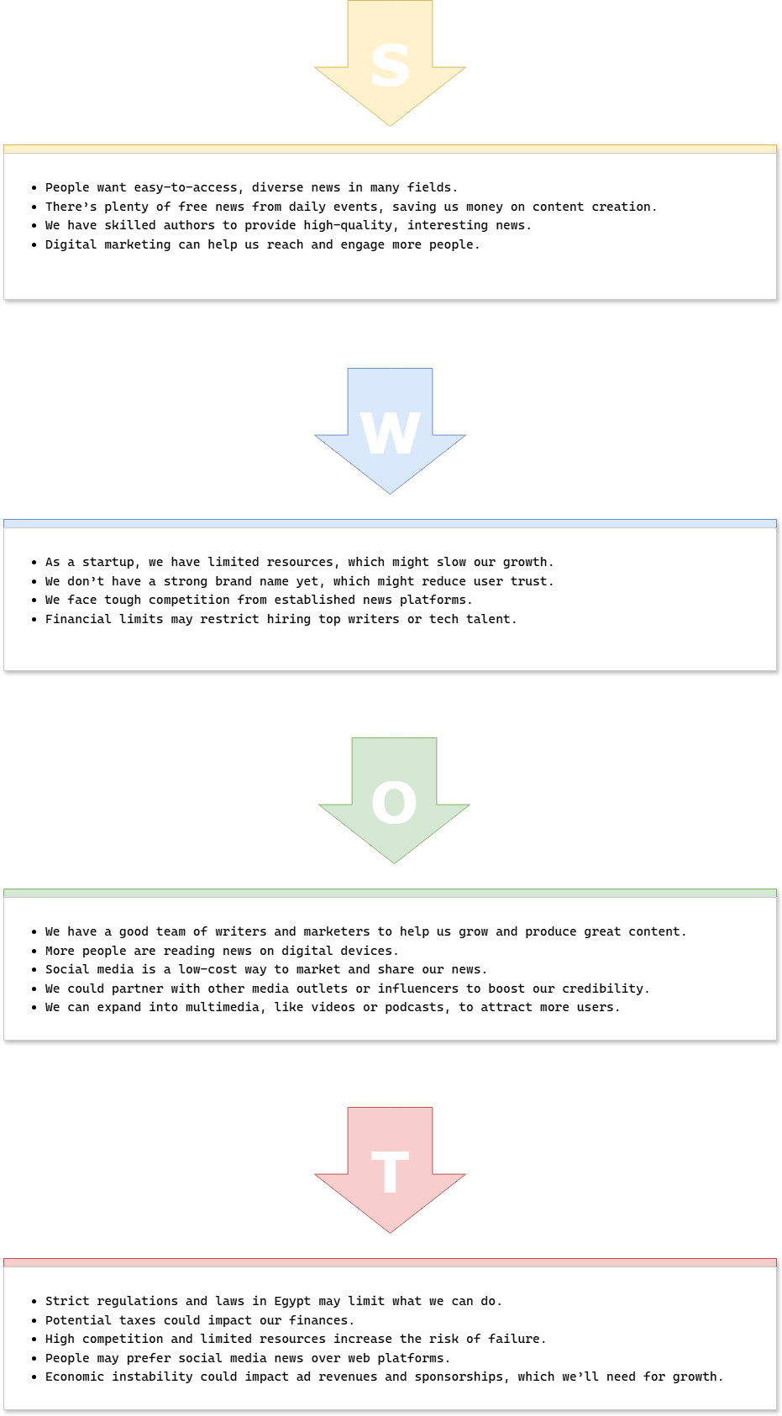

## Business Model

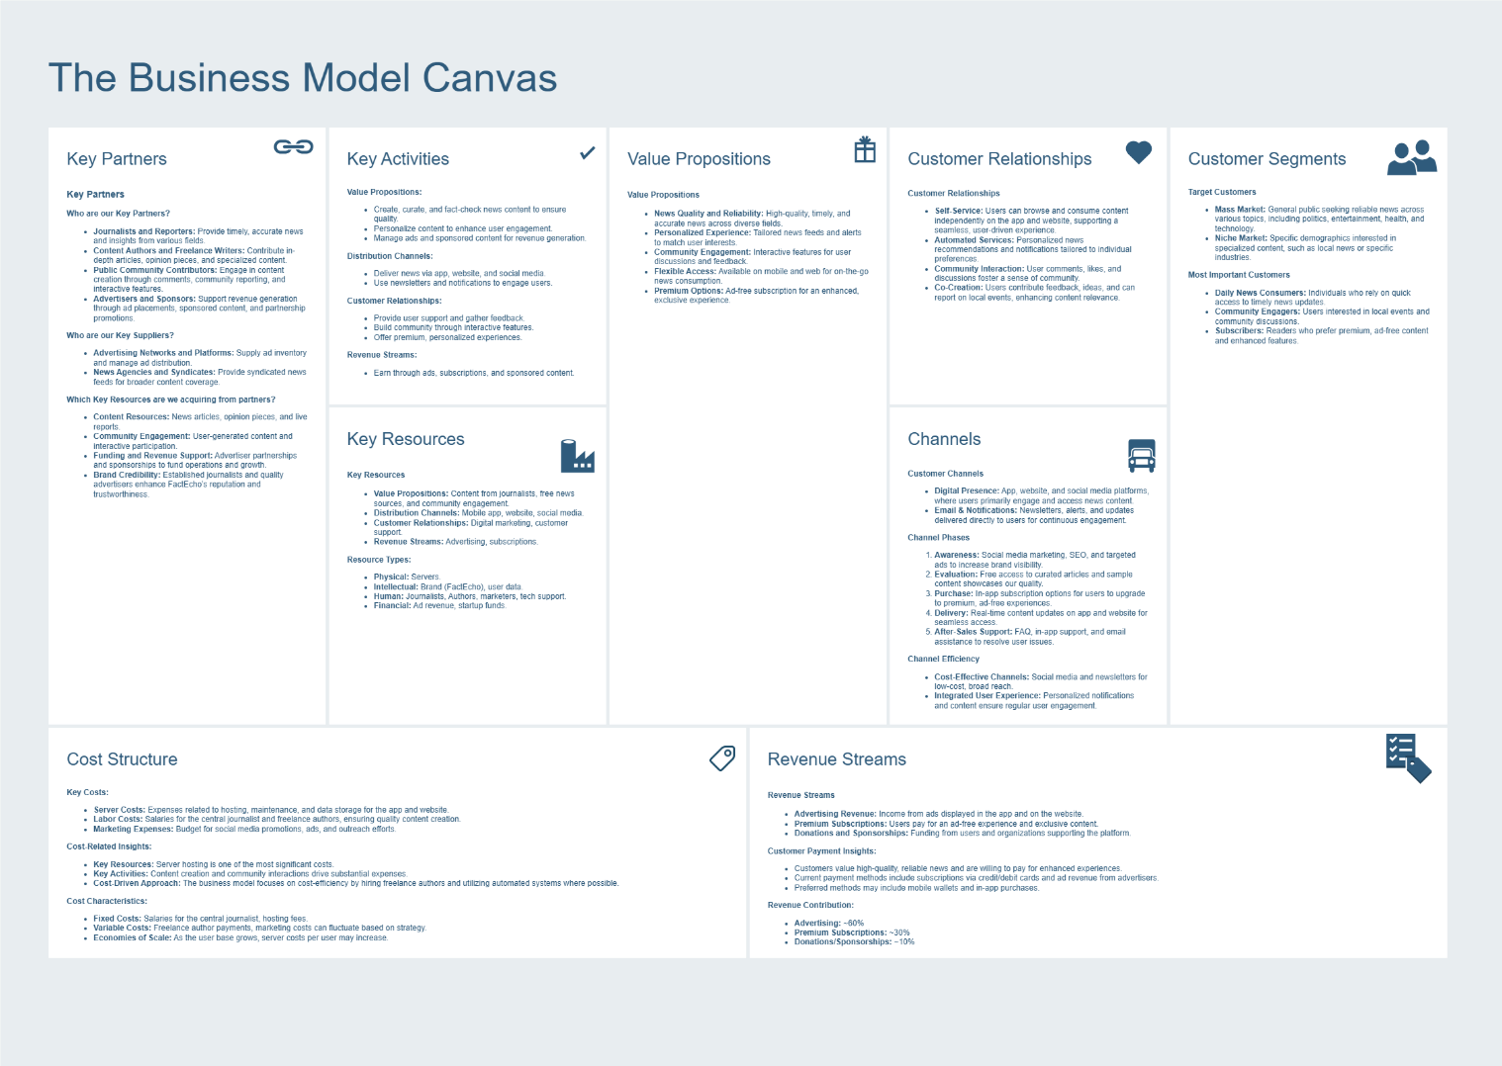

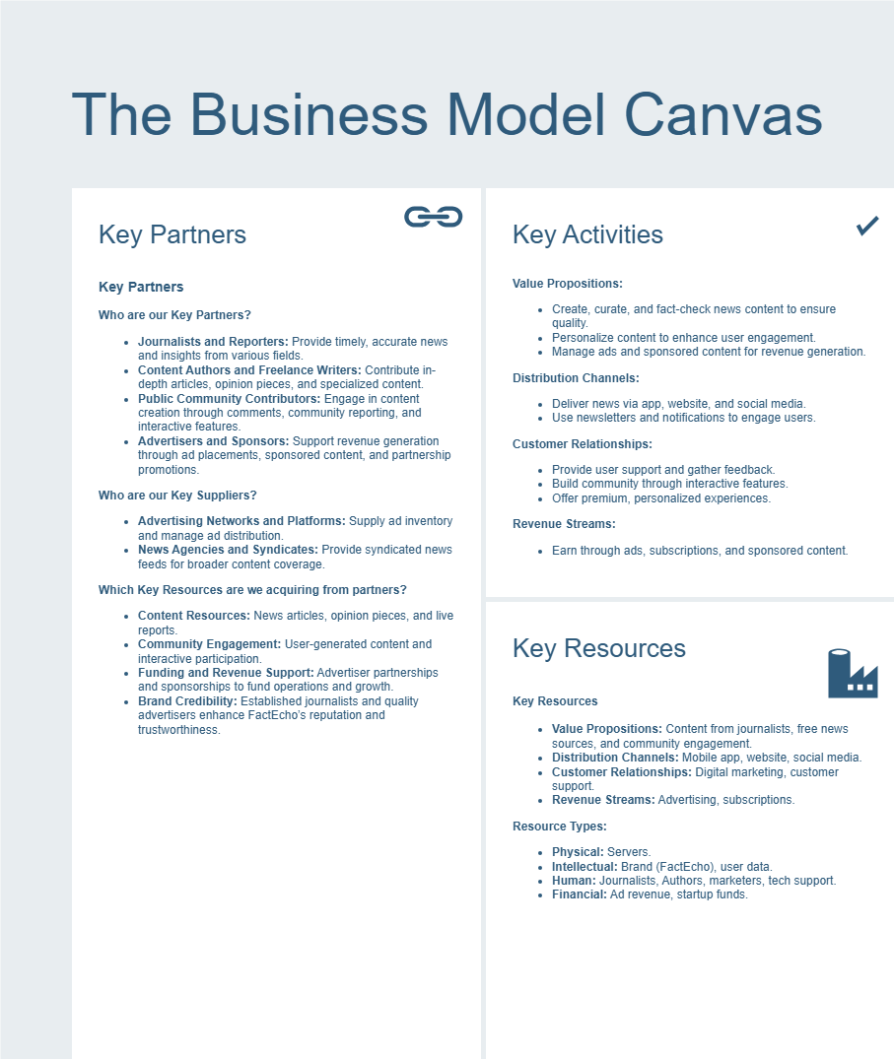

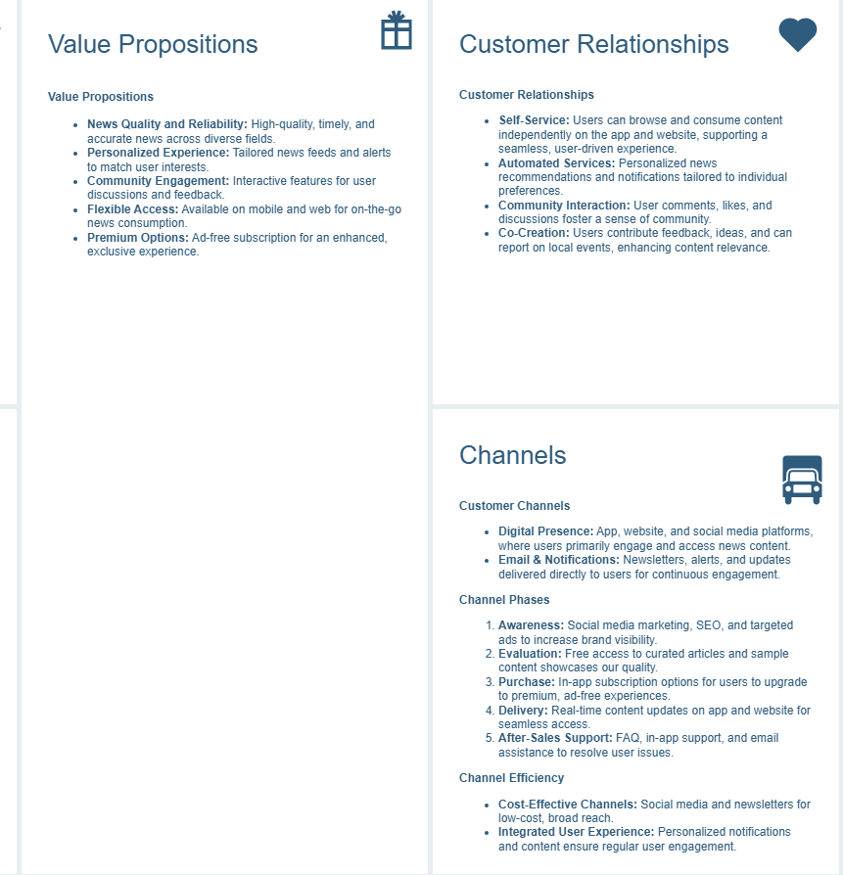

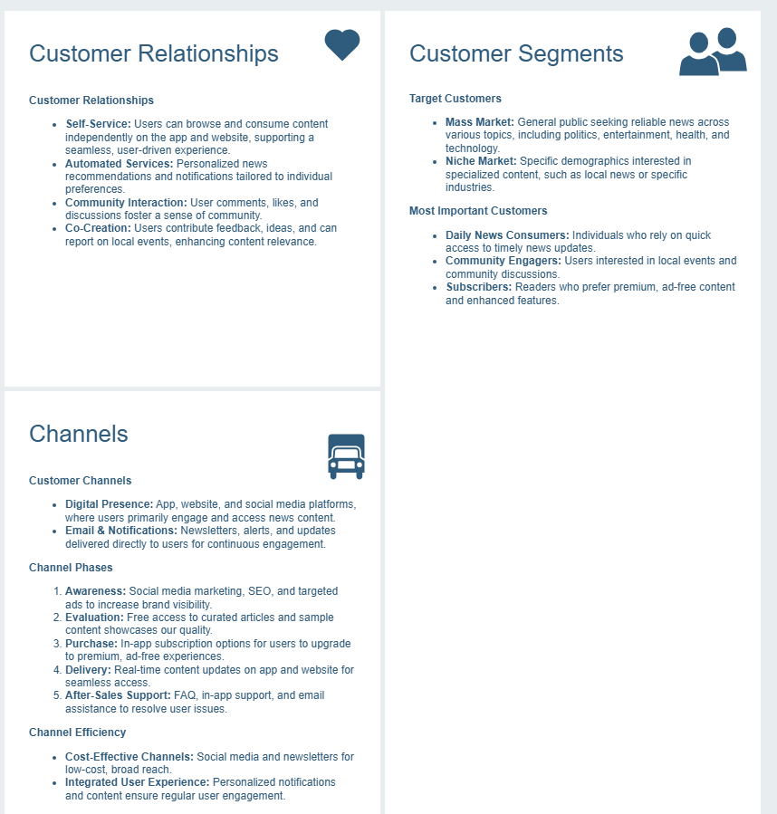

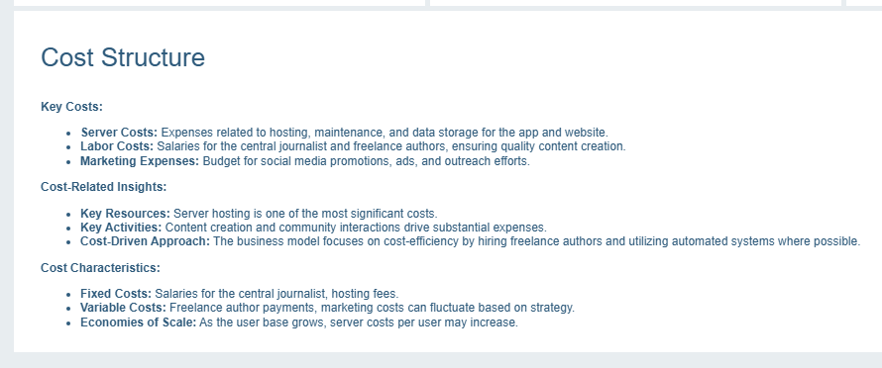

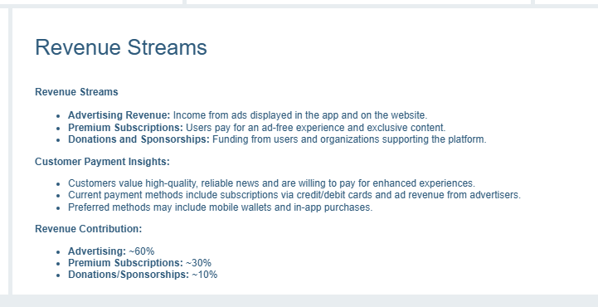

## Use Case Diagram

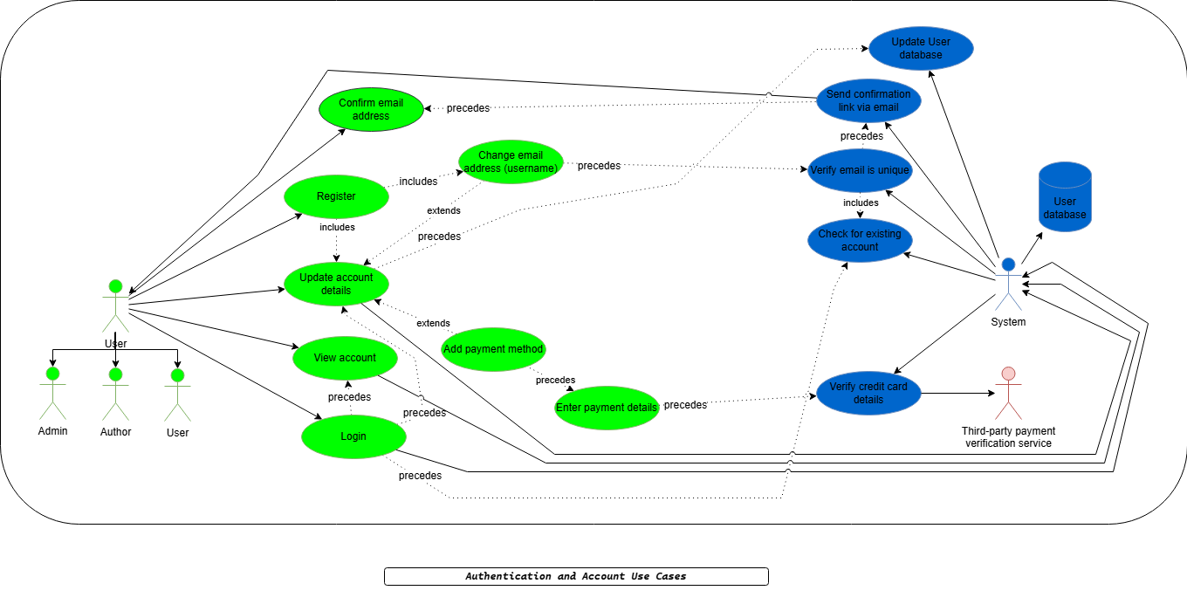

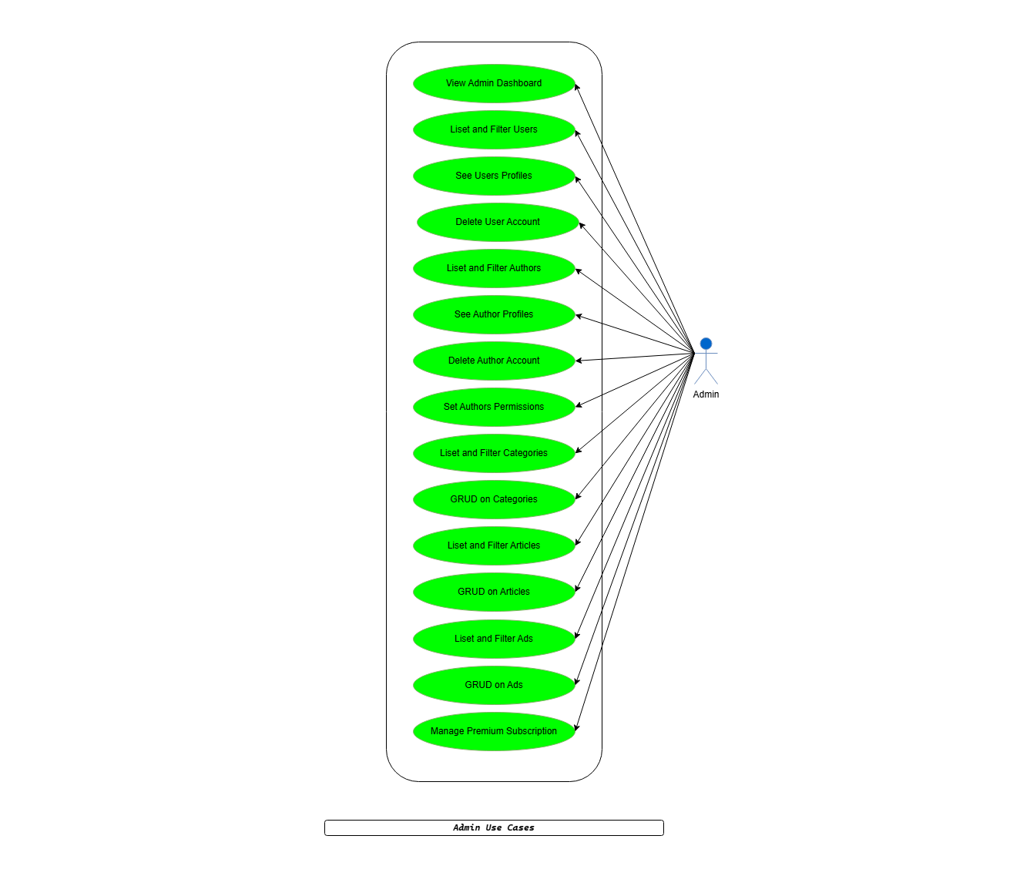

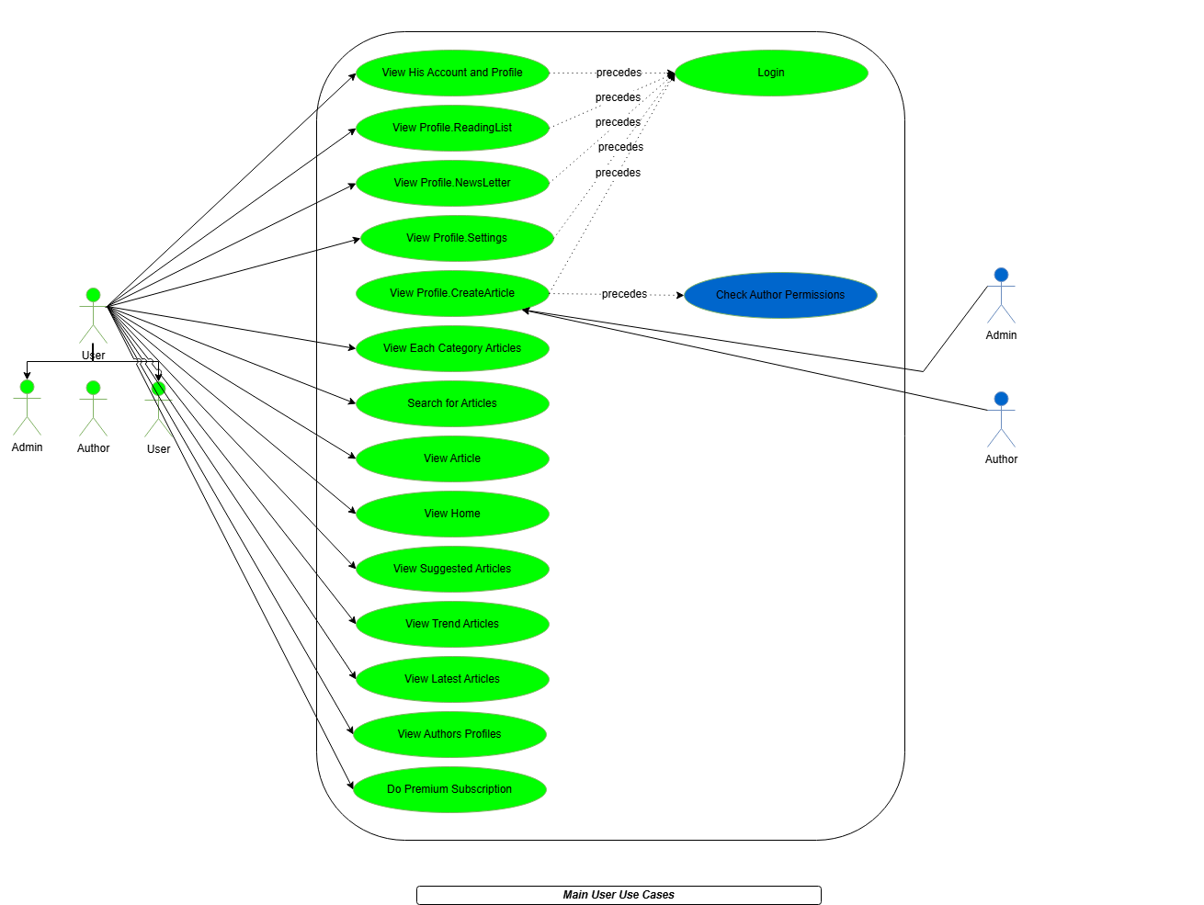

## Activity Diagram

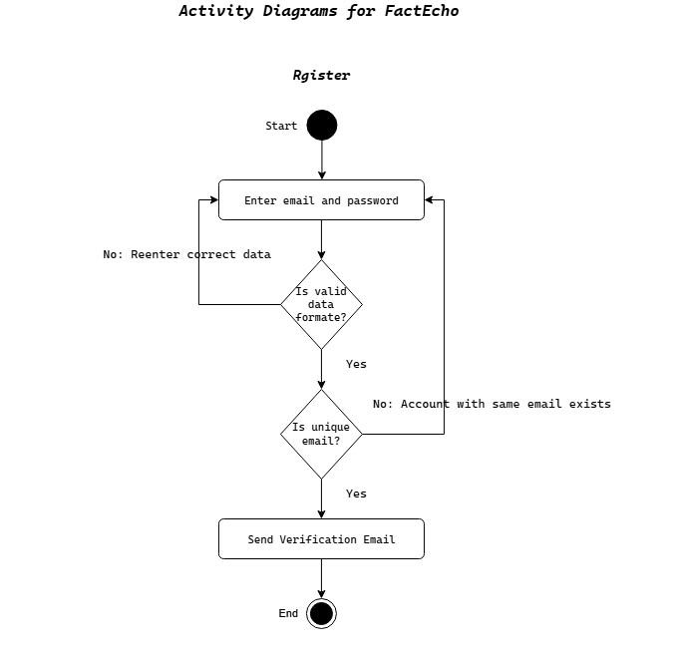

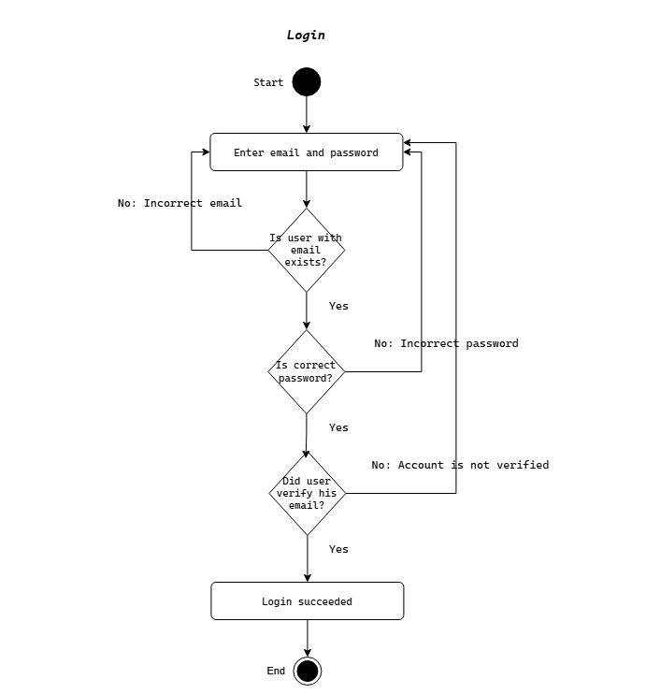

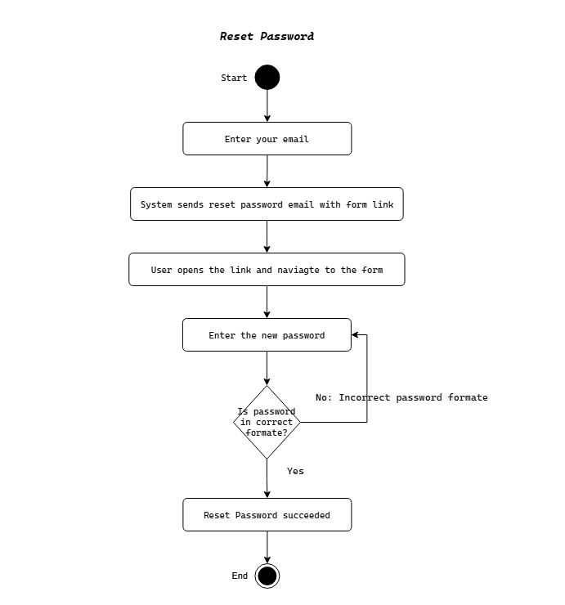

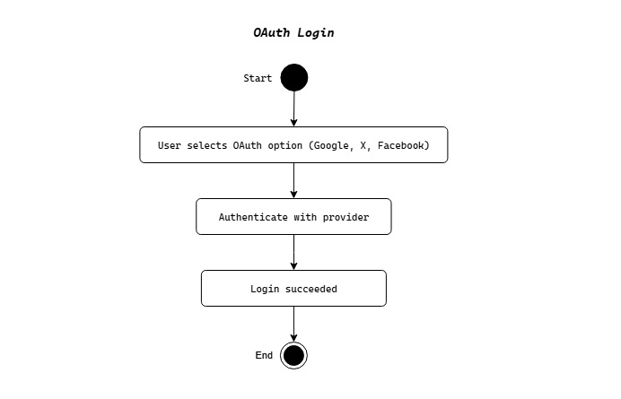

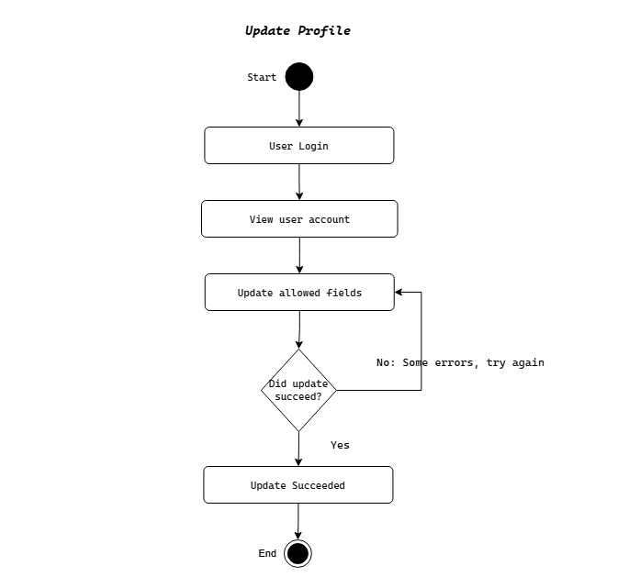

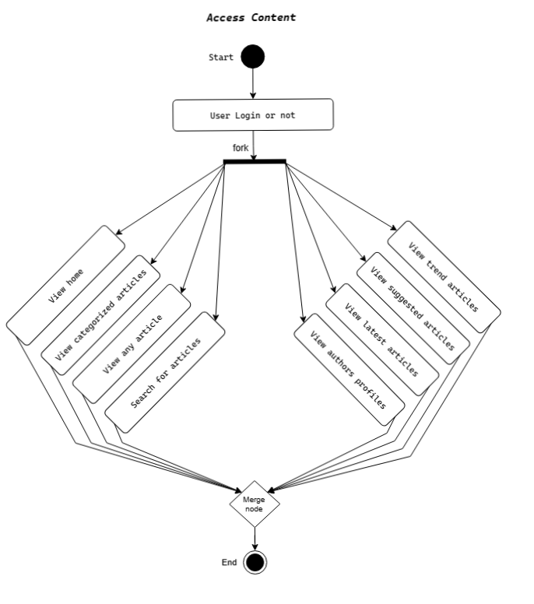

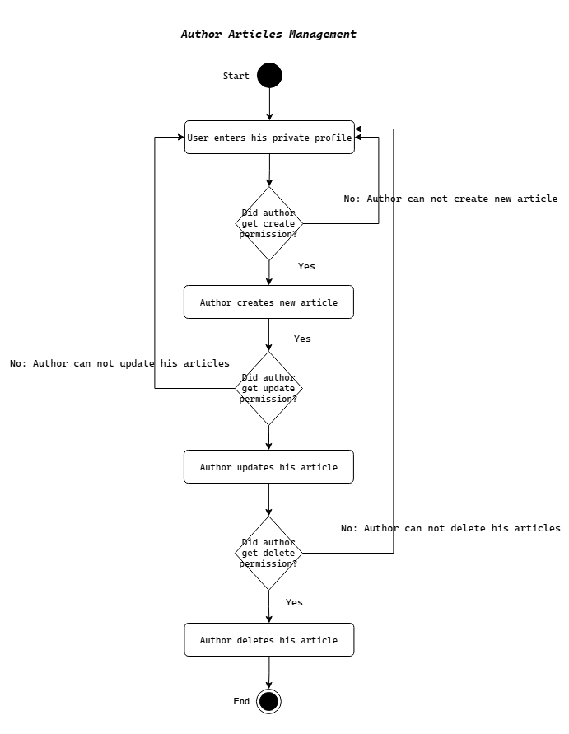

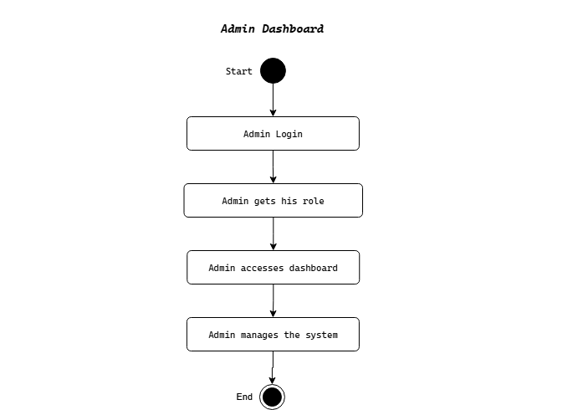

## Sequence Diagram

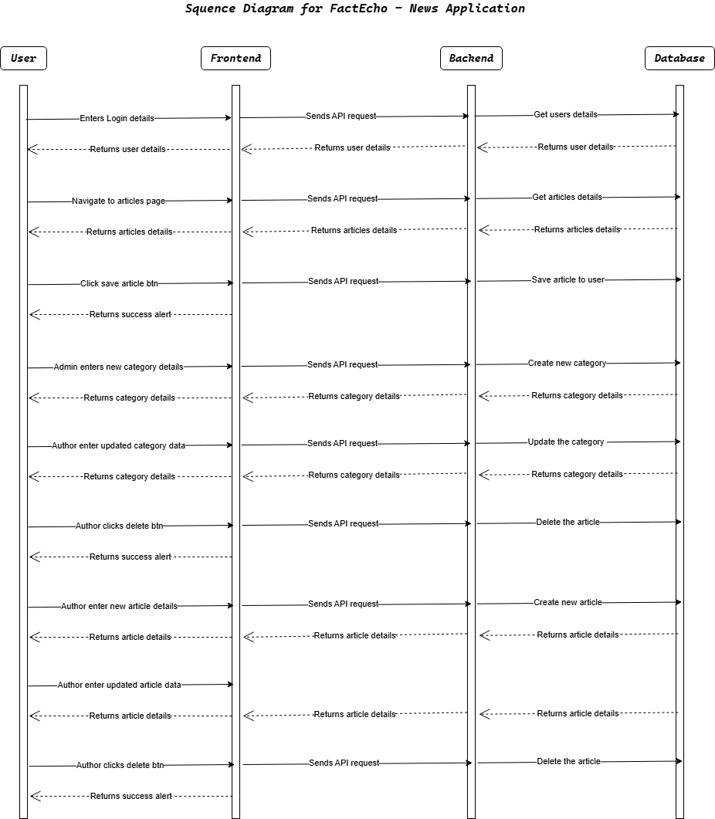

## Technologies Used

* **Analysis and design**: draw.io, docs
* **Frontend**: HTML, CSS, TypeScript, React.js, Tailwind CSS
* **Backend**: Node.js, TypeScript, Express.js
* **Testing**: Jest
* **Database**: PostgreSQL
* **Media Storage**: Cloudinary
* **Authentication**: JWT (JSON Web Tokens)

## Clients

we’ll start with a single web client..

The web client will be implemented in React.js.

The App will take design like https://www.bbc.com/arabic.

See design snapshots here <./UI.Snapshots.md>.

API server will serve a static bundle of the React app.

Uses Tailwind CSS UI for building the CSS components.

## Hosting

The code will be hosted on Github.

The web server and client will be hosted on vercel platform as a test prototype.

The server should be hosted at paid VIM.

The client should have a domain name and SSL/TLS.

The server will have closed CORS policy except for the domain name and the web host server.