Anna Irene Margaritis S1905566

Computer Games (Software Development)

*I confirm that the code contained in this file (other than that provided or authorised) is all my own work and has not been submitted elsewhere in fulfilment of this or any other award*.

*Signature*.

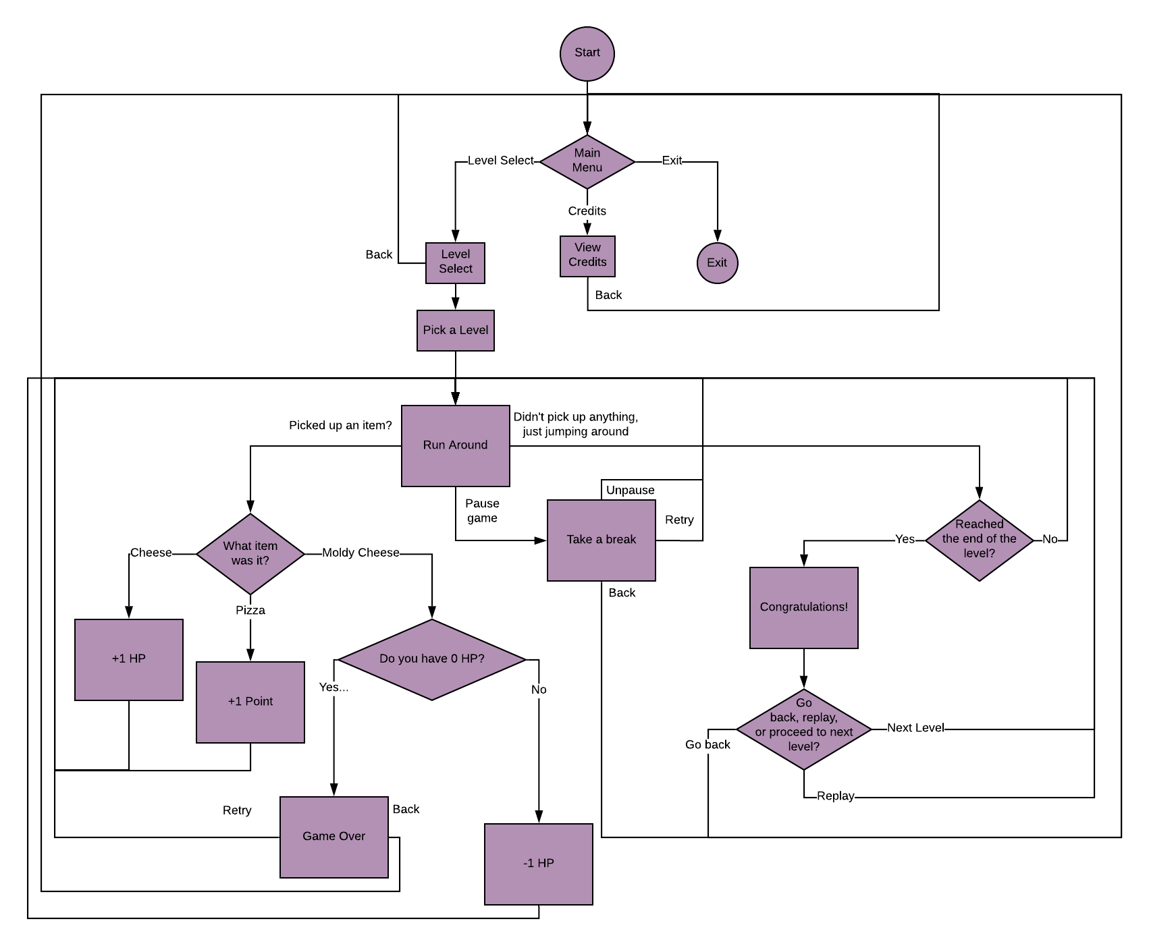This game is a 2D platformer. The player plays as a chef, jumping over obstacles and collecting various food scattered across the levels, which may be hovering in plain sight, or hidden away, challenging the player to find it.

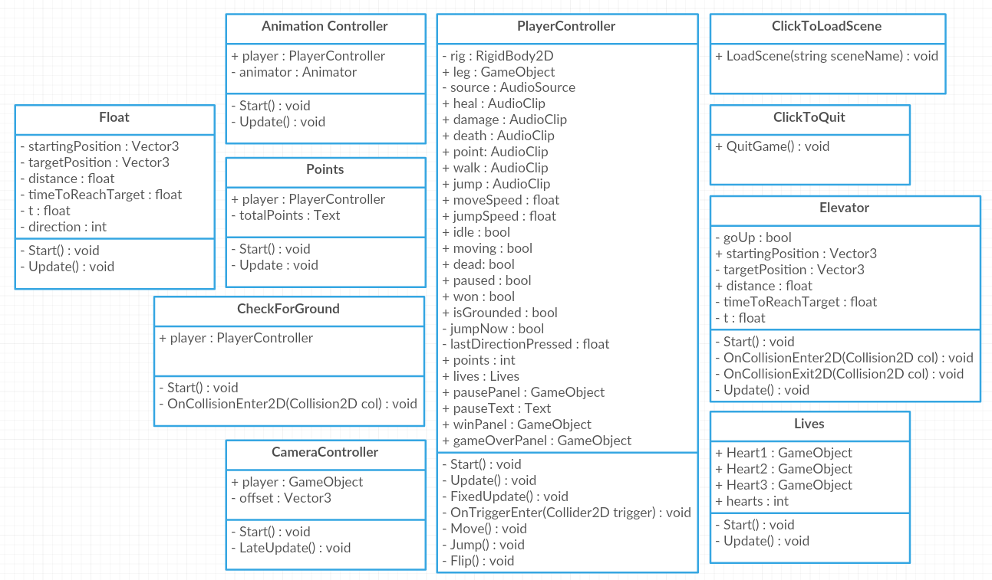

Youtube link to demo:

Credits for assets used:

Graphics:

Chef sprite by me, inspired by Quentin Nicolson's chef sprite: <https://www.artstation.com/quentinnicolson>

Tilemap by Hyptosis: <https://opengameart.org/content/lots-of-free-2d-tiles-and-sprites-by-hyptosis>

Pizza image by PancInteractive: <https://opengameart.org/users/pancinteractive>

Cheese images by bluecarrot16, Daniel Eddeland (daneeklu), Joshua Taylor, Richard Kettering (Jetrel), thekingphoenix, RedVoxel, and Molly "Cougarmint" Willits: <https://opengameart.org/users/bluecarrot16>

Keys by Programmer16: <https://opengameart.org/users/programmer16>

City background image by Gariot: <https://opengameart.org/users/gariot>

Wall background image by Eris: <https://opengameart.org/users/eris>

Button image by Buch: <https://opengameart.org/users/buch>

Heart image by Matt Hackett of Lost Decade Games: <https://opengameart.org/users/richtaur>

Audio:

Music by Alex McCulloch: <https://opengameart.org/users/pro-sensory>

Point sounds by Luke.RUSTLTD: <https://opengameart.org/users/lukerustltd>

Player sounds by Jack Menhorn: <https://opengameart.org/content/fps-placeholder-sounds>

UI sounds by p0ss: <https://opengameart.org/users/p0ss>