# COMP9322 - Week 6 Lab Exercise 1

What is DBpedia?

Visit their home page and have a look: <https://wiki.dbpedia.org/about>

DBpedia is a knowledgebase that utilize semantic web technologies to provide information.

You are going to explore DBpedia to learn about London. Explore and fill in the blacks of questions 1~4.

* Find the page of the English chapter of DBpedia (DBpedia.org) providing the description of **London**. For instance you can use the magic formula "london site:dbpedia.org" in Google to search for “London” in DBpedia.

**Make sure you are on the English chapter (dbpedia.org) as there are many others (fr.dbpedia.org, de.dbpedia.org)**

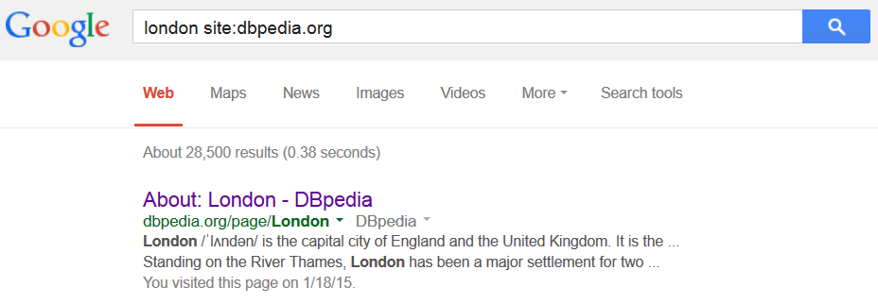

* As you can see, the page contains a long table of data. The first column gives the names of the attributes, properties or relations of the resource described. The second column provides the values of these attributes for that resource.
* For in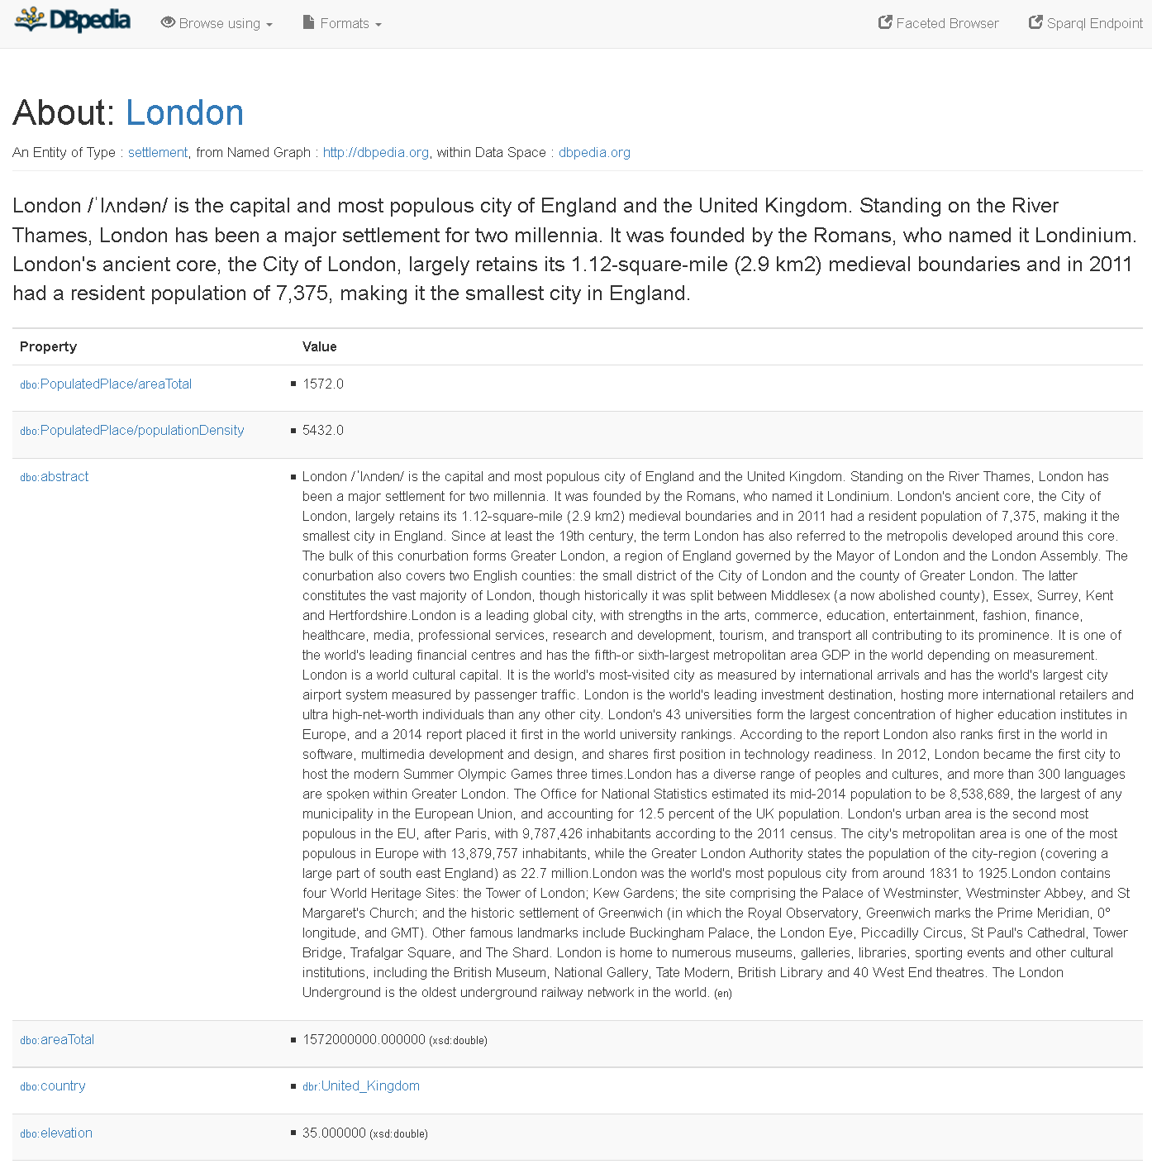stance, if you search for the property "dbo:country" in the page (all browsers have a functionality to search the content text of a page - usually Ctrl or Cmd + F), you will see the value "dbr:United_Kingdom" for London for this property which means “London has for country United Kingdom”

1. Data about London

Among all the attributes given for London, in the page find the property “dbp:populationDemonym” but do not click on it. Just locate the value (one word) given for that property for London and copy it below.

_____________________________

* From capital to capital
* Among all the properties of London, now find the property "rdf:type" that indicates all the categories to which London belong in DBpedia.
* Among the listed categories you will find the category "yago:WikicatCapitalsInEurope". Click on this category to access it like any resource. You will then see all the resources in that category that is all the capitals in Europe according to DBpedia.
* Search this list of capitals to find Vienna and click on it to access its data.
* Data about Vienna

On top of the page, just after the mention "About:", the link "Vienna" gives the address of the resource representing that capital. With a right-click on the link or using ctrl+click on a Mac you can copy this address and paste it in the text box below.

**Warning:** Be careful with content negotiation and redirection, the URL of the page you are currently viewing is different from the URI of the resource. Also make sure to keep that address in a document as you will need it for the last exercise.

1. What is the complete HTTP URI of Vienna in DBpedia?

_____________________________

1. In the data about Vienna, you will find the property "geo:long". Copy the value (just the numerical value) of this property for Vienna and paste it below.

What is the value of the property geo:long for Vienna?

_____________________________

1. In the data about Vienna, you will find the property "dbo:country" which value indicates the URI of the resource representing the country for that city. With a right-click on the link of that value or using ctrl+click on a Mac you can copy the URI of that country and paste it in the text box below.

_______________________