# COMP9322 - Week 6 Lab Exercise 2

# Visualizing FOAF Ontology

Let’s look at a simple schema developed to generate linked-data on the web, used by DBpedia and other applications. Go to:

<http://www.visualdataweb.de/webvowl/>

WebVOWL (Visual Data on the Web) is an application developed to visualize linked-data schemas (also known as ontologies) in a graph structure. The default schema shown in the landing page shows FOAF (<http://xmlns.com/foaf/spec/>) devoted to linking people and information using the Web. Observe how classes, object properties and data properties are illustrated in different colours. When you select a class or a property, “Selection Details” section on the right hand panel will show details of the selected element.

Observe the visualization and find answers to these questions:

1. Name three data properties of “Person” class.

__________________________________________________

1. What object property connects “Group” and “Agent” classes?

___________________________________________________

1. What is an “Agent” in FOAF vocabulary? Select the “Agent” class and note down the description of it shown under the “comment” in “Selection Details” section.

___________________________________________________

# Exploring DBPEDIA Using Protege

Now let’s use Protégé tool to explore the schema developed for DBpedia data we looked at in the tutorial. This schema is an ontology we can import into Protégé.

1. Install Protégé

# Download the app from Protégé website: <http://protege.stanford.edu/>

* Install and launch.

(also see notes in attached Powerpoint)

1. Name three different tabs open in Protégé? (You can open more tabs by Window->Tabs )

____________________________________

# Import DBPedia Ontology into Protégé/

* Go to Dbpedia web site: <http://wiki.dbpedia.org/services-resources/ontology> and read the ontology details.

1. Note down the total number of instances in DBpedia ontology.

_________________________

1. What class in DBpedia ontology has largest number of instances?

_________________________

* Download [DBpedia Ontology T-BOX (Schema](http://downloads.dbpedia.org/2014/dbpedia_2014.owl.bz2)) and extract it in your computer.

1. What is the format of the downloaded file?

_________________________

* Open downloaded file in Protégé. File->Open
* Explore “Active Ontology” tab, read the description provided under “rdfs:comment”.

1. Fill in following information form “Active Ontology” tab.

Ontology IRI:- _______________

Creator:- ____________________

Year of the version:- ________________

* Got to “Entities” tab. Class hierarchy is shown in left. You can click any class and the annotation and usage will be shown in right. Expand the hierarchy to see sub-levels.

1. What are the sub-levels (subclasses) of “award?

____________________________

1. Look at the “Class Annotation” tab in the top right window of the class “colour”, how many languages are used to express its label?

____________________________

* You can see the IRI of a class when you hover over it. Open the IRI of class “Satellite” in your browser and see whether you can see the same information shown online, in Protégé as well as online.
* Explore “Data Properties” tab. It is used to define data/attributes of each class.

1. What is the datatype of “average” property? (see Range defined in “Description” tab, on lower-right corner)

_________________________

1. What class has the property “demolition date”? (see Domain defined in “Description” tab, on lower-right corner.)

_________________________

* Explore “Object Properties” tab. It is used to define relationships between two classes.

1. Find property “produced by” and see two classes it connects together (Domain and Range), defined in “Description” tab, on lower-right corner.
2. ________________________

* In the week 6 lab exercise 1, we explored data on DBpedia such as the details of Sydney, and Paris. This ontology is the schema/data-structure used to define those data. Find ”City” class. You may use “Search” button on top-right. Observe the IRI. Now go to DPpedia page on Sydney (<http://dbpedia.org/page/Sydney>).
* Under “rdf:type” property, can you find the IRI of “City” class? Note: prefixes are used to shorten the IRIs. “dbo” stands for <http://dbpedia.org/ontology/>.

# Visualizing DBPEDIA Ontology

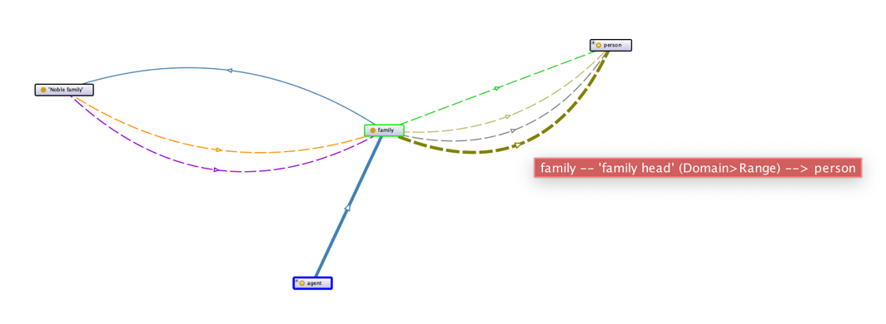There are 2 ways: using Protégé or WebVOWL web site.

Visualizing linked data in Protégé. Got to “OntoGraf” tab in Protégé. If it is not shown, you have to open it from Window->Tabs. Select different classes to see how they are linked to other classes, with different object properties. You can search for classes, click on a class form left-hand pane and use “Node Types” and “Arc Types” in “OntoGraf” tab’s tool bar to get the graph legend. Figure below visualizes the “Family” class.

Alternatively, you may use WebVOWL <http://www.visualdataweb.de/webvowl/> to visualize DBpedia ontology as well. Go to browser app, click “Ontology” on bottom panel and under “Custom Ontology” upload the “dbpedia_2014.owl” you downloaded for Protégé.