Program no: login
Main_Activity.java
package com.example.fpgm;
import androidx.appcompat.app.AppCompatActivity;
import android.os.Bundle;
import android.view.View;
import android.widget.Button;
import android.widget.EditText;
import android.widget.Toast;
public class MainActivity extends AppCompatActivity {
EditText email;
EditText pass;
Button btnlogin;
@Override
protected void onCreate(Bundle savedInstanceState) {
super.onCreate(savedInstanceState);
setContentView(R.layout.activity_main);
email=findViewById(R.id.user);
pass=findViewById(R.id.pass);
btnlogin=findViewById(R.id.login);
}
public void click(View view){
String s1=email.getText().toString();
String s2=pass.getText().toString();
if(s1.equals("shirin") && s2.equals("shirin"))
{
Toast.makeText(this, "successfully", Toast.LENGTH_SHORT).show();
}
else
{
Toast.makeText(this, "login failed", Toast.LENGTH_SHORT).show();
}
}
}

activity_main.xml
<?xml version="1.0" encoding="utf-8"?>
<androidx.constraintlayout.widget.ConstraintLayout xmlns:android="http://schemas.android.com/apk/res/android"
xmlns:app="http://schemas.android.com/apk/res-auto"
xmlns:tools="http://schemas.android.com/tools"
android:layout_width="match_parent"
android:layout_height="match_parent"
tools:context=".MainActivity">
<LinearLayout
android:layout_width="285dp"
android:layout_height="351dp"
android:layout_marginEnd="60dp"
android:layout_marginBottom="216dp"
android:orientation="vertical"
app:layout_constraintBottom_toBottomOf="parent"
app:layout_constraintEnd_toEndOf="parent">
<LinearLayout
android:layout_width="match_parent"
android:layout_height="70dp"
android:orientation="horizontal">
<TextView
android:id="@+id/textView5"
android:layout_width="138dp"
android:layout_height="29dp"
android:layout_weight="1"
android:text="user name" />
<EditText
android:id="@+id/user"
android:layout_width="wrap_content"
android:layout_height="wrap_content"
android:layout_weight="1"
android:ems="10"
android:inputType="textPersonName"
android:text="Name" />
</LinearLayout>
<LinearLayout
android:layout_width="match_parent"
android:layout_height="78dp"
android:orientation="horizontal">
<TextView
android:id="@+id/textView6"
android:layout_width="wrap_content"
android:layout_height="wrap_content"
android:layout_weight="1"
android:text="password" />
<EditText
android:id="@+id/pass"
android:layout_width="wrap_content"
android:layout_height="wrap_content"
android:layout_weight="1"
android:ems="10"
android:inputType="textPassword" />
</LinearLayout>
<LinearLayout
android:layout_width="match_parent"
android:layout_height="73dp"
android:orientation="horizontal">
<Button
android:id="@+id/login"
android:layout_width="wrap_content"
android:layout_height="wrap_content"
android:layout_weight="1"
android:onClick="click"
android:text="login" />
</LinearLayout>
</LinearLayout>
</androidx.constraintlayout.widget.ConstraintLayout>

Output:
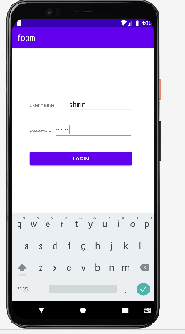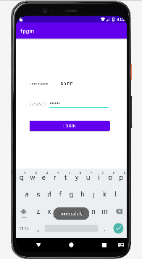

Pgm no: 2 Addition

Activity_main.xml
<?xml version="1.0" encoding="utf-8"?>
<androidx.constraintlayout.widget.ConstraintLayout xmlns:android="http://schemas.android.com/apk/res/android"
xmlns:app="http://schemas.android.com/apk/res-auto"
xmlns:tools="http://schemas.android.com/tools"
android:layout_width="match_parent"
android:layout_height="match_parent"
tools:context=".MainActivity">
<LinearLayout
android:layout_width="254dp"
android:layout_height="384dp"
android:orientation="vertical"
tools:layout_editor_absoluteX="1dp"
tools:layout_editor_absoluteY="1dp">
<TextView
android:id="@+id/textView8"
android:layout_width="match_parent"
android:layout_height="wrap_content"
android:text="number1" />
<EditText
android:id="@+id/num1"
android:layout_width="match_parent"
android:layout_height="wrap_content"
android:ems="10"
android:inputType="textPersonName" />
<TextView
android:id="@+id/textView9"
android:layout_width="match_parent"
android:layout_height="wrap_content"
android:text="number2" />
<EditText
android:id="@+id/num2"
android:layout_width="match_parent"
android:layout_height="wrap_content"
android:ems="10"
android:inputType="textPersonName" />
<TextView
android:id="@+id/textView10"
android:layout_width="match_parent"
android:layout_height="wrap_content"
android:text="result" />
<EditText
android:id="@+id/res"
android:layout_width="match_parent"
android:layout_height="wrap_content"
android:ems="10"
android:inputType="textPersonName" />
<Button
android:id="@+id/btn_add"
android:layout_width="match_parent"
android:layout_height="wrap_content"
android:onClick="onClick"
android:text="ADD" />
</LinearLayout>
</androidx.constraintlayout.widget.ConstraintLayout>

MainActivity.java

package com.example.program3;
import androidx.appcompat.app.AppCompatActivity;
import android.os.Bundle;
import android.view.View;
import android.widget.Button;
import android.widget.EditText;
import android.widget.TextView;
public class MainActivity extends AppCompatActivity {
EditText num1;
EditText num2;
TextView res;
Button btn;
@Override
protected void onCreate(Bundle savedInstanceState) {
super.onCreate(savedInstanceState);
setContentView(R.layout.activity_main);
num1=findViewById(R.id.num1);
num2=findViewById(R.id.num2);
res=findViewById(R.id.res);
btn=findViewById(R.id.btn_add);
}
public void onClick(View view) {
int n1=Integer.parseInt(num1.getText().toString());
int n2=Integer.parseInt(num2.getText().toString());
int sum=n1+n2;
res.setText(sum+"");
}
}

output

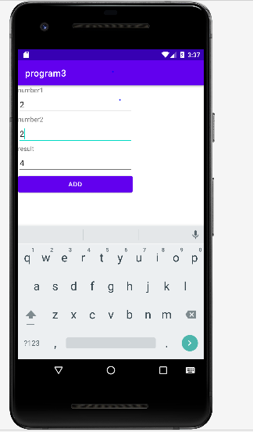

PROGRAM 3 : calculator

Activity_main.xml

<?xml version="1.0" encoding="utf-8"?>
<androidx.constraintlayout.widget.ConstraintLayout xmlns:android="http://schemas.android.com/apk/res/android"
xmlns:app="http://schemas.android.com/apk/res-auto"
xmlns:tools="http://schemas.android.com/tools"
android:layout_width="match_parent"
android:layout_height="match_parent"
tools:context=".MainActivity">
<LinearLayout
android:layout_width="match_parent"
android:layout_height="match_parent"
android:orientation="vertical">
<TextView
android:id="@+id/textView"
android:layout_width="match_parent"
android:layout_height="47dp"
android:text="Number1" />
<EditText
android:id="@+id/num1"
android:layout_width="match_parent"
android:layout_height="wrap_content"
android:ems="10"
android:inputType="textPersonName" />
<TextView
android:id="@+id/textView2"
android:layout_width="match_parent"
android:layout_height="wrap_content"
android:text="Number2" />
<EditText
android:id="@+id/num2"
android:layout_width="match_parent"
android:layout_height="wrap_content"
android:ems="10"
android:inputType="textPersonName" />
<Button
android:id="@+id/btn_add"
android:layout_width="match_parent"
android:layout_height="wrap_content"
android:onClick="sum"
android:text="ADD" />
<Button
android:id="@+id/btn_sub"
android:layout_width="match_parent"
android:layout_height="wrap_content"
android:onClick="sub"
android:text="SUB" />
<Button
android:id="@+id/btn_mul"
android:layout_width="match_parent"
android:layout_height="wrap_content"
android:onClick="mul"
android:text="MUL" />
<Button
android:id="@+id/btn_div"
android:layout_width="match_parent"
android:layout_height="wrap_content"
android:onClick="div"
android:text="DIV" />
<TextView
android:id="@+id/textView3"
android:layout_width="match_parent"
android:layout_height="wrap_content"
android:text="Result" />
<EditText
android:id="@+id/res"
android:layout_width="match_parent"
android:layout_height="wrap_content"
android:ems="10"
android:inputType="textPersonName" />
</LinearLayout>
</androidx.constraintlayout.widget.ConstraintLayout>

MainActivity.java

package com.example.program3;
import androidx.appcompat.app.AppCompatActivity;
import android.os.Bundle;
import android.view.View;
import android.widget.Button;
import android.widget.EditText;
public class MainActivity extends AppCompatActivity {
EditText num1,num2,res;
Button btn_add,btn_sub,btn_mul,btn_div;
@Override
protected void onCreate(Bundle savedInstanceState) {
super.onCreate(savedInstanceState);
setContentView(R.layout.activity_main);
num1=findViewById(R.id.num1);
num2=findViewById(R.id.num2);
btn_add=findViewById(R.id.btn_add);
btn_sub=findViewById(R.id.btn_sub);
btn_mul=findViewById(R.id.btn_mul);
btn_div=findViewById(R.id.btn_div);
res=findViewById(R.id.res);
}
public void sum(View view){
int n1=Integer.parseInt(num1.getText().toString());
int n2=Integer.parseInt(num2.getText().toString());
int sum=n1+n2;
res.setText(sum+"");
}
public void sub(View view){
int n1=Integer.parseInt(num1.getText().toString());
int n2=Integer.parseInt(num2.getText().toString());
int sub=n1-n2;
res.setText(sub+"");
}
public void mul(View view) {
int n1 = Integer.parseInt(num1.getText().toString());
int n2 = Integer.parseInt(num2.getText().toString());
int mul = n1 * n2;
res.setText(mul + "");
}
public void div(View view) {
int n1 = Integer.parseInt(num1.getText().toString());
int n2 = Integer.parseInt(num2.getText().toString());
int div = n1 / n2;
res.setText(div + "");
}
}

output

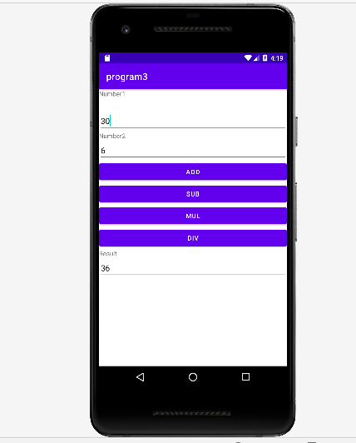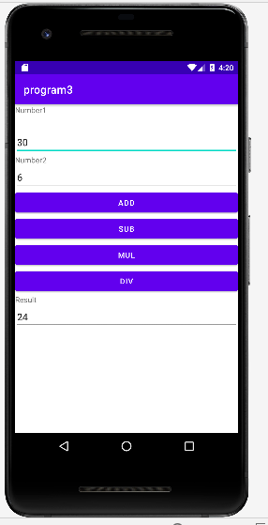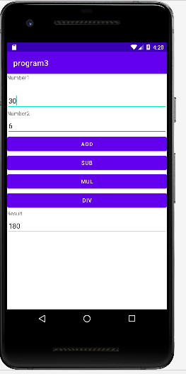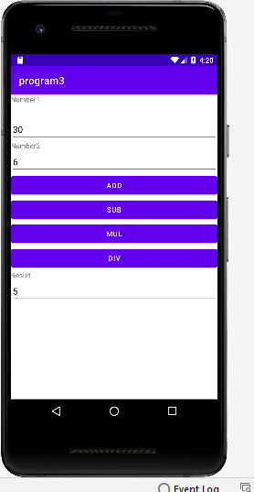

Grid calculator

mainActivity.java

package com.example.co22;
import androidx.appcompat.app.AppCompatActivity;
import android.os.Bundle;
import android.view.View;
import android.widget.Button;
import android.widget.TextView;
public class MainActivity extends AppCompatActivity implements View.OnClickListener {
TextView number;
double n1=0,n2=0;
String op="";
Button b1,b2,b3,b4,b5,b6,b7,b8,b9,b0,b_add,b_mul,b_sub,b_div,b_clr,b_eq;
@Override
protected void onCreate(Bundle savedInstanceState) {
super.onCreate(savedInstanceState);
setContentView(R.layout.activity_main);
number=findViewById(R.id.t_view);
b1=findViewById(R.id.btn1);
b2=findViewById(R.id.btn2);
b3=findViewById(R.id.btn3);
b4=findViewById(R.id.btn4);
b5=findViewById(R.id.btn5);
b6=findViewById(R.id.btn6);
b7=findViewById(R.id.btn7);
b8=findViewById(R.id.btn8);
b9=findViewById(R.id.btn9);
b0=findViewById(R.id.btn0);
b_add=findViewById(R.id.b_add);
b_clr=findViewById(R.id.b_clr);
b_div=findViewById(R.id.b_div);
b_mul=findViewById(R.id.b_mul);
b_sub=findViewById(R.id.b_sub);
b_clr=findViewById(R.id.b_clr);
b_eq=findViewById(R.id.b_eq);
b1.setOnClickListener(this);
b2.setOnClickListener(this);
b3.setOnClickListener(this);
b4.setOnClickListener(this);
b5.setOnClickListener(this);
b6.setOnClickListener(this);
b7.setOnClickListener(this);
b8.setOnClickListener(this);
b9.setOnClickListener(this);
b0.setOnClickListener(this);
b_add.setOnClickListener(this);
b_sub.setOnClickListener(this);
b_mul.setOnClickListener(this);
b_div.setOnClickListener(this);
b_clr.setOnClickListener(this);
b_eq.setOnClickListener(this);
}
@Override
public void onClick(View view){
Button b=(Button) view;
if(view==b_clr)
{
number.setText("");
}
else if(view==b_add || view==b_mul || view==b_div || view==b_sub )
{
n1=Integer.parseInt(number.getText().toString());
op=b.getText().toString();
number.setText("");
}
else if(view == b_eq)
{
n2=Integer.parseInt(number.getText().toString());
if(op.equals("+"))
{
number.setText(n1+n2+"");
}
else if(op.equals("-"))
{
number.setText(n1-n2+"");
}
else if(op.equals("/"))
{
number.setText(n1/n2+"");
}
else if(op.equals("*"))
{
number.setText(n1*n2+"");
}
}
else
{
String s=number.getText().toString();
number.setText(s+b.getText().toString());
}
}
}

Activity_main.xml

<?xml version="1.0" encoding="utf-8"?>
<LinearLayout xmlns:android="http://schemas.android.com/apk/res/android"
xmlns:app="http://schemas.android.com/apk/res-auto"
xmlns:tools="http://schemas.android.com/tools"
android:layout_width="match_parent"
android:layout_height="match_parent"
android:orientation="vertical"
tools:context=".MainActivity">
<LinearLayout
android:layout_width="408dp"
android:layout_height="84dp"
android:orientation="vertical"
tools:ignore="MissingConstraints"
tools:layout_editor_absoluteX="3dp"
tools:layout_editor_absoluteY="1dp">
<EditText
android:id="@+id/t_view"
android:layout_width="match_parent"
android:layout_height="wrap_content"
android:ems="10"
android:hint="......"
android:inputType="textPersonName" />
</LinearLayout>
<androidx.gridlayout.widget.GridLayout
android:layout_width="wrap_content"
android:layout_height="268dp"
android:layout_gravity="center"
tools:layout_editor_absoluteX="3dp"
tools:layout_editor_absoluteY="87dp">
<Button
android:id="@+id/btn1"
android:layout_width="wrap_content"
android:layout_height="66dp"
android:text="1"
android:textSize="20sp"
app:layout_column="0"
app:layout_row="0" />
<Button
android:id="@+id/btn2"
android:layout_width="wrap_content"
android:layout_height="65dp"
android:text="2"
android:textSize="20sp"
app:layout_column="1"
app:layout_row="0" />
<Button
android:id="@+id/btn3"
android:layout_width="wrap_content"
android:layout_height="66dp"
android:text="3"
android:textSize="20sp"
app:layout_column="2"
app:layout_row="0" />
<Button
android:id="@+id/b_add"
android:layout_width="wrap_content"
android:layout_height="65dp"
android:text="+"
android:textSize="20sp"
app:layout_column="3"
app:layout_row="0" />
<Button
android:id="@+id/btn4"
android:layout_width="wrap_content"
android:layout_height="61dp"
android:text="4"
android:textSize="20sp"
app:layout_column="0"
app:layout_row="1" />
<Button
android:id="@+id/btn5"
android:layout_width="wrap_content"
android:layout_height="61dp"
android:text="5"
android:textSize="20sp"
app:layout_column="1"
app:layout_row="1" />
<Button
android:id="@+id/btn6"
android:layout_width="wrap_content"
android:layout_height="61dp"
android:text="6"
android:textSize="20sp"
app:layout_column="2"
app:layout_row="1" />
<Button
android:id="@+id/b_sub"
android:layout_width="wrap_content"
android:layout_height="61dp"
android:text="-"
android:textSize="20sp"
app:layout_column="3"
app:layout_row="1" />
<Button
android:id="@+id/btn7"
android:layout_width="wrap_content"
android:layout_height="60dp"
android:text="7"
android:textSize="20sp"
app:layout_column="0"
app:layout_row="2" />
<Button
android:id="@+id/btn8"
android:layout_width="wrap_content"
android:layout_height="60dp"
android:text="8"
android:textSize="20sp"
app:layout_column="1"
app:layout_row="2" />
<Button
android:id="@+id/btn9"
android:layout_width="wrap_content"
android:layout_height="62dp"
android:text="9"
android:textSize="20sp"
app:layout_column="2"
app:layout_row="2" />
<Button
android:id="@+id/btn0"
android:layout_width="wrap_content"
android:layout_height="60dp"
android:text="0"
android:textSize="20sp"
app:layout_column="1"
app:layout_row="3" />
<Button
android:id="@+id/b_mul"
android:layout_width="wrap_content"
android:layout_height="63dp"
android:text="*"
android:textSize="20sp"
app:layout_column="3"
app:layout_row="2" />
<Button
android:id="@+id/b_div"
android:layout_width="wrap_content"
android:layout_height="59dp"
android:text="/"
android:textSize="20sp"
app:layout_column="2"
app:layout_row="3" />
<Button
android:id="@+id/b_eq"
android:layout_width="wrap_content"
android:layout_height="62dp"
android:text="="
android:textSize="20sp"
app:layout_column="3"
app:layout_row="3" />
<Button
android:id="@+id/b_clr"
android:layout_width="85dp"
android:layout_height="60dp"
android:text="CLEAR"
android:textSize="14sp"
app:layout_column="0"
app:layout_row="3" />
</androidx.gridlayout.widget.GridLayout>
</LinearLayout>

Output:

lifecycle
MainActivity.java

package com.example.program2;
import androidx.appcompat.app.AppCompatActivity;
import android.os.Bundle;
import android.widget.Toast;
public class MainActivity extends AppCompatActivity {
@Override
protected void onCreate(Bundle savedInstanceState) {
super.onCreate(savedInstanceState);
setContentView(R.layout.activity_main);
Toast.makeText(this,"OnCreate",Toast.LENGTH_LONG).show();
}
@Override
protected void onStart(){
super.onStart();
Toast.makeText(this,"OnStart",Toast.LENGTH_LONG).show();
}
@Override
protected void onResume(){
super.onResume();
Toast.makeText(this,"OnResume",Toast.LENGTH_LONG).show();
}
@Override
protected void onPause(){
super.onPause();
Toast.makeText(this,"OnPause",Toast.LENGTH_LONG).show();
}
@Override
protected void onStop(){
super.onStop();
Toast.makeText(this,"OnStop",Toast.LENGTH_LONG).show();
}
@Override
protected void onDestroy(){
super.onDestroy();
Toast.makeText(this,"OnDestroy",Toast.LENGTH_LONG).show();
}
@Override
protected void onRestart(){
super.onRestart();
Toast.makeText(this,"OnRestart",Toast.LENGTH_LONG).show();
}
}

Output:
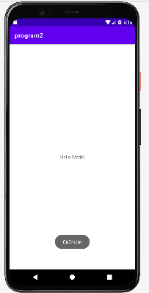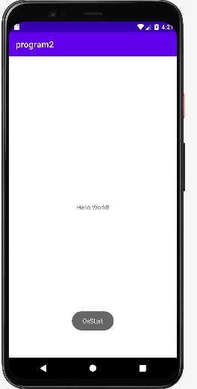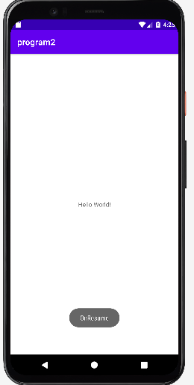

Registration

MainActivity.java
package com.example.registration;
import androidx.appcompat.app.AppCompatActivity;
import android.os.Bundle;
import androidx.appcompat.app.AppCompatActivity;
import android.os.Bundle;
import android.view.View;
import android.widget.Button;
import android.widget.CheckBox;
import android.widget.EditText;
import android.widget.RadioButton;
import android.widget.RadioGroup;
import android.widget.TextView;
import android.widget.Toast;
public class MainActivity extends AppCompatActivity {
EditText fname, lname, dob, mail, pass; //variables names to be used
Button button; // variables names to be used
Boolean isAllFieldsChecked;
RadioGroup gender;
CheckBox c_agree;
RadioButton male,female,other;
@Override
protected void onCreate(Bundle savedInstanceState) {
super.onCreate(savedInstanceState);
setContentView(R.layout.activity_main);
fname = findViewById(R.id.fname);
lname = findViewById(R.id.lname);
dob = findViewById(R.id.dob);
male= findViewById(R.id.rb1);
female= findViewById(R.id.rb2);
other= findViewById(R.id.rb3);
mail = findViewById(R.id.email);
pass = findViewById(R.id.pass);
button = findViewById(R.id.btn_register);
}
public void submit(View view) {
isAllFieldsChecked = CheckAllFields();
if (isAllFieldsChecked) {
Toast.makeText(this, "Sucessfully", Toast.LENGTH_SHORT).show();
}
}
private Boolean CheckAllFields() {
if (fname.length() == 0) {
fname.setError("This field is required");
return false;
}
if (lname.length() == 0) {
lname.setError("This field is required");
return false;
}
if (dob.length() == 0) {
dob.setError("This field is required");
return false;
}
if(gender.getCheckedRadioButtonId()== -1)
{
female.setError("Select Gender");
female.requestFocus();
return false;
}
if(gender.getCheckedRadioButtonId()== -1)
{
male.setError("Select Gender");
male.requestFocus();
return false;
}
if(gender.getCheckedRadioButtonId()== -1)
{
other.setError("Select Gender");
other.requestFocus();
return false;
}
if(!c_agree.isChecked()){
c_agree.setError("please agree");
c_agree.requestFocus();
return false;
}
if (mail.length() == 0) {
mail.setError(" Email is required");
return false;
}
else{
String smail=mail.getText().toString();
String checkmail="[a-zA-Z0-9._-]+@[a-z]+.+[a-z]+";
if(!smail.matches(checkmail))
{
mail.setError("Invalid Email");
return false;
}
}
if (pass.length() == 0) {
pass.setError("This field is required");
return false;
}
else if(pass.length()<8)
{
pass.setError("Password must be minimum 8 characters..");
return false;
}
return true;
}
}

Activitymain.xml
<?xml version="1.0" encoding="utf-8"?>
<androidx.constraintlayout.widget.ConstraintLayout xmlns:android="http://schemas.android.com/apk/res/android"
xmlns:app="http://schemas.android.com/apk/res-auto"
xmlns:tools="http://schemas.android.com/tools"
android:layout_width="match_parent"
android:layout_height="match_parent"
tools:context=".MainActivity">
<LinearLayout
android:layout_width="409dp"
android:layout_height="729dp"
android:orientation="vertical"
tools:layout_editor_absoluteX="1dp"
tools:layout_editor_absoluteY="1dp">
<LinearLayout
android:layout_width="match_parent"
android:layout_height="42dp"
android:orientation="horizontal">
<TextView
android:id="@+id/textView"
android:layout_width="wrap_content"
android:layout_height="41dp"
android:layout_weight="1"
android:text="Enter the Details of Registration"
android:textAlignment="center"
android:textSize="20sp"
android:textColor="#151412"
/>
</LinearLayout>
<LinearLayout
android:layout_width="match_parent"
android:layout_height="67dp"
android:orientation="horizontal">
<EditText
android:id="@+id/fname"
android:layout_width="wrap_content"
android:layout_height="wrap_content"
android:layout_weight="1"
android:ems="10"
android:hint="FIRST NAME"
android:inputType="textPersonName" />
<EditText
android:id="@+id/lname"
android:layout_width="wrap_content"
android:layout_height="wrap_content"
android:layout_weight="1"
android:ems="10"
android:hint="LAST NAME"
android:inputType="textPersonName" />
</LinearLayout>
<LinearLayout
android:layout_width="match_parent"
android:layout_height="62dp"
android:orientation="horizontal">
<RadioGroup
android:id="@+id/gender"
android:layout_width="match_parent"
android:layout_height="61dp"
android:orientation="horizontal">>
<RadioButton
android:id="@+id/rb1"
android:layout_width="wrap_content"
android:layout_height="wrap_content"
android:layout_weight="1"
android:text="MALE" />
<RadioButton
android:id="@+id/rb2"
android:layout_width="wrap_content"
android:layout_height="wrap_content"
android:layout_weight="1"
android:text="FEMALE" />
<RadioButton
android:id="@+id/rb3"
android:layout_width="wrap_content"
android:layout_height="wrap_content"
android:layout_weight="1"
android:text="OTHER" />
</RadioGroup>
</LinearLayout>
<LinearLayout
android:layout_width="match_parent"
android:layout_height="55dp"
android:orientation="horizontal">
<TextView
android:id="@+id/textView3"
android:layout_width="wrap_content"
android:layout_height="wrap_content"
android:layout_weight="1"
android:text="DATE OF BIRTH" />
<EditText
android:id="@+id/dob"
android:layout_width="wrap_content"
android:layout_height="wrap_content"
android:layout_weight="1"
android:ems="10"
android:hint="ddmmyy"
android:inputType="date" />
</LinearLayout>
<LinearLayout
android:layout_width="match_parent"
android:layout_height="56dp"
android:orientation="horizontal">
<EditText
android:id="@+id/email"
android:layout_width="wrap_content"
android:layout_height="wrap_content"
android:layout_weight="1"
android:ems="10"
android:hint="Enter your E-mail Id"
android:inputType="textPersonName" />
</LinearLayout>
<LinearLayout
android:layout_width="421dp"
android:layout_height="55dp"
android:orientation="horizontal">
<EditText
android:id="@+id/pass"
android:layout_width="wrap_content"
android:layout_height="wrap_content"
android:layout_weight="1"
android:ems="10"
android:hint="Enter Password"
android:inputType="textPersonName" />
</LinearLayout>
<LinearLayout
android:layout_width="match_parent"
android:layout_height="81dp"
android:orientation="vertical">
<CheckBox
android:id="@+id/c_agree"
android:layout_width="match_parent"
android:layout_height="wrap_content"
android:text="Agree? Privacy Policy" />
</LinearLayout>
<LinearLayout
android:layout_width="match_parent"
android:layout_height="match_parent"
android:orientation="vertical">
<Button
android:id="@+id/btn_register"
android:layout_width="161dp"
android:layout_height="wrap_content"
android:onClick="submit"
android:text="REGISTER"
android:layout_gravity="center"/>
</LinearLayout>
</LinearLayout>
</androidx.constraintlayout.widget.ConstraintLayout>

Colors.xml
<?xml version="1.0" encoding="utf-8"?>
<resources>
<color name="purple_200">#FFBB86FC</color>
<color name="purple_500">#FF6200EE</color>
<color name="purple_700">#FF3700B3</color>
<color name="teal_200">#FF03DAC5</color>
<color name="teal_700">#FF018786</color>
<color name="black">#FF000000</color>
<color name="white">#FFFFFFFF</color>
</resources>

