Program
Bundle
MainActivity.java
package com.example.c02_sample;
import androidx.appcompat.app.AppCompatActivity;
import android.content.Intent;
import android.os.Bundle;
import android.view.View;
import android.widget.Button;
import android.widget.EditText;
public class MainActivity extends AppCompatActivity {
EditText t1,t2;
Button b1;
@Override
protected void onCreate(Bundle savedInstanceState) {
super.onCreate(savedInstanceState);
setContentView(R.layout.activity_main);
t1=findViewById(R.id.text1);
t2=findViewById(R.id.text3);
}
public void onclick(View view) {
Intent i=new Intent(MainActivity.this,MainActivity2.class);
String val=t1.getText().toString();
String val2=t2.getText().toString();
//int n1= Integer.parseInt()
Bundle b=new Bundle();
b.putString("Name",val);
b.putString("Age",val2);
i.putExtras(b);
// int n1=Integer.parseInt(t1.getText().toString());
// i.putExtra("name",n1);
startActivity(i);
}
}

activity_main.xml
<?xml version="1.0" encoding="utf-8"?>
<androidx.constraintlayout.widget.ConstraintLayout xmlns:android="http://schemas.android.com/apk/res/android"
xmlns:app="http://schemas.android.com/apk/res-auto"
xmlns:tools="http://schemas.android.com/tools"
android:layout_width="match_parent"
android:layout_height="match_parent"
tools:context=".MainActivity">
<TextView
android:layout_width="wrap_content"
android:layout_height="wrap_content"
android:text="Hello World!"
app:layout_constraintBottom_toBottomOf="parent"
app:layout_constraintEnd_toEndOf="parent"
app:layout_constraintStart_toStartOf="parent"
app:layout_constraintTop_toTopOf="parent" />
<LinearLayout
android:layout_width="409dp"
android:layout_height="354dp"
android:orientation="vertical"
tools:layout_editor_absoluteX="1dp"
tools:layout_editor_absoluteY="1dp">
<EditText
android:id="@+id/text1"
android:layout_width="match_parent"
android:layout_height="wrap_content"
android:ems="10"
android:hint="Name"
android:inputType="textPersonName" />
<EditText
android:id="@+id/text3"
android:layout_width="match_parent"
android:layout_height="wrap_content"
android:ems="10"
android:hint="Name"
android:inputType="textPersonName" />
<Button
android:id="@+id/button"
android:layout_width="match_parent"
android:layout_height="wrap_content"
android:onClick="onclick"
android:text="Button" />
</LinearLayout>
</androidx.constraintlayout.widget.ConstraintLayout>

MainActivity2.java

package com.example.c02_sample;
import androidx.appcompat.app.AppCompatActivity;
import android.content.Intent;
import android.os.Bundle;
import android.widget.EditText;
import android.widget.TextView;
import android.widget.Toast;
public class MainActivity2 extends AppCompatActivity {
EditText t2,t4;
@Override
protected void onCreate(Bundle savedInstanceState) {
super.onCreate(savedInstanceState);
setContentView(R.layout.activity_main2);
Toast.makeText(this, "Welcome", Toast.LENGTH_SHORT).show();
t2=findViewById(R.id.et_1);
t4=findViewById(R.id.et_2);
//Intent intent=getIntent();
//fetching values into bundle
Bundle b1=getIntent().getExtras();
//extracting string with id val
String v1 = b1.getString("Name");
String v2 = b1.getString("Age");
//String v1 = intent.getString("name");
//int v1 = intent.getIntExtra("name",112);
t2.setText(v1+"");
t4.setText(v2+"");
}
}

activity_main2.xml

<?xml version="1.0" encoding="utf-8"?>
<LinearLayout xmlns:android="http://schemas.android.com/apk/res/android"
xmlns:app="http://schemas.android.com/apk/res-auto"
xmlns:tools="http://schemas.android.com/tools"
android:layout_width="match_parent"
android:layout_height="match_parent"
tools:context=".MainActivity2">
<LinearLayout
android:layout_width="409dp"
android:layout_height="729dp"
android:orientation="horizontal"
tools:layout_editor_absoluteX="1dp"
tools:layout_editor_absoluteY="1dp">
<EditText
android:id="@+id/et_1"
android:layout_width="wrap_content"
android:layout_height="174dp"
android:layout_weight="1"
android:ems="10"
android:inputType="textPersonName" />
<EditText
android:id="@+id/et_2"
android:layout_width="wrap_content"
android:layout_height="181dp"
android:layout_weight="1"
android:ems="10"
android:inputType="textPersonName" />
</LinearLayout>
</LinearLayout>

Output:
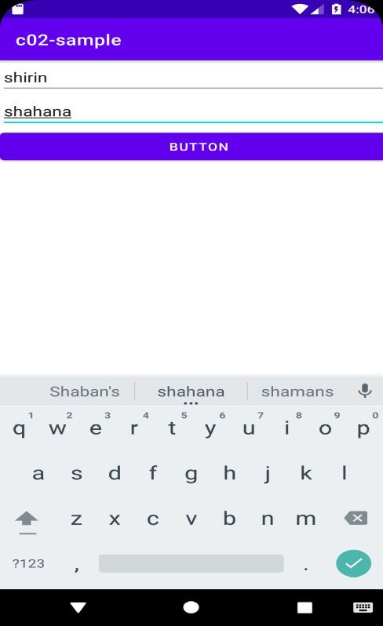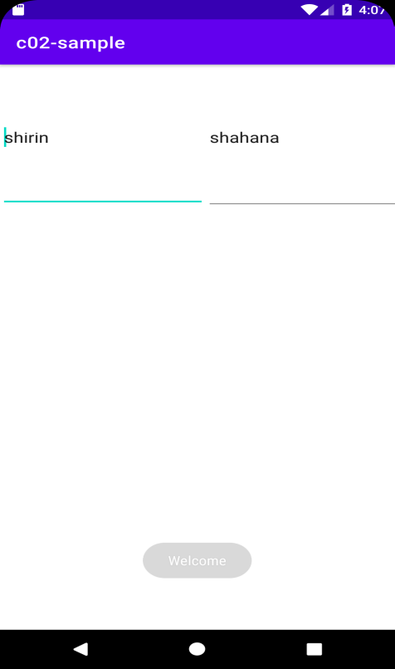

Program
shared preference

mainActivity.java

package com.example.co2_sharedpreference;
import androidx.appcompat.app.AppCompatActivity;
import android.content.Intent;
import android.content.SharedPreferences;
import android.os.Bundle;
import android.view.View;
import android.widget.Button;
import android.widget.EditText;
public class MainActivity extends AppCompatActivity {
EditText name,passwd;
Button b1;
SharedPreferences sp;
@Override
protected void onCreate(Bundle savedInstanceState) {
super.onCreate(savedInstanceState);
setContentView(R.layout.activity_main);
name=findViewById(R.id.user);
passwd=findViewById(R.id.passwd);
sp=getSharedPreferences("Login",MODE_PRIVATE);
}
public void onclick(View view) {
SharedPreferences.Editor ed=sp.edit();
ed.putString("Username",name.getText().toString());
ed.putString("Password",passwd.getText().toString());
ed.commit();
//Intent i=new Intent(MainActivity.this,MainActivity2.class);
Intent i=new Intent(MainActivity.this,MainActivity2.class);
startActivity(i);
}
}

activity_main.xml
<?xml version="1.0" encoding="utf-8"?>
<LinearLayout xmlns:android="http://schemas.android.com/apk/res/android"
xmlns:app="http://schemas.android.com/apk/res-auto"
xmlns:tools="http://schemas.android.com/tools"
android:layout_width="match_parent"
android:layout_height="match_parent"
tools:context=".MainActivity">
<LinearLayout
android:layout_width="match_parent"
android:layout_height="match_parent"
android:orientation="vertical"
android:layout_gravity="center">
<EditText
android:id="@+id/user"
android:layout_width="match_parent"
android:layout_height="wrap_content"
android:ems="10"
android:hint="User name"
android:inputType="textPersonName" />
<EditText
android:id="@+id/passwd"
android:layout_width="match_parent"
android:layout_height="84dp"
android:ems="10"
android:hint="Password"
android:inputType="textPersonName" />
<Button
android:id="@+id/button1"
android:layout_width="match_parent"
android:layout_height="wrap_content"
android:onClick="onclick"
android:text="Button" />
</LinearLayout>
</LinearLayout>

mainActivity2.java
package com.example.co2_sharedpreference;
import androidx.appcompat.app.AppCompatActivity;
import android.content.SharedPreferences;
import android.os.Bundle;
import android.widget.TextView;
public class MainActivity2 extends AppCompatActivity {
TextView t1,t2;
SharedPreferences sp;
@Override
protected void onCreate(Bundle savedInstanceState) {
super.onCreate(savedInstanceState);
setContentView(R.layout.activity_main2);
t1=findViewById(R.id.textV4);
t2=findViewById(R.id.textV6);
sp=getSharedPreferences("Login",MODE_PRIVATE);
String name=sp.getString("Username","ABC");
String passwd=sp.getString("Password","123");
t1.setText(name);
t2.setText(passwd);
}
}

activity_main2.xml
<?xml version="1.0" encoding="utf-8"?>
<LinearLayout xmlns:android="http://schemas.android.com/apk/res/android"
xmlns:app="http://schemas.android.com/apk/res-auto"
xmlns:tools="http://schemas.android.com/tools"
android:layout_width="match_parent"
android:layout_height="match_parent"
android:orientation="vertical"
tools:context=".MainActivity2">
<LinearLayout
android:layout_width="match_parent"
android:layout_height="120dp"
android:orientation="horizontal">
<TextView
android:id="@+id/textV3"
android:layout_width="wrap_content"
android:layout_height="96dp"
android:layout_weight="1"
android:text="Name" />
<TextView
android:id="@+id/textV4"
android:layout_width="wrap_content"
android:layout_height="96dp"
android:layout_weight="1" />
</LinearLayout>
<LinearLayout
android:layout_width="match_parent"
android:layout_height="143dp"
android:orientation="horizontal">
<TextView
android:id="@+id/textV5"
android:layout_width="26dp"
android:layout_height="96dp"
android:layout_weight="1"
android:text="Password" />
<TextView
android:id="@+id/textV6"
android:layout_width="wrap_content"
android:layout_height="94dp"
android:layout_weight="1" />
</LinearLayout>
</LinearLayout>

Output
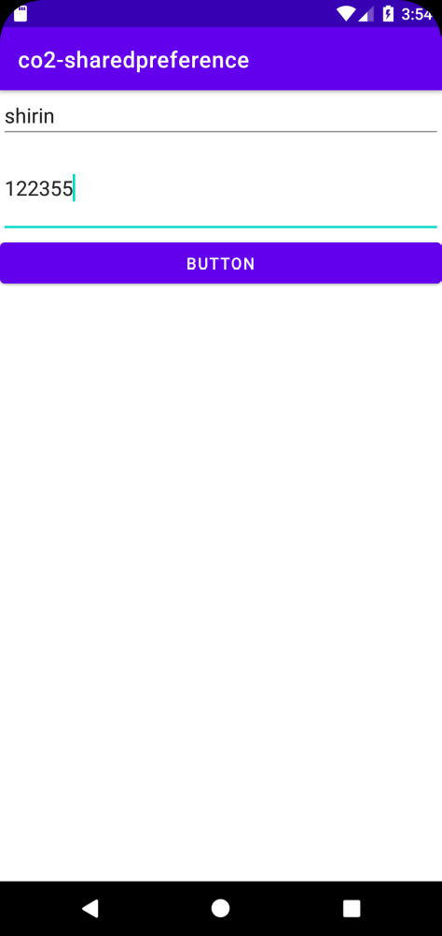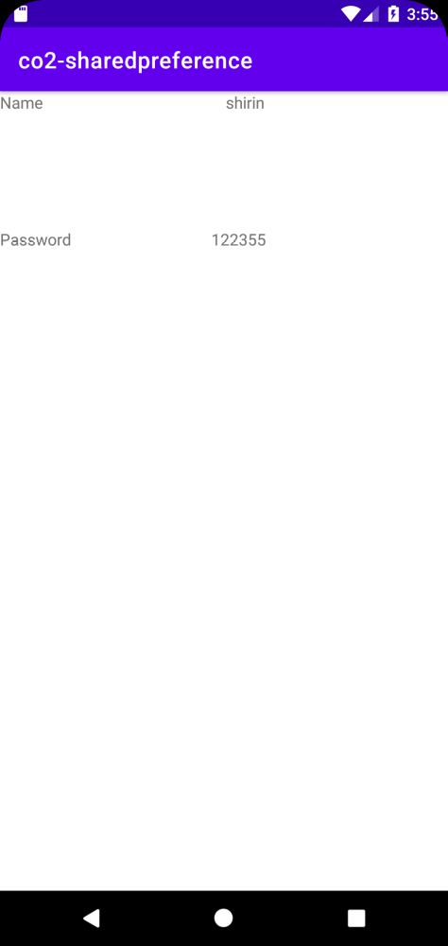

Program 2: MyApplication6
Toggle image
Main_Activity.java
package com.example.myapplication;
import androidx.appcompat.app.AppCompatActivity;
import android.os.Bundle;
import android.view.View;
import android.widget.ImageView;
public class MainActivity extends AppCompatActivity implements View.OnClickListener {
ImageView img,img1;
@Override
protected void onCreate(Bundle savedInstanceState) {
super.onCreate(savedInstanceState);
setContentView(R.layout.activity_main);
img=findViewById(R.id.img);
img1=findViewById(R.id.img1);
img.setOnClickListener(this);
img1.setOnClickListener(this);
}
public void onClick(View v) {
if(v==img){
img.setVisibility(View.GONE);
img1.setVisibility(View.VISIBLE);
}else{
img1.setVisibility(View.GONE);
img.setVisibility(View.VISIBLE);
}
}
}

Activity_main.xml
<?xml version="1.0" encoding="utf-8"?>
<FrameLayout xmlns:android="http://schemas.android.com/apk/res/android"
xmlns:app="http://schemas.android.com/apk/res-auto"
xmlns:tools="http://schemas.android.com/tools"
android:layout_width="match_parent"
android:layout_height="match_parent"
tools:context=".MainActivity">
<LinearLayout
android:layout_width="match_parent"
android:layout_height="match_parent"
android:orientation="horizontal">
<ImageView
android:id="@+id/img"
android:layout_width="166dp"
android:layout_height="168dp"
app:srcCompat="@android:drawable/btn_star_big_on" />
<ImageView
android:id="@+id/img1"
android:layout_width="160dp"
android:layout_height="166dp"
android:visibility="invisible"
app:srcCompat="@android:drawable/ic_delete" />
</LinearLayout>
</FrameLayout>
Output:
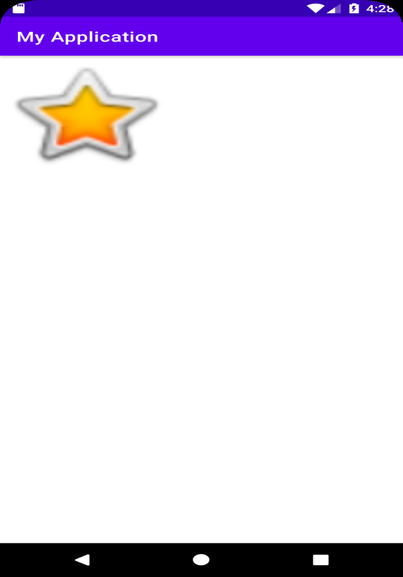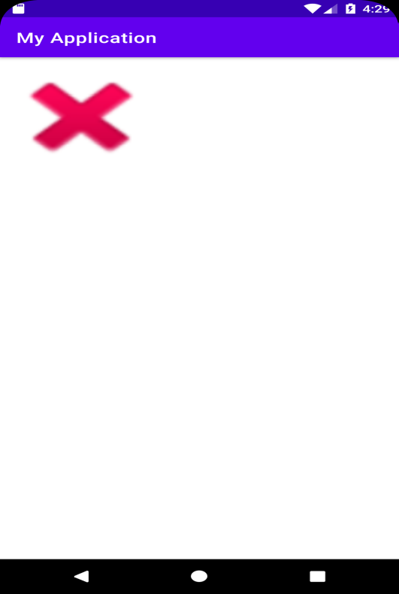

Program:
Fb_logo
Main_activity.xml
<?xml version="1.0" encoding="utf-8"?>
<RelativeLayout xmlns:android="http://schemas.android.com/apk/res/android"
xmlns:app="http://schemas.android.com/apk/res-auto"
xmlns:tools="http://schemas.android.com/tools"
android:layout_width="match_parent"
android:layout_height="match_parent"
android:background="#374DB6"
tools:context=".MainActivity">
<ImageView
android:id="@+id/imageView4"
android:layout_width="190dp"
android:layout_height="150dp"
android:layout_centerHorizontal="true"
android:layout_marginTop="100dp"
app:srcCompat="@drawable/facebook" />
<EditText
android:id="@+id/user_name"
android:layout_width="wrap_content"
android:layout_height="wrap_content"
android:layout_centerHorizontal="true"
android:layout_marginTop="280dp"
android:ems="10"
android:hint="user name or email"
android:inputType="textPersonName" />
<EditText
android:id="@+id/password"
android:layout_width="wrap_content"
android:layout_height="wrap_content"
android:layout_centerHorizontal="true"
android:layout_marginTop="320dp"
android:ems="10"
android:hint="password"
android:inputType="textPassword" />
<Button
android:id="@+id/login"
android:layout_width="121dp"
android:layout_height="59dp"
android:layout_centerHorizontal="true"
android:layout_marginTop="390dp"
android:background="#715E5E"
android:backgroundTint="@color/purple_500"
android:text="login" />
</RelativeLayout>

Mainactivity.java
package com.example.co2_3;
import androidx.appcompat.app.AppCompatActivity;
import android.os.Bundle;
public class MainActivity extends AppCompatActivity {
@Override
protected void onCreate(Bundle savedInstanceState) {
super.onCreate(savedInstanceState);
setContentView(R.layout.activity_main);
}
}

OUTPUT:
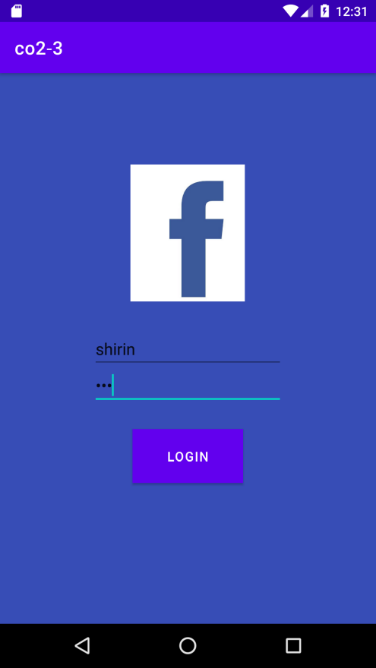

2. Implement Intent to navigate between multiple activities
Mainactivity.java
package com.example.c02_sample;
import androidx.appcompat.app.AppCompatActivity;
import android.content.Intent;
import android.os.Bundle;
import android.view.View;
import android.widget.Button;
import android.widget.EditText;
public class MainActivity extends AppCompatActivity {
EditText t1,t2;
Button b1;
@Override
protected void onCreate(Bundle savedInstanceState) {
super.onCreate(savedInstanceState);
setContentView(R.layout.activity_main);
t1=findViewById(R.id.text1);
t2=findViewById(R.id.text3);
}
public void onclick(View view) {
Intent i=new Intent(MainActivity.this,MainActivity2.class);
String val=t1.getText().toString();
String val2=t2.getText().toString();
//int n1= Integer.parseInt()
Bundle b=new Bundle();
b.putString("Name",val);
b.putString("Age",val2);
i.putExtras(b);
// int n1=Integer.parseInt(t1.getText().toString());
// i.putExtra("name",n1);
startActivity(i);
}
}

activity_main.xml

<?xml version="1.0" encoding="utf-8"?>
<LinearLayout xmlns:android="http://schemas.android.com/apk/res/android"
xmlns:app="http://schemas.android.com/apk/res-auto"
xmlns:tools="http://schemas.android.com/tools"
android:layout_width="match_parent"
android:layout_height="match_parent"
tools:context=".MainActivity">
<LinearLayout
android:layout_width="409dp"
android:layout_height="354dp"
android:orientation="vertical"
tools:layout_editor_absoluteX="1dp"
tools:layout_editor_absoluteY="1dp">
<EditText
android:id="@+id/text1"
android:layout_width="match_parent"
android:layout_height="wrap_content"
android:ems="10"
android:hint="Name"
android:inputType="textPersonName" />
<EditText
android:id="@+id/text3"
android:layout_width="match_parent"
android:layout_height="wrap_content"
android:ems="10"
android:hint="Name"
android:inputType="textPersonName" />
<Button
android:id="@+id/button"
android:layout_width="match_parent"
android:layout_height="wrap_content"
android:onClick="onclick"
android:text="Button" />
</LinearLayout>
</LinearLayout>

Mainactivity2.java

package com.example.c02_sample;
import androidx.appcompat.app.AppCompatActivity;
import android.content.Intent;
import android.os.Bundle;
import android.widget.EditText;
import android.widget.TextView;
import android.widget.Toast;
public class MainActivity2 extends AppCompatActivity {
EditText t2,t4;
@Override
protected void onCreate(Bundle savedInstanceState) {
super.onCreate(savedInstanceState);
setContentView(R.layout.activity_main2);
Toast.makeText(this, "Welcome", Toast.LENGTH_SHORT).show();
t2=findViewById(R.id.et_1);
t4=findViewById(R.id.et_2);
//Intent intent=getIntent();
//fetching values into bundle
Bundle b1=getIntent().getExtras();
//extracting string with id val
String v1 = b1.getString("Name");
String v2 = b1.getString("Age");
//String v1 = intent.getString("name");
//int v1 = intent.getIntExtra("name",112);
t2.setText(v1+"");
t4.setText(v2+"");
}
}
activity_main2.xml

<?xml version="1.0" encoding="utf-8"?>
<LinearLayout xmlns:android="http://schemas.android.com/apk/res/android"
xmlns:app="http://schemas.android.com/apk/res-auto"
xmlns:tools="http://schemas.android.com/tools"
android:layout_width="match_parent"
android:layout_height="match_parent"
tools:context=".MainActivity2">
<LinearLayout
android:layout_width="409dp"
android:layout_height="729dp"
android:orientation="horizontal"
tools:layout_editor_absoluteX="1dp"
tools:layout_editor_absoluteY="1dp">
<EditText
android:id="@+id/et_1"
android:layout_width="wrap_content"
android:layout_height="174dp"
android:layout_weight="1"
android:ems="10"
android:inputType="textPersonName" />
<EditText
android:id="@+id/et_2"
android:layout_width="wrap_content"
android:layout_height="181dp"
android:layout_weight="1"
android:ems="10"
android:inputType="textPersonName" />
</LinearLayout>
</LinearLayout>

Output:

