Program: menu driven

Main_ activity.java
package com.example.menu_option;
import androidx.appcompat.app.AppCompatActivity;
import android.content.Intent;
import android.os.Bundle;
import android.view.Menu;
import android.view.MenuInflater;
import android.view.MenuItem;
import android.widget.Toast;
public class MainActivity extends AppCompatActivity {
@Override
protected void onCreate(Bundle savedInstanceState) {
super.onCreate(savedInstanceState);
setContentView(R.layout.activity_main);
}
public boolean onCreateOptionsMenu(Menu menu)
{
MenuInflater inflater=getMenuInflater();
inflater.inflate(R.menu.sample_menu,menu);
return true;
}
public boolean onOptionsItemSelected(MenuItem item){
switch(item.getItemId()){
case R.id.item1:
//Intent i=new Intent(this,MainActivity.class);
//startActivity(i);
Toast.makeText(this,"Item 1",Toast.LENGTH_LONG).show();
break;
case R.id.item2:
Toast.makeText(this,"Item 2",Toast.LENGTH_LONG).show();
}
return true;
}
}

Activity_main.xml
<?xml version="1.0" encoding="utf-8"?>
<androidx.constraintlayout.widget.ConstraintLayout xmlns:android="http://schemas.android.com/apk/res/android"
xmlns:app="http://schemas.android.com/apk/res-auto"
xmlns:tools="http://schemas.android.com/tools"
android:layout_width="match_parent"
android:layout_height="match_parent"
tools:context=".MainActivity">
<TextView
android:layout_width="wrap_content"
android:layout_height="wrap_content"
android:text="Hello World!"
app:layout_constraintBottom_toBottomOf="parent"
app:layout_constraintEnd_toEndOf="parent"
app:layout_constraintStart_toStartOf="parent"
app:layout_constraintTop_toTopOf="parent" />
</androidx.constraintlayout.widget.ConstraintLayout>

Sample_menu.xml
<?xml version="1.0" encoding="utf-8"?>
<menu xmlns:app="http://schemas.android.com/apk/res-auto"
xmlns:android="http://schemas.android.com/apk/res/android">
<item
android:id="@+id/item1"
android:title="Item1">
<menu>
<item
android:id="@+id/subitem1"
android:title="sub1"
/>
<item
android:id="@+id/subitem2"
android:title="sub2"/>
</menu>
</item>
<item
android:id="@+id/item2"
android:title="Item2" />
<item
android:id="@+id/item3"
android:title="Item3" />
</menu>

OUTPUT:
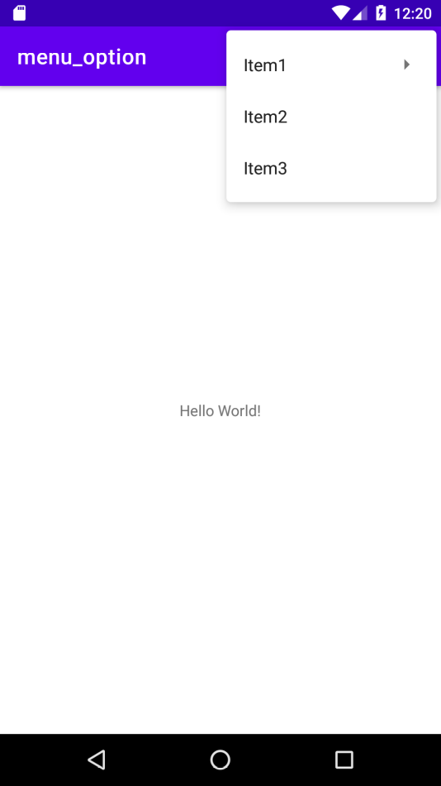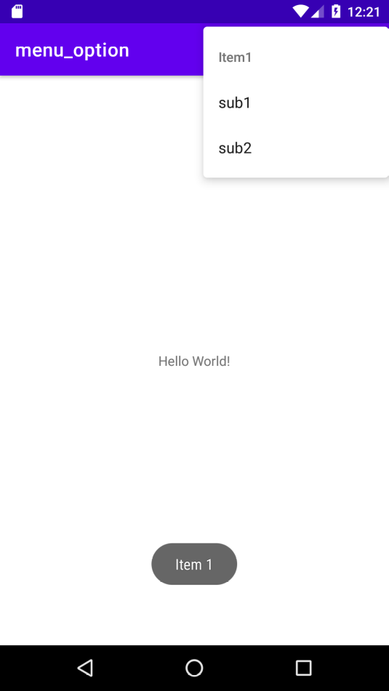

Program: Relative Layout
Activity_main.xml
<?xml version="1.0" encoding="utf-8"?>
<RelativeLayout xmlns:android="http://schemas.android.com/apk/res/android"
xmlns:app="http://schemas.android.com/apk/res-auto"
xmlns:tools="http://schemas.android.com/tools"
android:layout_width="match_parent"
android:layout_height="match_parent"
android:background="#374DB6"
tools:context=".MainActivity">
<ImageView
android:id="@+id/imageView4"
android:layout_width="190dp"
android:layout_height="150dp"
android:layout_centerHorizontal="true"
android:layout_marginTop="100dp"
app:srcCompat="@drawable/facebook" />
<EditText
android:id="@+id/user_name"
android:layout_width="wrap_content"
android:layout_height="wrap_content"
android:layout_centerHorizontal="true"
android:layout_marginTop="280dp"
android:ems="10"
android:hint="user name or email"
android:inputType="textPersonName" />
<EditText
android:id="@+id/password"
android:layout_width="wrap_content"
android:layout_height="wrap_content"
android:layout_centerHorizontal="true"
android:layout_marginTop="320dp"
android:ems="10"
android:hint="password"
android:inputType="textPassword" />
<Button
android:id="@+id/login"
android:layout_width="121dp"
android:layout_height="59dp"
android:layout_centerHorizontal="true"
android:layout_marginTop="390dp"
android:background="#715E5E"
android:backgroundTint="@color/purple_500"
android:text="login" />
</RelativeLayout>

mainActivity.java
package com.example.co2_3;
import androidx.appcompat.app.AppCompatActivity;
import android.os.Bundle;
public class MainActivity extends AppCompatActivity {
@Override
protected void onCreate(Bundle savedInstanceState) {
super.onCreate(savedInstanceState);
setContentView(R.layout.activity_main);
}
}

output:

