2.leap year

s=int(input("Enter starting year"))

e=int(input("Enter ending year"))

if(s<e):

print("leap years are",end=" ")

for i in range(s,e):

if(i%4==0 and i%100!=0 or i%400==0 and i%100==0):

print(i,end=" ")

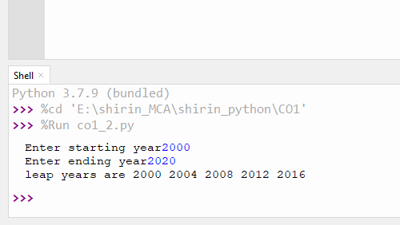

3. .**List comprehensions:**

**3.a Generate positive list of numbers from a given list of integers**

for i in [-1,2,3,-87,8,87,-9]:

if(i>0):

print(i)

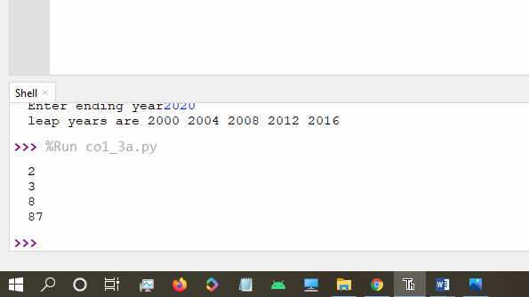

3.b **Square of N number**

n=int(input("Enter limit"))

i=1

print("squares of n numbers")

while(i<=n):

print(i*i,end=" ")

i=i+1

output:

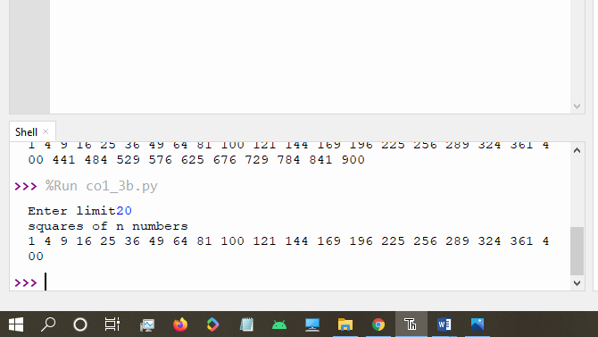

3.c **Form a list of vowels selected from a given word**

word=input("Enter word")

print("The original values of character:")

for i in word:

print(i,end=":")

print(ord(i))

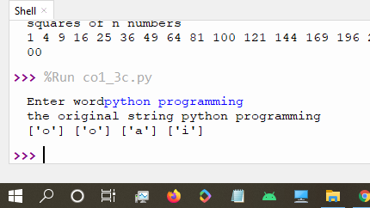

3.d **List ordinal value of each element of a word (Hint: use ord() to get ordinal values)**

word=input("Enter word")

print("The original values of character:")

for i in word:

print(i,end=":")

print(ord(i))

output:

>>> %Run co1_3d.py

Enter wordpython

The original values of character:

p:112

y:121

t:116

h:104

o:111

n:110

>>>

4. .**Count the occurrences of each word in a line of text.**

str1 = input("Enter a string : ")

wordlist = str1.split()

count= []

for w in wordlist: count.append(wordlist.count(w))

print("count of the occurrence:" + str(list(zip(wordlist, count))))

output:

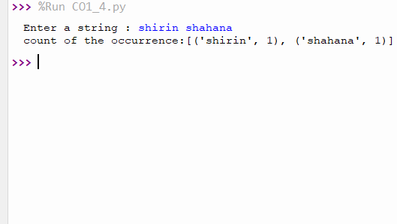

5. **Prompt the user for a list of integers. For all values greater than 100, store ‘over’ instead**

n=[]

s=int(input("Enter a limit"))

print("Enter values")

i=0

while(i<s):

num=input("value:")

n.append(int(num))

i=i+1

print("\n the list after assigning:\n")

i=0

while(i<len(n)):

if(n[i]>100):

print("over")

else:

print(n[i])

i=i+1

6.Store a list of first names. Count the occurrences of ‘a’ within the list

list1=['a','b','s','a']

occ=list1.count('a')

print("count=",occ)

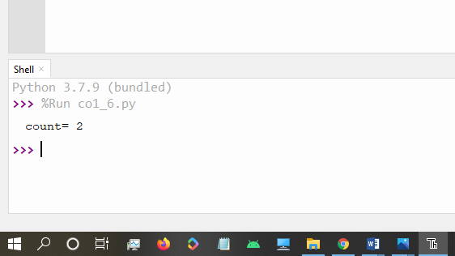

7.Enter 2 lists of integers. Check (a) Whether list are of same length (b) whether list sums to same value (c) whether any value occur in both

lst=[1,3,5,7,9,11,34]

lst1=[5,13,45,7,20,65,1]

s=int(0)

c=int(0)

if(len(lst)==len(lst1)):

print("List are of same length")

else:

print("list have different length")

for i in range(0,len(lst) and len(lst1)):

s=s+lst[i]

c=c+lst1[i]

if(s==c):

print("equal sum")

else:

print("not same sum")

print("Elements that matched are:")

l=[]

for i in range(0,len(lst)):

for j in range(0,len(lst1)):

if lst[i]==lst1[j]:

l.append(lst[i] and lst1[j])

else:

continue

print(l)

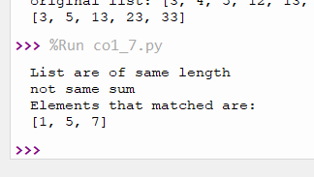

8. .Get a string from an input string where all occurrences of first character replaced with ‘$’, except first character. [eg: onion -> oni$n]

str='onion'

char=str[0]

str=str.replace(char,'$')

print(char+str[1:])

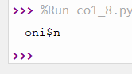

9.Create a string from given string where first and last characters exchanged. [eg: python -> nythop]

str=input("Enter a string")

print(str[-1]+str[1:-1]+str[0])

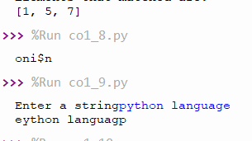

10.Accept the radius from user and find area of circle.

p=3.14

rad=float(input("Enter radius"))

area=p*rad*rad

print("area of circle",area)

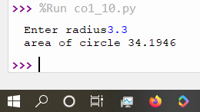

11. . Find biggest of 3 numbers entered

#biggest of 3 numbers

a=int(input("Enter first number"))

b=int(input("Enter second numbers"))

c=int(input("Enter third number"))

if(a>b and a>c):

print(a,"is largest")

elif(b>c):

print(b,"is largest")

else:

print(c,"is largest")

output:

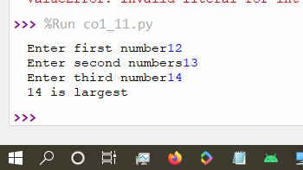

12..Accept a file name from user and print extension of **that**

file=input("Enter filename:")

f=file.split(".")

print("extension of the file is "+f[-1])

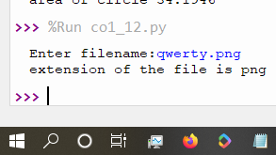

13. Create a list of colors from comma-separated color names entered by user.Display first and last colors.

a=[]

n=int(input("Enter limit"))

for i in range(0,n):

b=input("Enter the color:")

a.append(b)

print(a)

print(a[0])

print(a[n-1])

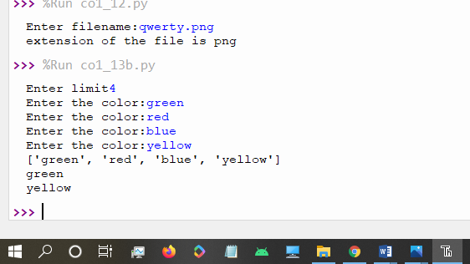

14.Accept an integer n and compute n+nn+nnn

n=int(input("Enter a number:"))

x=int("%s"%n)

y=int("%s%s"%(n,n))

z=int("%s%s%s"%(n,n,n))

print("n+nn+nnn",x+y+z)

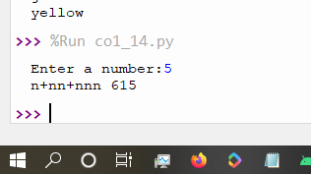

15..Print out all colors from color-list1 not contained in color-list2.

color_list_1=set(["White","pink","blue"])

color_list_2=set(["red","green","pink"])

print(color_list_1.difference(color_list_2))

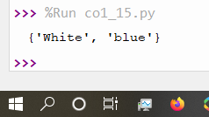

16. Create a single string separated with space from two strings by swapping the character at position 1

a="programming"

b="lab"

#r1=a[0]

#r2=b[0]

print(b[0]+a[1:]+" "+a[0]+b[1:])

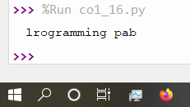

17.Sort dictionary in ascending and descending order**.**

#sort dictionary in ascending order

import operator

d={1:2,3:4,4:3,2:1,0:0}

print("original dictionary:",d)

sorted_d = sorted(d.items(), key=operator.itemgetter(1))

print('Dictionary in ascending order by value ',sorted_d)

sorted_d = dict( sorted(d.items(),key=operator.itemgetter(1),reverse=True))

print('Dictionary in descending order by value : ',sorted_d)

output:

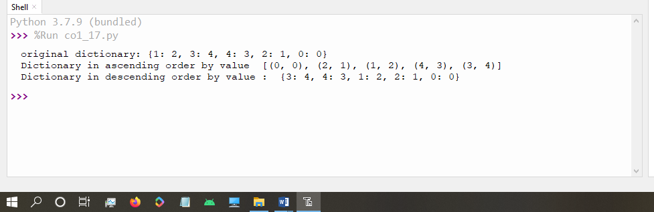

18.Merge two dictionaries

#merge 2 dictionaries

d1 ={ 'a': 100, 'b': 200}

d2 ={'x' : 300, 'y': 200}

print ("Dict ionary 1=:", d1)

print ("Dictionary 2-: ", d2)

d1.update(d2)

print("Merged Dictionary:",d1)

output:

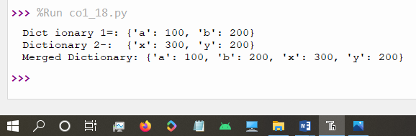

19.Find gcd of 2 numbers

#gcd

a=int(input("Enter 1st number"))

b=int(input("Enter 2nd number"))

i=1

while(i<=a and i<=b):

if(a%i==0 and b%i==0):

gcd=i

i=i+1

print("GCD:",gcd)

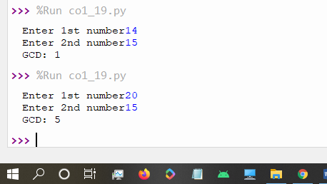

20. From a list of integers, create a list removing even numbers

#removing even numbers

num=[3,4,5,12,13,23,33]

n=[]

print("original list:",num)

for i in num:

if(i%2!=0):

n.append(i)

print(n)

