1.Program to find the factorial of a number

#factorial

n=int(input("Enter number"))

f=1

for i in range(1,n+1):

f=f*i

print("factorial of",n,"is",f)

output:

> %Run co2_1.py

Enter number5

factorial of 5 is 120

>>>

# 2. Pgrm 2

Generate Fibonacci series of N terms

#fibonacci series

n=int(input("Enter limit"))

a=0

b=1

sum=0

print("Fibonacci series:",end=" ")

i=1

while(i<=n):

print(sum,end=" ")

a=b

b=sum

sum=a+b

i=i+1

output:

%Run co2_2.py

Enter limit5

Fibonacci series: 0 1 1 2 3

3. Find the sum of all items in a list

#small of all items in alist

list1=[10,15,20,25,30]

total=sum(list1)

print("sum of list:",total)

output

%Run co2_3.py

sum of list: 100

>>>

4.Display the given pyramid with step number accepted from user.

from math import sqrt as s

for i in range(1000,10000):

if s(i)==int(s(i)) and i%2==0:

print(i,end=" ")

output:

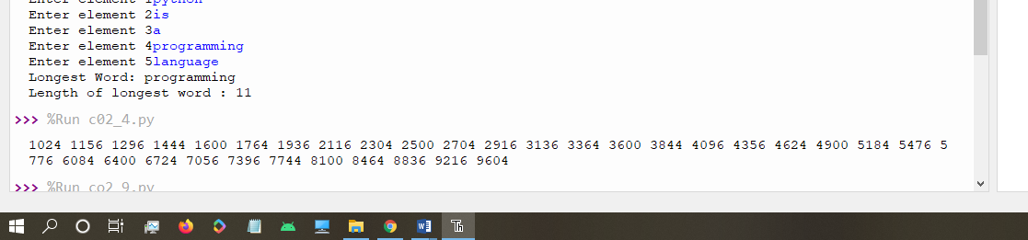

5.Count the number of characters (character frequency) in a string.

#display pyramid

rows=int(input("Enter the number of rows"))

for i in range(1,rows+1):

for j in range(1,i+1):

print(i*j,end=' ')

print()

output:

> %Run co2_5.py

Enter the number of rows6

1

2 4

3 6 9

4 8 12 16

5 10 15 20 25

6 12 18 24 30 36

>>>

6.Count the number of characters (character frequency) in a string.

test_str=str(input("Enter the string : "))

freq = {}

for i in test_str:

if i in freq:

freq[i] += 1

else:

freq[i] = 1

print ("Count of all characters : "+ str(freq))

output:

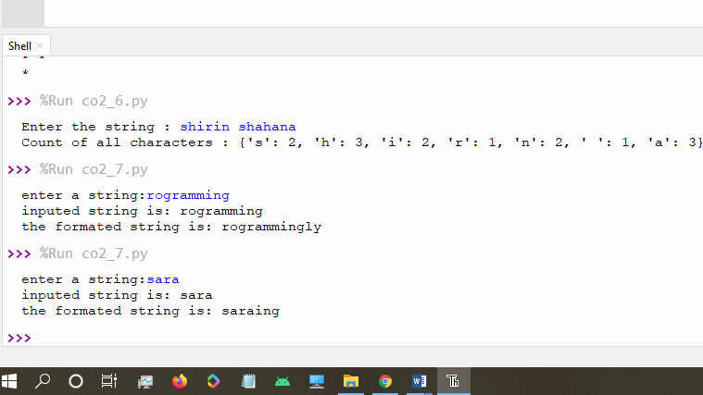

7.Add ‘ing’ at the end of a given string. If it already ends with ‘ing’, then add ‘ly’

str=input("enter a string:")

print("inputed string is:",str)

if(str.endswith("ing")):

str=str+'ly'

else:

str=str+'ing'

print("the formated string is:",str)

output:

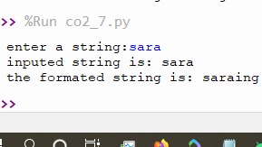

8.Accept a list of words and return length of longest word.

#accept a list of word and return length of longest word

a=[]

n= int(input("Enter the number of elements in list:"))

for x in range(0,n):

element=input("Enter element "+ str(x+1) )

a.append(element)

max1=len(a[0])

temp=a[0]

for i in a:

if(len(i)>max1):

max1=len(i)

temp=i

print("Longest Word:",temp)

print("Length of longest word :",max1)

output:

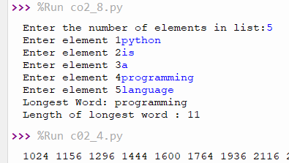

9. Construct following pattern using nested loop

#construct a pattern

n= int(input("Enter the limit:"))

for i in range(n):

for j in range(i):

print ('* ', end="")

print('')

for i in range(n,0,-1):

for j in range(i):

print('* ', end="")

print('')

output:

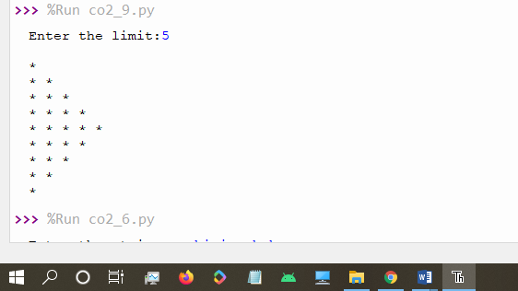

10.Generate all factors of a number. def print_factors(x):

#generate factors of a number: def print_factors(x):

def print_factors(n):

for i in range(1,n+1):

if(n%i==0):

print(i)

n=int(input("Enter a number:"))

print_factors(n)

output:

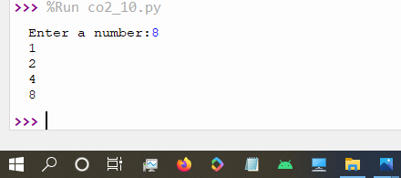

11. lambda function to find area of square,rectangle and triangle

s_area=lambda a:a*a

r_area=lambda a,b:a*b

t_area=lambda b,h:1/2*b*h

print("Area of square:",s_area(10))

print("Area of rectangle",r_area(10,20))

print("Area of triangle:",t_area(5,3))

output:

