1. **COURSE OUTCOME 5(CO5) PROGRAM NO: 1 DATE:20/11/2020**

**AIM: Write a Python program to read a file line by line and store it into a list.**

f1=open("firstfile.txt","w")

f1.write("This is my first file in python.\nWant to work with files.\n This is my third")

f1.close()

f1=open("firstfile.txt","r")

f1.seek(0,0)

ff=f1.readlines()

for x in range(0,len(ff)):

print(ff[x])

print()

print(ff)

f1.close()

**OUTPUT:**

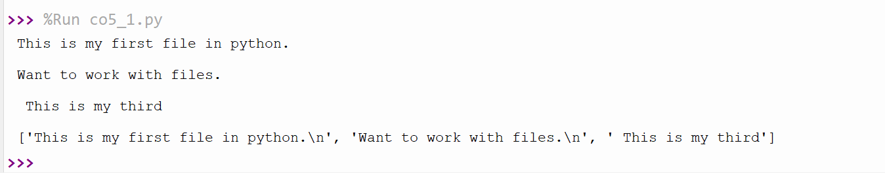

1. **COURSE OUTCOME 5(CO5) PROGRAM NO: 2 DATE:20/11/2020**

**AIM : Python program to copy odd lines of one file to other**

f1=open("firstfile.txt","r")

for x in f1:

print(x)

f1.seek(0,0)

print()

f2=open("odd.txt","w")

ff=f1.readlines()

with open('odd.txt','w') as f2:

for x in range(0,len(ff)):

if(x%2!=0):

print(ff[x])

f2.write(ff[x])

**OUTPUT:**

