INTRODUCTION
In this paper I solve problems in quantitative genetics and population genetics from Benjamin Pierce's Genetics: A Conceptual Approach Fourth ed. (New York: Freeman, 2012) using the R statistical package, covering every relevant problem in chapters 24 and 25. R is a powerful open-source software program with user-designed packages, also known as as “libraries” of functions, for just about every purpose, including genetics. Although chapter 24 bears the title “Quantitative Genetics” and chapter 25 “Population Genetics,” problems from both are quantitative in nature. Nonetheless, I will follow Pierce’s convention in my word usage.
There are five datasets in chapter 24, and the problems associated with them can be solved using functions in base R. Chapter 25 problems require R add-on packages. I solve all problems in chapter 25 that consist of two alleles at each locus, using functions in the HardyWeinberg package, which can handle loci with two allele possibilities. The last relevant problem in the chapter has three alleles at the locus. Fortunately, the R genetics package, can handle multiple alleles at each loci. So I use that for the problem.
For chapter 24 problems, I reproduce each problem in its entirety before I answer them. For chapter 25, since each problem consists of analyzing genotype counts, I merely list the counts without repeating the problem verbatim.
Finally, Chapter 26, “Evolutionary Genetics,” covers phylogenetic trees, which can also be constructed in R, but due to time constraints I do not cover it.

QUANTITATIVE GENETICS

24.21 The following data are the numbers of digits per foot in 25 guinea pigs. Construct a frequency distribution for these data.
4,4,4,5,3,4,3,4,4,5,4,4,3,2,4,4,5,6,4,4,3,4,4,4,5

Answer: Based on the presentation on page 665, by “frequency distribution” Pierce means a histogram. And this procedure can be done with the hist() function in R. I created a vector called “digits” and graphed the histogram. The argument main denotes the title of the graph. The other arguments inside the function are self-explanatory.

> digits<-c(4,4,4,5,3,4,3,4,4,5,4,4,3,2,4,4,5,6,4,4,3,4,4,4,5)
> hist(digits,col="red",main="Frequency Distribution of Digits per Foot of Guinea Pigs")
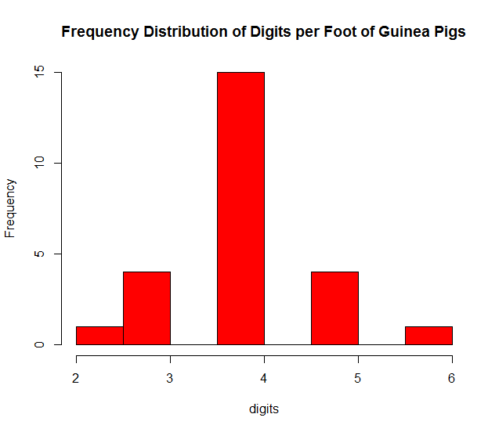
24.22 Ten male Harvard students were weighed in 1916. Their weights are given here in kilograms. Calculate the mean, variance, and standard deviation for these weights.

51,69,69,57,61,57,75,105,69,63
Answer: The problem asks for summary statistics for the set: mean, variance, and standard deviation. R has parsimonious functions to return those numbers.. The answers are in bold.

> weight<-c(51,69,69,57,61,57,75,105,69,63)
> mean(weight)
[1] 67.6
> var(weight)
[1] 224.9333
> sd(weight)
[1] 14.99778

24.25 Body weight and length were measured on six mosquito fish; these measurements are given in the following table. Calculate the correlation coefficient for weight and length in these fish.

Wet Weight (g) | Length (mm)
115 | 18
130 | 19
210 | 22
110 | 17
140 | 20
185 | 21

Answer: The correlation coefficient is easily calculated in base R Just create vectors for wet weight and length, then use R's cor() function. The graph of one variable on another is done with plot(). The answer is in bold. I then plot on variable on another, then draw a best-fit line with R's abline() function.

> wetweight<-c(115,130,210,110,140,185)
> length<-c(18,19,22,17,20,21)
> cor(wetweight,length)
[1] 0.9542215
> plot(wetweight,length,main='Mosquito Fish Dimensions',xlab='Wet Weight (g)',ylab='Length (mm)',pch=19,col='blue')
> abline(lm(length~wetweight),col="red",lwd=2)
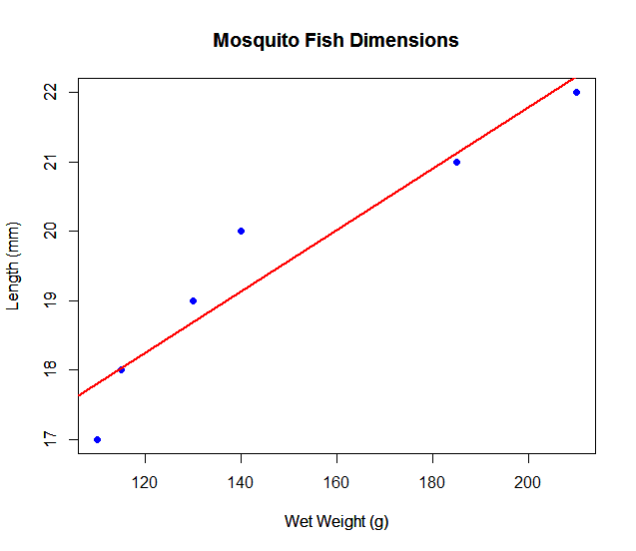

24.26 The heights of mothers and daughters are given in the following table. (a) Calculate the correlation coefficient for the heights of the mothers and daughters. (b) Using regression, predict the expected height of a daughter whose mother is 67 inches tall.

Height of Mother (in) | Height of Daughter (in)
64 | 66
65 | 66
66 | 68
64 | 65
63 | 65
63 | 62
59 | 62
62 | 64
61 | 63
60 | 62

Answer: The correlation coefficient is can be computed through the cor() function, regression through the lm() function. The expected height of the daughter would just be the intercept + (regression coefficient)*(mother’s height). The correlation coefficient obtained is inconsistent with the answer given in the back of the book. But I am confident in my answer, as I've triangulated with both the cor() function the square-root of the R-squared value, and the formula given on equation 24.7 on page 668.

> htmother<-c(64,65,66,64,63,63,59,62,61,60)
> htdaughter<-c(66,66,68,65,65,62,62,64,63,62)
> cor(htmother,htdaughter)
[1] 0.8758156
> summary(heightreg<-lm(htdaughter~htmother))

Call:
lm(formula = htdaughter ~ htmother)

Coefficients:
Estimate Std. Error t value Pr(>|t|)
(Intercept) 13.2585 9.9503 1.332 0.219410
htmother 0.8141 0.1586 5.133 0.000893 ***
---
Signif. codes: 0 ‘***’ 0.001 ‘**’ 0.01 ‘*’ 0.05 ‘.’ 0.1 ‘ ’ 1

Residual standard error: 1.053 on 8 degrees of freedom
Multiple R-squared: 0.7671, Adjusted R-squared: 0.7379
F-statistic: 26.34 on 1 and 8 DF, p-value: 0.0008933

> 13.2585+.8141*67
[1] 67.8032
> plot(htmother,htdaughter,pch=19,col='blue',xlab='Height of mother (in)',ylab='Height of daughter (in)',main="Mother's Heights vs. Daughter's Height")
> abline(heightreg,col='red',lwd=2)
> sqrt(.7671)
[1] 0.8758425
> sd(htmother)
[1] 2.213594
> cov(htmother,htdaughter)/sd(htmother)/sd(htdaughter)
[1] 0.8758156
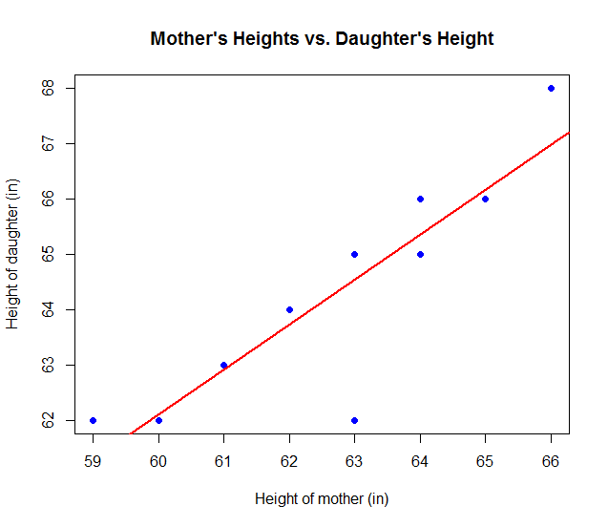
24.35 The length of the middle joint of the right index finger was measured on 10 sets of parents and their adult offspring. The mean parental lengths and the mean offspring lengths for each family are listed in the following table. Calculate the regression coefficient for regression of means offspring length against mean parental length and estimate the narrow-sense heritability for this characteristic.

Mean Parental Length | Mean offspring Length
30 | 31
35 | 36
28 | 31
33 | 35
26 | 27
32 | 30
31 | 34
29 | 28
40 | 38
33 | 34

Answer: The narrow-sense heritability is the regression coefficient for parental and is bolded in the code below.

> regcoeff<-lm(offspring~parental)
> summary(regcoeff)

Call:
lm(formula = offspring ~ parental)

Residuals:
Min 1Q Median 3Q Max
-2.6403 -0.9941 0.2602 1.4085 2.1606

Coefficients:
Estimate Std. Error t value Pr(>|t|)
(Intercept) 7.0128 4.7236 1.485 0.175937
parental 0.8009 0.1480 5.412 0.000637 ***
---
Signif. codes: 0 ‘***’ 0.001 ‘**’ 0.01 ‘*’ 0.05 ‘.’ 0.1 ‘ ’ 1

Residual standard error: 1.752 on 8 degrees of freedom
Multiple R-squared: 0.7855, Adjusted R-squared: 0.7586 F-statistic: 29.29 on 1 and 8 DF, p-value: 0.0006369

> plot(parental,offspring,pch=19,col='blue',main='Length of Middle Joint of Right Index Finger (mm)',xlab='Mean Parental Length',ylab='Mean Offspring Length')
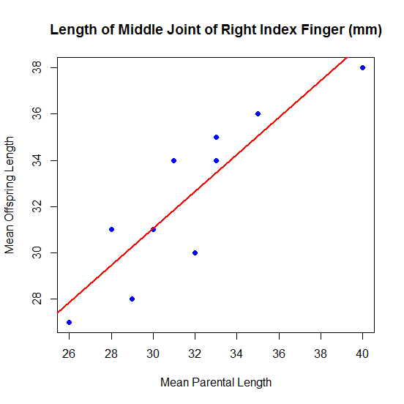
> abline(regcoeff,col='red',lwd=2)

POPULATION GENETICS

25.16 The problem asks for the genotypic and allelic frequencies for the given genotype counts:

T^{e}T^{e} | T^{e}T^{F} | T^{F}T^{F}
407 | 170 | 17

Answer: Finding the genotypic frequencies requires simple arithmetic. For allelic frequencies, the R HardyWeinberg package has the af() function that enables us to compute it handily once the genotypic frequencies are provided. The following code generates genotypic frequencies:

> library(HardyWeinberg)
> EE<-407
> EF<-170
> FF<-17
> TeTe<-EE/(EE+EF+FF)
> TeTf<-EF/(EE+EF+FF)
> TfTf<-FF/(EE+EF+FF)
> TeTe
[1] 0.6851852
> TeTf
[1] 0.2861953
> TfTf
[1] 0.02861953

Allelic frequencies with the af() function:

> Te<-af(c(TeTe,TeTf,TfTf))
> Te
[1] 0.8282828
> Tf<-1-Te
> Tf
[1] 0.1717172

25.17 The problem asks for the genotypic and allelic frequencies for the given genotype counts:

Genotype | Number
S¹S¹ | 4
S¹S² | 38
S²S² | 134

Answer: As with the previous problem, genotypic frequencies can be calculated with simple arithmetic, allelic frequencies with the af() function. In the code, I denote genotype counts with lower case letters and genotypic frequencies with upper case letters. The genotypic frequencies:

> s1s1<-4
> s1s2<-38
> s2s2<-134
> S1S1<-s1s1/(s1s1+s1s2+s2s2)
> S1S2<-s1s2/(s1s1+s1s2+s2s2)
> S2S2<-s2s2/(s1s1+s1s2+s2s2)
> S1S1
[1] 0.02272727
> S1S2
[1] 0.2159091
> S2S2
[1] 0.7613636

For allelic frequencies:

> S1<-af(c(S1S1,S1S2,S2S2))
> S1
[1] 0.1306818
> S2<-1-S1
> S2
[1] 0.8693182

25.18: The problem asks for the allelic frequencies for the following X-linked allele genotype counts.

Genotype | Number
X^{O}X^{O} females | 11
X^{O}X⁺ female | 70
X⁺X⁺ females | 94
X^{O}Y males | 36
X⁺Y males | 112

Answer: The method for obtaining frequencies for genotypes of this nature is found on Table 25.1 on page 699. First we get the genotype frequencies, then we use the af() function to return the allelic frequencies. Again, I use lower case for the genotype counts in the code, caps for the genotype frequencies.

> xoxo<-11
> xoxp<-70
> xpxp<-94
> xoy<-36
> xpy<-112
> XOXO<-xoxo/(xoxo+xoxp+xpxp+xoy+xpy)
> XOXP<-xoxp/(xoxo+xoxp+xpxp+xoy+xpy)
> XOY<-xoy/(xoxo+xoxp+xpxp+xoy+xpy)
> XPY<-xpy/(xoxo+xoxp+xpxp+xoy+xpy)
> XOXO+XOXP+XPXP+XOY+XPY
> XPXP<-xpxp/(xoxo+xoxp+xpxp+xoy+xpy)
> XOXO+XOXP+XPXP+XOY+XPY
[1] 1

To obtain the following allelic frequencies:

Allele | Frequency
X^{O} | 0.14
X⁺ | 0.86

> p<-af(c(XOXO,XOXP,XPXP,XOY,XPY))
> p
[1] 0.1424149
> q<-1-p
> q
[1] 0.8575851
>

25.19 The problem asks to perform a chi-squared test on whether the following genotype count is in Hardy-Weinberg Equilibrium.

Blood Type | Number
M | 1787
MN | 3039
N | 1310

Answer: This can be done with the HWChisq function. Results show no deviation from the Equilibrium.

> m<-1787
> mn<-3039
> n<-1303
> HWChisq(c(m,mn,n),cc=0,verbose=TRUE)
Chi-square test for Hardy-Weinberg equilibrium
Chi2 = 0.02698008 p-value = 0.8695295 D = -3.194771 f = 0.002098103
$chisq
[1] 0.02698008

$pval
[1] 0.8695295

$D
[1] -3.194771

$p
[1] 0.4605156

$f
[1] 0.002098103

25.20 The problem asks for (a) the A and G allele frequencies, (b) the expected genotypic frequencies if the population is in Hardy-Weinberg Equilibrium, and (c) a test of whether the population is indeed in the Equilibrium.

Genotype | Number
AA | 42
AG | 24
GG | 21

Answer: (a) To compute the allele frequencies, I first compute the genotype frequencies, then create a vector with those frequencies inside the af() function.

Allele | Frequency
A | 0.62
G | 0.38

> aa<-42
> ag<-24
> gg<-21
> AA<-42
> AA<-aa/(aa+ag+gg)
> AG<-ag/(aa+ag+gg)
> GG<-gg/(aa+ag+gg)
> p<-af(c(AA,AG,GG))
> p #Allele A
[1] 0.6206897
> q<-1-p
> q #Allele G
[1] 0.3793103

(b) For the expected genotype frequencies, I apply the Hardy-Weinberg Equation and get the following:

Genotype | Formula | Expected Frequency
AA | p² | 0.39
AG | 2pq | 0.47
GG | q² | 0.14

> p^2
[1] 0.3852556
> 2*p*q
[1] 0.470868
> q^2
[1] 0.1438763

(c) And to test whether the population is in Hardy-Weinberg Equilibrium, I use the HWChisq function to find out that the population has deviated from the Equilibrium.

> HWChisq(c(aa,ag,gg),cc=0,verbose=1)
Chi-square test for Hardy-Weinberg equilibrium
Chi2 = 14.92164 p-value = 0.00011207 D = -8.482759 f = 0.4141414
$chisq
[1] 14.92164

$pval
[1] 0.00011207

$D
[1] -8.482759

$p
[1] 0.3793103

$f
[1] 0.4141414

25.21 The problem asks to for (a) the genotypic and allelic frequencies for a leopard frog population with the following genotype counts, (b) The expected number of genotypes if the population were in Hardy-Weinberg equilibrium. For good measure, (c) I will also test whether the population is in Hardy-Weinberg equilibrium.

Genotype | Number
M¹M¹ | 20
M¹M² | 45
M²M² | 42
M¹M³ | 4
M²M³ | 8
M³M³ | 6

Answer: The HardyWeinberg package cannot handle loci with more than two allelic possibilities. One must install and load the R genetics library.

> library(genetics)
Loading required package: combinat

After the load, I create a vector with each genotype, with a “/” separating the two alleles in each genotype.

> x<-c(rep("m1/m1",20),rep("m1/m2",45),rep("m2/m2",42),rep("m1/m3",4),rep("m2/m3",8),rep("m3/m3",6))

Then I apply the genotype() function to the vector to read it into genotypes in an object called m, then use the table() funtion to ensure the genotypes have the correct counts. Afterwards, I use the summary() function to get allelic and genotypic frequencies. The answers are in bold.

> m<-genotype(x)
> table(m)
m
m1/m1 m1/m3 m2/m1 m2/m2 m2/m3 m3/m3
20 4 45 42 8 6
> summary(m)

Number of samples typed: 125 (100%)

Allele Frequency: (3 alleles)
Count Proportion
m2 137 0.55
m1 89 0.36
m3 24 0.10

Genotype Frequency:
Count Proportion
m2/m2 42 0.34
m2/m1 45 0.36
m2/m3 8 0.06
m1/m1 20 0.16
m1/m3 4 0.03
m3/m3 6 0.05

Heterozygosity (Hu) = 0.566008
Poly. Inf. Content = 0.4797541

(b) To compute expected genotypic frequencies under Hardy-Weinberg Equilibrium, I use Table 25.1 on page 699.

> m1^2*125
[1] 16.2
> 2*m1*m2*125
[1] 49.5
> m2^2*125
[1] 37.8125
> 2*m2*m3*125
[1] 13.75
> m3^2*125
[1] 1.25
> m1*m3*125
[1] 4.5

M¹M¹ | 16
M¹M² | 50
M²M² | 38
M¹M³ | 5
M²M³ | 14
M³M³ | 1

(c) The chi-squared test reveals with a near-certain probability that the population deviates from Hardy-Weinberg Equilibrium.

> HWE.chisq(m)

Pearson's Chi-squared test with simulated p-value (based on 10000
replicates)

data: tab
X-squared = 26.7503, df = NA, p-value = 9.999e-05

