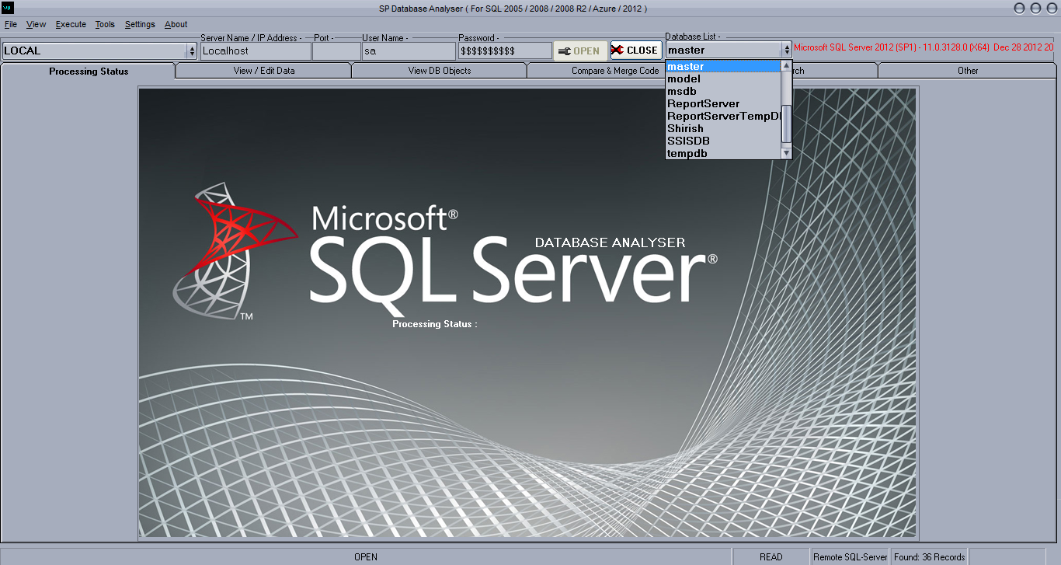

**SP Database Analyser   
*( For SQL Server 2000 / 2005 / 2008 / 2008 R2 / Azure / 2012 / 2014 )***

**Revision History**

|  |  |  |  |
| --- | --- | --- | --- |
| **Date** | **Author** | **Version\*** | **Description** |
| 02/26/2007 | Shirish Patel | 1.0 | Initial version |
| 06/16/2013 | Shirish Patel | 2.0 | Added new menus :-  How old are the index usage stats?  Index usage  Identify indexes that have never been accessed  Identify indexes that are being maintained but not used  Potentially inefficient non-clustered indexes (writes > reads)  Detailed activity information for indexes not used for user reads  Identify locking and blocking at the row level  Identify latch waits of over 15 milliseconds  Identify lock escalations  Identify indexes associated with lock contention  Finding the most beneficial missing indexes |
| 08/24/2013 | Shirish Patel | 3.0 | Added new menus :- 🡪 Execute Get all db objects in the database Get all cross database dependencies Get all dependencies in the database Get all Foreign Key relationships in database  Get all tables with NO Foreign Key relationships in database  Get all Foreign Key relationships in database with entire table and column details  Get all Input/Output Parameters of all UDF and SP  How old are the index usage stats?  Index usage  Index fragmentation details  Identify indexes that have never been accessed  Identify indexes that are being maintained but not used  Potentially inefficient non-clustered indexes (writes > reads)  Detailed activity information for indexes not used for user reads  Identify locking and blocking at the row level  Identify latch waits of over 15 milliseconds  Identify lock escalations  Identify indexes associated with lock contention  Finding the most beneficial missing indexes 🡪 Tools Import Flat File to DB |
| 01/29/2015 | Shirish Patel | 4.0 | Added new menus :-  Tools 🡪 Express Profiler  Execute 🡪 SQL Server 2014 🡪  List of all COLUMNSTORE Index Segment creation details List of all the Memory Optimized Tables List of database bound to a resource pool  Execute 🡪 Tests & Analysis List all heap tables List of all triggers and status List of all disabled indexes  Execute 🡪 CLR Functions |

SP Database Analyser *( For SQL Server 2000 / 2005 / 2008 / 2008 R2 / Azure / 2012 / 2014 )* 1

1 Overview 4

2 Connect to SQL Server 6

2.1 Defining & connecting to a SQL Server Database 6

3 View DB Objects 7

3.1 SP View 7

3.2 Default View 7

3.3 Dependency View 9

• 1st grid displays – “All dependencies found” 9

• Partition View 10

4 Execute 11

5 Search 15

6 Tools 15

6.1 Append multiple files by adding header, footer, find and replace... 15

6.2 Rename multiple files at once... 15

6.3 Search for specific text in files... e.g. SQL Azure - Deprecated features search for (NOLOCK) in UI code 15

6.4 Generate a list of files in a specific folder... 15

7 Control Panel 16

8 Themes 17

# Overview

This software was developed by Shirish Patel and is intended to ease the database development and troubleshooting various parts of the database. It is a stand-alone windows application that can be used to connect to a SQL Server and analyze various database objects in the server.

Many of the features which are present in this software are the most commonly required features which is not provided directly by SQL Server Management Studio.

This software can be used by any developer / tester without the knowledge of structured query language.

SP Database Analyser is a very simple and fast SQL query tool. It was primarily designed to meet the everyday needs of ordinary database users who need to work with data first and foremost, rather than to design databases. It enables you to build queries on many different database servers without needing deep knowledge of SQL syntax and to work with data fast and easy.

The SP Database Analyser facilitates the process of building SQL by letting you quickly drag and drop tables to create queries, from simple to complex, and combine visual query building with direct SQL text editing.

The SP Database Analyser combines a powerful means of working with SQL queries, high-speed data retrieval, and one-click data export and printing to make your work with data more productive than ever before!

Handy for professionals and a must-have to newbies, the SP Database Analyser is free to use.

**Functional Features List**

* Connects to different versions of SQL Server like 7.0, 2000, 2005, etc. and different editions like Express, Standard, Enterprise, etc.
* Once connected, lists out different database objects like Tables, Views, Stored Procedures and User Defined Functions in different panes enabling a quicker search and with following additional features:
  + Tables
    - Lists column properties (name, type, length, nullable, identity, default value, etc.)
    - Marks Primary Keys, Unique Keys, Foreign Keys
    - Lists data in a grid where it can be sorted by any columns
    - Lists Referring and Referred tables
    - Lists triggers and other dependent objects
    - Generates SQL scripts for Insert, Update, Delete, Select and Create
    - Exports data in the table as Insert SQL statements
  + Views
    - Displays the data in a grid where it can be sorted by any columns
    - Displays the content text of the view
  + Stored Procedures
    - Displays the parameters and its properties
    - Displays the content text of the stored procedure
    - Generates VB and SQL codes to execute a stored procedure
  + User Defined Functions
    - Displays the parameters and its properties
    - Displays the content text of the User Defined Functions
  + Provides a basic query window for execution of SQL statements.
  + Provides Search inside db objects. This feature can be used to search for a text (like table name or an author name) that appears inside a stored procedure, view or user defined functions.
  + Generates Excel reports of database objects with details of table properties.
  + Easy backup and restore options
  + Compares database objects with objects in another database.

# Connect to SQL Server

# Defining & connecting to a SQL Server Database

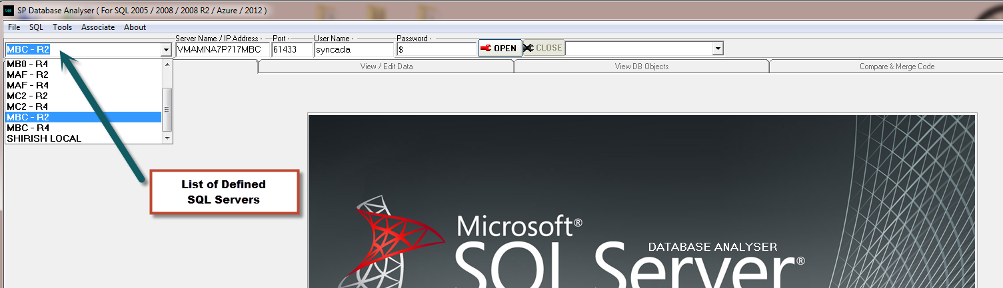

* Enter name of server which you can easily relate to.
* Enter SQL Server Name / IP Address
* Enter SQL Server Port. If it is default SQL Server Port 1433 then leave BLANK.
* Enter SQL Server User Name
* Enter SQL Server Password

Note : The details will be saved for quick access in the future. The drop down will be populated with a list of all database servers connected.

# View DB Objects

# SP View

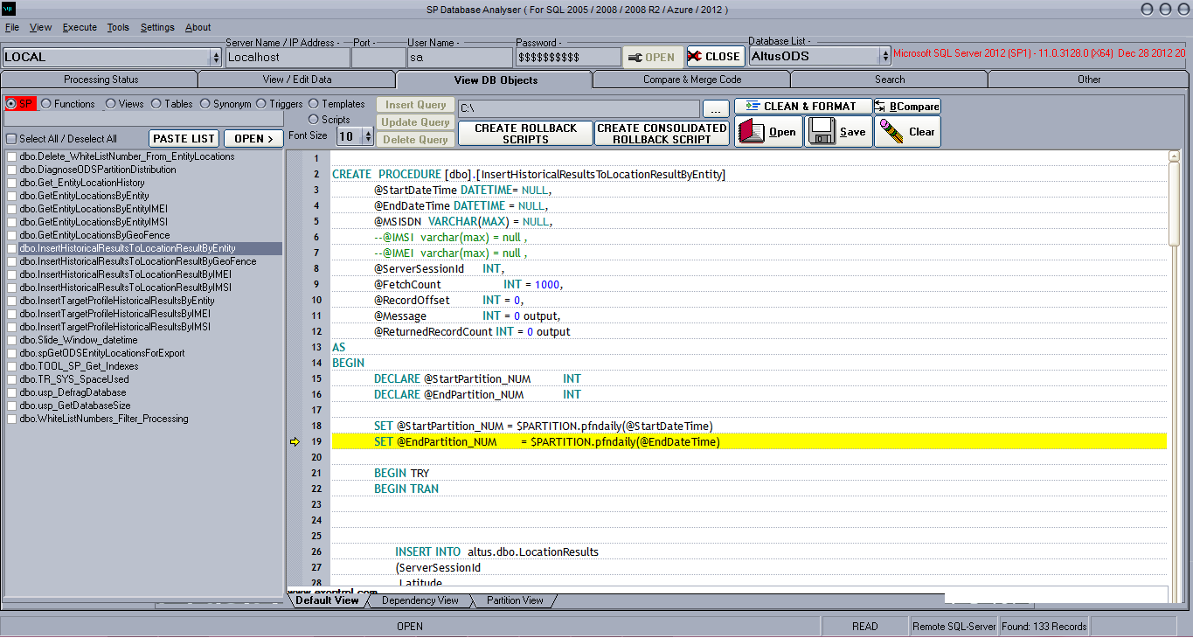

* Has a full support of SQL syntax for Microsoft SQL Server

# Default View

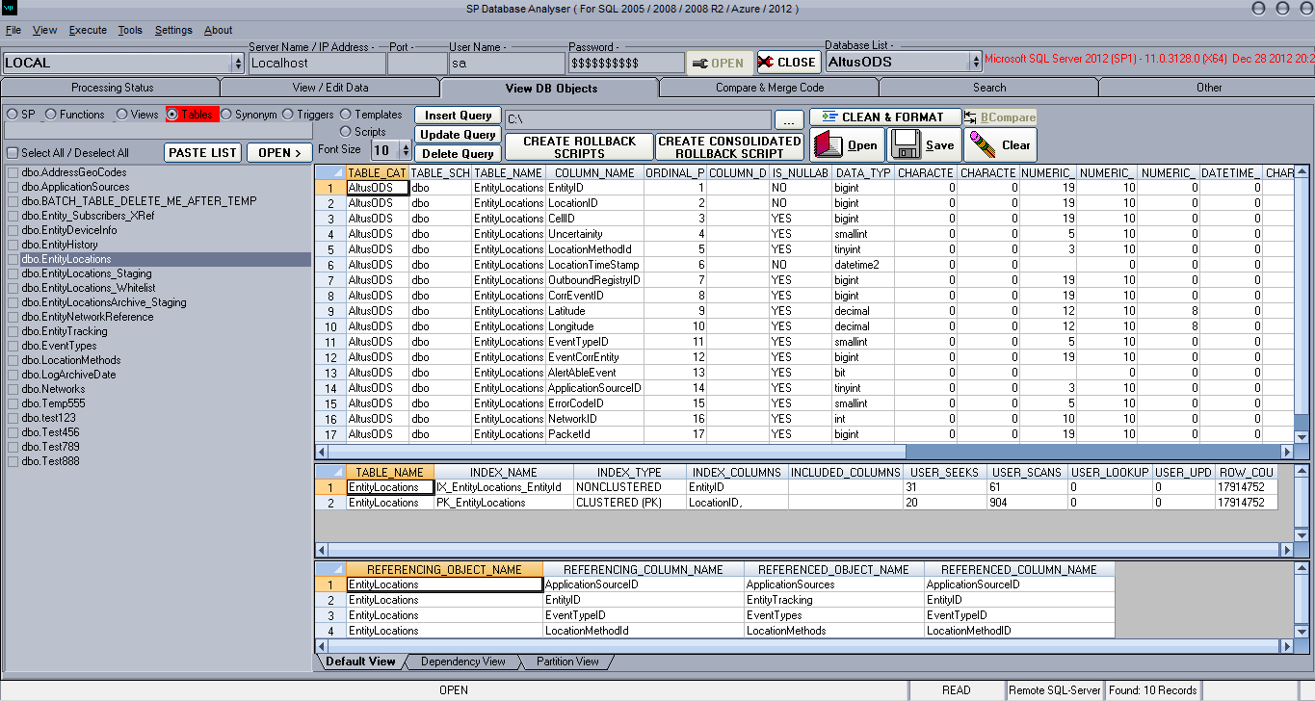

# Dependency View

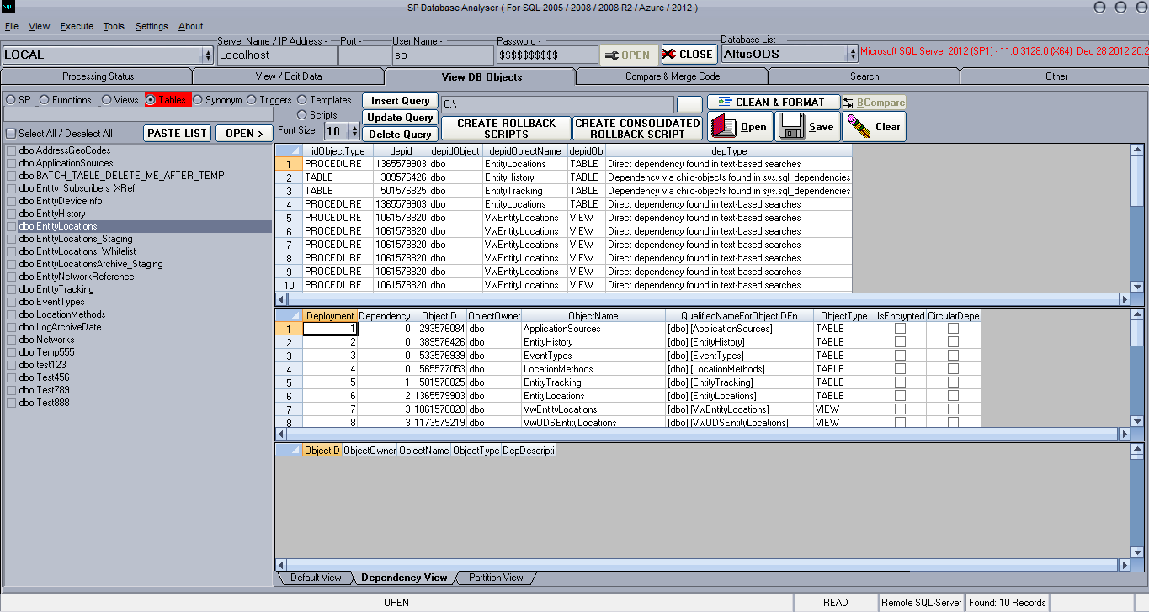

# 1st grid displays – “All dependencies found”

* 2nd grid displays – “Object deployment order and dependency hierarchy level”
* 3rd grid displays – “Circular dependencies found”

# Partition View

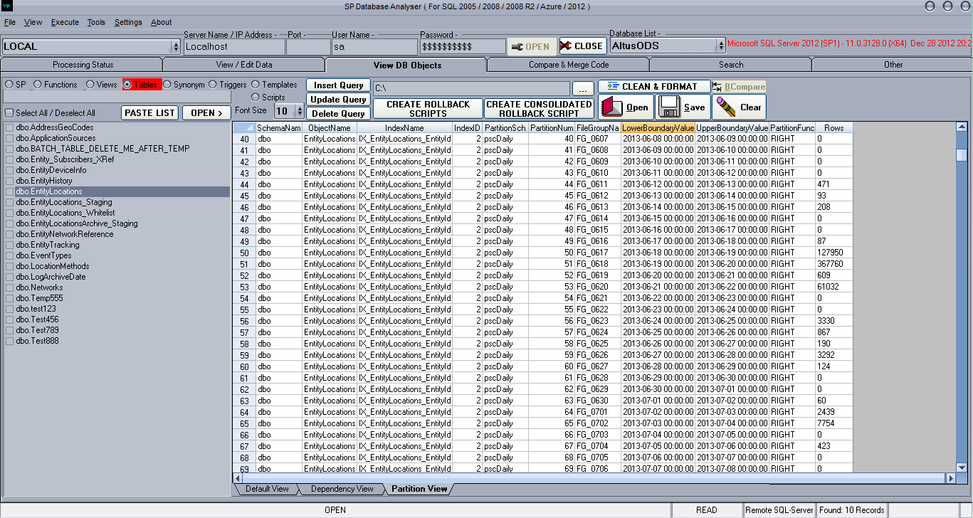

# Execute

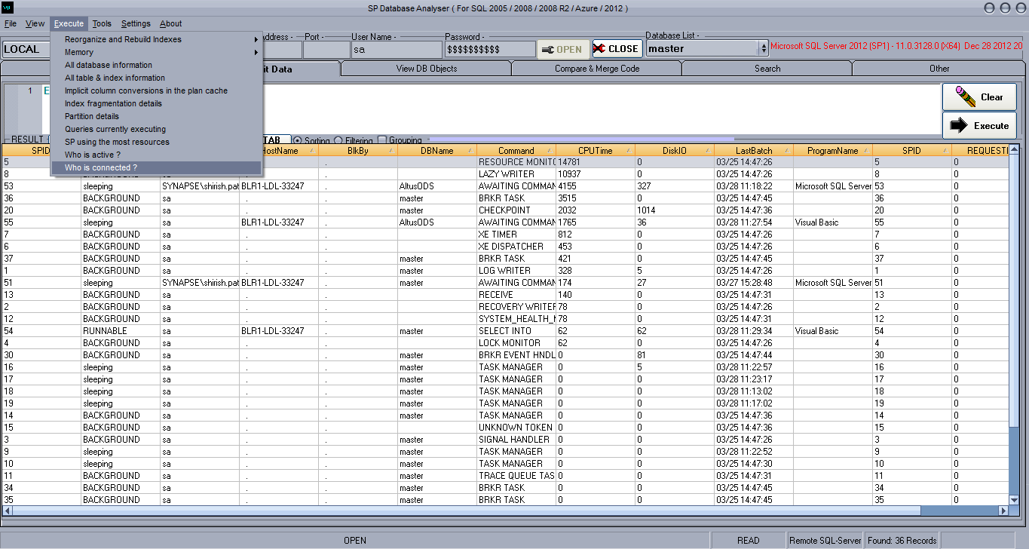

1. Count
   1. Quick record count of all tables and all databases
   2. Record count of all tables
   3. Total Reads and Writes of all tables
2. Clean Up
   1. Clean entire database records & reset identity columns
   2. Fix the identity increment issue
3. CLR Functions ( Pre-coded usable functions )
   1. BLOB Compress
   2. BLOB Decompress
   3. File / Folder operations
      1. Move Folder
      2. Move File
      3. Read Text File
      4. Read File
      5. Get Folders
      6. Get Files
      7. Get Drives
      8. Folder Exists
      9. File Exists
      10. Delete Folder
      11. Delete Files Older Than
      12. Delete Files
      13. Delete File
      14. Create Text File
      15. Create File
      16. Create Folder
      17. Copy File
      18. Append Text File
   4. Send Email
4. E-Mail
   1. Get E-Mail server delivery status
   2. Delete all E-Mail history
5. Index
   1. Reorganize and Rebuild Indexes
      1. Single Index
      2. All indexes on a specific table
      3. All indexes in the database
   2. How old are the index usage stats?
   3. Index usage
   4. Index fragmentation details
   5. Identify indexes that have never been accessed
   6. Identify indexes that are being maintained but not used
   7. Potentially inefficient non-clustered indexes (writes > reads)
   8. Detailed activity information for indexes not used for user reads
   9. Identify locking and blocking at the row level
   10. Identify latch waits of over 15 milliseconds
   11. Identify lock escalations
   12. Identify indexes associated with lock contention
   13. Finding the most beneficial missing indexes
   14. List of disabled indexes
6. Information
   1. All table last accessed details
7. Jobs
   1. Get complete job history
   2. Get all problematic jobs
   3. Get all running jobs
8. Memory
   1. Clean Cache – FREEPROCCACHE
   2. Clean Just SQL Plans
   3. Clean Buffer – DROPCLEANBUFFERS
9. Processes
   1. Find all the blocked processes
   2. Kill all the blocked processes of current database
   3. Kill all the processes of current database
   4. % CPU Usage
   5. % Memory Usage
10. SQL Server
    1. All Databases Files with Size and Free Space
    2. SQL Services installed and its current status
11. SQL Server 2014
    1. List of all COLUMNSTORE Index Segment creation details
    2. List of all the Memory Optimized Tables
    3. List of database bound to a resource pool
12. Tests & Analysis
    1. SQL Server’s Index Sanity Test
    2. SQL Server Plan Cache Analysis
    3. Troubleshoot Slow SQL Servers
    4. SQL Server Health Check Script
    5. List all heap tables
    6. List of all triggers and status
    7. List of all disabled indexes Users
    8. Get all user permissions on all databases
    9. Security Audit Report
    10. Who is active?
    11. Who is connected?
13. Users
    1. Get all user permissions on all databases
    2. Security Audit Report
    3. Who is active ?
    4. Who is connected ?
14. All database information
15. All table & index information
16. Get backup history of all the databases
17. Get information on all open snapshot transactions
18. Get all db objects in the database
19. Get all cross database dependencies
20. Get all dependencies in the database
21. Get all Foreign Key relationships in database
22. Get all tables with NO Foreign Key relationships in database
23. Get all Foreign Key relationships in database with entire table and column details
24. Get all Input/Output Parameters of all UDF and SP
25. Implicit column conversions in the plan cache
26. Partition details
27. Queries currently executing
28. SP using the most resources

# Search

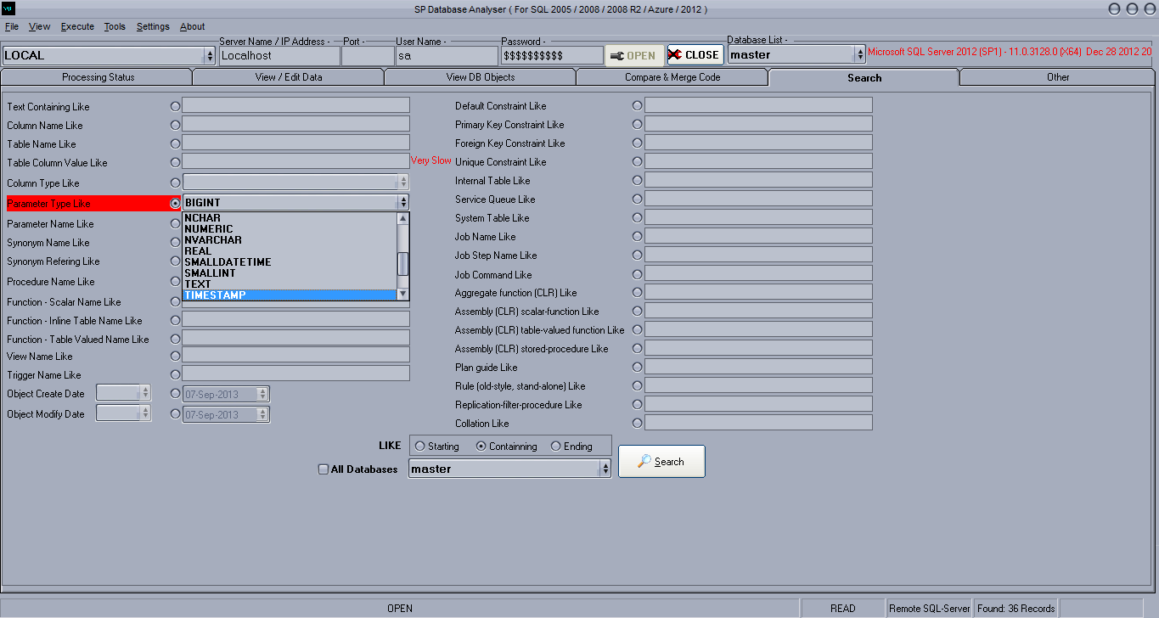

# Tools

# Express Profiler

# Append multiple files by adding header, footer, find and replace...

# Rename multiple files at once...

# Search for specific text in files... e.g. SQL Azure - Deprecated features search for (NOLOCK) in UI code

# Import Flat File To DB

# Generate a list of files in a specific folder..

# Query Builder

# Settings 🡪 Control Panel

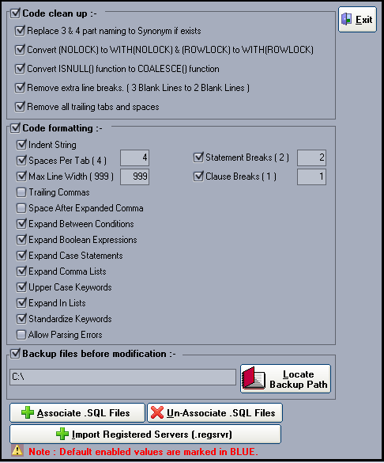

* Import Registered Servers ( xml file ) .regsrvr  
  Note : It will only import SQL Server Name ( Description ) and SQL Server IP / Name

# Themes

There are 31 themes provided with this software.

If you wish to deactivate the theme then select the last theme named “No Theme”

|  |  |
| --- | --- |
| **No.** | **Theme Name** |
| 1 | _SQL Server 7 Sphinx 7.0 |
| 2 | _SQL Server 2000 Shiloh 8.0 |
| 3 | _SQL Server 2005 Yukon 9.0 |
| 4 | _SQL Server 2008 Katmai 10.0 |
| 5 | _SQL Server 2008 R2 Kilimanjaro 10.5 |
| 6 | _SQL Server 2012 Denali 11.0 |
| 7 | _SQL Server 2014 Hekaton 12.0 |
| 8 | Fresco |
| 9 | gfxOasis |
| 10 | Gorilla |
| 11 | Infini8RC1 |
| 12 | iTunesA |
| 13 | iTunesB |
| 14 | Kuantum |
| 15 | Le5 |
| 16 | MM |
| 17 | Office2007 |
| 18 | ProLCD |
| 19 | Quantum |
| 20 | Seer |
| 21 | Sentinel |
| 22 | Studio28 |
| 23 | Tech45 |
| 24 | Thallos |
| 25 | Tiger |
| 26 | Underling |
| 27 | Vista |
| 28 | ViXPta |
| 29 | VXP |
| 30 | WinXP.Luna |
| 31 | WinXP.Royale |
| 32 | No Theme |