SCER-Mamba Loan Default Prediction: Results Summary
4 October 2026
SCER-Mamba predicts which mortgage loans become 60+ days delinquent within 6 months (Fannie Mae data). It performs on par with the LSTM, beats XGBoost on long histories, and is interpretable.

Methods
- Data: Fannie Mae 2023Q1 (main) and 2015Q1 (pre-COVID, 12–48 months of history); 12 static + 13 monthly features.
- Preprocessing: cleaning, 6-month label, monthly sequences, stratified 70/15/15 split, scaling fitted on training only.
- Imbalance: focal loss on the real data (best of 7 methods tested); validation and test kept at the real ratio.
- Model: static MLP encoder + Mamba (1 layer) + risk-event attention + multi-pooling + classifier.
- Training: AdamW, early stopping on validation PR-AUC, threshold tuned on validation, 3 seeds.
- Baselines and tests: LSTM, XGBoost, logistic regression, rule; paired bootstrap significance test.

Results

2023Q1, 24 months (test set)
Model | Accuracy | Precision | Recall | F1 | ROC-AUC | PR-AUC
LSTM | 0.987 | 0.405 | 0.511 | 0.452 | 0.921 | 0.364
SCER-Mamba | 0.986 | 0.382 | 0.521 | 0.441 | 0.917 | 0.354
XGBoost | 0.985 | 0.357 | 0.545 | 0.431 | 0.914 | 0.345
Logistic regression | 0.987 | 0.396 | 0.424 | 0.410 | 0.917 | 0.327
Rule (30+ days late) | 0.988 | 0.416 | 0.436 | 0.426 | 0.715 | 0.187
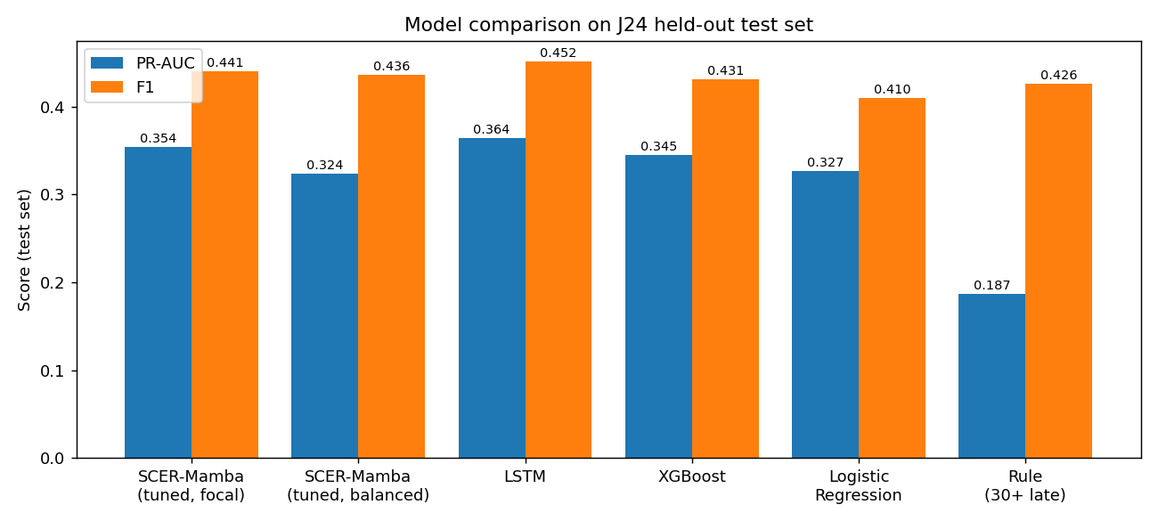
Figure 1: Model comparison, PR-AUC and F1 (2023Q1)
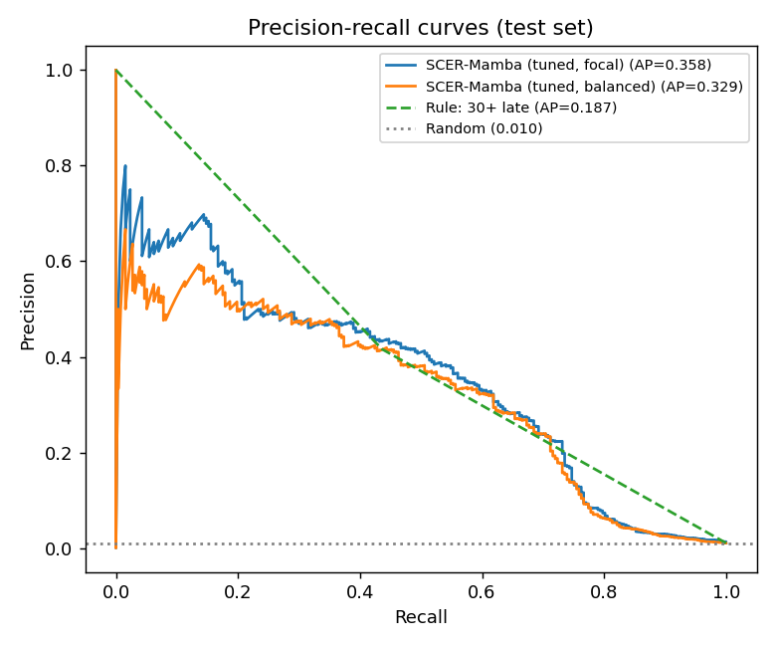
Figure 2: Precision-recall curves (2023Q1 test set)
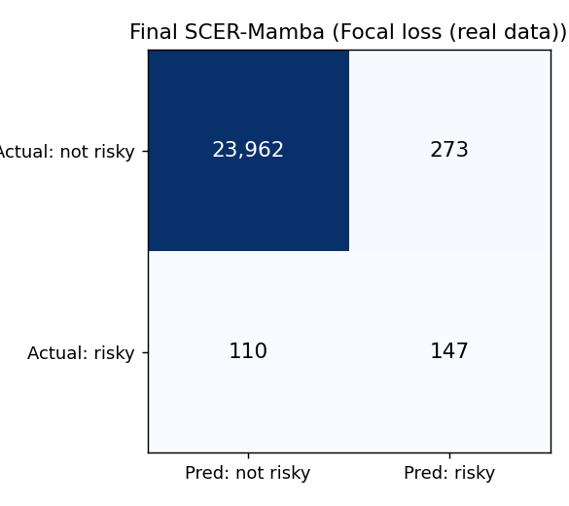
Figure 3: Confusion matrix of the final SCER-Mamba

Class imbalance (SCER-Mamba, 2023Q1)
Method | Train risky / not risky | Accuracy | Precision | Recall | F1 | ROC-AUC | PR-AUC
Focal loss | 1,198 / 113,098 | 0.986 | 0.386 | 0.533 | 0.448 | 0.915 | 0.335
Oversampling | 113,098 / 113,098 | 0.985 | 0.366 | 0.556 | 0.441 | 0.907 | 0.325
Hybrid | 20,000 / 20,000 | 0.984 | 0.346 | 0.549 | 0.424 | 0.900 | 0.314
Undersampling | 1,198 / 1,198 | 0.986 | 0.379 | 0.475 | 0.421 | 0.882 | 0.283
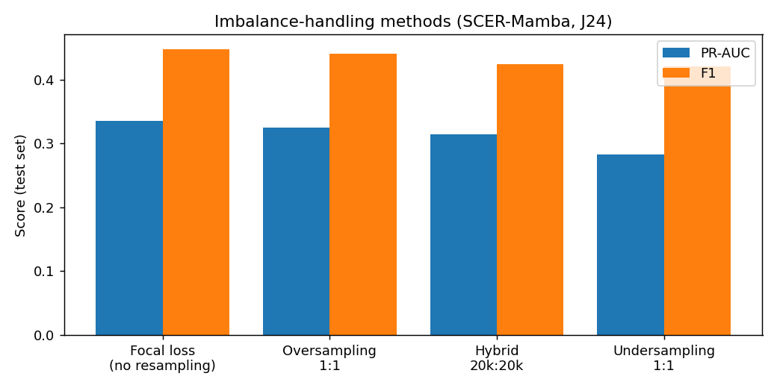
Figure 4: Imbalance-handling methods compared

2015Q1 history length (PR-AUC)
History | SCER-Mamba | LSTM | XGBoost | p-value (SCER vs LSTM)
12 months | 0.203 | 0.216 | 0.204 | 0.12
24 months | 0.287 | 0.317 | 0.303 | 0.14
36 months | 0.320 | 0.332 | 0.297 | 0.46
48 months | 0.308 | 0.309 | 0.281 | 0.53
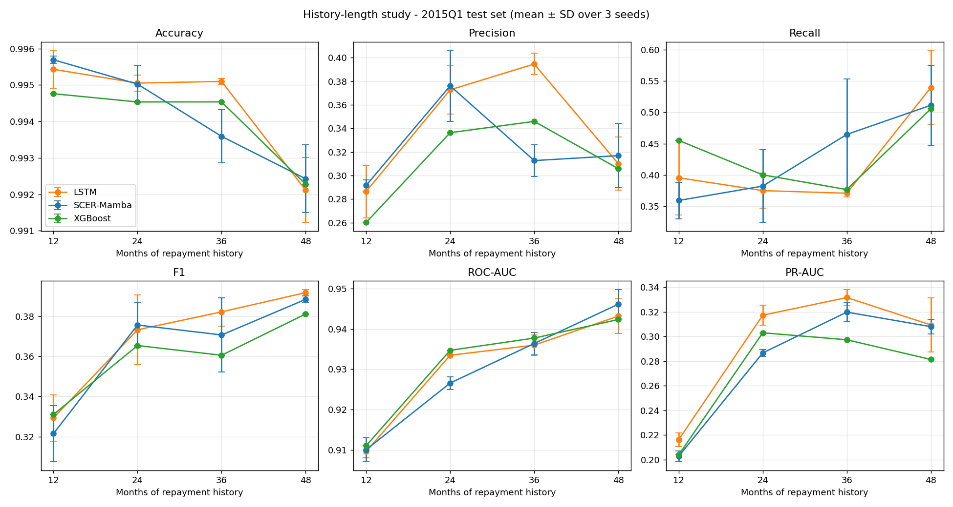
Figure 7: All metrics vs history length (2015Q1)
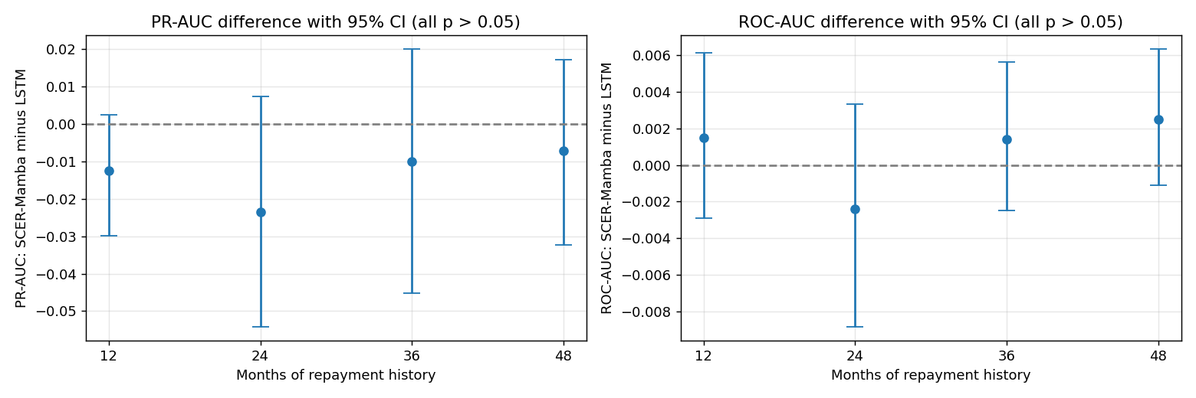
Figure 8: SCER-Mamba minus LSTM with 95% CI

2015Q1, 48 months + categorical features
Model | Accuracy | Precision | Recall | F1 | ROC-AUC | PR-AUC
SCER-Mamba | 0.994 | 0.353 | 0.426 | 0.385 | 0.941 | 0.317
LSTM | 0.993 | 0.323 | 0.519 | 0.395 | 0.946 | 0.312
XGBoost | 0.993 | 0.302 | 0.449 | 0.361 | 0.942 | 0.299
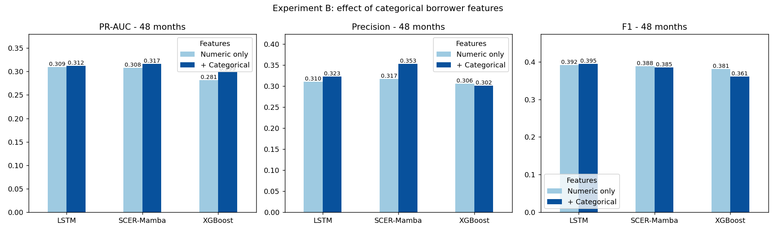
Figure 9: With vs without categorical features (48 months)

Interpretability
No SCER-Mamba vs LSTM difference is statistically significant (all p > 0.05). Attention on late-payment months: 3.7× (2023Q1) and 3.8× (2015Q1).
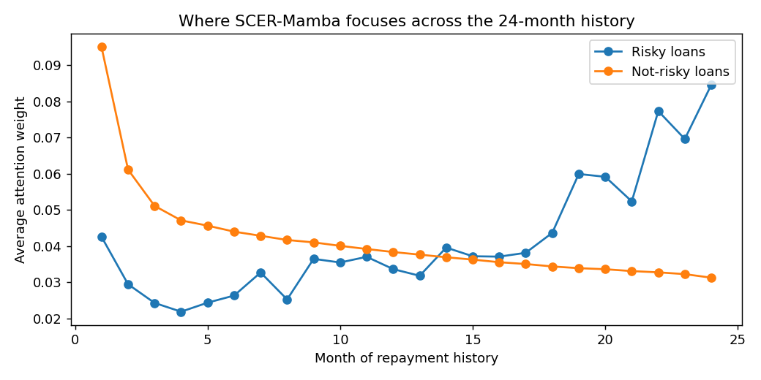
Figure 5: Attention by month, risky vs not-risky loans (2023Q1, 24 months)
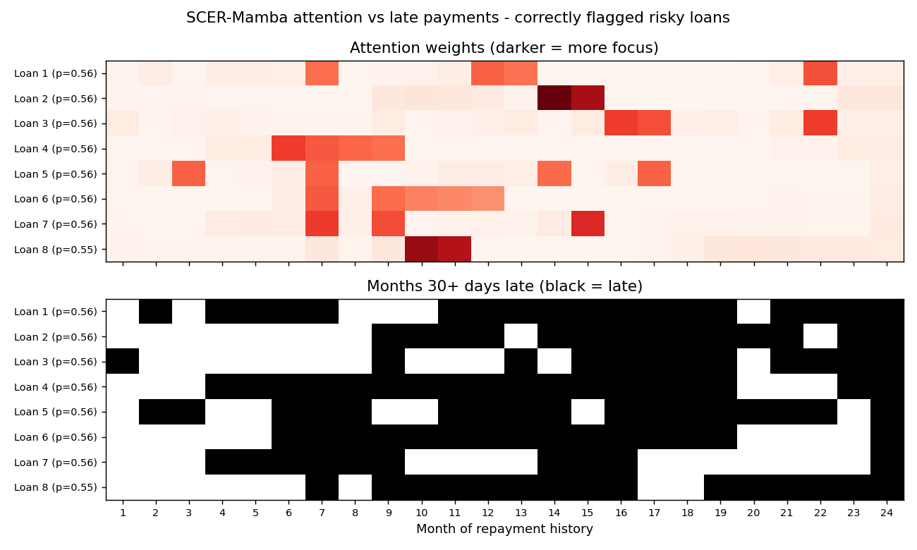
Figure 6: Attention vs late payments for top risky loans (2023Q1)
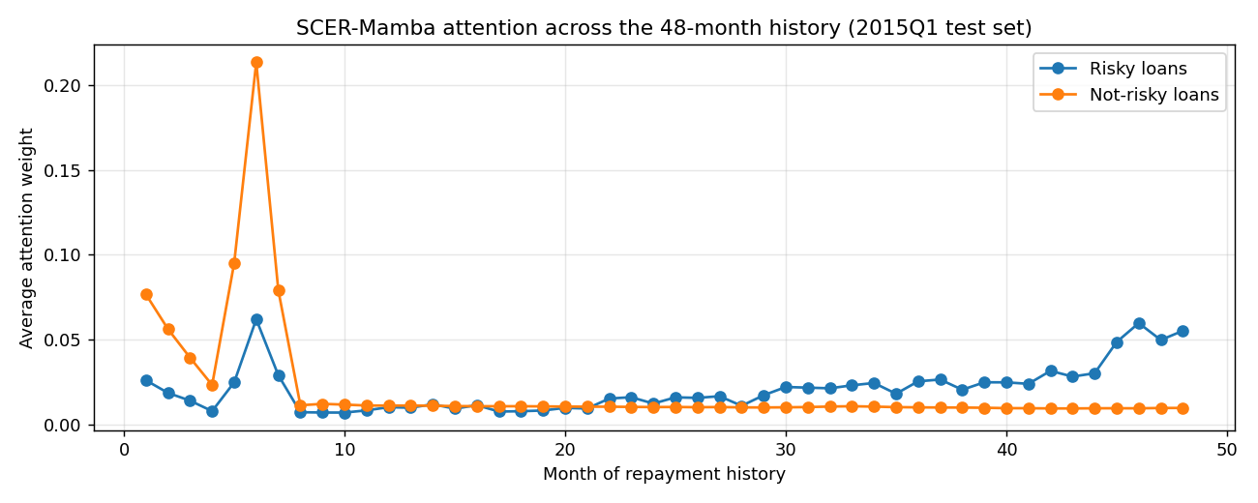
Figure 10: Attention across the 48-month history (2015Q1)
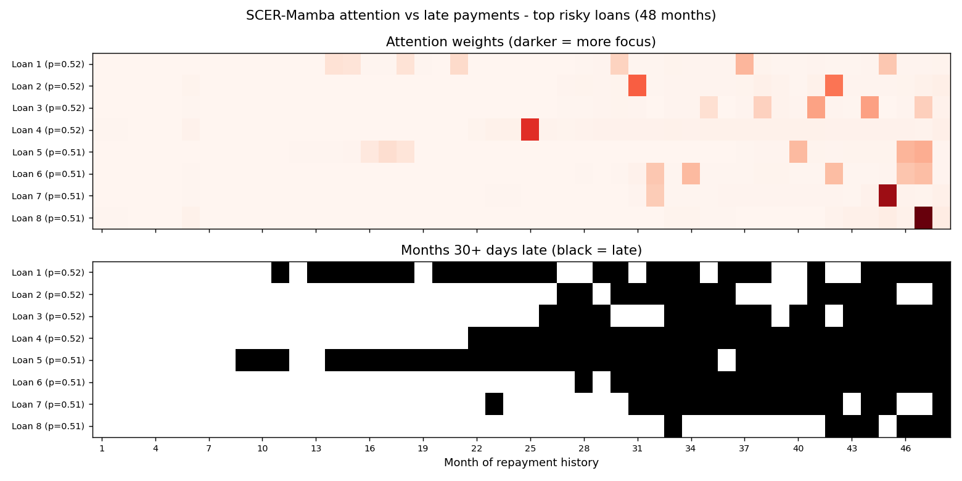
Figure 11: Attention vs late payments for top risky loans (48 months)

Conclusion
SCER-Mamba is statistically on par with the LSTM, beats XGBoost on long histories, is more stable across seeds, and shows which months drive its predictions.

