1. Install Jenkins and run Jenkins on port number 8081.

🡺Install jenkins and run jenkins on port number 8081.  
🡺First create the instance with 20GB storage  
🡺then open the instance in CLI and install the jenkins  
🡺Download jenkins Repo:  
🡺sudo wget -O /etc/yum.repos.d/jenkins.repo   
🡺https://pkg.jenkins.io/redhat-stable/jenkins.repo  
🡺Import the jenkins key:  
🡺sudo rpm --import   
🡺https://pkg.jenkins.io/redhat-stable/jenkins.io-2023.key  
🡺Update ec2:  
🡺sudo yum upgrade  
🡺Add required dependencies for the jenkins package:  
🡺sudo amazon-linux-extras enable corretto17  
🡺sudo yum clean metadata  
🡺sudo yum install java-17-amazon-corretto-devel -y  
🡺Install Jenkins:  
🡺sudo yum install jenkins  
🡺To change the port number:  
🡺sudo mkdir -p /etc/systemd/system/jenkins.service.d  
sudo tee   
/etc/systemd/system/jenkins.service.d/override.conf >   
/dev/null <<EOF  
[Service]  
ExecStart=  
ExecStart=/usr/bin/java -Djava.awt.headless=true -jar   
/usr/share/java/jenkins.war --httpPort=8081

EOF  
🡺then restart the jenkins:  
🡺sudo systemctl daemon-reload  
🡺sudo systemctl restart jenkins

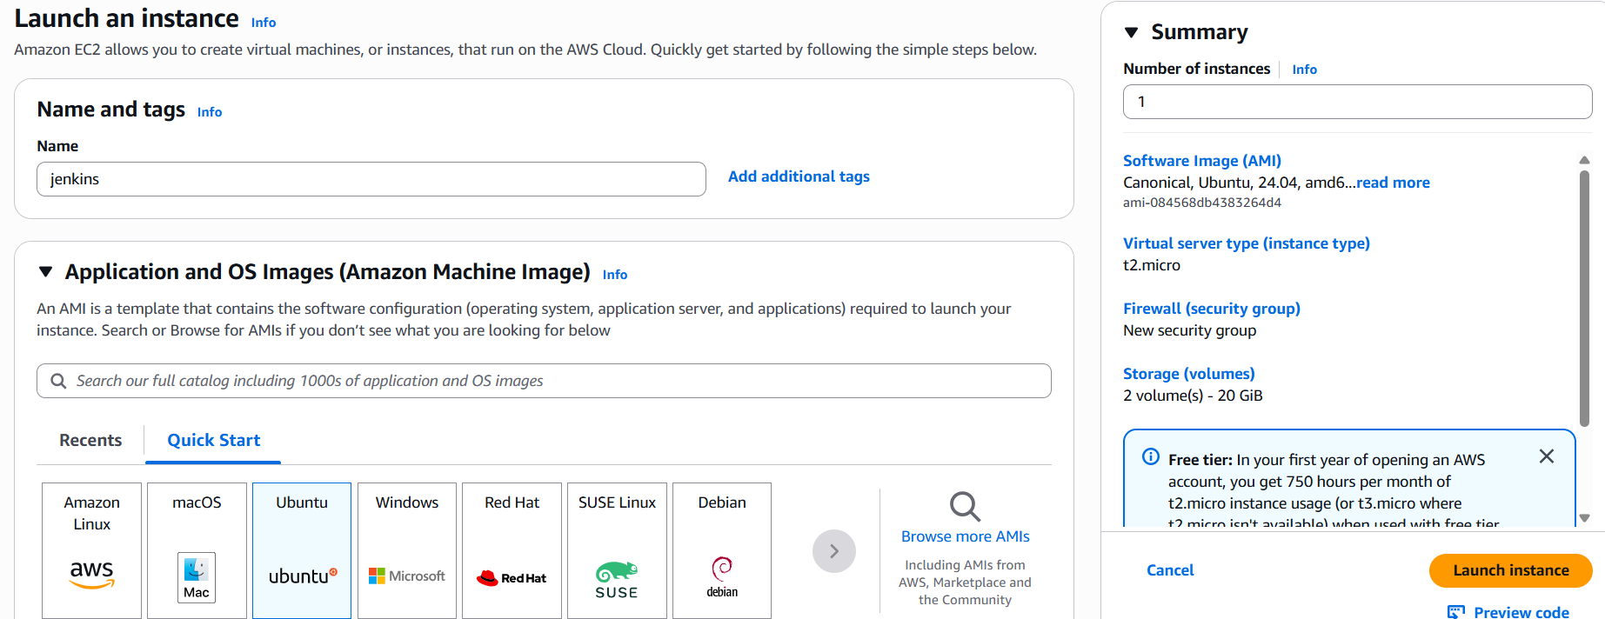

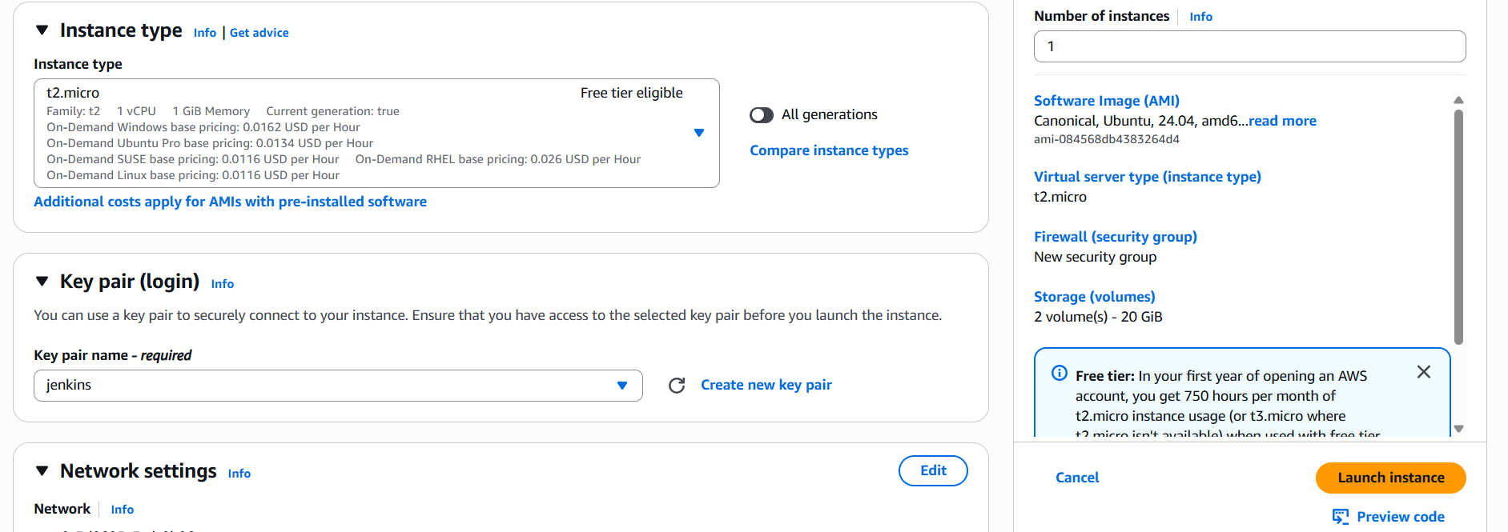

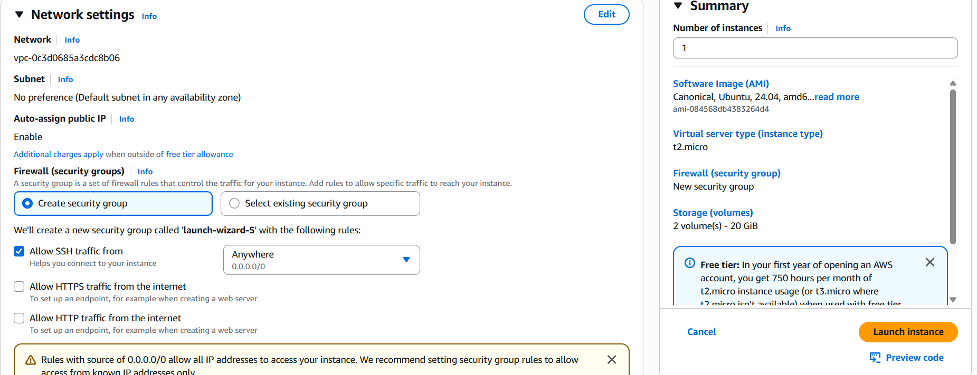

5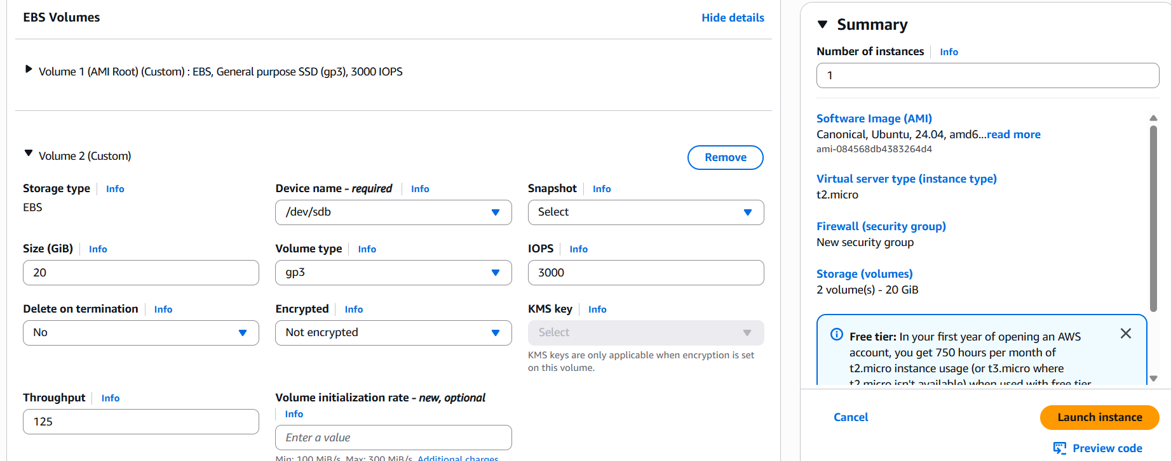

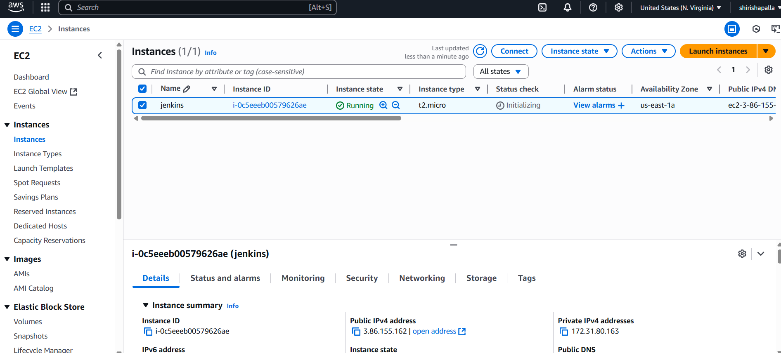

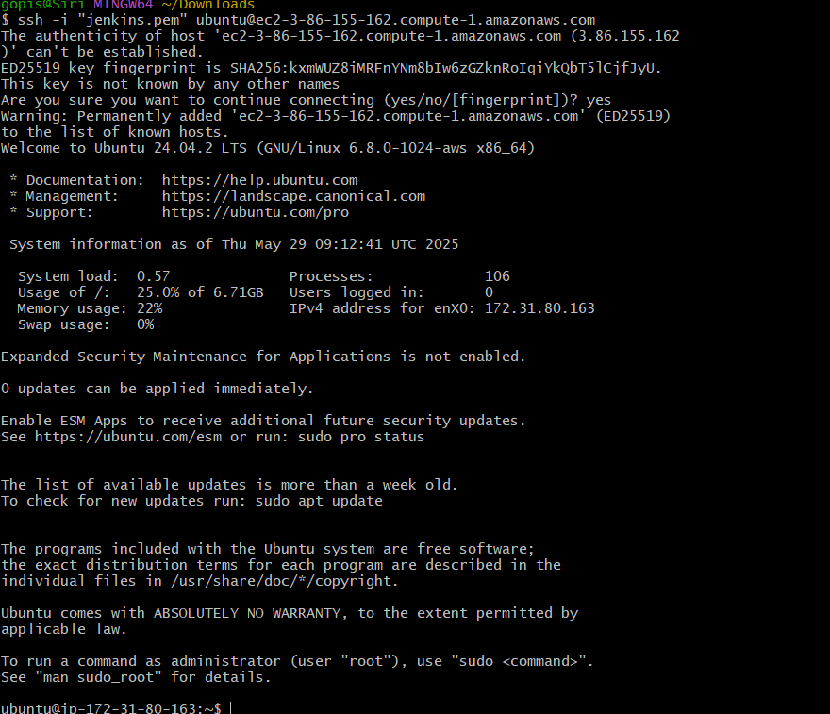

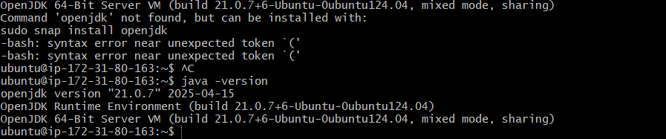

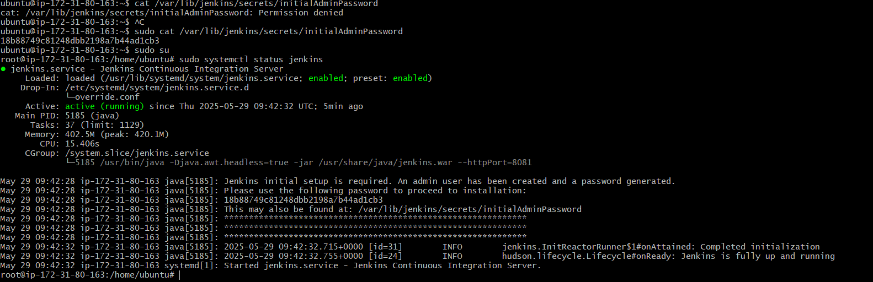



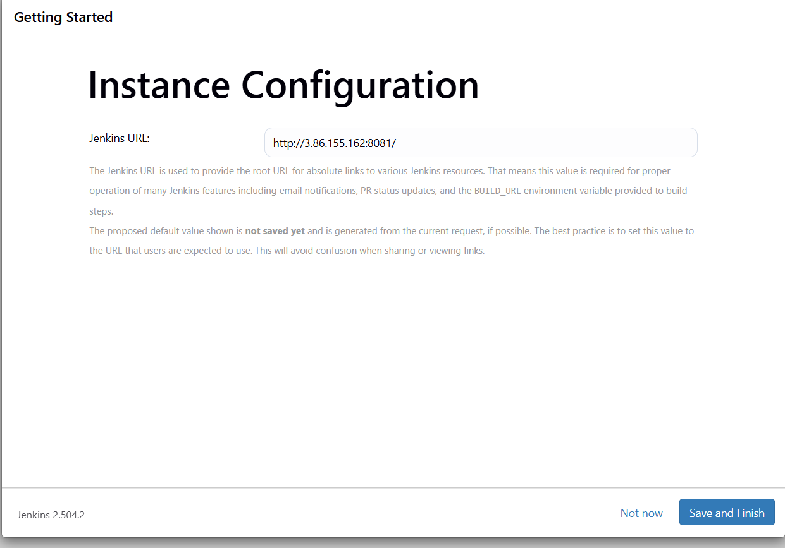

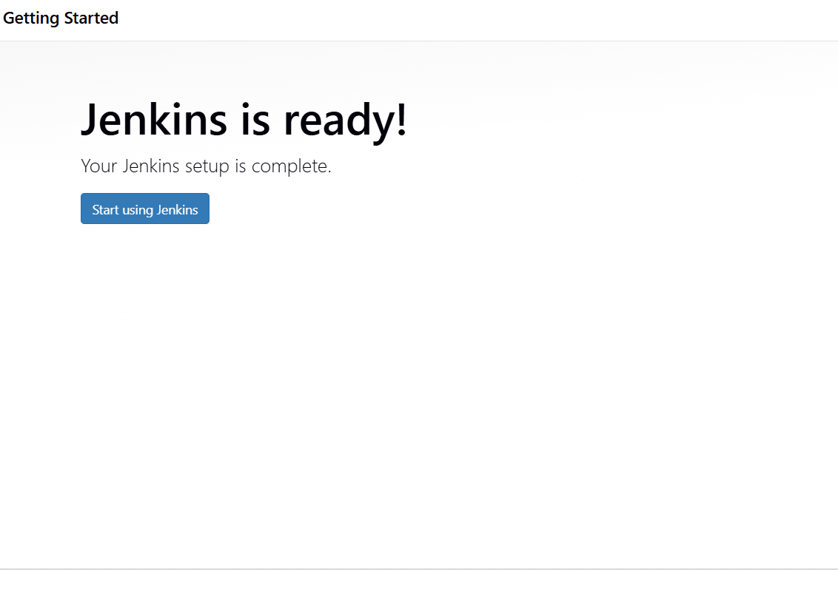

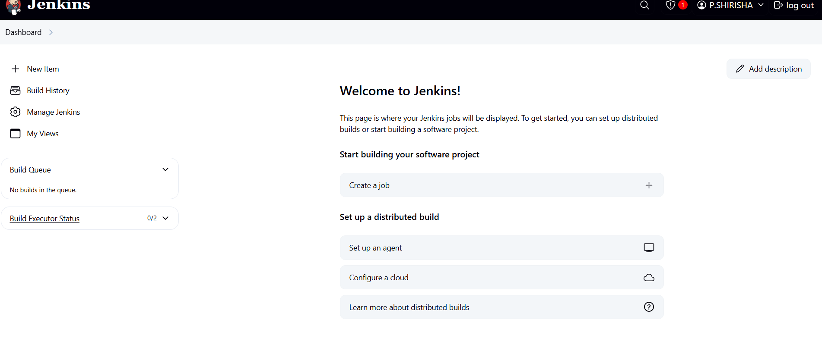

2)Secure Jenkins server

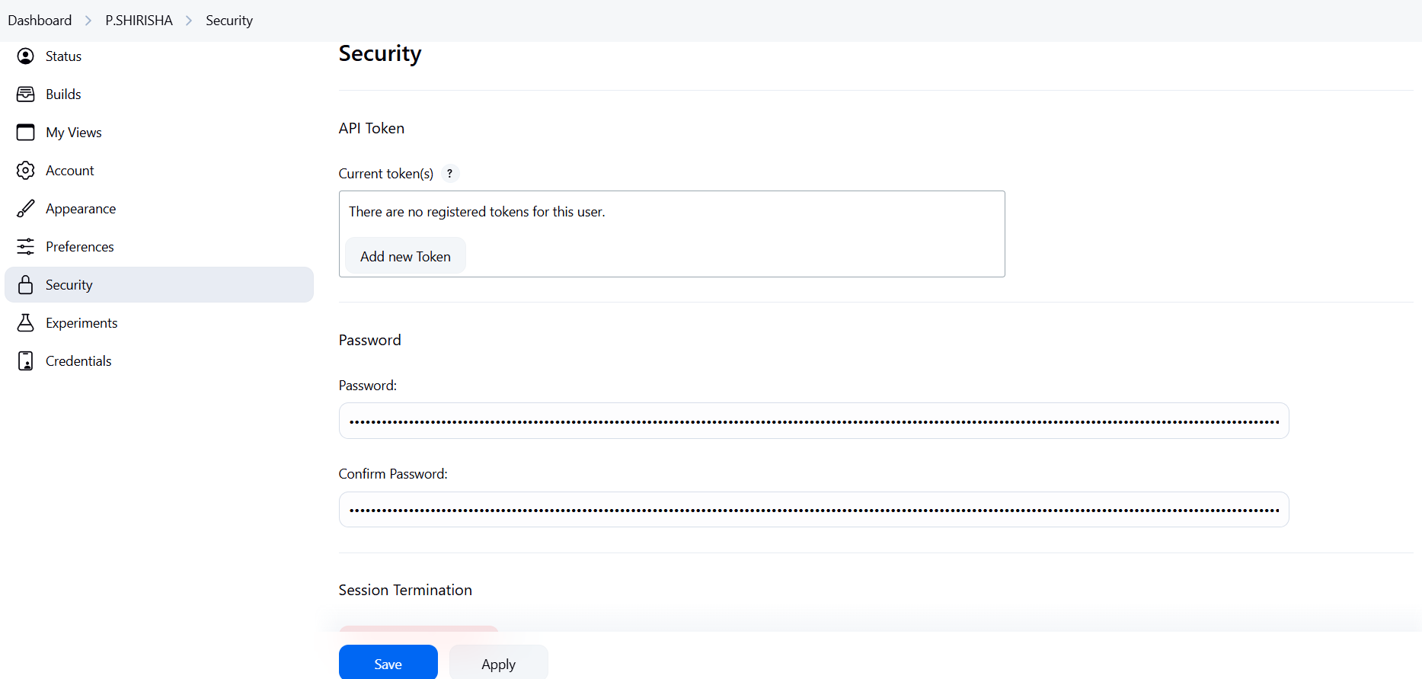

3)Create users called Devops, Testing in Jenkins with Limited access.

**1. Install the Role-Based Authorization Strategy Plugin**

1. Navigate to **Manage Jenkins** > **Manage Plugins**.
2. Under the **Available** tab, search for **Role-based Authorization Strategy**.
3. Select the plugin and click **Install without restart**.
4. After installation, go to **Manage Jenkins** > **Configure Global Security**.
5. In the **Authorization** section, select **Role-Based Strategy** and save the configuration. [LabEx+6DevOPs Diary+6Jenkins+6](https://devopsdiaryblog.wordpress.com/2020/04/06/how-to-restrict-jenkins-project-access-to-users-and-groups-using-roles/?utm_source=chatgpt.com)[Reddit+2Stack Overflow+2DevOPs Diary+2](https://stackoverflow.com/questions/14381832/user-access-in-jenkins-how-can-i-give-someone-access-to-only-see-jobs?utm_source=chatgpt.com)

**2. Create Users: Devops and Testing**

1. Go to **Manage Jenkins** > **Users** > **Create User**.
2. Fill in the required details for each user:
   * **Username**: Devops or Testing
   * **Password**: [Choose a secure password]
   * **Full Name**: [Optional]
   * **Email Address**: [Optional]
3. Click **Create User**. [Medium](https://medium.com/%40srghimire061/how-to-manage-users-and-roles-in-jenkins-fe6a7a8be344?utm_source=chatgpt.com)[Jenkins+4Guru99+4Medium+4](https://www.guru99.com/create-users-manage-permissions.html?utm_source=chatgpt.com)[YouTube+13Jenkins+13LabEx+13](https://www.jenkins.io/doc/book/managing/users/?utm_source=chatgpt.com)

**3. Define Roles and Assign Permissions**

1. Navigate to **Manage Jenkins** > **Manage and Assign Roles** > **Manage Roles**.
2. Under **Global roles**, add new roles:
   * **Role Name**: Devops
   * **Role Name**: Testing
3. Assign permissions to each role based on the required access level. For example:
   * **Devops**:
     + Overall: Read
     + Job: Build, Read
     + View: Read
   * **Testing**:
     + Overall: Read
     + Job: Read
     + View: Read
4. Click **Save** to apply the roles.[Jenkins](https://community.jenkins.io/t/help-with-setting-up-access-for-new-users-admins/15847?utm_source=chatgpt.com)[Reddit+17Guru99+17Stack Overflow+17](https://www.guru99.com/create-users-manage-permissions.html?utm_source=chatgpt.com)

**4. Assign Roles to Users**

1. Go to **Manage Jenkins** > **Manage and Assign Roles** > **Assign Roles**.
2. Under **Global roles**, assign the appropriate role to each user:
   * User Devops: Assign the Devops role.
   * User Testing: Assign the Testing role.
3. Click **Save** to finalize the assignments.[Reddit+8](https://community.jenkins.io/t/help-with-setting-up-access-for-new-users-admins/15847?utm_source=chatgpt.com)

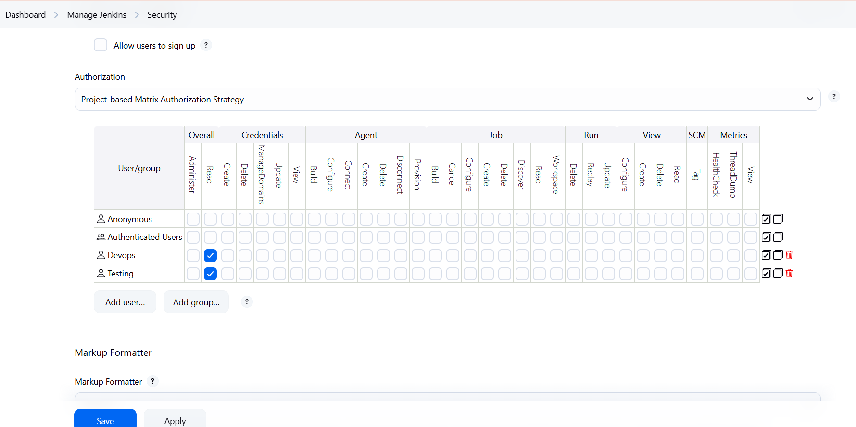

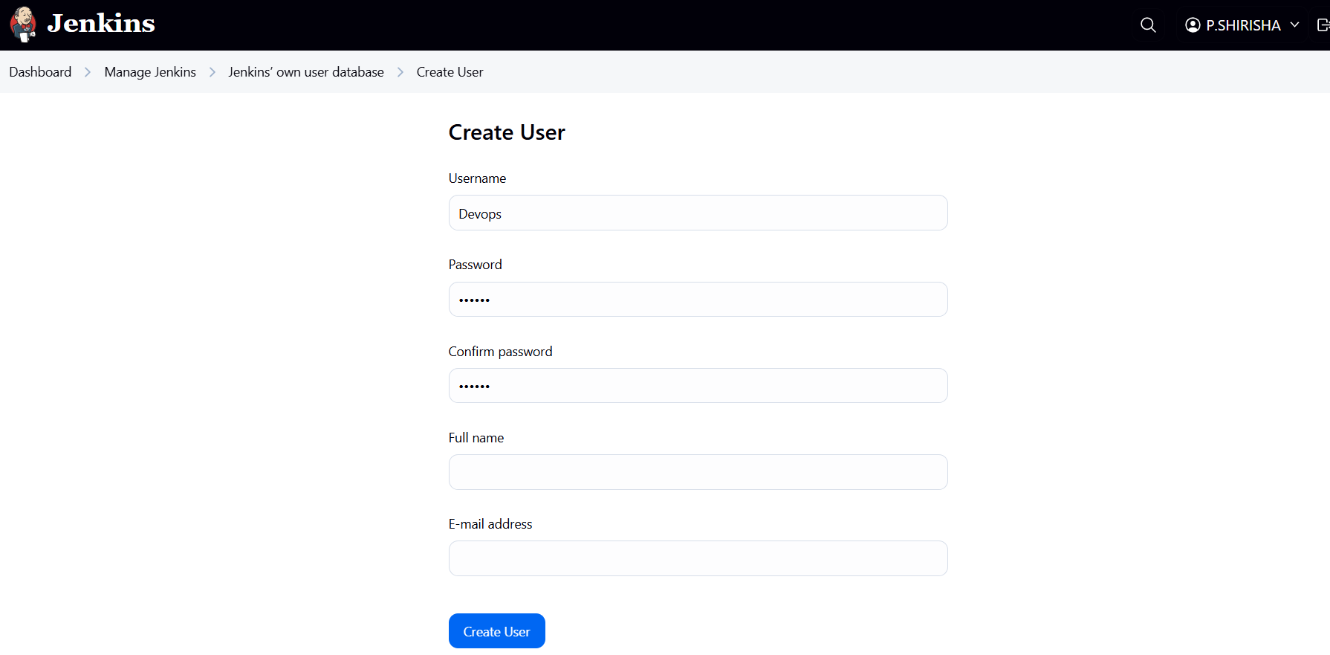

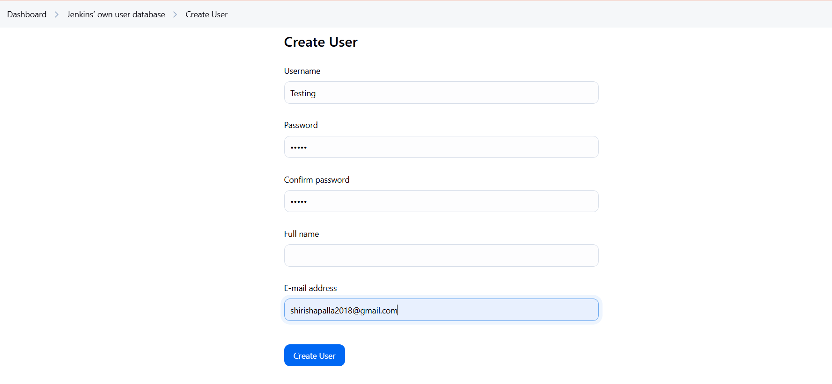

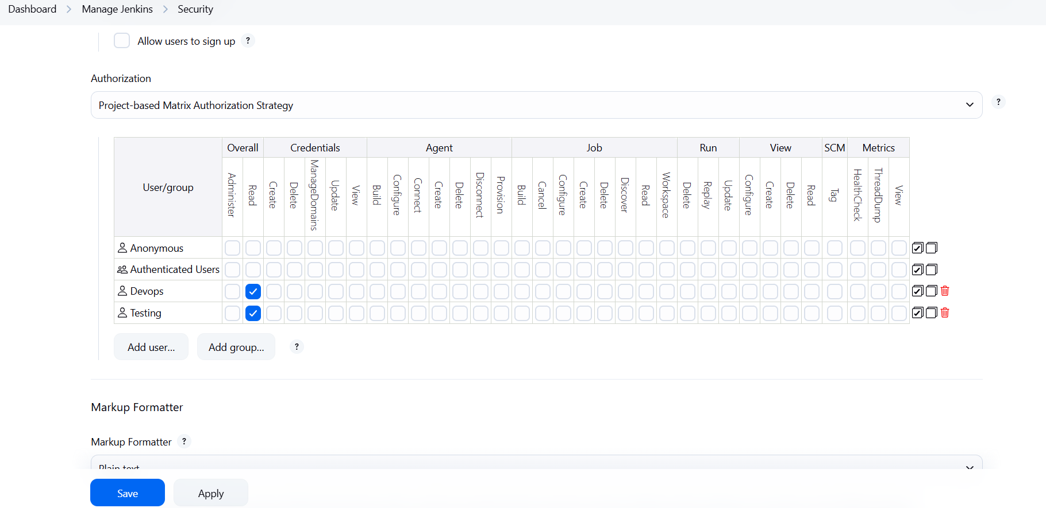

4)Configure labels and restrict the jobs to execute based on label only.

Go to Nodes  
•Click on “Manage Jenkins” from the left menu  
•Click on “Nodes”  
 Select the Node  
•You’ll see a list like:  
Built-In Node (master)  
Any agent you’ve added

Click on the node where you want to assign a label (e.g., Built-In Node)  
Configure the Node  
•Click on “Configure” (left side)  
•Find the “Labels” text box  
Go to Your Job  
•From the Dashboard, click on the job  
•If you don’t have a job, create one  
 Open Job Configuration  
•Click on “Configure”  
 Set Label Restriction  
•In the General section:  
LABEL

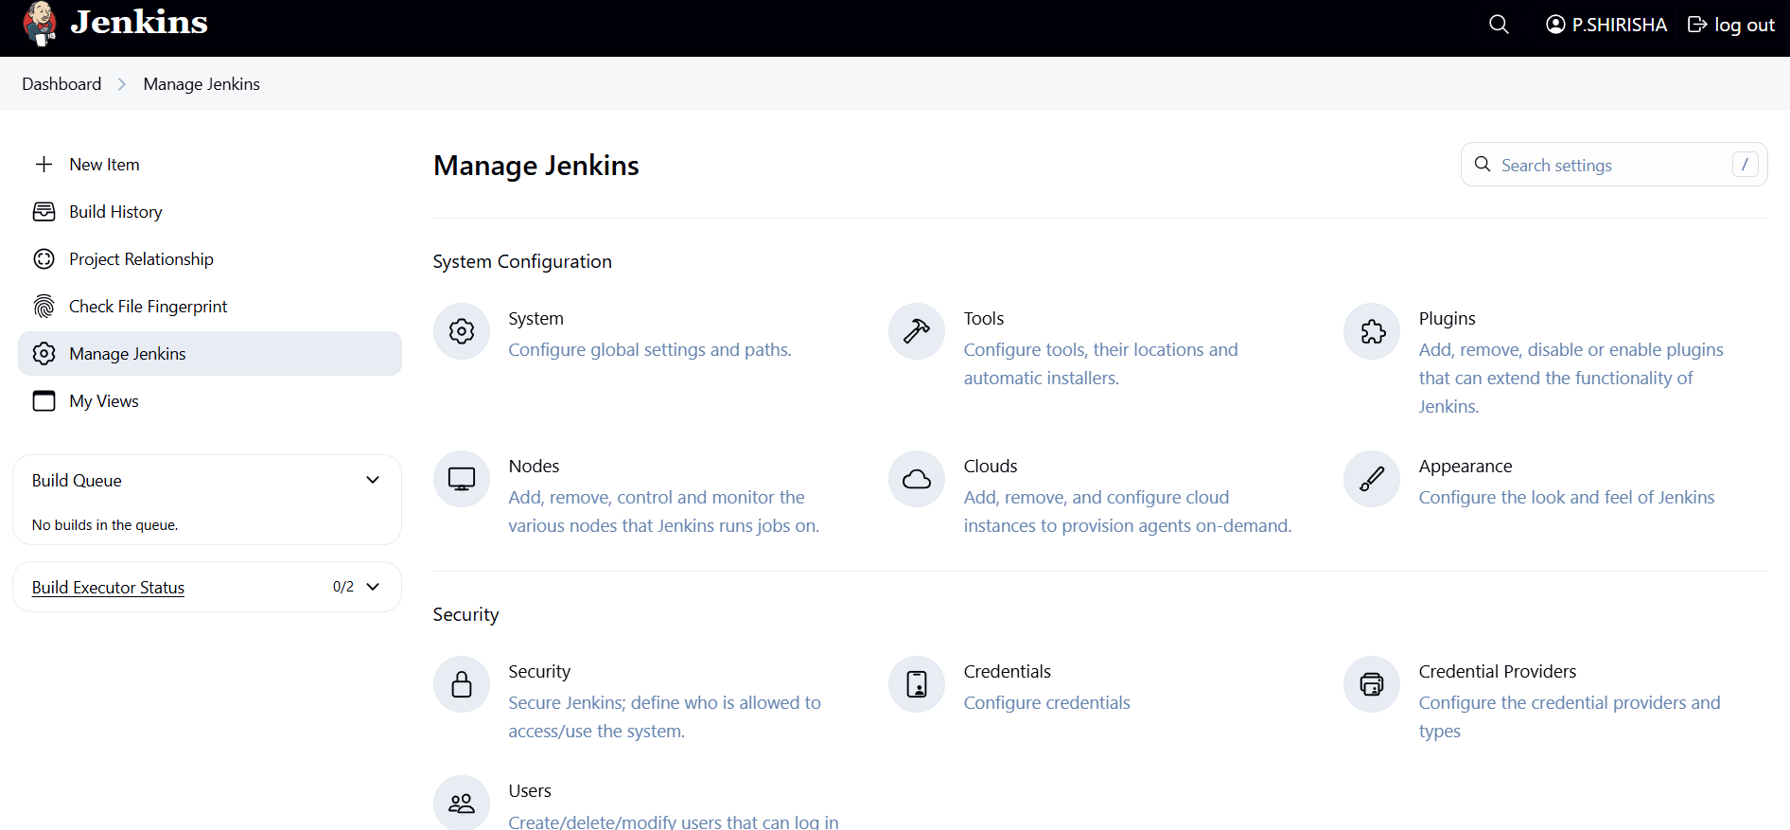

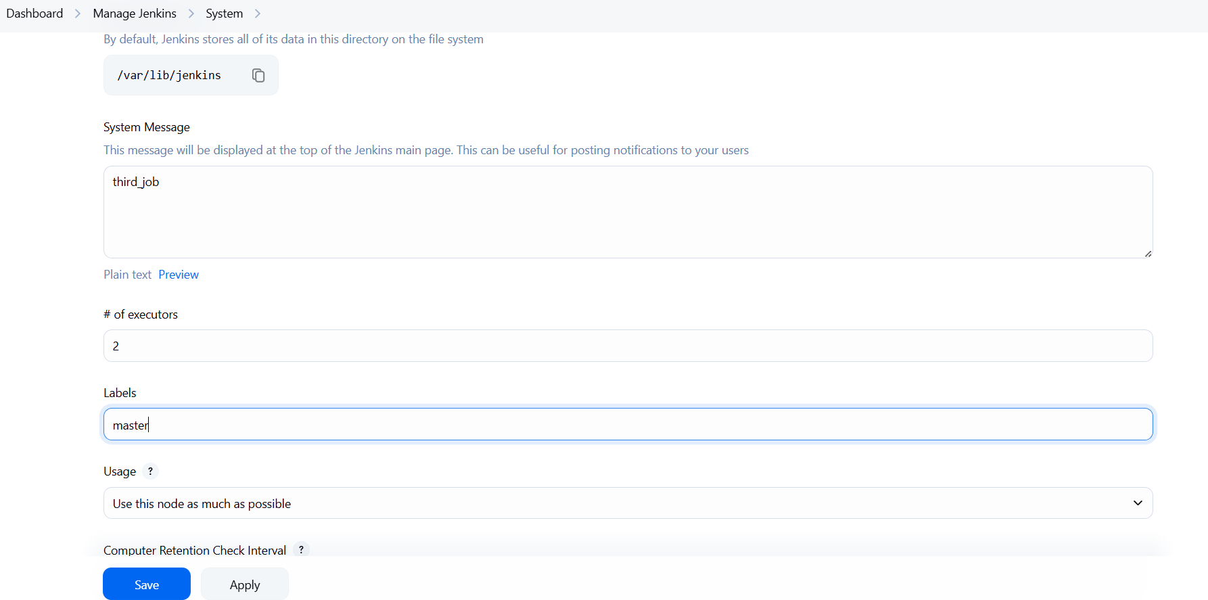 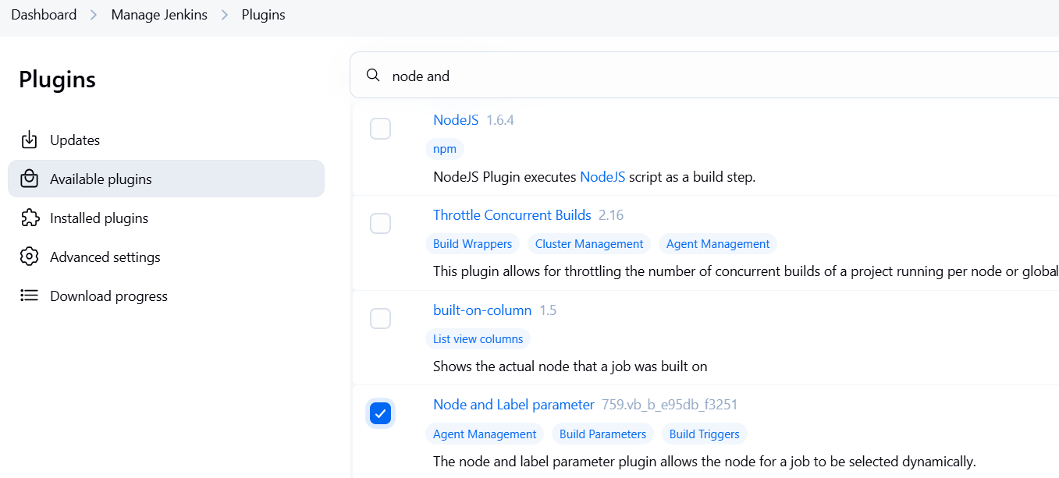

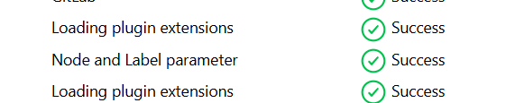

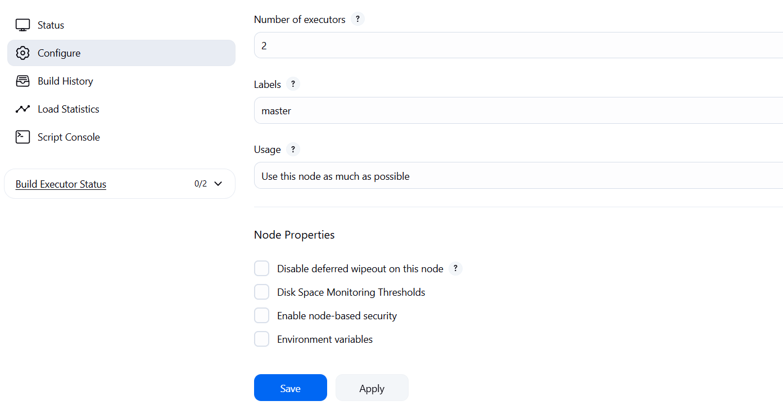

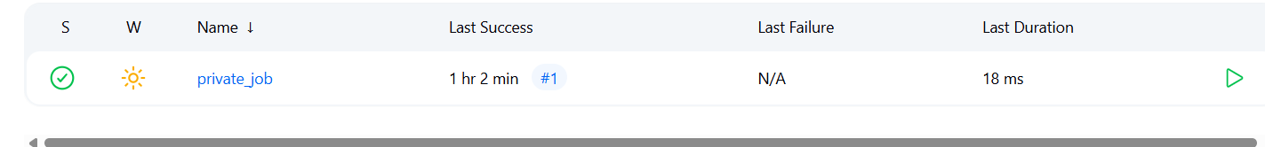

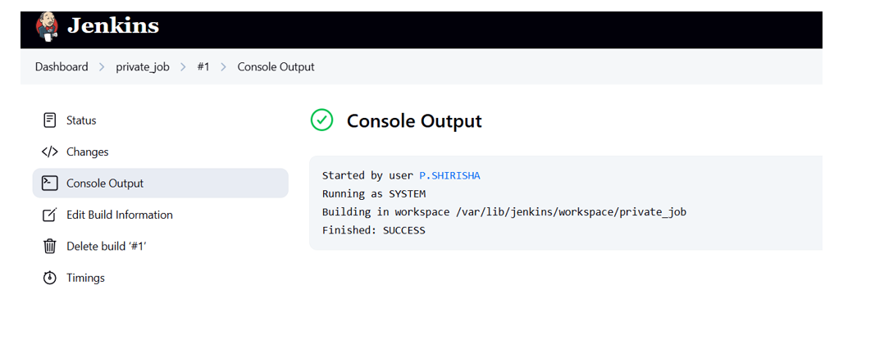

5)Create Three sample jobs using the below URL. <https://github.com/betawins/Techie_horizon_Login_app.git>

* Go to the dashboard and click on >new item give a   
  name >select freestyle>click save  
  go to general>give discription>go to option   
  git>paste the github url check twice that the url is   
  working or not >then in the triggers>select github   
  triggers>in the build test>choose execute   
  shell>give a sample script and run >save  
  click on build now>if the status success>go the   
  ques >see the output status  
  same do the for the next two sample jobs

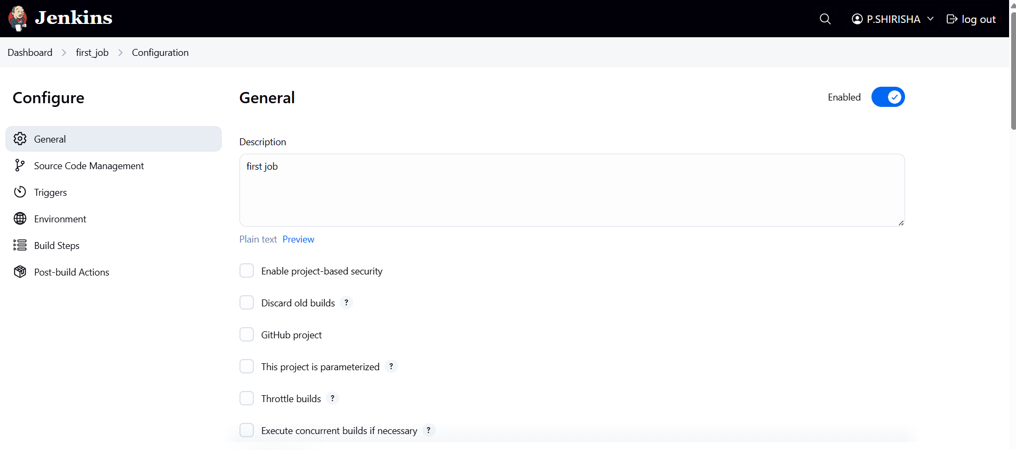

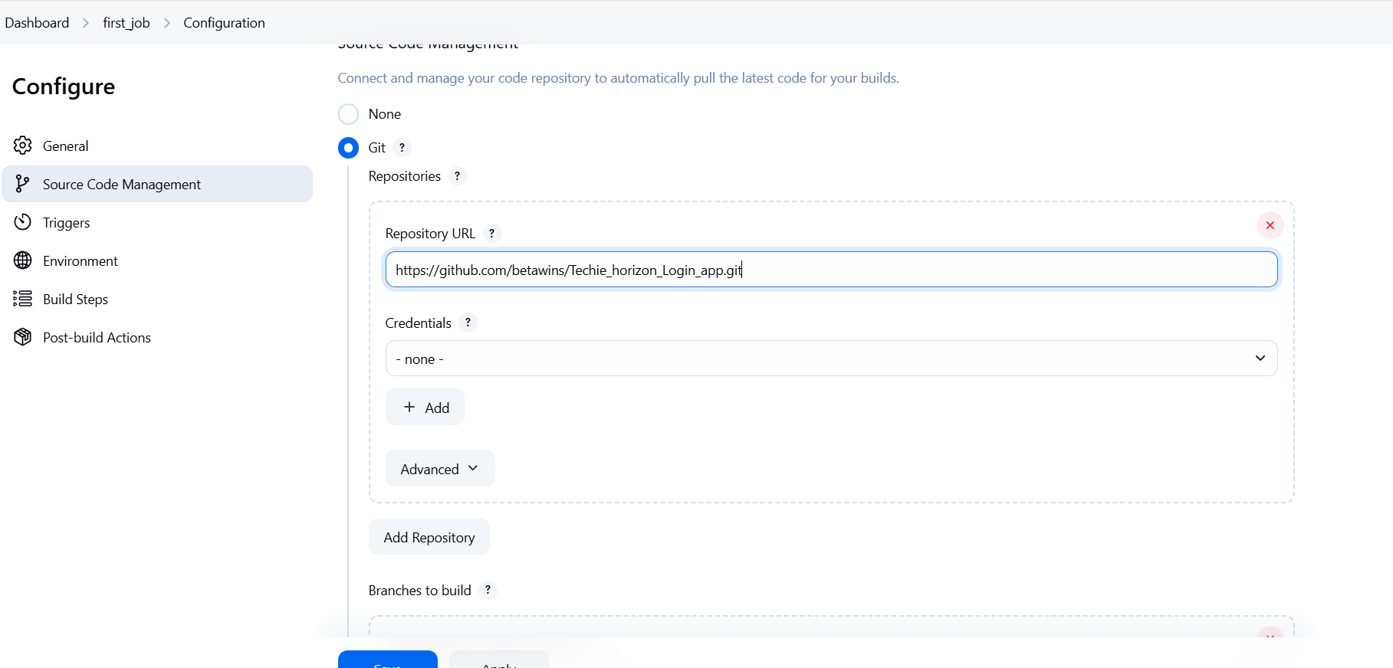

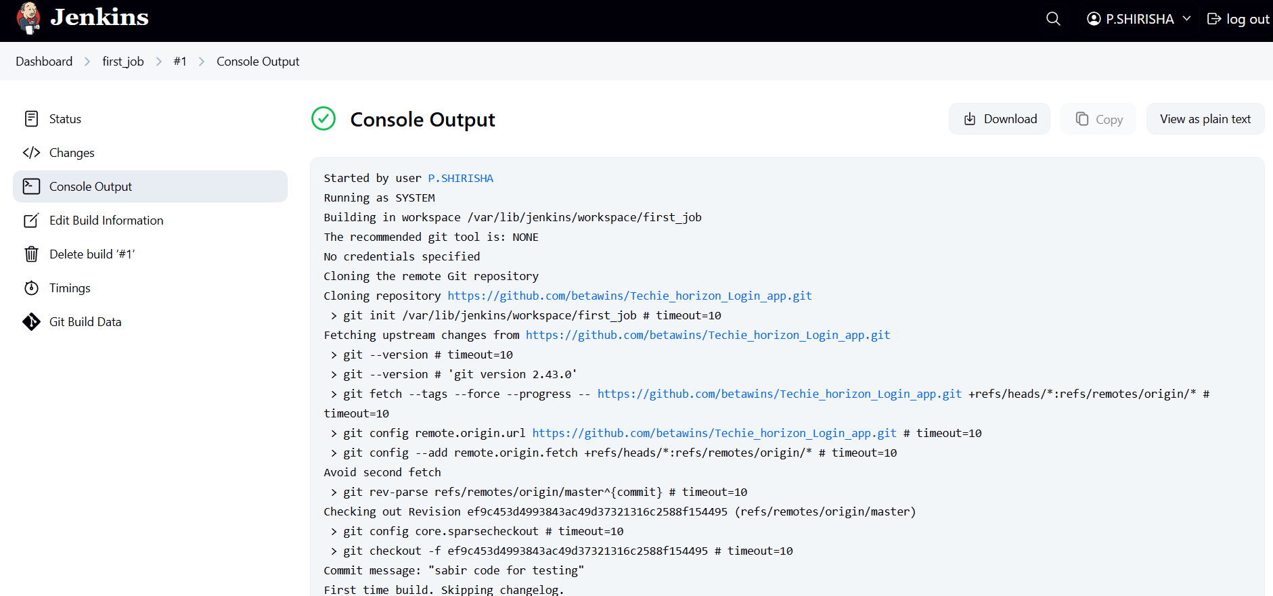

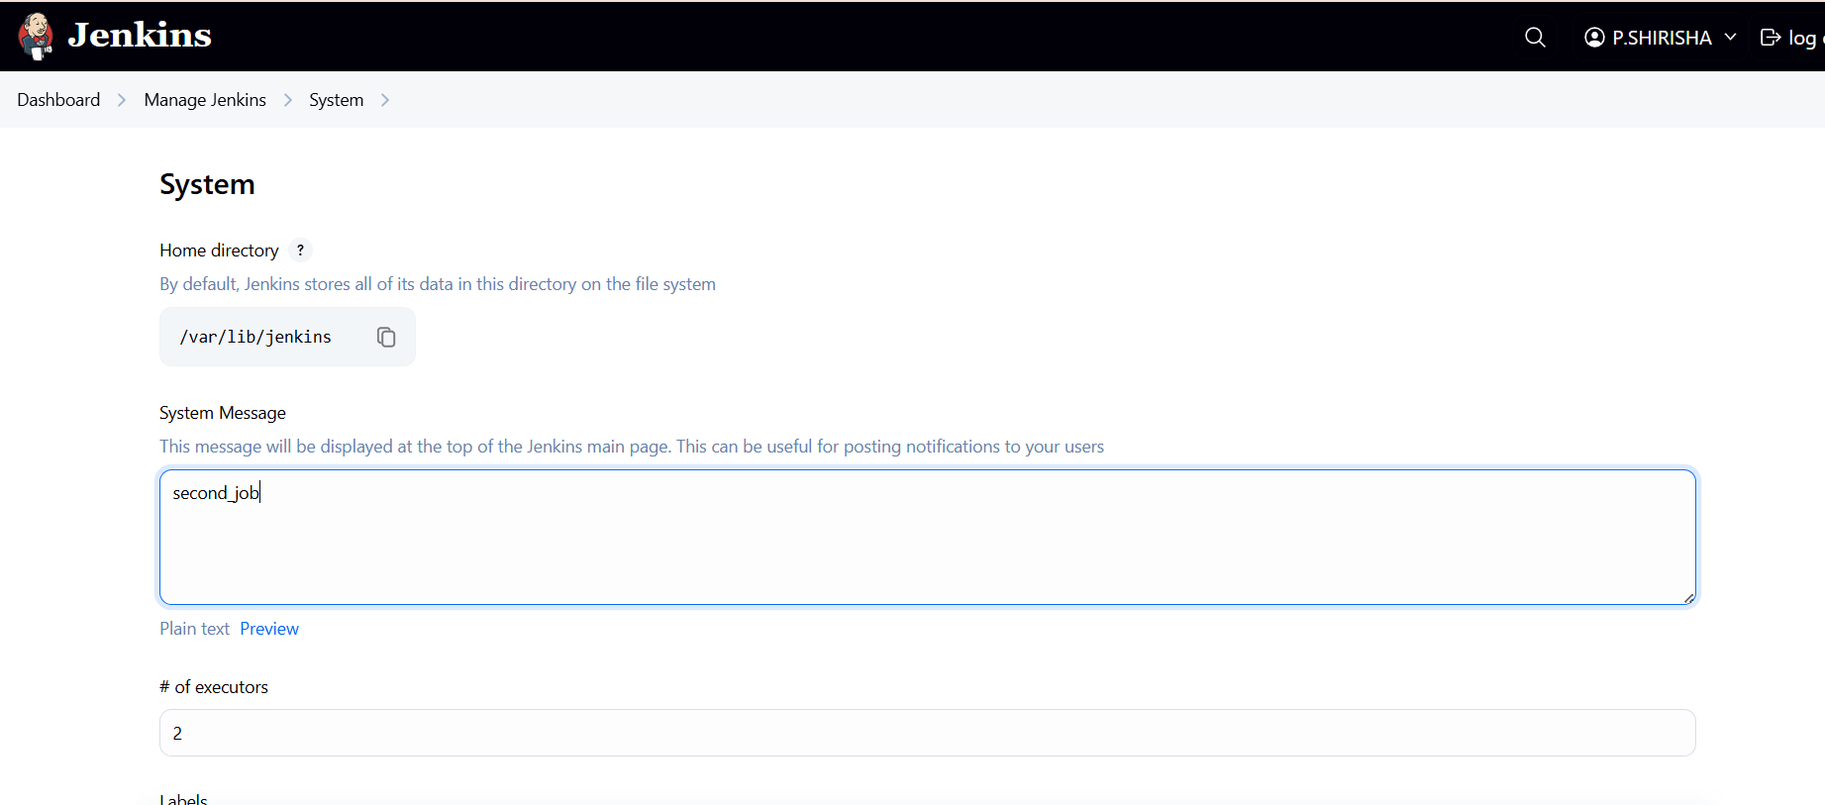

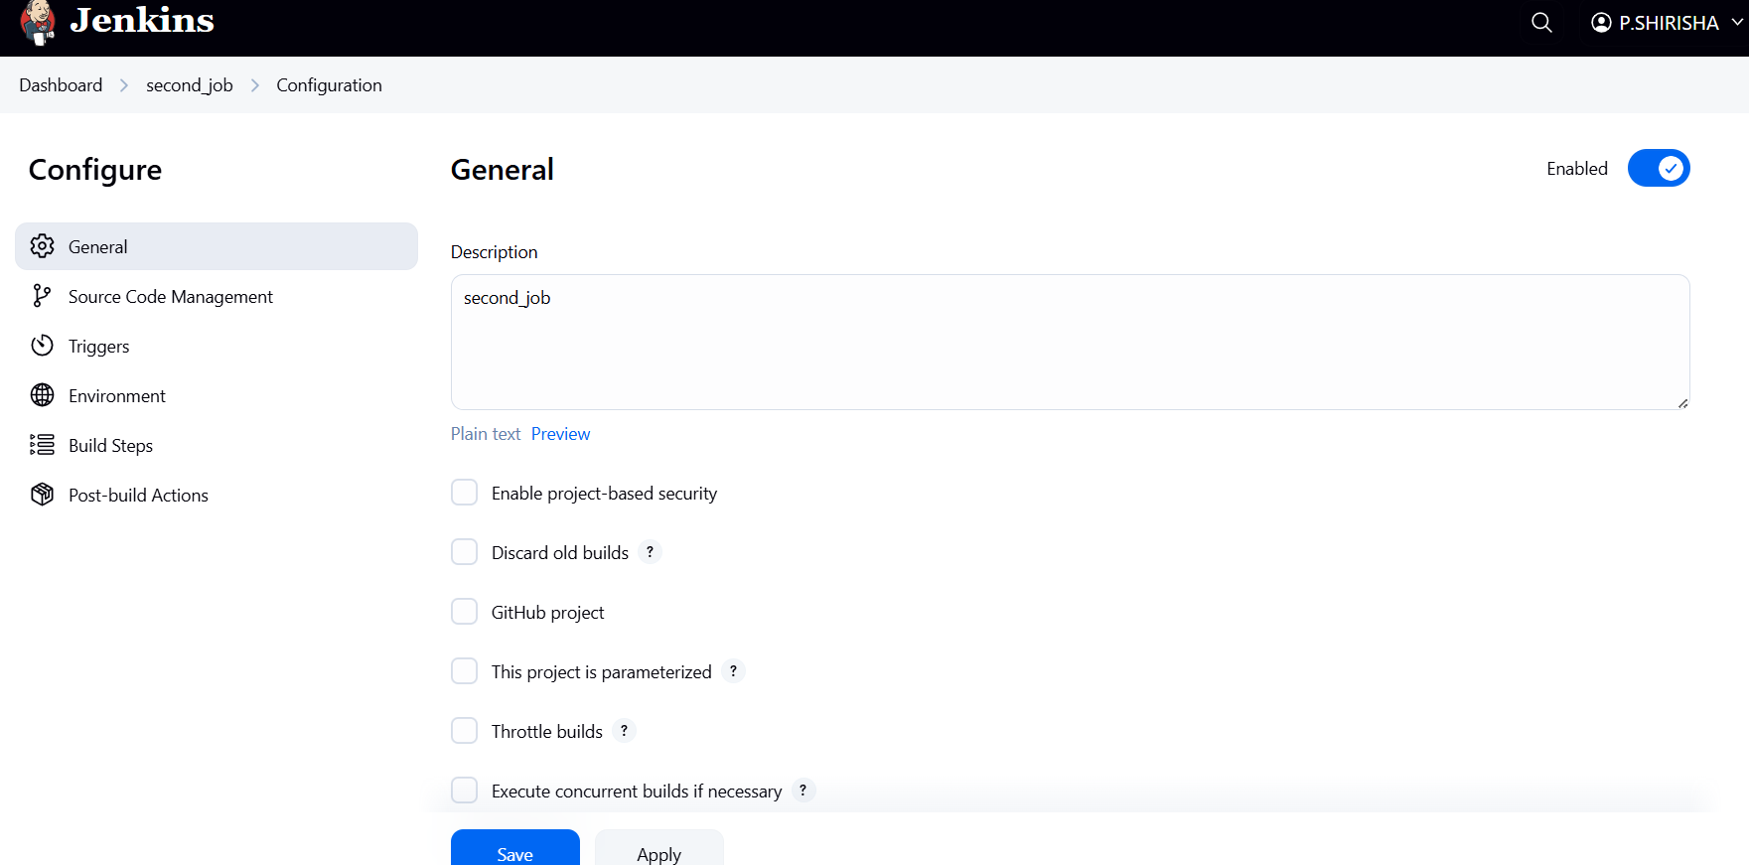

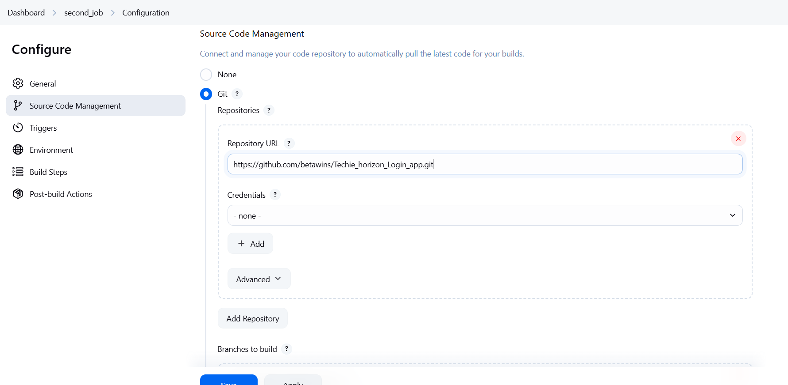

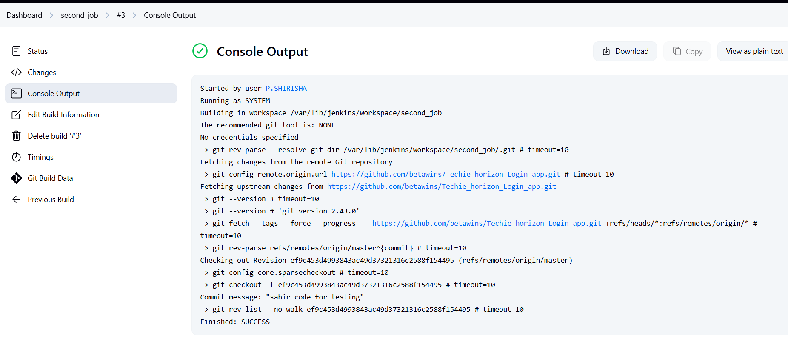

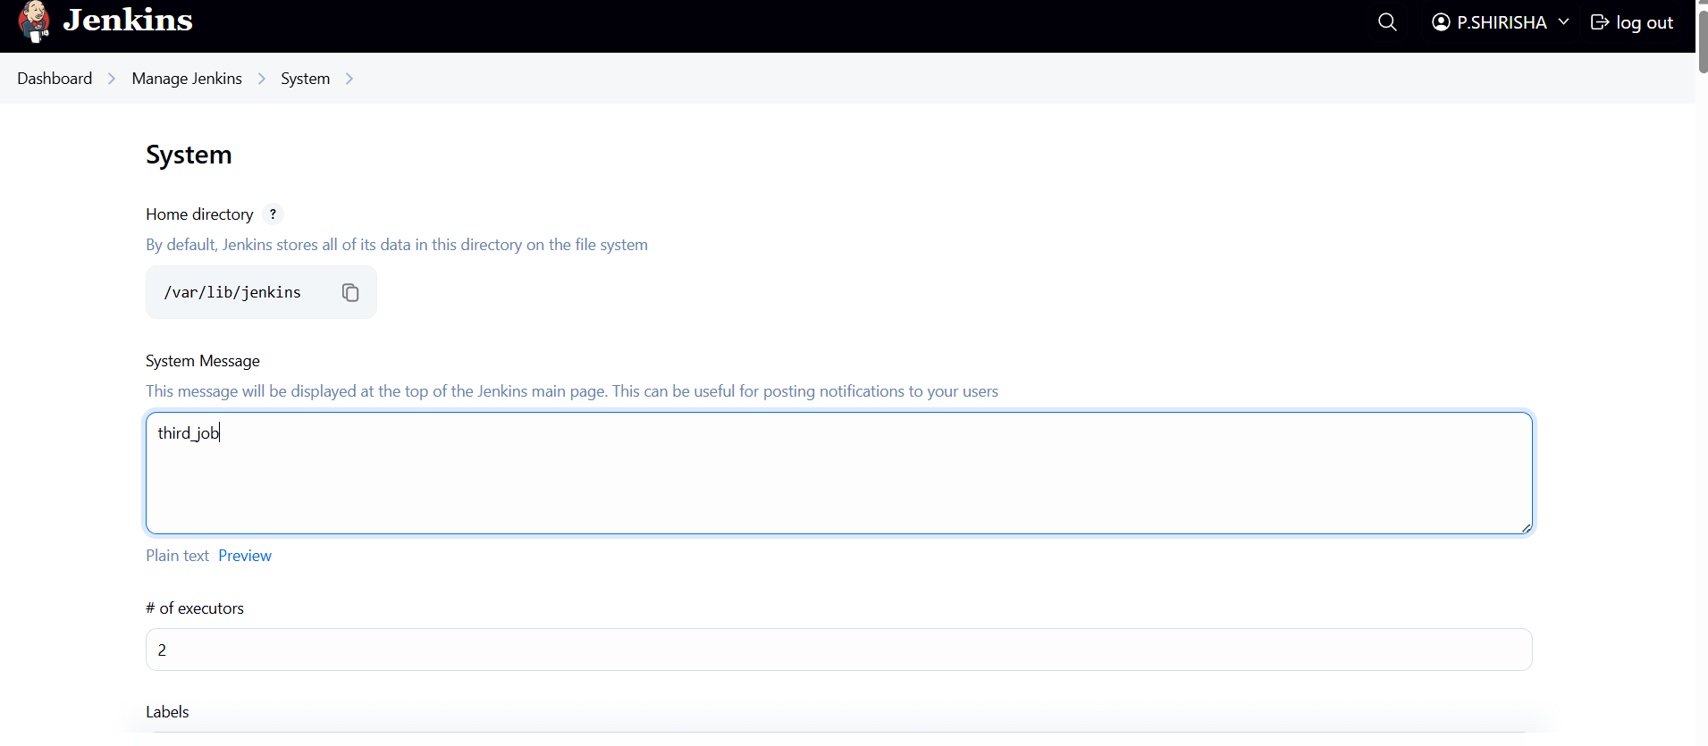

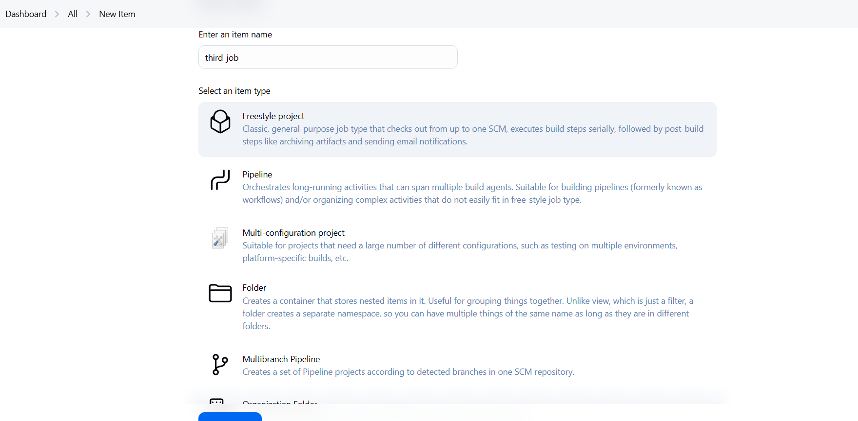

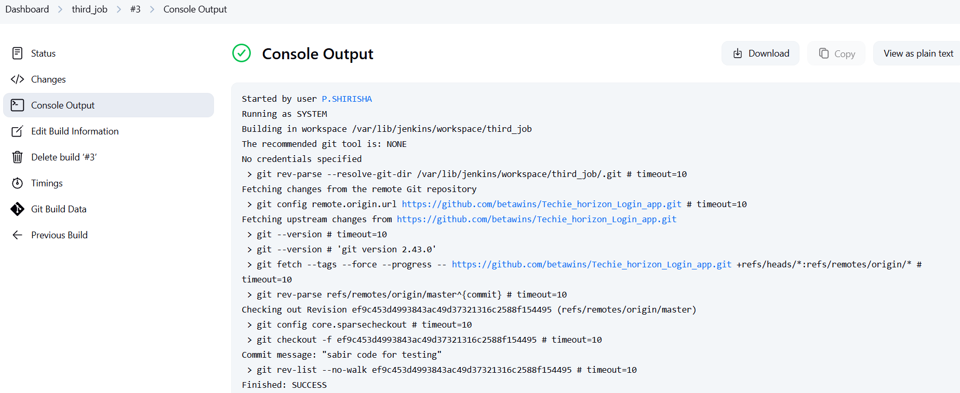

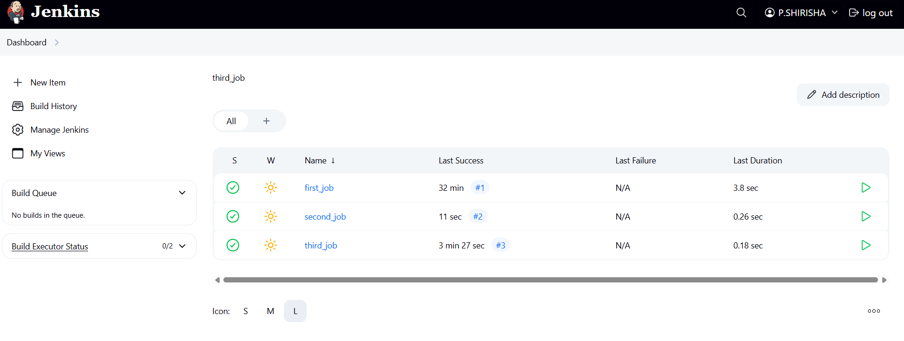

6)Create one jenkins job using git hub Private repository.

first you need to create personal key>in github   
create private repo >go settings>go to developer   
settings>then generate a key>give read access to   
the private repo >in the permissions select content   
to read-only>click on generate >after generate   
copy the key  
go to jenkins dashboard>in the manage keys   
>select credentials>go to globol   
credentials>click on create credentials>give the   
repo username>password is the generate key pateit   
there >give the name >give id any name >click   
on save  
go to dash board > new item>create new job>in   
the job generals>give the github url>chose private   
repo>>give any build test bash script >click on save  
now click on build now >see in in the queue   
>select the test and see the status it will success

