1) Create VPC with 2 private and 2 public subnets.

. Go to the VPC Dashboard

-In the search bar, type "VPC" and go to the VPC Dashboard.

-Click “Create VPC”

- Name tag: MyVPC01

- IPv4 CIDR block: 10.0.0.0/16

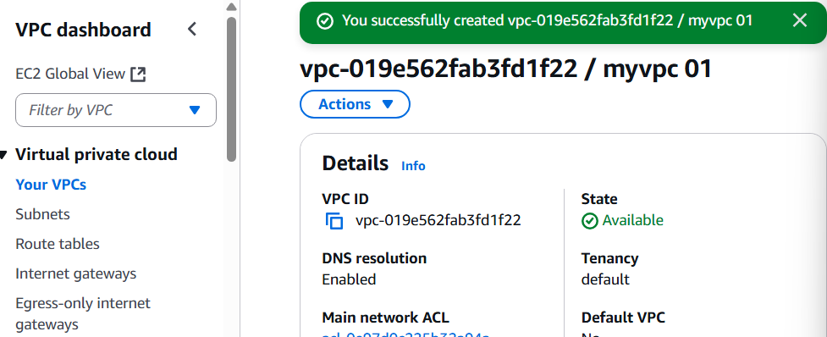

-Create vpc

Create Subnets

🡺 Public Subnet 1

-Go to Subnets > Create subnet

-VPC ID: Choose MyCustomVPC

-Subnet name: Public-Subnet-1

-Availability Zone: Pick one (e.g., us-east-1a)

-IPv4 CIDR block: 10.0.1.0/24

🡺Public Subnet 2

-Same process, use:

-Name: Public-Subnet-2

-AZ: us-east-1b

-CIDR: 10.0.2.0/24

🡺Private Subnet 1

-Name: Private-Subnet-1

-AZ: us-east-1a

-CIDR: 10.0.3.0/24

🡺Private Subnet 2

-Name: Private-Subnet-2

-AZ: us-east-1b

-CIDR: 10.0.4.0/24

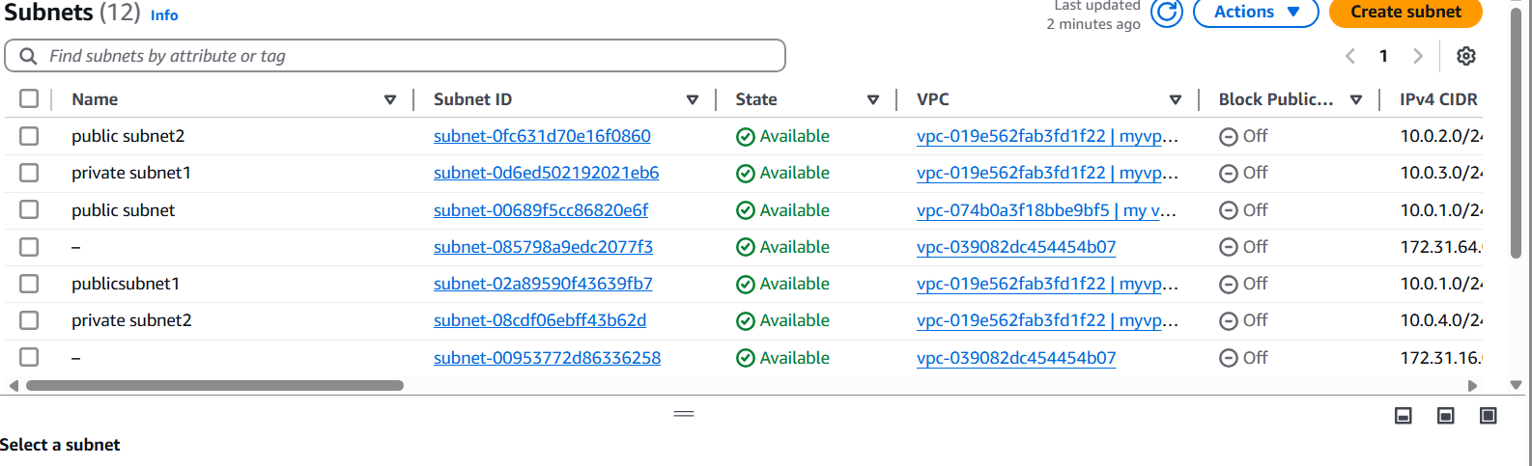

2) Enable DNS Hostname in VPC

-firstly go to action. it should be on right side top. in that go to edit vpc settings.  
-In that vpc settings click on enable DNS hostname

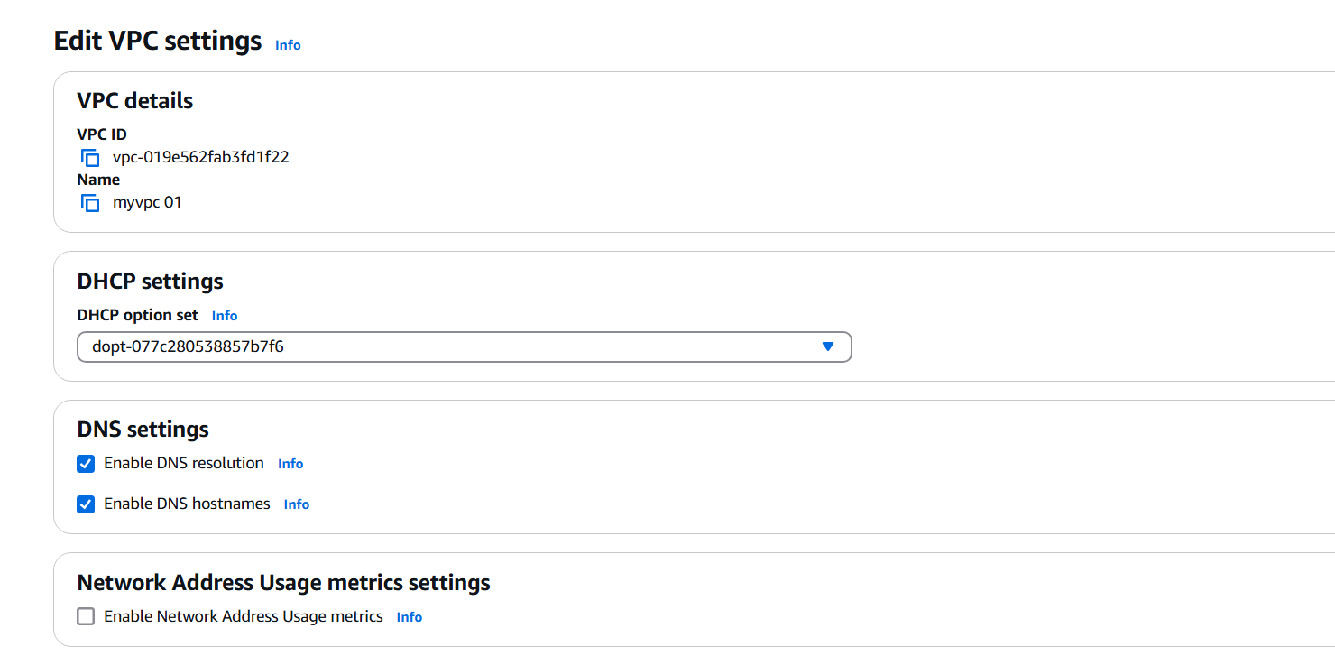

Click the checkbox next to your custom VPC

With the VPC selected, click Actions > Edit VPC settings

3) Enable Auto Assign Public ip in 2 public subnets

1. Go to VPC Dashboard → Subnets  
2. Click the Subnet ID (not the checkbox) for the public subnet  
3. Scroll down to the Subnet settings section  
4. Click the Edit button near “Auto-assign IP settings”  
5. Enable: "Auto-assign IPv4 address"  
6. Click Save changes

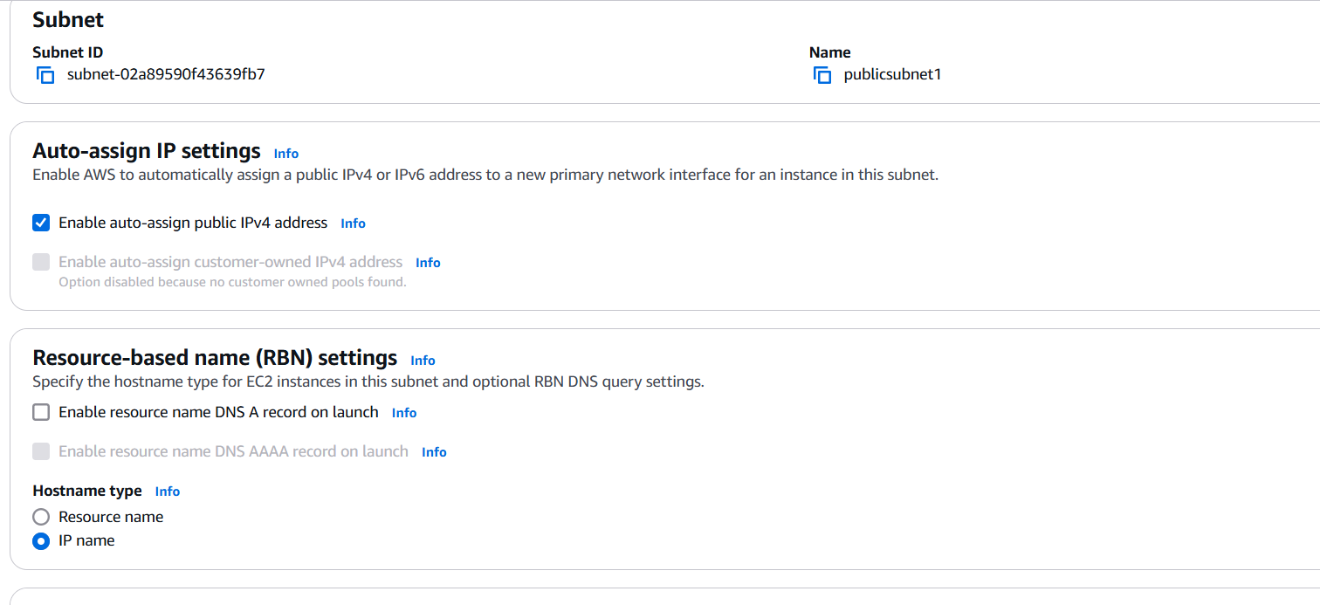

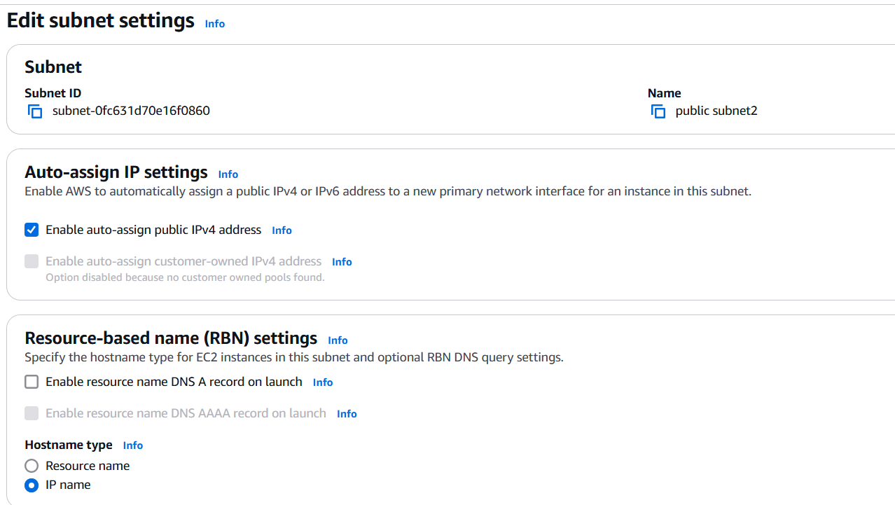  
 4) Add 2 private subnets in private route table

Go to the VPC Dashboard  
•Open the AWS VPC Console  
•In the left-hand menu, click on Route Tables  
2. Select Your Private Route Table  
•Identify your private route table (not associated with an internet gateway)  
•Click the Route Table ID  
3. Go to Subnet Associations  
•Click the “Subnet associations” tab  
•Click “Edit subnet associations”  
4. Add Your Private Subnets  
•From the list of available subnets, check the boxes next to:  
 -Private-Subnet-1  
 -Private-Subnet-2  
•Click Save associations

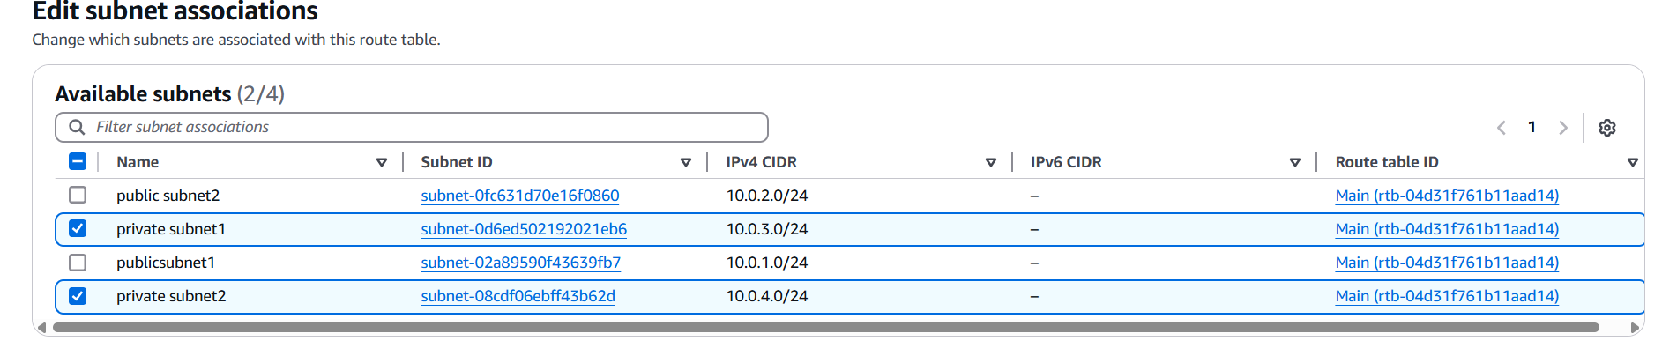

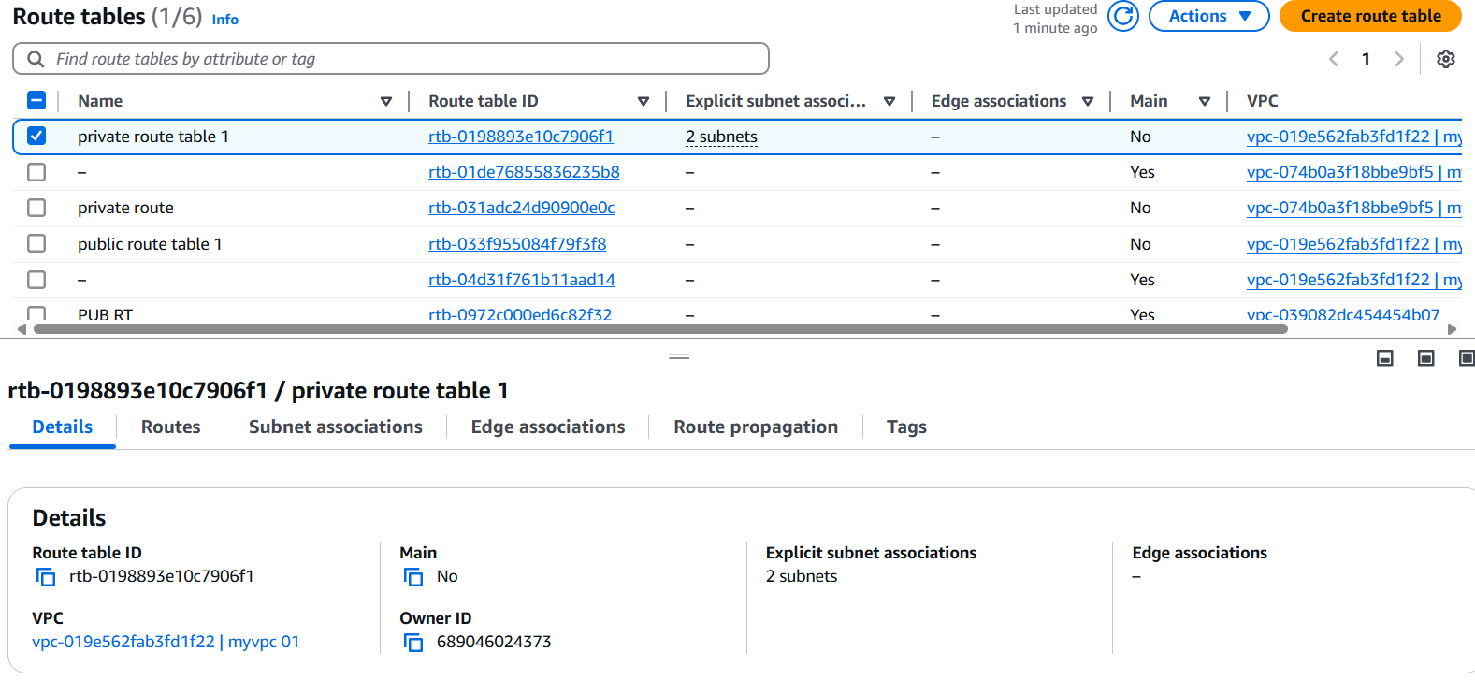

5) Add 2 public subnets in public route table

1. Go to the VPC Dashboard  
 •Open the AWS VPC Console  
 •In the left-hand menu, click Route Tables  
2. Select Your Public Route Table  
 •Find the route table that is:  
 Associated with your Internet Gateway  
 Contains a route like 0.0.0.0/0 → igw-xxxx  
 •Click the Route Table ID  
 3. Go to Subnet Associations  
 •Click the Subnet associations tab  
 •Click Edit subnet associations  
 4. Add the Public Subnets  
 •From the list, check:  
 Public-Subnet-1  
 Public-Subnet-2  
 •Click Save associations

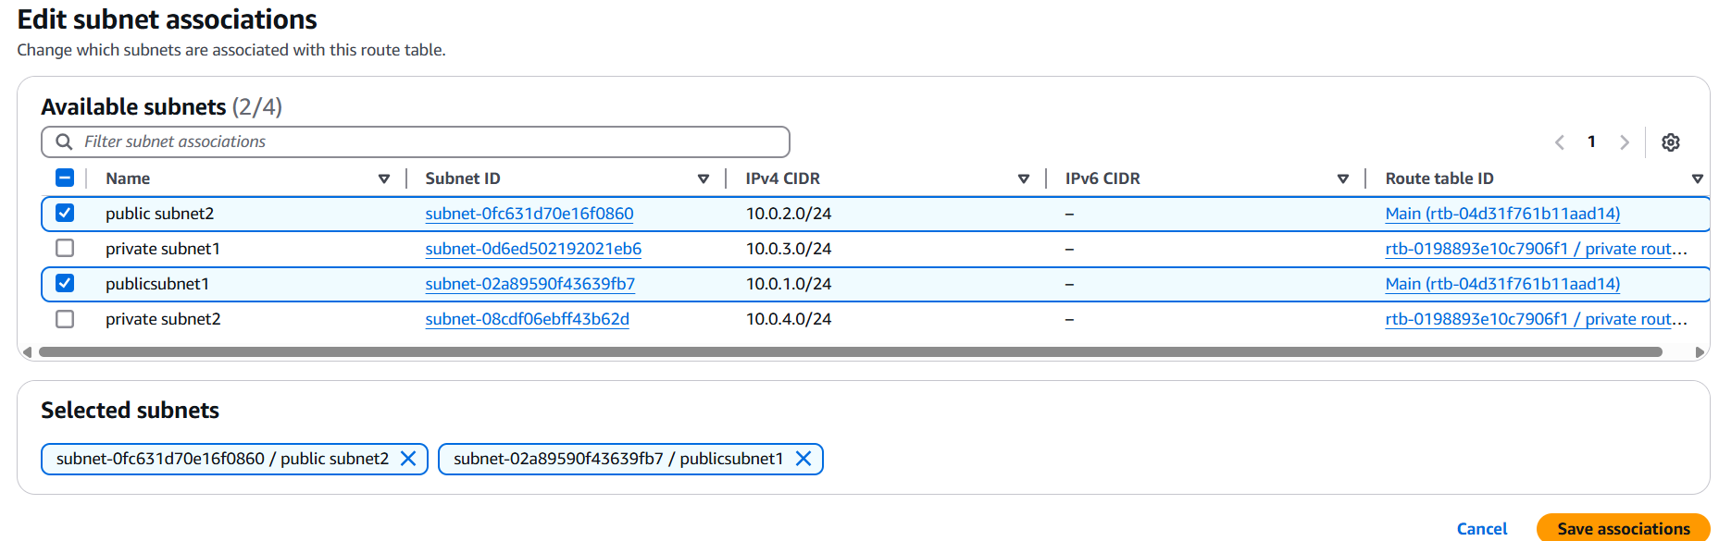

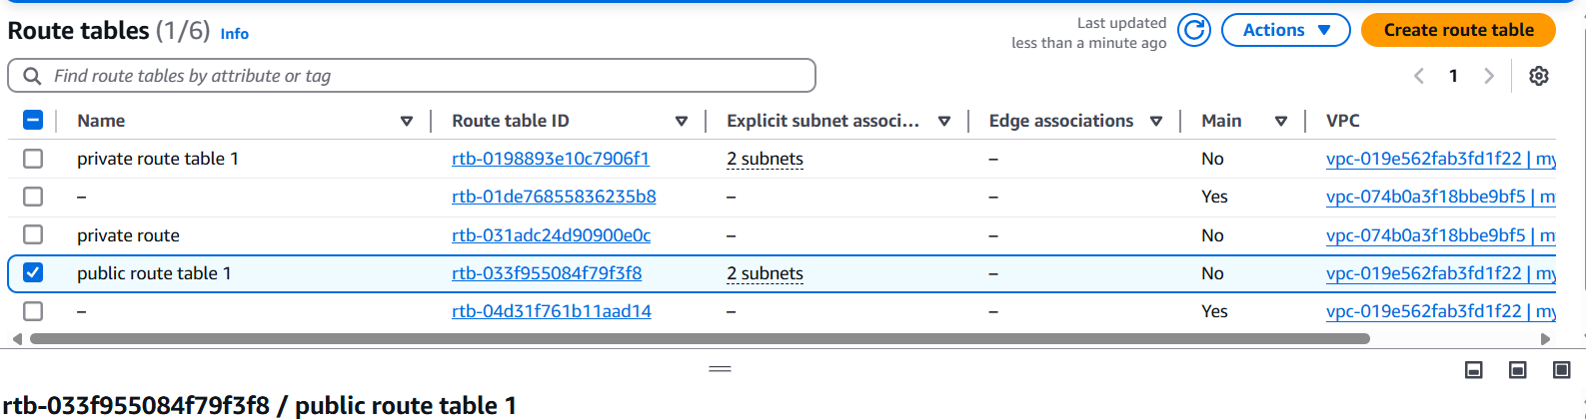

6) Public route table will have the routes to internet and local

In the Routes tab, you should see these two routes:  
1. Internet route:  
Destination: 0.0.0.0/0  
Target: igw-xxxxxxxx (your Internet Gateway)  
2. Local route:  
Destination: 10.0.0.0/16 (or the CIDR block for your VPC)  
Target: local  
Your public route table will now allow:  
•Instances in public subnets to access the internet via the Internet   
Gateway  
•Instances within the VPC to communicate with each other via the local

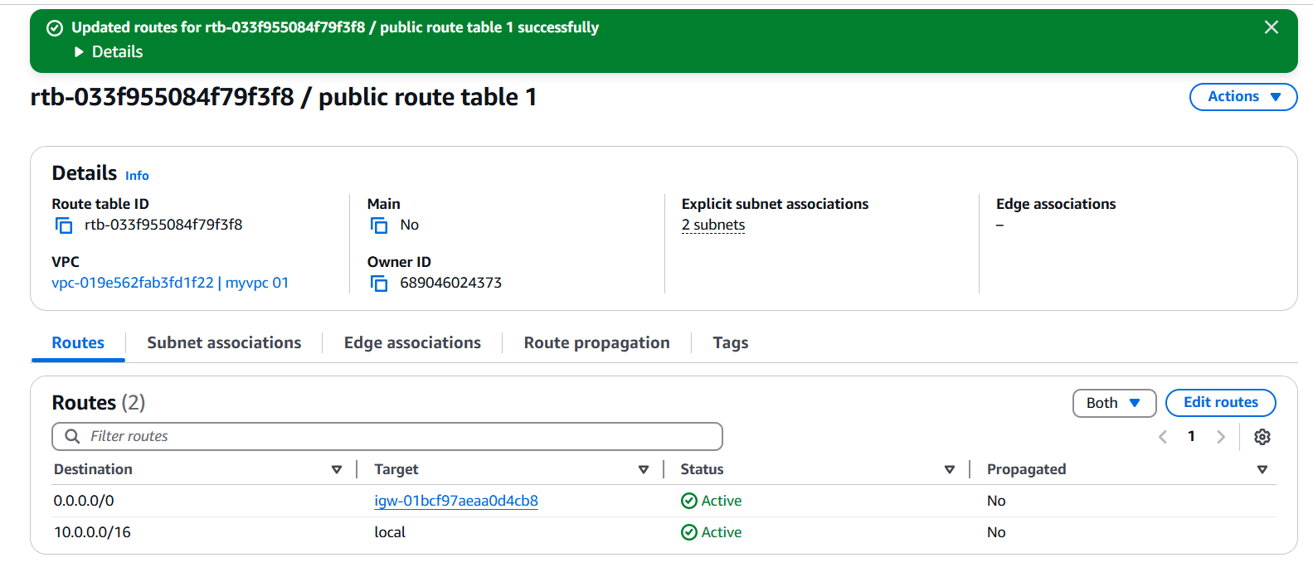

7) Create Ec2 in public subnet with t2micro and install php

● Create and launce an instance like usual , just select your   
VPC and public subnet in the settings

● ssh into it and install php, we also need to install http cuz   
PHP scripts like index.php need a web server to be executed  
and shown in the browser  
● yum update -y  
yum install -y httpd php  
systemctl start httpd  
systemctl enable httpd  
● add a php file with some php function or just add your   
content and check in through the browser 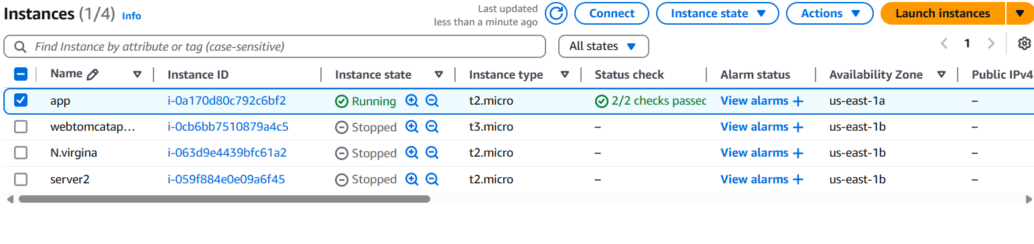

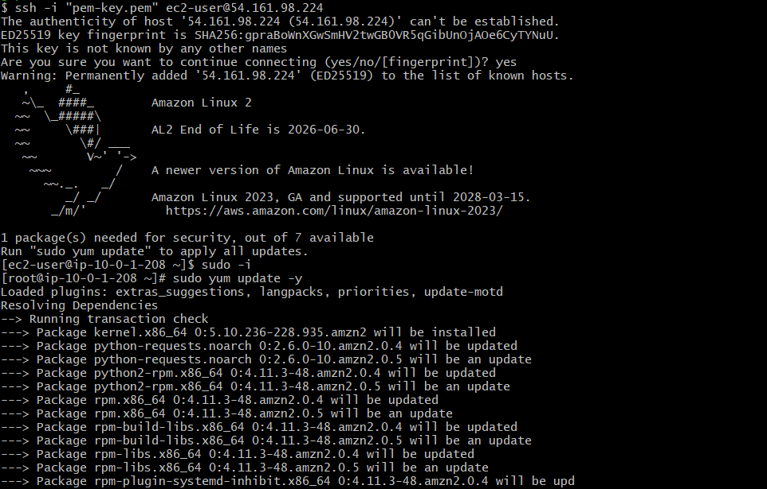

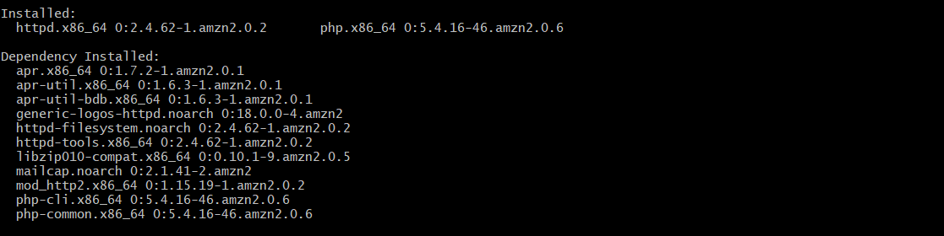

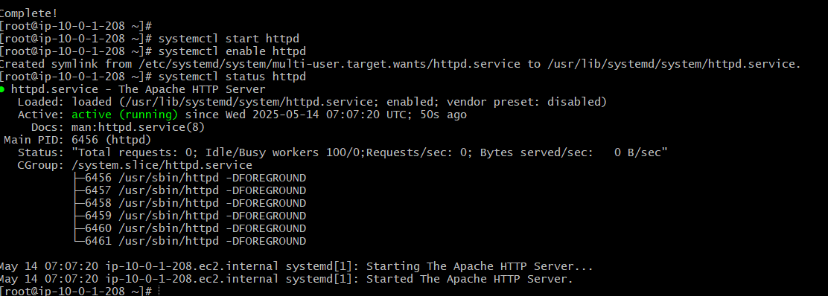

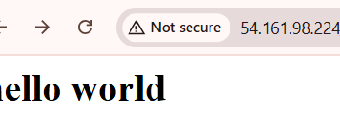

8) Configure Nat gateway in public subnet and connect to private Instance

Create a NAT Gateway  
- Go to the AWS Console → Navigate to VPC.  
- Create an Elastic IP: Go to Elastic IPs and allocate a new one.  
- Launch a NAT Gateway:  
- Go to NAT Gateways → Click Create NAT Gateway

-Select the public subnet.  
- Attach the Elastic IP.  
- Click Create.  
Update Route Table for Private Subnet  
- Go to Route Tables → Select the private subnet’s route table.  
- Edit Routes:  
- Add a new route: 0.0.0.0/0 → Target: NAT Gateway.  
- Save changes

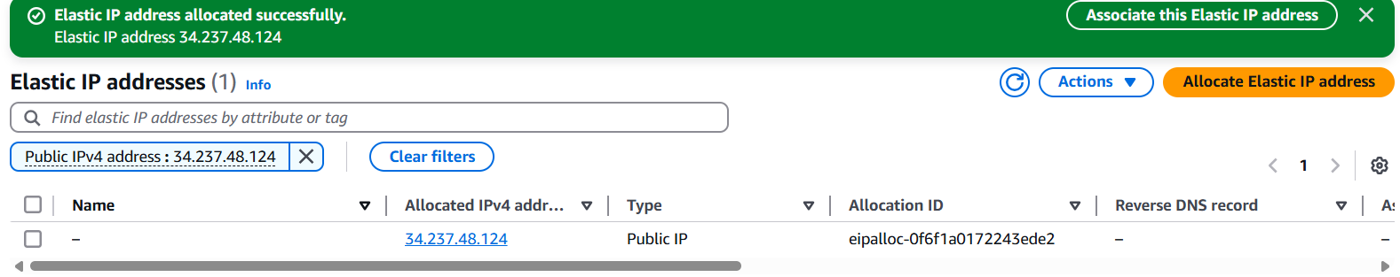

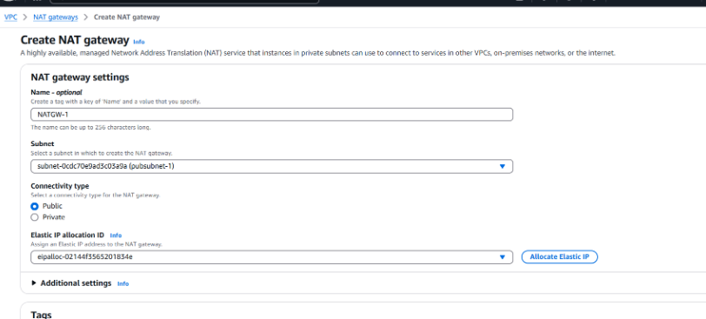

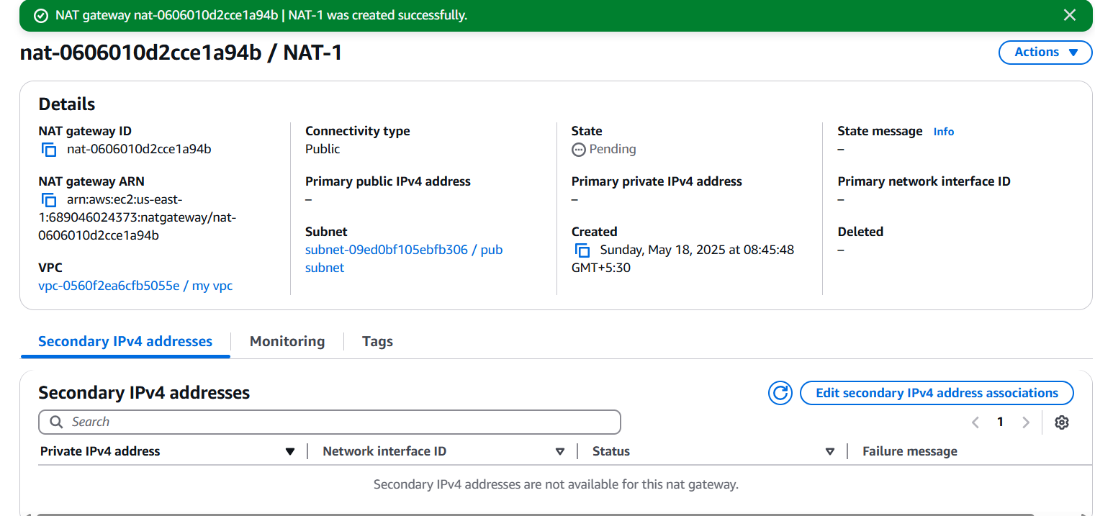

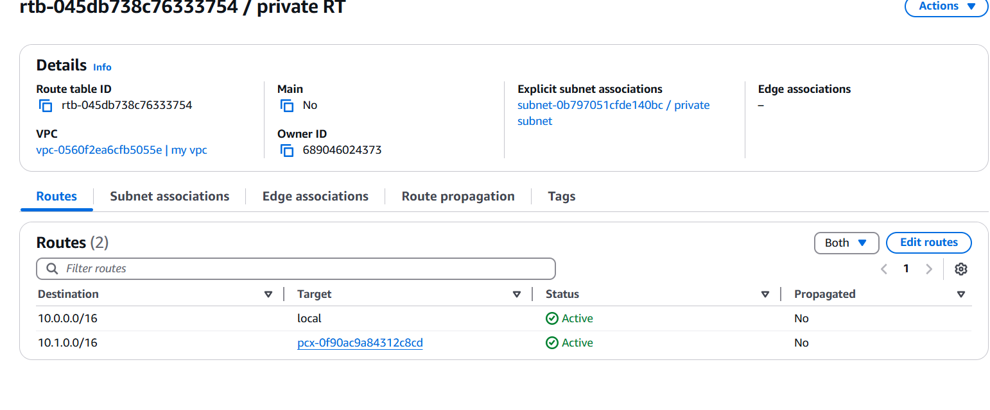

Test Connectivity  
- Launch an EC2 instance in the private subnet.  
- SSH into a public instance (if needed)

10) Configure VPC flow logs and store the logs in s3 and cloudwatch.

Step 1: Create or Choose an S3 Bucket  
1. Open the S3 Console:  
Go to the S3 Console: S3 Console.  
2. Create a New Bucket (Optional):  
If you don't already have an S3 bucket to store the logs, create a new   
one.  
Click Create bucket and follow the wizard to create the bucket

