Statistical Downscaling: Initial Findings
Study domain: 24–38°N, 30–38°E (Eastern Mediterranean and Middle East) Study period: 1990–1999 Notebook: notebooks/01_initial_data_exploration.ipynb

1. Overview
The objective of this analysis is to develop a statistical downscaling framework that learns a mapping from coarse-resolution global climate model (GCM) output to fine-resolution near-surface temperature fields over the Eastern Mediterranean and Middle East (EMME). The predictor dataset consists of daily near-surface air temperature (TAS) from the CMIP6 CESM2-WACCM historical simulation (~1° grid), and the target dataset is the ERA5-Land reanalysis 2 m temperature (T2M) at 0.1° resolution. The study region spans 24–38°N, 30–38°E, and the analysis period covers 1990–1999. Statistical downscaling exploits the empirical relationship between the large-scale temperature field and its fine-resolution counterpart to produce high-resolution estimates from GCM output — a prerequisite for regional climate impact assessments.

2. Datasets
Dataset | Variable | Period | Nominal resolution | Calendar
ERA5-Land (target) | 2 m temperature (t2m) | 1990–1999 | 0.1° × 0.1° (~11 km) | Gregorian
CMIP6 CESM2-WACCM (predictor) | Near-surface air temperature (tas) | 1990–1999 | ~0.94° × 1.25° (~100 km) | No-leap
The actual spatial extents extracted from the NetCDF files are reported in notebooks/01_initial_data_exploration.ipynb (Section 1), as the downloaded domain includes padding beyond the nominal study boundaries.
Descriptive statistics (after conversion to °C, land pixels only for ERA5-Land):
Dataset | Minimum | Mean | Maximum
ERA5-Land T2M | −21.3°C | 19.2°C | 40.6°C
CMIP6 CESM2-WACCM TAS | −14.7°C | 20.5°C | 41.5°C

3. Main Statistics
Metric | Value
Study domain | 24–38°N, 30–38°E
Study period | 1990–1999 (3,650 days, no-leap calendar)
ERA5-Land land pixels | 7,683
CMIP6 cells in domain | 97
Total pixel × day pairs | ~28,000,000
ERA5-Land mean T2M | 19.2°C
CMIP6 mean TAS | 20.5°C
Missing data fraction | 32.7% (land–sea mask, static)
Pearson r (cell-level) | ≈ 0.9

4. Data Alignment & Preprocessing

4.1 Calendar harmonisation
ERA5-Land adheres to the proleptic Gregorian calendar, which includes 29 February in leap years (1992 and 1996 within the study period). The CMIP6 CESM2-WACCM model employs a no-leap calendar (365 days per year). To produce a common time axis, the two ERA5-Land leap days were removed, yielding a shared record of 3,650 days spanning 1 January 1990 to 31 December 1999.

4.2 Unit conversion
Both datasets store temperature in Kelvin (K). Values were converted to degrees Celsius (°C) by subtracting 273.15 K.

4.3 Land–sea mask and missing values
ERA5-Land provides data exclusively over land grid cells; oceanic pixels are assigned NaN. Approximately 32.7% of grid cells in the target domain contain missing values. This is a structural property of the dataset, not a data quality issue — the same pixels are missing on every day in the record, consistent with a static land–sea mask. The missing pattern aligns precisely with the Eastern Mediterranean Sea, the Red Sea, and the Persian Gulf.
The binary map below shows which pixels contribute to the analysis. Land pixels are shown in green; ocean (no-data) pixels in blue.
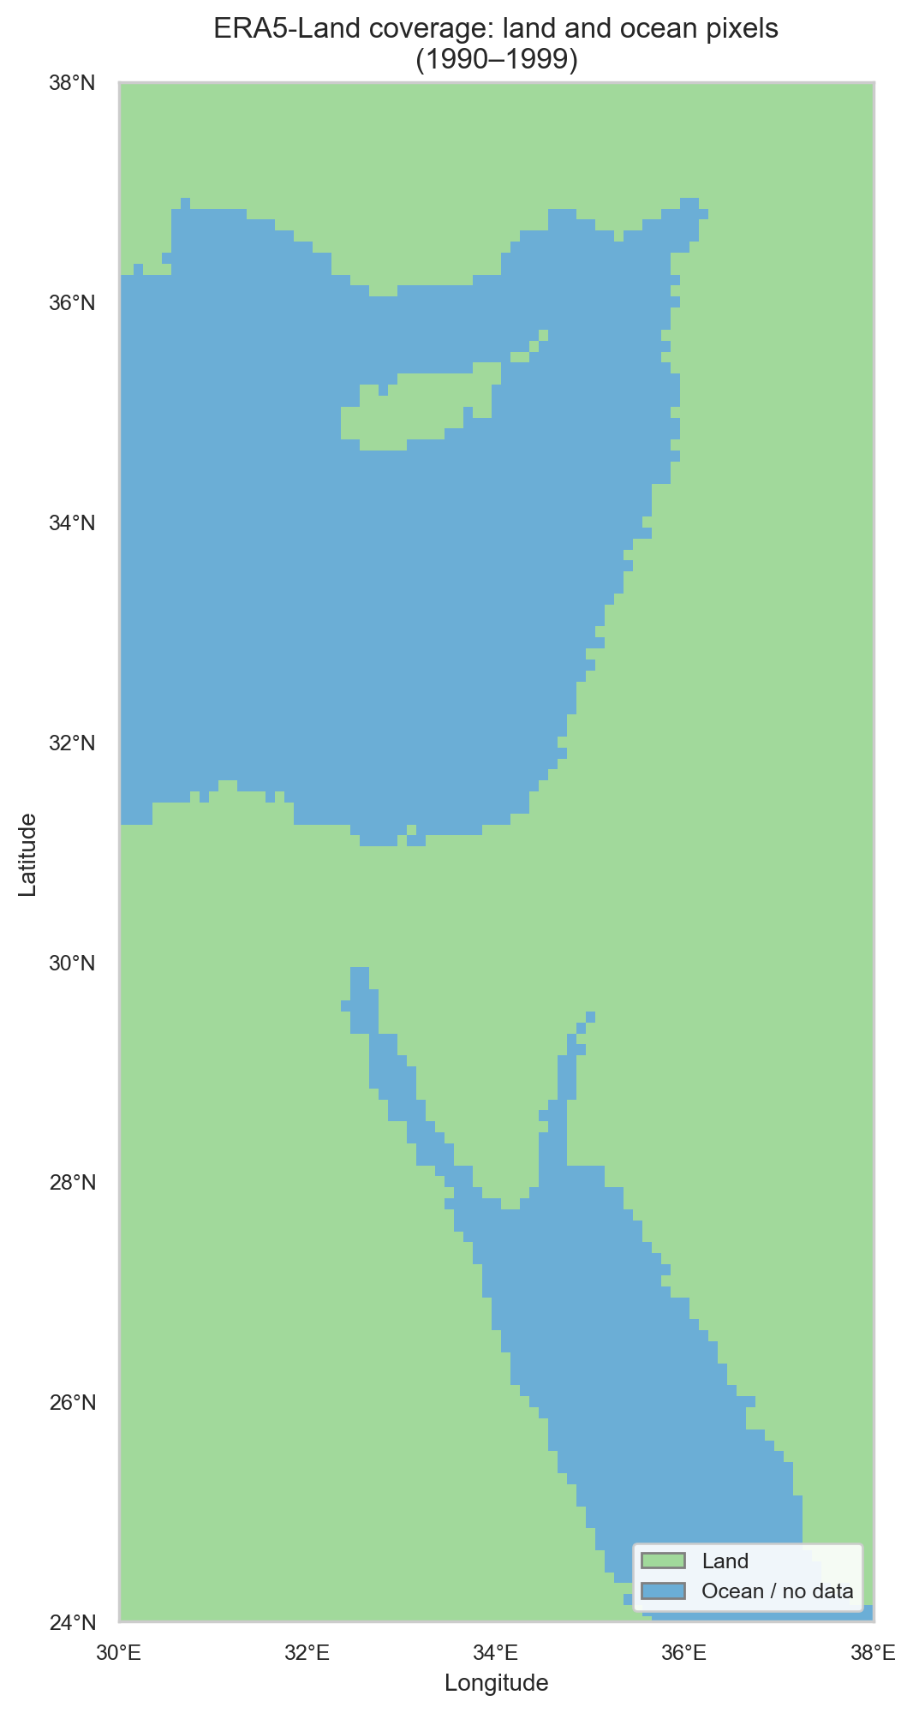
Fig. 1b
Fig. 1b. ERA5-Land land and ocean pixels, 1990–1999. Green: valid land pixels. Blue: ocean grid cells (always NaN in ERA5-Land). The static land–sea boundary follows the Eastern Mediterranean Sea, Red Sea, and Persian Gulf. Data: ERA5-Land T2M, 24–38°N, 30–38°E.

5. Exploratory & Descriptive Analysis

5.1 Temporal variation
Domain-averaged daily temperature time series for both datasets reproduce the same unimodal annual seasonal cycle across the full decade (Fig. 3a), with a summer maximum of approximately 30–32°C (July–August) and a winter minimum of approximately 8–10°C (January–February). The CMIP6 CESM2-WACCM domain mean (~20.5°C) is systematically higher than ERA5-Land (~19.2°C) by approximately 1–2°C. This warm bias is consistent across the full period and is most pronounced in late winter and early spring.
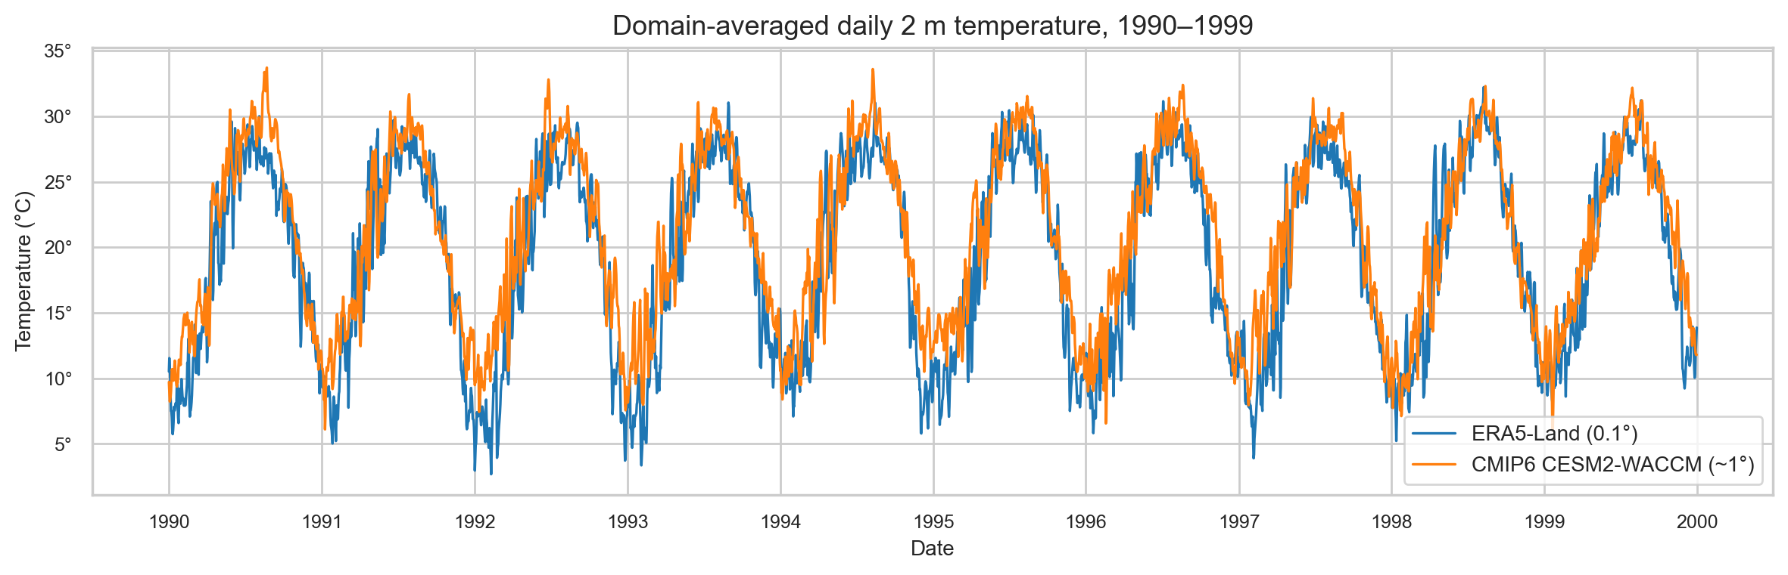
Fig. 3a
Fig. 3a. Domain-averaged daily 2 m temperature, 1990–1999. ERA5-Land (blue) and CMIP6 CESM2-WACCM (orange) are shown for all 3,650 days. Both datasets exhibit the same unimodal seasonal cycle; CMIP6 is systematically ~1–2°C warmer. Data: ERA5-Land T2M and CMIP6 TAS, 24–38°N, 30–38°E.
The monthly climatology (Fig. 3b) summarises the seasonal cycle and confirms that the warm bias is present in all months but is largest in February–March.
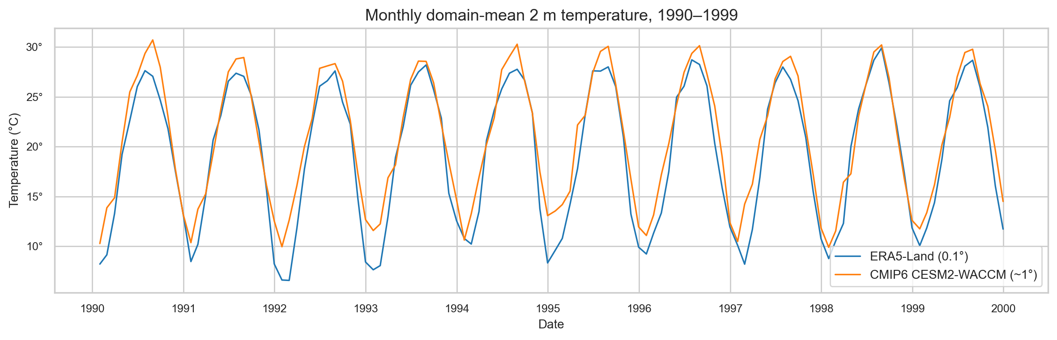
Fig. 3 (monthly trend)
Fig. 3 (monthly trend). Monthly domain-mean 2 m temperature, 1990–1999. Each point is the area-averaged temperature for one calendar month (120 points total, Jan 1990 → Dec 1999), revealing year-to-year variability within each season. The warm bias of CMIP6 CESM2-WACCM (~1–2°C) persists throughout the decade. Data: ERA5-Land T2M and CMIP6 TAS, 24–38°N, 30–38°E.
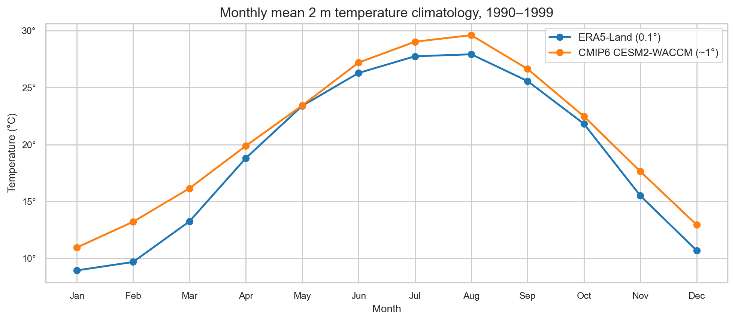
Fig. 3b
Fig. 3b. Monthly mean 2 m temperature climatology, 1990–1999. Each point represents the multi-year mean for that calendar month. Data: ERA5-Land T2M and CMIP6 CESM2-WACCM TAS, 24–38°N, 30–38°E.

5.2 Spatial variation
The mean 2 m temperature climatology (1990–1999) reveals a clear north–south thermal gradient (Fig. 2). The highest mean temperatures occur over the Arabian Peninsula (~35–40°C), and the lowest over the highlands of Turkey and the Levant (~5–15°C). Coastal and topographically complex areas exhibit pronounced spatial variability in ERA5-Land that is not resolved at the CMIP6 grid scale.
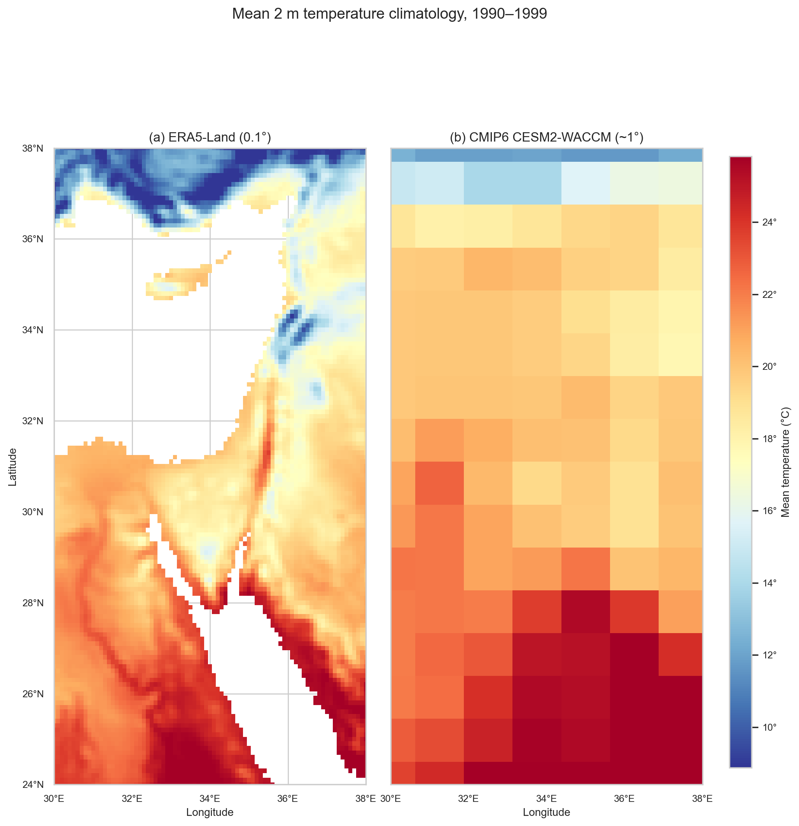
Fig. 2
Fig. 2. Mean 2 m temperature climatology, 1990–1999. Panel (a): ERA5-Land reanalysis at 0.1° resolution. Panel (b): CMIP6 CESM2-WACCM historical simulation at ~1° resolution. Both panels share the same colour scale. Data: ERA5-Land T2M and CMIP6 TAS, 24–38°N, 30–38°E.

5.3 Seasonal patterns
The four seasonal maps (Fig. 4) show ERA5-Land and CMIP6 side-by-side for each meteorological season. The north–south gradient is strongest in summer (JJA), when the Arabian heat low dominates, and weakest in winter (DJF), when the meridional temperature gradient is compressed.
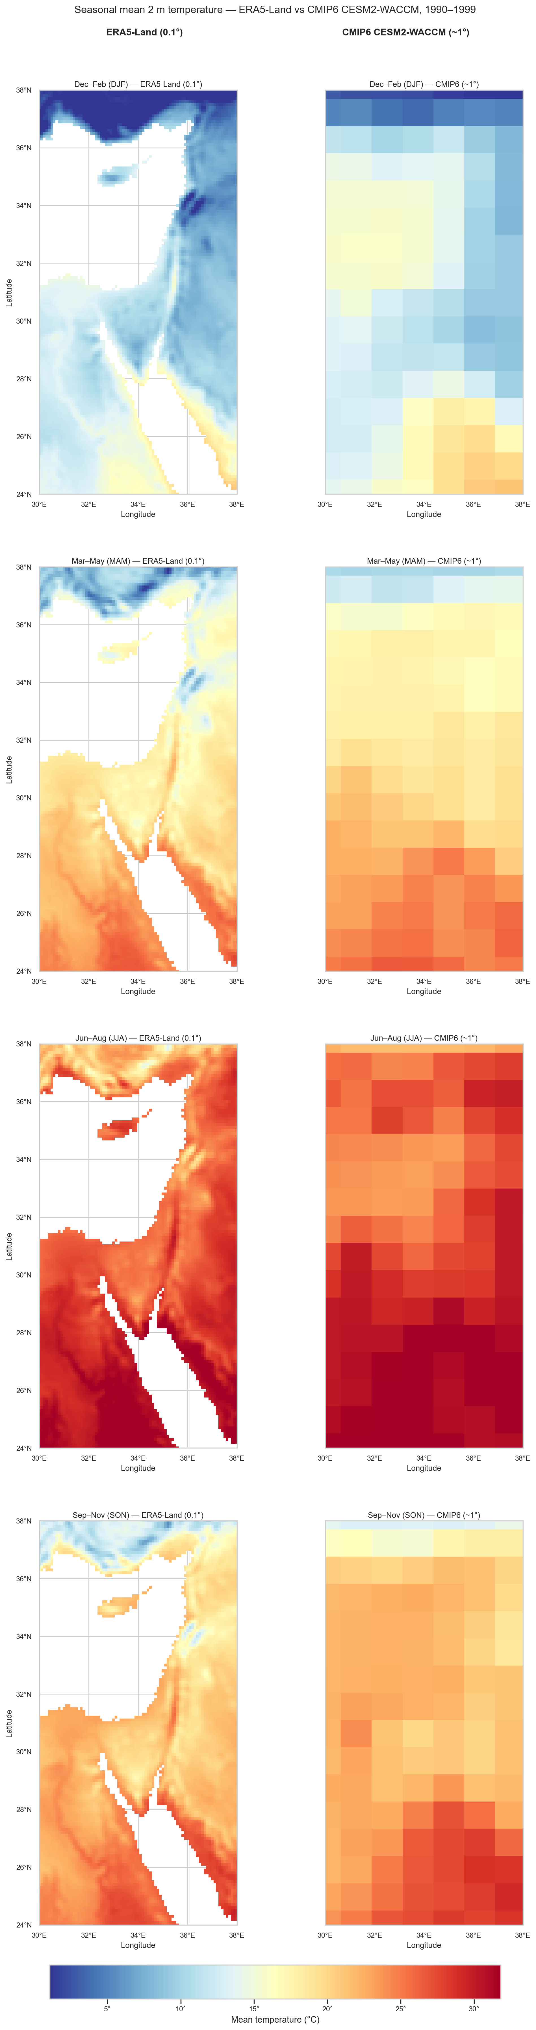
Fig. 4
Fig. 4. Seasonal mean 2 m temperature climatology, 1990–1999. Each row shows one meteorological season (DJF, MAM, JJA, SON). Left column: ERA5-Land at 0.1° resolution. Right column: CMIP6 CESM2-WACCM at ~1° resolution. All panels share the same colour scale. Data: ERA5-Land T2M and CMIP6 TAS, 24–38°N, 30–38°E.

5.4 Temperature distribution
The distribution of daily 2 m temperature values across all land pixels and all days (Fig. 5) shows that both datasets have broadly similar distributions. CMIP6 has a slightly higher median consistent with the warm bias, and narrower tails due to spatial averaging at the coarser grid.
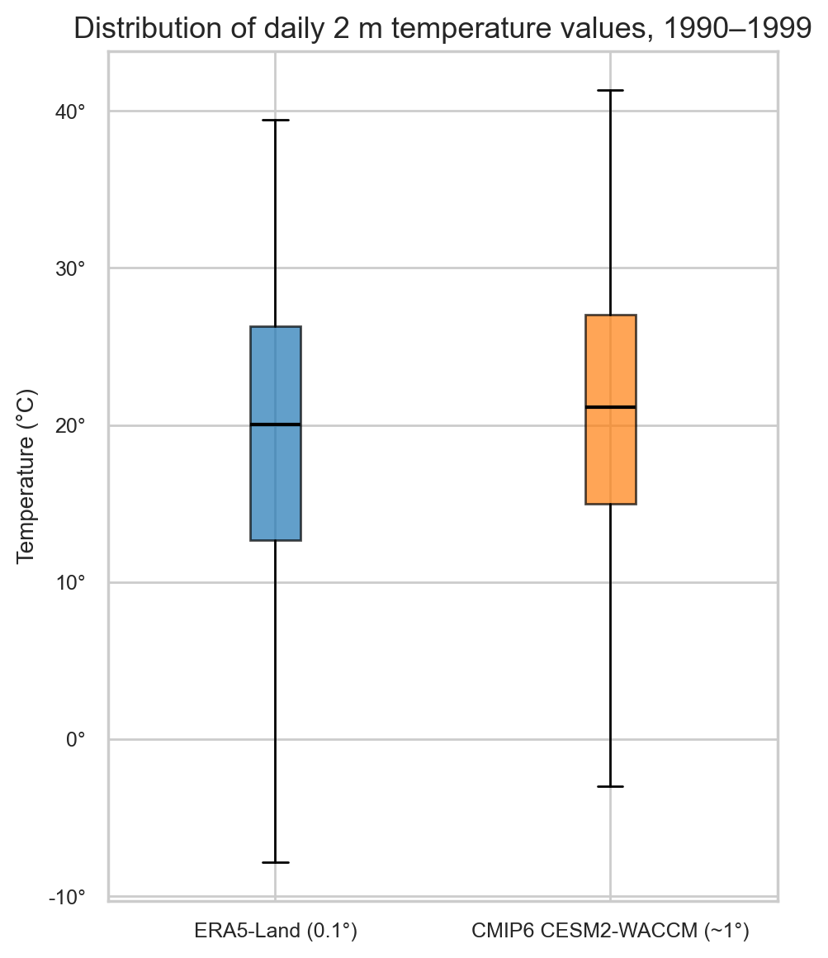
Fig. 5
Fig. 5. Distribution of daily 2 m temperature values, 1990–1999. Boxplots show the full distribution across all land pixels and all days for ERA5-Land (0.1°) and CMIP6 CESM2-WACCM (~1°). Box edges: 25th and 75th percentiles; whiskers: 1.5 × IQR; points: outliers. Data: ERA5-Land T2M and CMIP6 TAS, 24–38°N, 30–38°E.

5.5 Warming trends
Detecting a statistically meaningful decadal warming trend over a 10-year baseline (1990–1999) is inherently difficult: the interannual variability of regional daily temperature (~5–10°C standard deviation) far exceeds the expected forced trend signal (~0.02–0.05°C yr⁻¹ under late-twentieth-century forcing). Nevertheless, a structured exploratory analysis was performed to characterise the degree to which any trend is visible in this dataset, progressing from the domain-wide aggregate to a single pixel–date combination.
Step 1 — Domain-wide aggregate (no trend detectable). Domain-averaged daily temperature over 1990–1999 (Fig. 3a) shows strong seasonal periodicity but no visually discernible multi-year trend at the domain level. The large spatial averaging (7,683 land pixels) and the dominance of seasonal variance mask any underlying forced signal.
Step 2 — Fixed seasonal reference: 1 August. To remove the seasonal cycle, domain-wide minimum and maximum temperatures were extracted for 1 August in each of the ten years (Fig. 10a). By conditioning on a single calendar date, interannual variability in the domain range can be examined without the confound of seasonal modulation. The ERA5-Land domain range (min–max spread) on 1 August is approximately 25–30°C, driven primarily by the north–south thermal gradient. No coherent monotonic trend is apparent across the domain over the decade, confirming that the 10-year period is too short to isolate a forced signal from natural variability at this spatial scale.
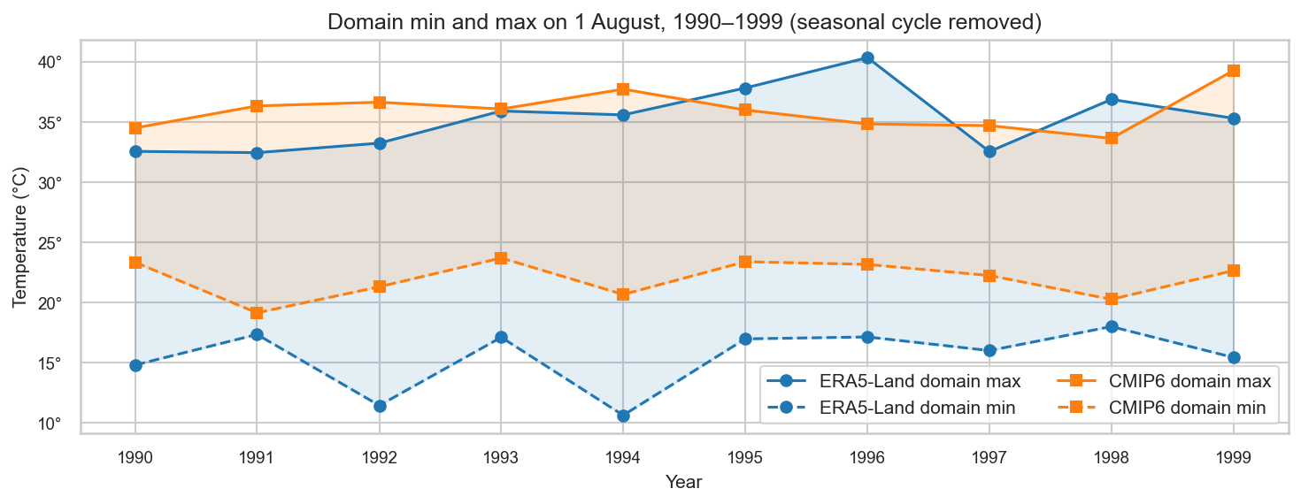
Fig. 10a
Fig. 10a. ERA5-Land and CMIP6 domain-wide minimum and maximum 2 m temperature on 1 August, 1990–1999. The shaded bands show the domain temperature range for each dataset. No consistent monotonic trend is visible across the ten years. Data: ERA5-Land T2M and CMIP6 TAS, 24–38°N, 30–38°E.
Step 3 — Single pixel and single date (trend becomes discernible). To further reduce noise, temperature was extracted from a single ERA5-Land pixel and its paired CMIP6 cell — the grid point closest to 35°E, 32°N (central Levant) — on 1 August of each year (Fig. 10b). At this point-scale, inter-annual noise is substantially lower than for the full domain. A linear OLS fit yields a positive trend of +0.217 °C yr⁻¹ for ERA5-Land and +0.121 °C yr⁻¹ for CMIP6 at this location over the decade. These values should be interpreted with caution: the 10-year record is too short to distinguish a forced trend from low-frequency natural variability, and a single pixel is subject to local noise not present in spatially averaged data.
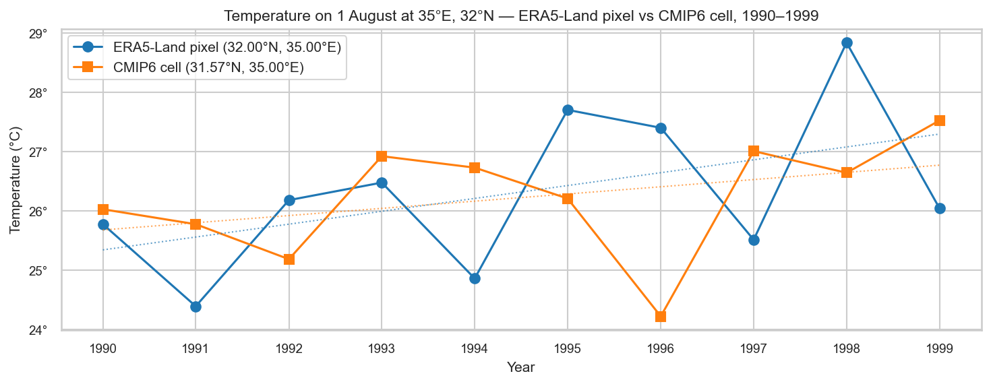
Fig. 10b
Fig. 10b. 2 m temperature on 1 August at the ERA5-Land pixel and CMIP6 cell nearest to 35°E, 32°N, 1990–1999. Dotted lines show OLS linear trend fits (ERA5-Land: +0.217 °C yr⁻¹; CMIP6: +0.121 °C yr⁻¹). Data: ERA5-Land T2M and CMIP6 TAS.
Step 4 — Quarterly means at the representative location. To obtain a more robust (less noisy) view of intra-decadal variability, quarterly (seasonal) mean temperatures were computed at the same location for each of the four meteorological seasons (Fig. 10). Seasonal means aggregate ~90 days per quarter, substantially reducing day-to-day noise relative to the single-date approach. The resulting time series confirm the general agreement between ERA5-Land and CMIP6 in terms of inter-annual variability, with CMIP6 exhibiting a systematic warm bias of ~1–2°C that is broadly constant across seasons and years. No season shows a statistically significant monotonic trend over the 10-year period, consistent with the domain-level analysis.
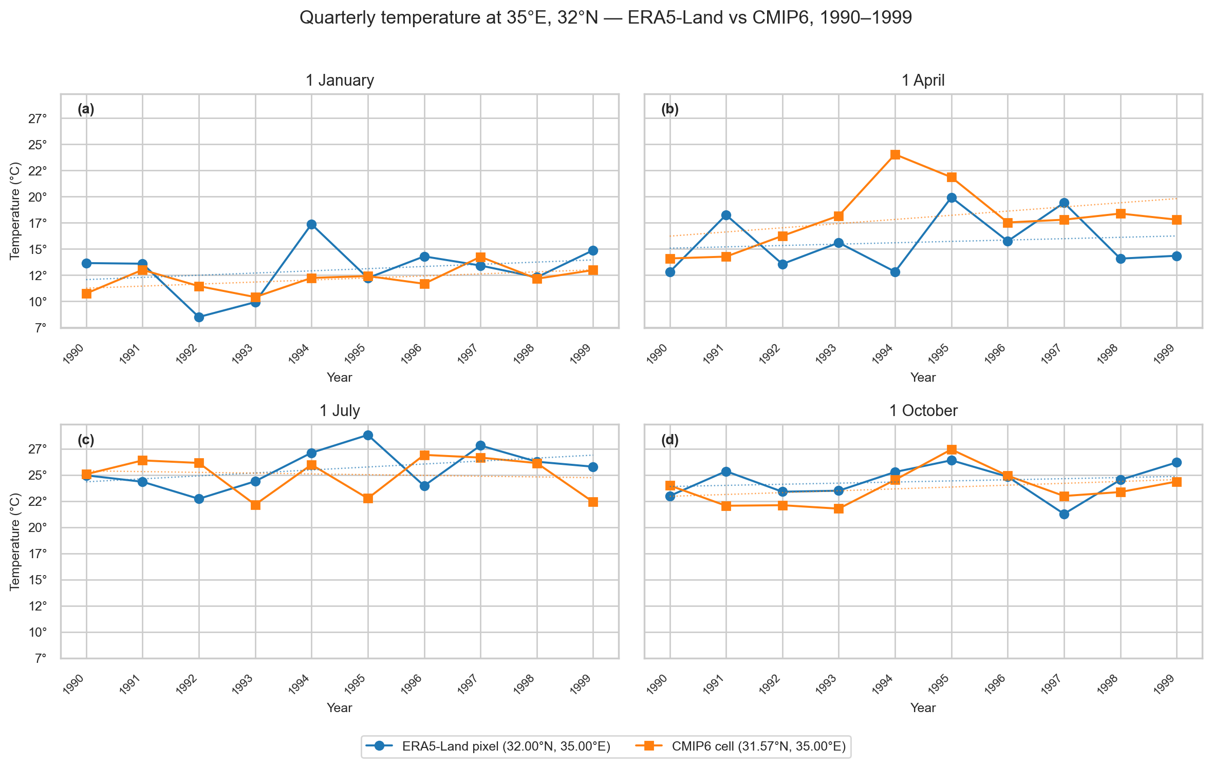
Fig. 10
Fig. 10. Quarterly mean 2 m temperature at the location nearest to 35°E, 32°N, 1990–1999. Each panel shows one meteorological season (DJF, MAM, JJA, SON). ERA5-Land (blue) and CMIP6 (orange) quarterly means are plotted for each year of the study period. Data: ERA5-Land T2M and CMIP6 TAS, 24–38°N, 30–38°E.

6. Pairing Mechanism

6.1 Nearest-neighbour pixel-to-cell assignment
Each of the 7,683 ERA5-Land land pixels was assigned to the nearest CMIP6 grid cell using nearest-neighbour matching along the latitude and longitude axes independently (an approximation to geodetic distance, adequate at these spatial scales). This procedure yielded 97 unique CMIP6 cells covering the target domain.
The nearest-neighbour method assigns each fine-resolution pixel to exactly one coarse cell, ignoring partial spatial overlaps with adjacent cells. Alternative methods (bilinear interpolation, area-weighted remapping) are discussed in analysis_guidelines.md.
Table 1. Summary statistics of ERA5-Land (0.1°) pixel counts per CMIP6 (~1°) grid cell.
Statistic | Value
Number of CMIP6 cells | 97
Total land pixels assigned | 7,683
Mean pixels per cell | ~79
Median pixels per cell | (see notebook, Section 5)
Std. dev. | (see notebook, Section 5)
Minimum | (see notebook, Section 5)
Maximum | (see notebook, Section 5)
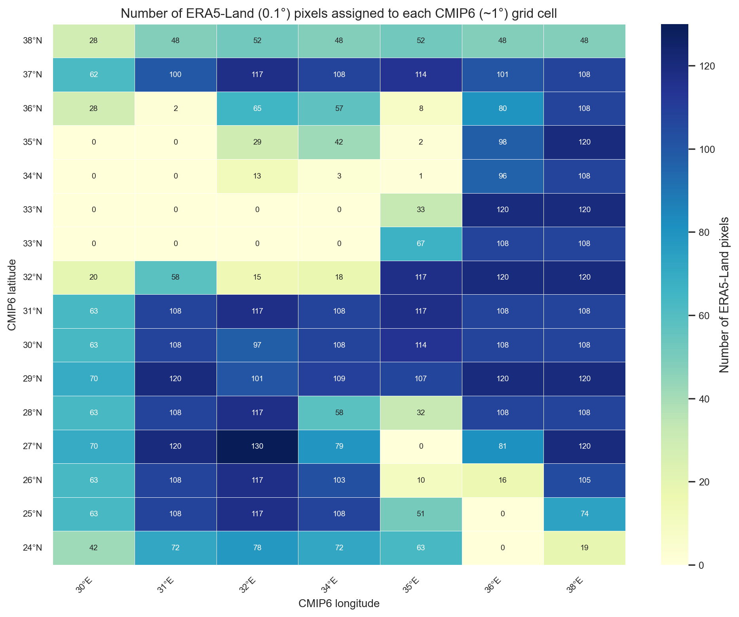
Fig. 6
Fig. 6. Number of ERA5-Land (0.1°) land pixels assigned to each CMIP6 CESM2-WACCM grid cell by nearest-neighbour matching. Cells located entirely over land receive the greatest number of ERA5-Land pixels; coastal cells straddling the land–sea boundary receive the fewest. Data: ERA5-Land and CMIP6 CESM2-WACCM, study region 24–38°N, 30–38°E.

6.2 CMIP6 grid padding
When subsetting the CMIP6 dataset to the target domain, a padding of 1.0° in latitude and 1.5° in longitude was applied beyond the nominal boundaries to ensure that grid cells whose centres lie outside the domain but whose footprints overlap it are retained. This is important for border pixels whose nearest cell centre may fall slightly outside the nominal region.

7. Coarse–Fine Temperature Relationship

7.1 Linear relationship
The fundamental diagnostic for downscaling feasibility is the bivariate relationship between CMIP6 TAS and ERA5-Land T2M (Fig. 7). Key findings:
- Strong positive linear correlation (Pearson r ≈ 0.9, cell-level aggregation). Both datasets measure the same physical quantity at different spatial scales; consequently, the coarse CMIP6 cell mean is a strong predictor of the ERA5-Land pixel temperature. The correlation at the pixel level is somewhat lower, as ERA5-Land resolves sub-grid variability that CMIP6 cannot.
- Systematic intercept bias. The OLS regression line does not pass through the origin, indicating a constant offset between the two datasets attributable to differences in land-surface scheme, topographic representation, and spatial averaging.
- Residual spread (downscaling signal). Scatter around the regression line represents sub-grid spatial heterogeneity — the influence of local elevation, land cover, and proximity to coastlines — that CMIP6 averages away but ERA5-Land resolves. This variability constitutes the primary target signal for the downscaling model.
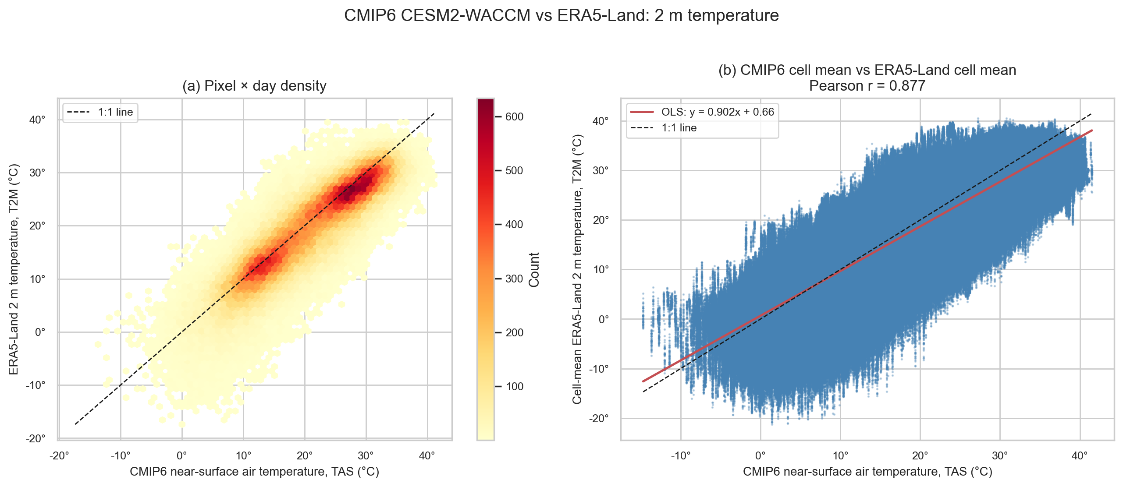
Fig. 7
Fig. 7. CMIP6 CESM2-WACCM TAS vs ERA5-Land T2M, 1990–1999. Panel (a): hexbin density plot of all pixel×day pairs; colour encodes log-density. Panel (b): cell-level daily means with OLS regression line (Pearson r annotated). Data: ERA5-Land T2M and CMIP6 TAS, 24–38°N, 30–38°E.

7.2 Residual diagnostics
OLS residuals (T2M minus predicted T2M) are examined as a function of CMIP6 TAS value and Euclidean distance from the assigned CMIP6 cell centre (Fig. 8).
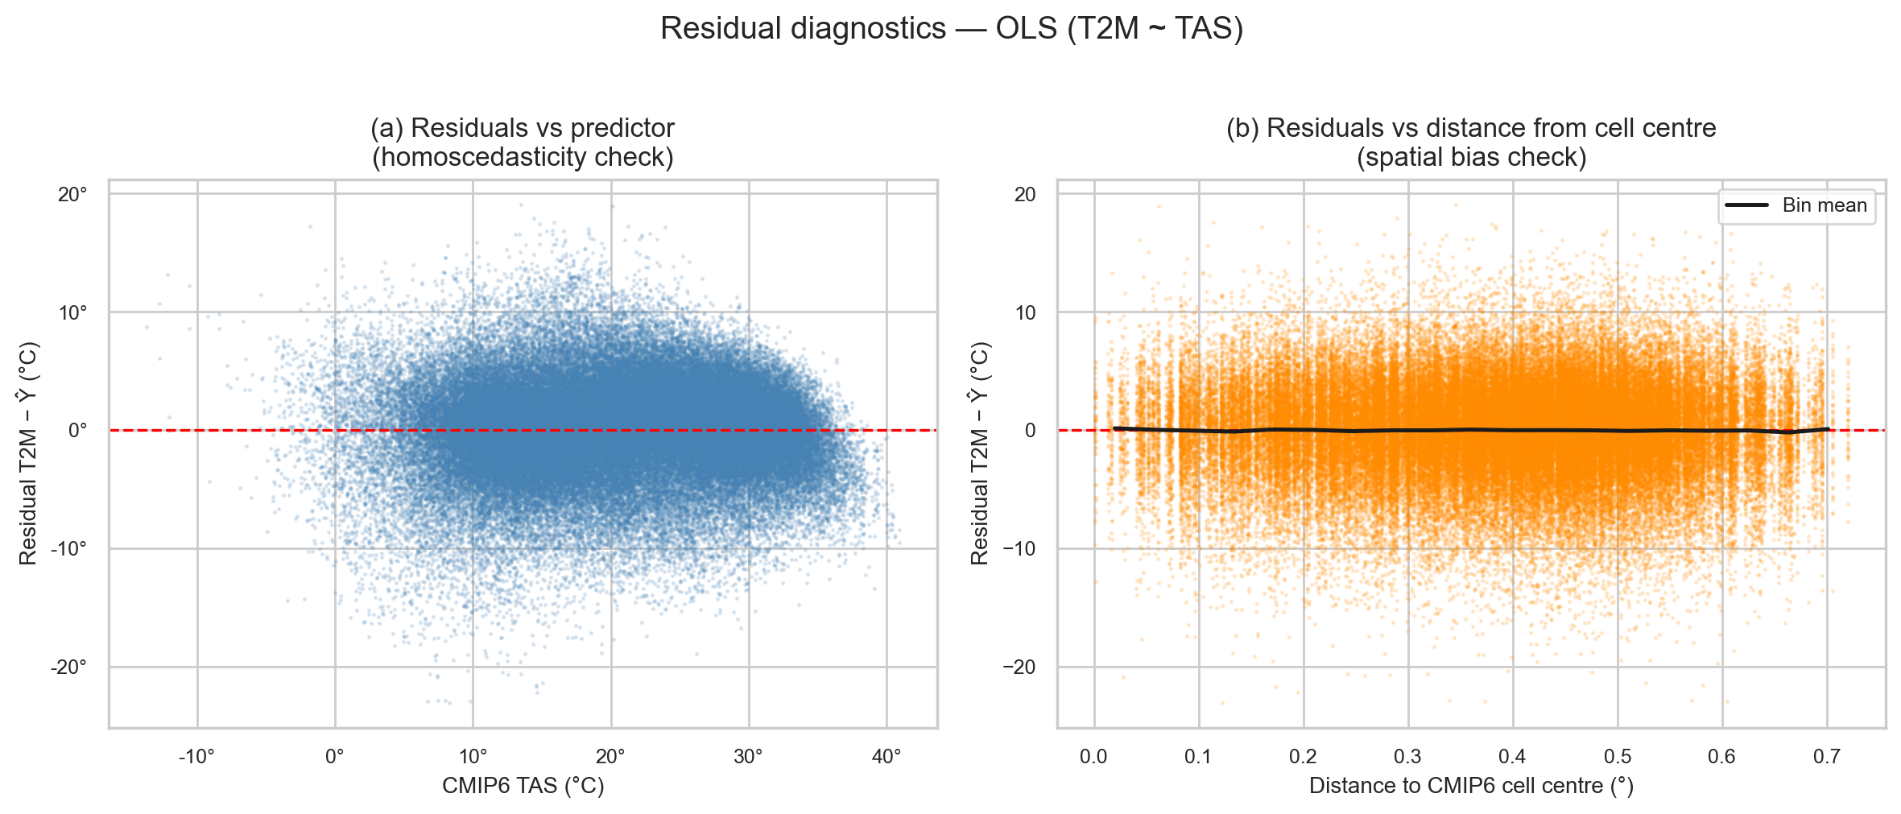
Fig. 8
Fig. 8. OLS residual diagnostics, 1990–1999. Panel (a): residuals versus CMIP6 TAS value; a horizontal band near zero indicates homoscedasticity. Panel (b): residuals versus Euclidean distance from the assigned CMIP6 cell centre in degrees; a non-zero slope would indicate boundary-assignment artefacts. Data: ERA5-Land T2M and CMIP6 TAS, 24–38°N, 30–38°E.

7.3 Residual structure by cell characteristics (work in progress)
To investigate whether the OLS residuals depend on cell-level properties, pixel×day residuals (~28 million pairs) were grouped by (a) CMIP6 cell sea fraction and (b) number of ERA5-Land pixels per CMIP6 cell. The box plots in Figs. 11 and 12 show that no single cell-level factor fully explains the residual variance: all bins have comparable interquartile ranges (~4–5°C), indicating that sub-grid topographic and land-cover heterogeneity — not coastal boundary effects or cell size — is the dominant source of downscaling uncertainty.
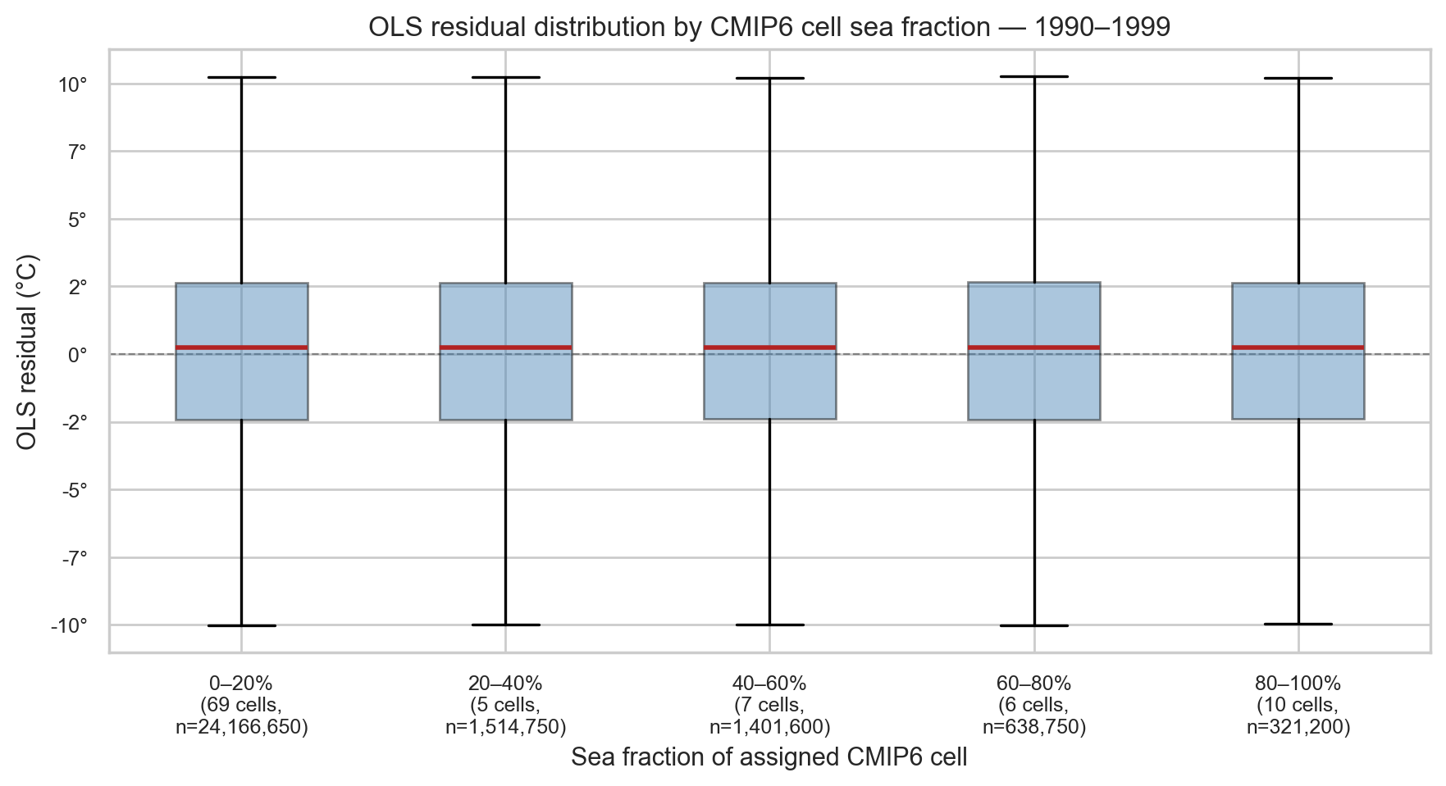
Fig. 11
Fig. 11. OLS residual distribution by CMIP6 cell sea fraction, 1990–1999. Each box summarises all pixel×day residuals for CMIP6 cells within a given sea-fraction bin (20% intervals). Data: ERA5-Land T2M and CMIP6 TAS, 24–38°N, 30–38°E.
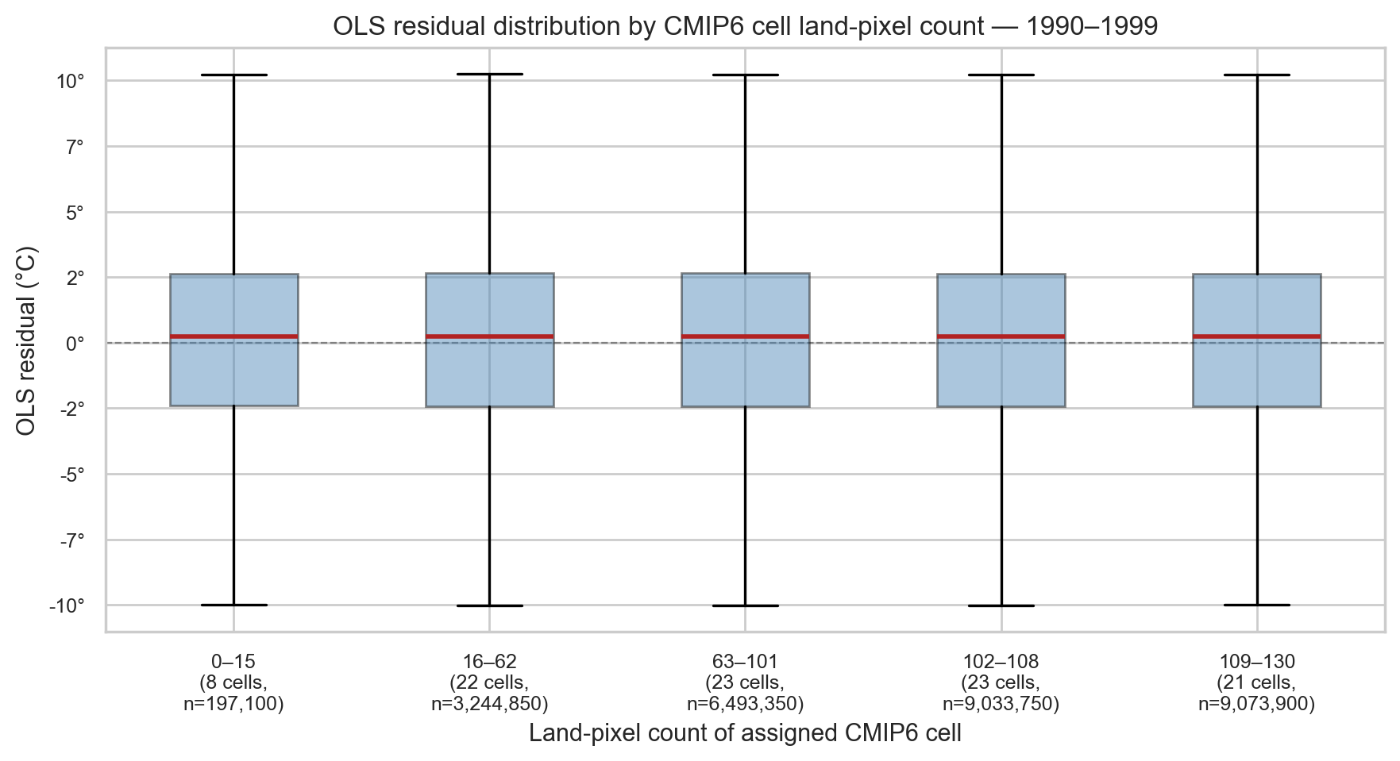
Fig. 12
Fig. 12. OLS residual distribution by CMIP6 cell land-pixel count, 1990–1999. Each box summarises all pixel×day residuals for CMIP6 cells within a given pixel-count quantile bin. Data: ERA5-Land T2M and CMIP6 TAS, 24–38°N, 30–38°E.

8. Feature Engineering (work in progress)
As proposed by Dorita Morin, the area-weighted global mean daily TAS from the CMIP6 model (computed over all grid cells worldwide) provides a large-scale thermodynamic predictor. This global signal encodes the overall state of the climate system on each day and may improve downscaling performance beyond the local cell temperature alone by capturing the background warming state.
Fig. 9 shows the global mean TAS time series for 1990–1999. The seasonal cycle is clearly visible, and the global mean is substantially lower (~14°C) than the EMME regional mean (~20.5°C), as expected for a global average that includes polar regions.
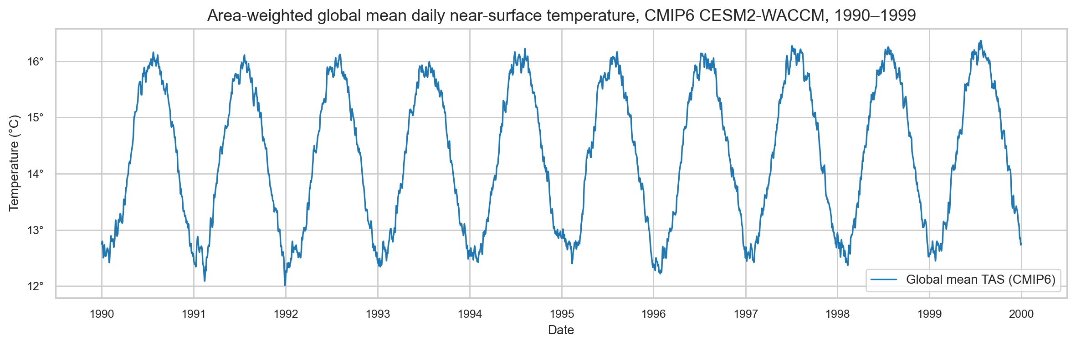
Fig. 9
Fig. 9. Area-weighted global mean daily near-surface air temperature (TAS) from CMIP6 CESM2-WACCM, 1990–1999. The seasonal cycle reflects the Northern Hemisphere’s dominance of land area. Data: CMIP6 CESM2-WACCM, global domain.

9. Next Steps
- Training/validation/test split — A temporally ordered split respecting year boundaries is required. Candidate partitions: 1990–2004 (training and validation) and 2005–2014, 2015–2025 (test periods), consistent with the project scope document (Data 8 Mar 2026.docx).
- Baseline linear model — A per-CMIP6-cell OLS regression T2M(pixel, day) ≈ α_cell · TAS(cell, day) + β_cell provides an interpretable benchmark that directly exploits the near-linear coarse–fine relationship.
- Feature engineering — Candidate predictors include: (a) area-weighted global mean TAS (large-scale thermodynamic predictor, proposed by Dorita Morin); (b) adjacent CMIP6 cell temperatures (for non-deep-learning models); (c) sea/land fraction per CMIP6 cell; (d) day-of-year (seasonal cycle encoding).
- Extension to multiple GCMs — The pipeline will be extended to the six CMIP6 models used by Andre Klif (see Data 8 Mar 2026.docx, Table 2), enabling assessment of model uncertainty.
- Advanced models — Random forests, gradient boosting, and neural network architectures will be evaluated against the linear baseline using spatial RMSE, bias, and correlation maps.

