**CONTENT BEYOND SYLLABUS**

**IMPLEMENTATION OF REMOTE COMMAND EXECUTION (RCE)**

**AIM**

To implement Remote Command Execution(RCE).

**ALGORITHM**

**CLIENT SIDE**

1. Establish a connection between the Client and Server.

Socket client=new Socket("127.0.0.1",6555);

2. Create instances for input and output streams.

Print Stream ps=new Print Stream(client.getOutputStream());

3. BufferedReaderbr=newBufferedReader(newInputStreamReader(System.in));

4. Enter the command in Client Window.

Send themessage to its output

str=br.readLine();

ps.println(str);

**SERVER SIDE**

1. Accept the connection request by the client.

ServerSocket server=new ServerSocket(6555);

Sockets=server.accept();

2. Getthe IPaddressfromitsinputstream.

BufferedReaderbr1=newBufferedReader(newInputStreamReader(s.getInputStream()));

ip=br1.readLine();

3. During runtime execute the process

Runtime r=Runtime.getRuntime();

Process p=r.exec(str);

**CLIENT PROGRAM**

import java.io.*;

import java.net.*;

class clientRCE

{

public static void main(String args[]) throws IOException

{

try

{

String str;Socket client=new Socket("127.0.0.1",6555);

PrintStream ps=new PrintStream(client.getOutputStream());

BufferedReader br=new BufferedReader(new InputStreamReader(System.in));

System.out.println("\t\t\t\tCLIENT WINDOW\n\n\t\tEnter TheCommand:");

str=br.readLine();

ps.println(str);

}

catch(IOException e)

{

System.out.println("Error"+e); }

}

}

**SERVER PROGRAM**

import java.io.*;

import java.net.*;

class serverRCE

{

public static void main(String args[]) throws IOException

{

try

{

String str;

ServerSocket server=new ServerSocket(6555);

Socket s=server.accept();

BufferedReader br=new BufferedReader(new InputStreamReader(s.getInputStream()));

str=br.readLine();

Runtime r=Runtime.getRuntime();

Process p=r.exec(str);

}

catch(IOException e)

{

System.out.println("Error"+e);

}

}

}

**OUTPUT**

C:\NetworkingPrograms>java serverRCE

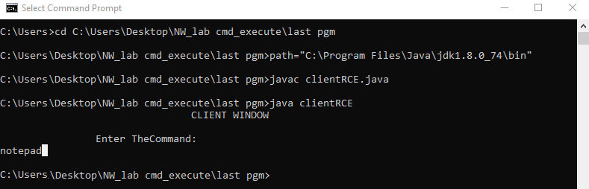

C:\NetworkingPrograms>java clientRCE

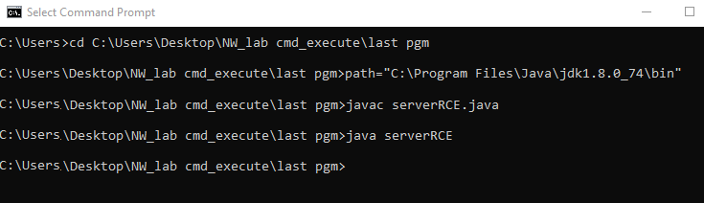

**CLIENT WINDOW**

EnterTheCommand:

Notepad

**RESULT**

Thus the implementation RCE is done & executed successfully.