**Appendix A**

**UNIVERSITI TUNKU ABDUL RAHMAN**

**LEE KONG CHIAN FACULTY OF ENGINEERING AND SCIENCE UECS1144 OBJECT-ORIENTED APPLICATION DEVELOPMENT GROUP ASSIGNMENT**

**June 2023 Trimester**

|  |  |  |  |
| --- | --- | --- | --- |
| **NO.** | **STUDENT NAME** | **PROGRAMME** | **Practical Group** |
| **1.** | **Hwang Jen Fung(Group Leader)** | **SE** | **P2** |
| **2.** | **Ding Yuan Xing** | **AM** | **P1** |
| **3.** | **Kok Yu San** | **SE** | **P1** |
| **4.** | **Kuik Rui Luan** | **SE** | **P5** |

**System Specification Requirement:**

1. System shall allow teachers to register for personal accounts and students’ accounts.
2. System shall allow teachers to log in with their ID and password.
3. System shall allow teachers to update their personal information.
4. System shall allow teachers to update students’ information to be stored.
5. System shall allow teachers to remove students’ account who have permanently left the school.
6. System shall allow teachers to record and update students’ subject marks.
7. System shall allow teachers to view the analysis of students' marks for a class.
   1. System shall allow teachers to view the average score for each subject.
   2. System shall allow teachers to view the highest achiever for each subject.
8. System shall allow teachers to view the analysis of students' marks for a standard.
   1. System shall allow teachers to view the average score for each subject.
   2. System shall allow teachers to view the passing rate for each subject.
9. System shall allow students to view their results which will be graded automatically.
10. System shall allow students to log in with their name and ID.

The console-based application designed for Primary School Marks Recording System is to assist teachers and students in managing academic information within a school environment. The users of this system are teachers and students. Teachers use the system for tasks related to student management, grading, and performance analysis, while students use it to access their marks and grades. This system streamlines academic administration, providing a convenient way to monitor students’ progress in real-time.

The general uses of the application are to allow the users to log in as teacher to add, delete, modify, view grades and analysis of academic performance of the students. Teachers can register for personal accounts by entering their IC, name and 8-digit password and a teacher ID is assigned by the system automatically. During registration for students’ accounts, teachers shall provide necessary information of students such as name, IC number, standard, class, sex in correct format. Registered teachers can log in using their unique ID and password. Upon successful login, they gain access to their dashboard. In case teachers forget their password, they can request a password hint by entering their correct IC number.

Teachers have the ability to update their personal information and student information via the system to ensure their records are up to date. Teachers can change their names and passwords while updating student information such as name, IC number, sex, standard and class. Teachers can remove student’s accounts for those who have graduated and permanently left the school. Therefore, this action ensures an up-to-date student database. Teachers can record and update students' subject marks in the system. Each of the subject marks will be graded by the system automatically following the primary school grading system in Malaysia.

Teachers can view the analysis of students' marks for a specific class, including average score and the highest achiever for each subject. The system calculates the average score and identifies the student with the highest score in each subject within the selected class and displays them. Teachers can also view the analysis of students' marks for an entire standard, such as average score and passing rate for each subject. For the passing rate, the system calculates and displays the percentage of students who passed each subject for the selected standard. Therefore, the system provides class-level and standard-level performance analysis for future academic improvement.

Furthermore, students can log in to the system using their name and student ID. Once logged in, they can view their academic results, which are graded automatically based on the scores recorded by teachers. Teachers utilize the system for student management, grading, and benefit from the system's efficiency in managing and analysing student data, making it easier to improve academic outcomes. Whereas students use the system to access their grades and track their academic progress, allowing them to stay informed about their performance.

**UML Class Diagram**

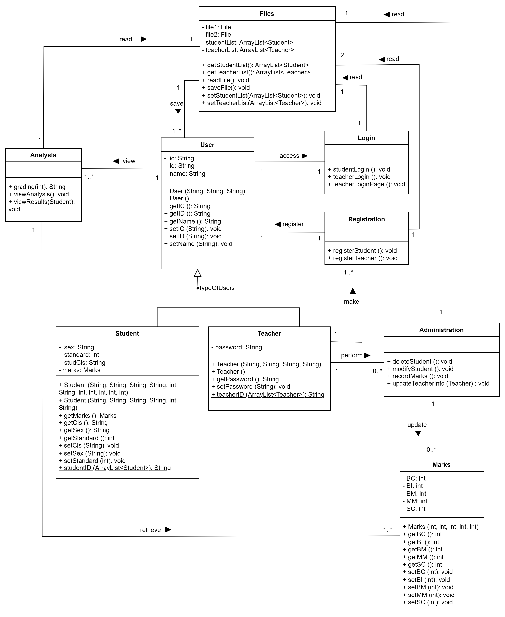

**Sample Output**

|  |  |
| --- | --- |
| Description | Screenshots |
| Main menu of grading system |  |
| Enter ‘1’ to enter teacher menu |  |
| Enter ‘1’ to login as teacher |  |
| Teachers enter their id to login |  |
| Teachers enter their correct password to login |  |
| Teachers login successfully and teacher main menu is displayed |  |
| System displays ‘Teacher not found’ when teachers enter invalid id |  |
| System displays ‘Teacher not found’ when teachers enter wrong password |  |
| Teacher enters ‘PW’ if forgot password and system displays the password hint when teacher enters the correct teacher’s ic and system prompts teacher to re-login |  |
| System displays ‘No teacher is found’ when teacher does not enter correct IC to get password hint |  |
| Enter ‘1’ to enter student registration page |  |
| Enter student’s ic in correct format for student registration |  |
| Enter student’s name for student registration |  |
| Enter student’s sex for student registration |  |
| Enter student’s standard for student registration |  |
| Enter student’s class for student registration |  |
| Student is successfully registered |  |
| Enter ‘Y’ to register another student |  |
| Enter ‘N’ to exit from student registration |  |
| System displays ‘Invalid IC’ when teacher enters student’s ic in wrong format which consists of ‘-’ and asks teacher to re-enter |  |
| System displays ‘Invalid IC’ when teacher enters student’s ic in wrong format which is more than 12 digits and asks teacher to re-enter |  |
| Enter ‘0’ to exit student registration |  |
| System displays ‘IC has been registered before as student’ when teacher enters registered student’s ic |  |
| System displays ‘IC has been registered before as teacher’ when teacher enters registered teacher’s ic |  |
| System displays ‘Invalid name’ when teachers enter student’s full name in term of digits and ask teachers to re-enter |  |
| Enter ‘0’ to exit student registration |  |
| System displays ‘Invalid gender’ when teachers do not enter ‘female’ or ‘male’ |  |
| Enter ‘0’ to exit student registration |  |
| System displays ‘Invalid standard’ when teacher do not enter digit from 1 to 6 |  |
| Enter ‘0’ to exit student registration |  |
| System displays ‘Invalid class’ when teachers enter invalid class which is not among the valid classes A, B, C, D, E |  |
| Enter ‘0’ to exit student registration |  |
| Enter ‘2’ to delete student’s account |  |
| Enter student’s ic in correct format to delete specific student |  |
| System displays the name and id of student to be deleted |  |
| Enter ‘Y’ to delete student |  |
| Enter ‘N’ to stop delete student |  |
| System displays ‘Invalid input’ when teachers enter input other than ‘Y’ or ‘N’ |  |
| System displays ‘IC not found’ when student’s ic entered is not found in the Student.txt file |  |
| Enter ‘0’ to exit from delete student account |  |
| Enter ‘3’ to modify student’s information |  |
| System displays ‘Student not found’ if the student’s name input by the teacher is not found in Student.txt file |  |
| Enter ‘0’ to exit from modifying students’ information |  |
| Enter student’s name to modify specific student’s information |  |
| Enter ‘1’ to enter student’s new name to update student’s name |  |
| Enter ‘2’ to enter student’s new ic to update student’s ic |  |
| Enter ‘3’ to enter student’s new sex to update student’s sex |  |
| Enter ‘4’ to enter student’s new standard to update student’s standard |  |
| Enter ‘5’ to enter student’s new class to update student’s class |  |
| Enter ‘0’ to exit from modifying student’s information |  |
| Enter ‘4’ to record and modify student’s marks |  |
| Enter student’s ic to record and modify specific student’s marks |  |
| Enter ‘Y’ to enter marks for specific student |  |
| Enter anything other than Y to exit from record and modify student’s marks |  |
| System displays error input if teacher enter digits out of the range of 0 to 100 |  |
| System displays error input if teacher enter a mark in term of char or String |  |
| Enter ‘5’ to update teachers’ information |  |
| Enter ‘1’ to update teacher’s name and allow teacher to enter new teacher’s name. |  |
| Enter ‘2’ to update teacher’s password and allow teacher to entered new teacher’s password |  |
| Enter ‘0’ to exit from updating teacher’s information |  |
| System displays ‘Invalid name’ when the teacher enters new name including digits |  |
| System displays ‘Invalid password’ when the teacher does not enter an 8-digit password |  |
| Enter ‘6’ to view analysis of students’ results |  |
| Enter ‘1’ to view mark analysis of a standard |  |
| Enter standard to view the marks analysis of the specific standard |  |
| Enter ‘1’ to view the average score for each subject for the specific standard |  |
| Enter ‘Y’ to continue to check mark analysis of a specific standard |  |
| Enter ‘2’ to view the passing rate for each subject for the specific standard |  |
| Enter ‘N’ to exit the analysis of students’ results |  |
| Enter ‘2’ to view mark analysis of a specific class. Enter standard and class to view the mark analysis of the specific class |  |
| Enter ‘1’ to view the average score for each subject achieved by the students in the specific class |  |
| Enter ‘2’ to view the highest achiever(s) for each subject in the specific class |  |
| Enter ‘N’ to exit the analysis of students’ results |  |
| Enter ‘0’ to exit teacher main menu |  |
| Enter’2’ to register a new teacher |  |
| New teacher registers themselves by entering IC number, name and password and a teacher ID is assigned to the new teacher by the system |  |
| System displays ‘Invalid IC’ when teacher enters ic in wrong format which consists of ‘-’ and asks teacher to re-enter |  |
| System displays ‘IC has been registered before as teacher when teacher enters registered teacher’s IC number |  |
| System displays ‘Invalid name’ when teacher enters teacher’s full name in term of digits and ask teachers to re-enter |  |
| System displays ‘Invalid password’ when teacher does not enter 8-digit password |  |
| Enter ‘0’ to exit from teacher menu |  |
| Enter ‘2’ to login as student |  |
| Students enter their name and ID to log in their account. System displays student’s result in marks and grades after successful login |  |
| System displays ‘Student not found’ when the student’s name does not match with the student’s ID in Student.txt |  |
| Enter ‘0’ to exit the grading system |  |