# Assignment 1 - ReactJS app.

Name: Tianxia Dong

## Overview.

Function:

Search the Recipe

Sort the Recipe

Add a comment

Show the recipe

## Installation requirements.

+ ReactJS v15.3.0

+ Bootstrap 3

+ create-react-app tool

+ react-dom: ^15.2.1

+ react-router: ^2.6.1

+ superagent: ^1.6.1

After download the software:

npm install

nppm start

## Data Model Design.

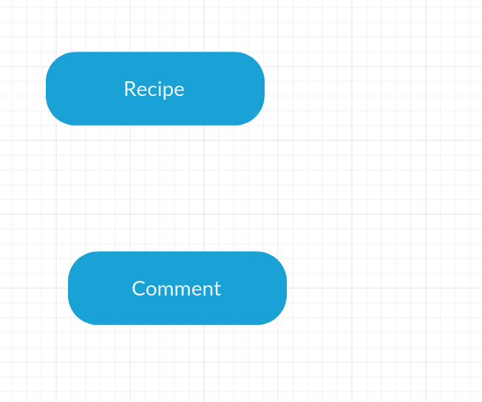

## App Component Design.

Recipe detail page:

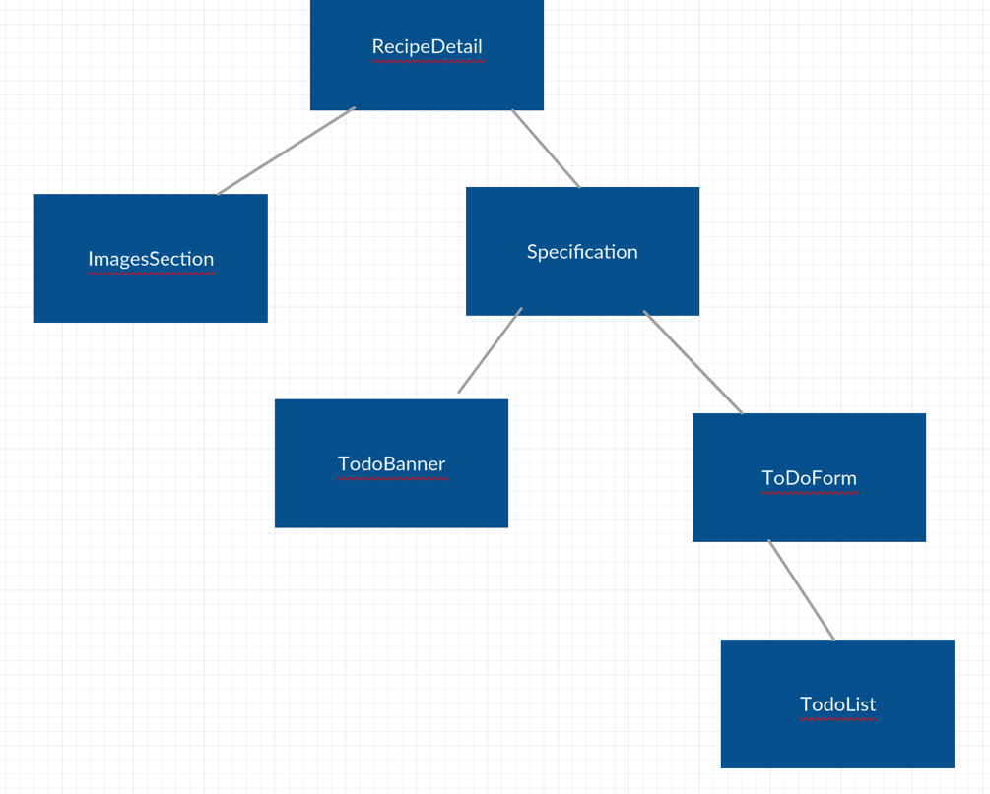

Recipe list page:

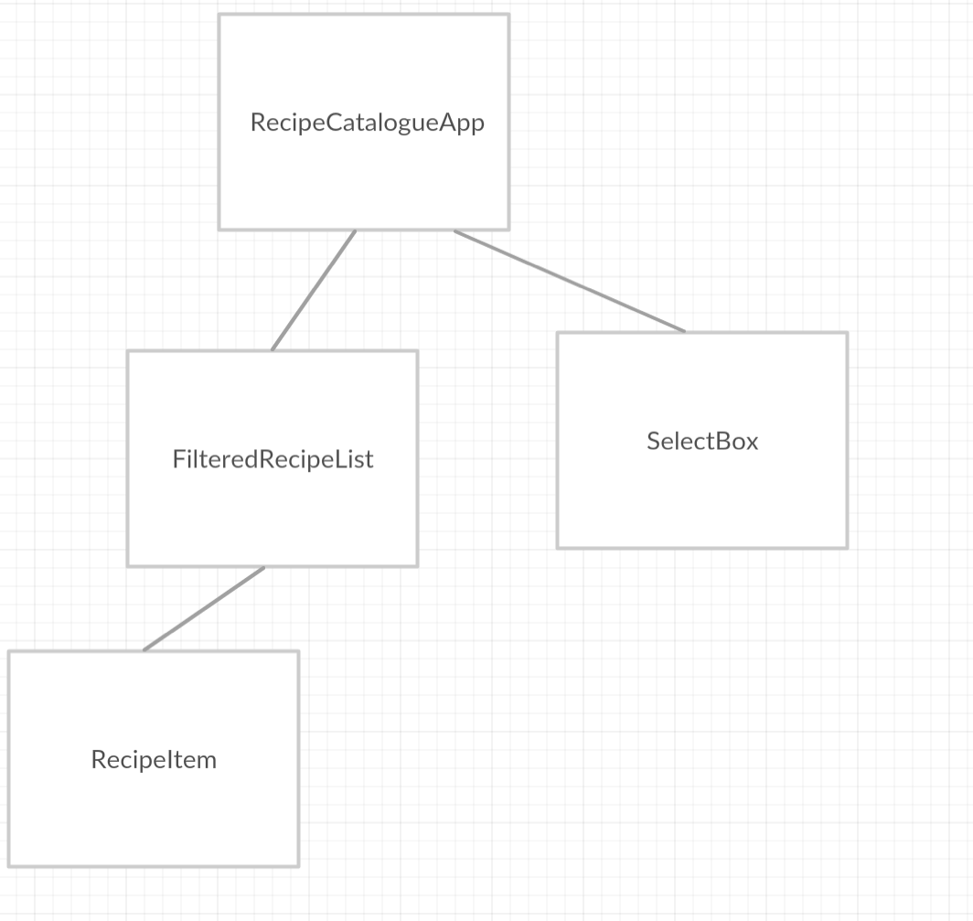

## UI Design.

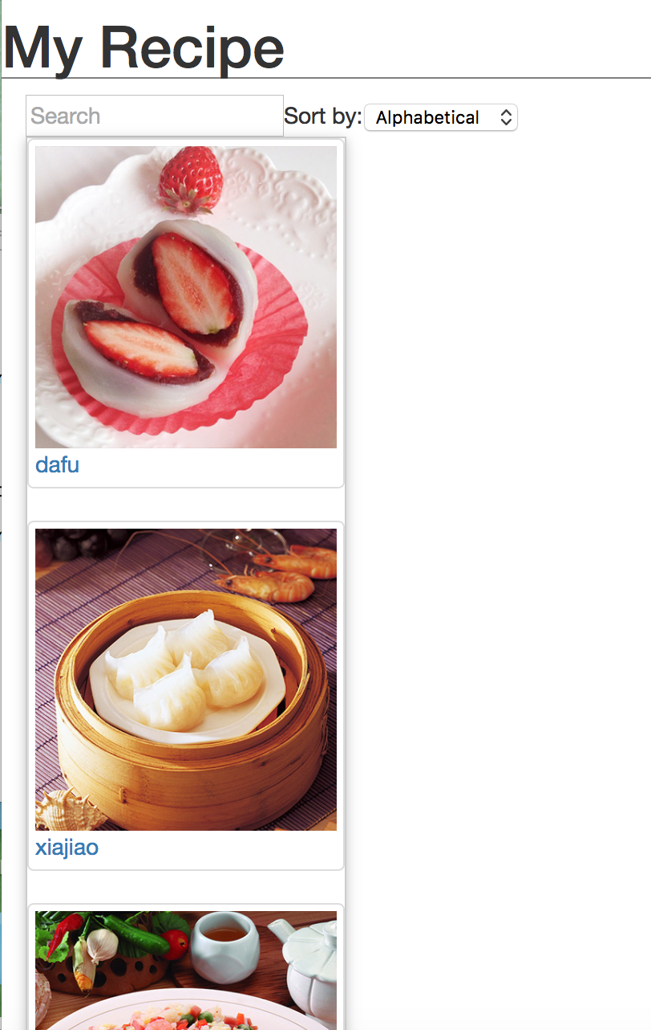

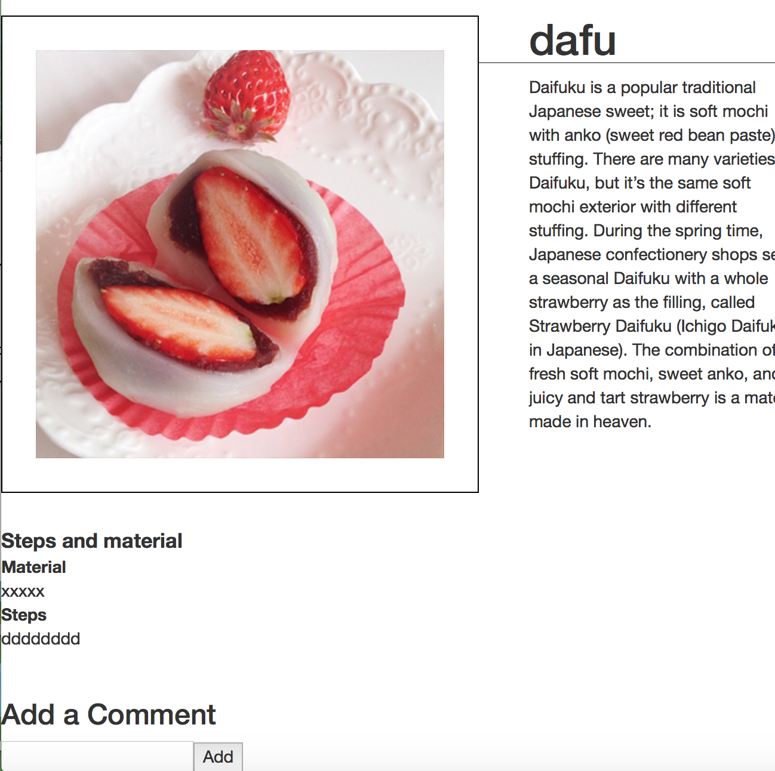

## Routing.

recipe list

myapp/src/intex.js

recipe detail

myapp/src/RecipeDetail.js

## Independent learning.

How to add a comment after the details.show the list of comment

Git Hub:

<https://github.com/ShirleyDong/React-app>