一、Demurger,Sylvie."Infrastructure development and economic growth:an explanation for regional disparities in China?"Journal of Comparative economics 29.1(2001):95-117. （文献已下载，见文件夹）

摘要：China's sustained high economic growth and increased competitiveness in manufacturing制造业has been underpinned by a massive development大规模发展 of physical infrastructure有形基础设施In this context, we investigate the role of infrastructure in promoting economic growth in China for the period 1975 to 2007. 调查了1975-2007年期间基础设施在促进中国经济增长中的作用 Overall, the results reveal that infrastructure stock, labor force, public and private investments基础设施存量、劳动力、公共与私人投资 have played an important role in economic growth in China. More importantly, we find that Infrastructure development in China has significant positive contribution to growth than both private and public investment.与私人和公共投资相比，中国的基础设施发展对增长有显著的积极贡献。

Further, there is unidirectional causality单向因果关系 from infrastructure development to output growth产出增长 justifying China's high spending on infrastructure development since the early nineties.说明了中国在基础设施建设上的高支出是合理的The experience from China suggests that it is necessary to design an economic policy that improves the physical infrastructure改善有形基础设施 as well as human capital formation人力资本形成 for sustainable economic growth in developing countries.

二、<https://www.ncbi.nlm.nih.gov/pmc/articles/PMC2652960/>

Fernando G De Maio ‘Income inequality measure’ Community Health. 2007 Oct; 61(10): 849–852.（文献已下载，见文件夹，对于九个衡量指标的讨论是重点）

摘要：The Gini coefficient - the most popular method for operationalising income inequality. 但其他方法offer researchers the means to develop a more nuanced（细微的） understanding of the distribution of income. Income inequality measures such as the generalised entropy index广义熵指数and the Atkinson index阿特金森指数 offer the ability to examine the effects of inequalities in different areas of the income spectrum, enabling more meaningful quantitative assessments of qualitatively different inequalities.

通过讨论衡量收入不平等的一些手段，来在公共卫生研究中制定一种更加细致的衡量收入不平等的方法

（灰色部分介绍了收入差距与公众健康的关系，铺垫了为什么要研究衡量收入差距的不同手段，貌似没用?）income inequality may influence patterns of population health have been investigated (including psycho- social mechanisms and the effects of social capital心理-社会机制和社会资本的影响), recent reviews of the income inequality and population health literature have reached mixed conclusions1–3 and the hypothesis is yet to be fully integrated within the broader literature on proximal and distal determinants of health.（假设还未纳入关于健康的近端和远端决定因素的更广泛的文献中）

The impetus behind the debate is Kawachi and Kennedy’s influential US study, which compared the behavior of six different measures of income inequality: the Gini coefficient, the decile ratio等分比率, the proportion of income earned by the poorest 50%, 60% and 70% of households最贫穷的50%、60%和70%家庭的收入比例, the Robin Hood index罗宾汉指数, the Atkinson index阿特金森指数 and Theil’s entropy measure泰尔熵测度. Their analysis indicated that the measures behaved very similarly and were highly correlated, with Pearson correlations ranging from 0.86 to 0.99. Furthermore, all of the measures were also highly correlated with state-level mortality indicators. 与州一级的死亡率指标高度相关 Given these relationships, Kawachi and Kennedy concluded that the choice of income inequality indicator was unlikely to influence results of empirical tests of the health effects of income inequality.不会影响！

反方：会有影响

For example, Weich et al., in their study of income inequality and self-rated health using the British Household Panel Survey, found important differences between the Gini coefficient and the generalised entropy (GE) index. More specifically, they observed that regional income inequality, operationalised using the Gini coefficient, was significantly associated with poor health among respondents from low-income groups, but that this relationship was not significant for GE indicators sensitive to inequalities at the top or bottom of the income spectrum入息组别？专有名词？就是不同的收入水平吧？. Similarly, recent research on Argentina has documented an ecological relationship between provincial income inequality (operationalised with the Gini coefficient) and life expectancy（平均寿命） for both males (r=20.55, p,0.01) and females (r=20.61, p,0.01).However, this relationship was not fully robust to the choice of income inequality summary index; the relationship between income inequality and life expectancy was strongest for the Gini and GE measures sensitive to inequalities in the middle of the income spectrum（中等收入水平用Gini and GE显著） and not significant at all for GE measures highly sensitive to inequalities at the top or bottom of the distribution.（但极高/低收入水平下GE会不显著）

So it is important to examine the robustness of the income inequality hypothesis under varying inequality measures. Using a variety of measures enables more meaningful analysis about the pathogenic effects of inequalities in different parts of the income spectrum. 收入范围不同部分的不平等的致病性影响After all, a situation of large income differences within the bottom, middle or top of the income distribution are different kinds of inequality收入分配的底层、中部或顶层存在不同类型的不平等

正文开始！讨论了9种衡量收入不平等的方法

1. 基尼系数Gini coefficient- most popular measure of income inequality

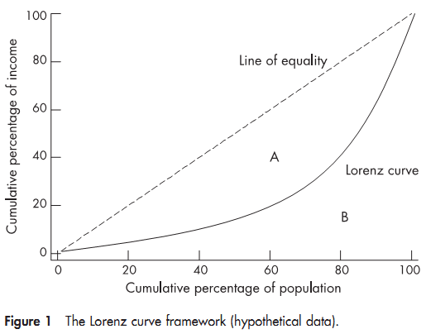

The Lorenz curve shows the percentage of total income earned by cumulative percentage of the population. 按人口累积百分比计算的总收入百分比In a perfectly equal society, the Lorenz curve would follow the path of the 45˚ line of equality. As inequality increases, the Lorenz curve deviates from the line of equality.

The Gini coefficient is equivalent to the size of the area between the Lorenz curve and the 45˚ line of equality divided by the total area under the 45˚ line of equality. 基尼系数等于洛伦兹曲线与45˚等值线之间面积的大小除以45˚等值线下的总面积。

In figure 1, it is depicted as area A divided by area A+B. The Gini coefficient can be presented as a value between 0 and 1 or as a percentage. A coefficient of 0 reflects a perfectly equal society in which all income is equally shared; in this case the Lorenz curve would follow the line of equality. The more the Lorenz curve deviates from the line of equality, the higher will be the resulting value of the Gini coefficient. A coefficient of 1 (or 100%) represents a perfectly unequal society wherein all income is earned by one individual.

基尼系数的缺点在于区分不了不同类别的收入差距，只在收入范围中部的不平等现象比较敏感The Gini coefficient’s main weakness as a measure of income distribution is that it is incapable of differentiating different kinds of inequalities. Lorenz curves may intersect, reflecting differing patterns of income distribution, but nevertheless resulting in very similar Gini coefficient values. This troubling property of the Lorenz framework complicates comparisons of Gini coefficient values and may confound tests of the income inequality hypothesis. Along with this limitation, researchers working with the Gini coefficient need to be aware that it is most sensitive to inequalities in the middle part of the income spectrum. Despite these limitations, the Gini coefficient has been used extensively in the public health literature, and it remains the most popular measure of income inequality. Yet because it is highly sensitive to inequalities in the middle of the income spectrum, the Gini coefficient is not ‘‘neutral’’ or value free基尼系数不是“中性”的，也不是无价值的.

2. Atkinson index 阿特金森指数

Atkinson index allows for varying sensitivity to inequalities in different parts of the income distribution. This was important to Atkinson, who was concerned with the inability of the Gini framework to give different parts of the income spectrum varying weights. 给收入范围的不同部分赋予不同的权重In his influential text The Economics of Inequality, Atkinson noted (p. 47) that inequality ‘‘cannot, in general, be measured without introducing social judgements. 不平等不能在不作出社会判断的情况下加以衡量Measures such as the Gini coefficient are not purely ‘statistical’ and they embody implicit judgements about the weight to be attached to inequality at different points on the income scale’’. 基尼系数包含了收入范围的不同点对不平等的重视程度的隐含判断 Therefore, his index incorporates a sensitivity parameter包含一个敏感参数 (ε); which can range from 0 (meaning that the researcher is indifferent about the nature of the income distribution对收入分配的性质漠不关心), to infinity (where the researcher is concerned only with the income position of the very lowest income group只关注极低收入群体的收入状况). Atkinson argued that this index was a way to incorporate Rawls’ conception of social justice into the measurement of income inequality. 将罗尔斯的社会正义概念纳入衡量收入不平等的一种方法 In practice, values of 0.5, 1, 1.5 or 2 are used; the higher the value, the more sensitive the Atkinson index becomes to inequalities at the bottom of the income distribution. 数值越高，阿特金森指数对收入分配底部的不平等就变得越敏感

The index can easily be generated with Stata’s ineqdeco command. 可用Stata的ineqdeco命令求出该指数

直观解释：Atkinson values can be used to calculate the proportion of total income that would be required to achieve an equal level of social welfare as at present if incomes were perfectly distributed. 阿特金森指数可用于计算实现社会福利水平平等，即收入完全分配，所需的总收入比例For example, an Atkinson index value of 0.20 suggests that we could achieve the same level of social welfare with only 1– 0.20=80% of income. 阿特金森指数0.20表明只需要80%的收入就可以达到相同的社会福利水平？The theoretical range of Atkinson values is 0 to 1, with 0 being a state of equal distribution.

3. Coefficient of variation (CV)变异系数

This measure of income inequality is calculated by the dividing the standard deviation of the income distribution by its mean. 将收入分配的标准差除以平均值 More equal income distributions will have smaller standard deviations; as such, the CV will be smaller in more equal societies.收入分配越平等，标准差就越小，变异系数也更小 虽然计算简单但不常用This may be attributed to important limitations of the CV measure: (1) it does not have an upper bound, unlike the Gini coefficient, making interpretation and comparison somewhat more difficult; 没有上限，解释和比较困难 and (2) the two components of the CV (the mean and the standard deviation) may be exceedingly influenced by anomalously low or high income values. 均值和标准差可能受到异常低或高收入值的极大影响In other words, the CV would not be an appropriate choice of income inequality measure if a study’s income data did not approach a normal distribution.如果收入数据不接近正态分布就不适合用CV测算

4. Decile ratios 等分比率

The calculation is done by taking, for example, the income earned by the top 10% of households and dividing that by the income earned by the poorest 10% of households. 将收入最高的10%家庭的收入除以最贫穷的10%家庭的收入An important advantage of this measure is that it enables sensitivity analyses; 优点是可以进行敏感性分析for example, the correlations between population health and the 20:80, 30:70, 40:60 decile ratios may be compared. 比较人口健康与20：80、30：70、40：60等分比率之间的相关性 This allows researchers to examine which sections of the income spectrum may be most important as a social determinant of health.可以检验收入范围中的哪部分作为健康的社会决定因素可能是最重要的

5. Generalised entropy (GE) index 广义熵指数

The GE index, like the Atkinson index, is more correctly labelled a family of income inequality measures. It also incorporates a sensitivity parameter (a) that varies in the weight given to inequalities in differing parts of the income spectrum. 纳入了一个敏感参数(a)对收入范围不同部分的不平等所给予的权重不同Typically, four GE measures are used: these are GE(–1), GE(0), GE(1) and GE(2). The more positive a (the sensitivity parameter; -1, 0, 1 or 2) is, the more sensitive GE(a) is to inequalities at the top of the income distribution. a越大，Ge(a)对收入分配顶部的不平等就越敏感 The theoretical range of GE values is 0 to infinity, with 0 being a state of equal distribution and values greater than 0 representing increasing levels of inequality. Another beneficial property of the GE measure is that it is decomposable; 另一个优点是它是可分解的that is, it can be broken down to component parts (i.e. population subgroups). 可以分解为各组成部分(即人口子群)This enables analysis of between- and within-area effects. 可以分析区域间和区域内的影响

the mean log deviation of income measure is functionally equivalent to the GE(0) index收入测度的平均对数偏差与GE(0)指标在功能上是等价的Theil’s entropy measure is equivalent to the GE(2) index泰尔熵测度与GE(2)指标是等价的

用Stata的ineqdeco命令可以求得The GE index

6. Kakwani progressivity index Kakwani累进指数

The Kakwani progressivity index builds from the Gini framework. Originally devised to measure the progressivity of tax systems, 最初是衡量税收制度的累进性 it is also used to examine health care issues such as equity in health care expenditures. 衡量医疗支出的公平性In this case, the Kakwani progressivity index is the difference between the Gini coefficient for incomes and the concentration index for out-of-pocket health care payments.是收入基尼系数和自费的医疗费用集中指数之间的差额（详见论文）

7. Proportion of total income earned占总收入的比例

The proportion of income received by the poorest nth% of the population is one of the most intuitive measures of income inequality. 最贫穷的第n%？人口获得的收入比例是衡量收入不平等最直观的指标之一。优点是直观However, this measure offers a very limited insight into the income distribution; the proportion of income received by the poorest 50% does not inform us about how equally income is shared by the poorest 50% and also reveals nothing about the nature of the income distribution among the other half of the population.最贫穷的50%的人所获得的收入比例并没有告诉我们最贫穷的50%的人如何平等地分配收入，也没有揭示出另一半人口中收入分配的性质

8. Robin Hood index罗宾汉指数

The Robin Hood Index, also known as the Pietra ratio, represents the maximum vertical distance from the Lorenz curve to the 45˚line of equality. 从Lorenz曲线到45˚等值线的最大垂直距离 It can be interpreted as the proportion of income that has to be transferred from those above the mean to those below the mean in order to achieve an equal distribution.表示必须从平均水平以上的收入，转移到低于平均水平的收入，以实现公平分配的收入比例Higher Robin Hood values indicate a more unequal society, wherein a larger share of income needs to be distributed to achieve equality. 越高表示社会越不平等，需要分配更多的收入来实现平等the Robin Hood framework does not incorporate a sensitivity parameter.不包含敏感参数

9. Sen poverty measure 森的贫困衡量指标

It incorporates the Gini coefficient for people living below the poverty line along with the headcount ratio of poverty and the average income of those below the poverty line. 纳入了生活在贫困线以下的人的基尼系数，贫穷人口比例和贫困线以下人口的平均收入

三、Moore,William S."Income inequality and industrial composition."Public Administration Quarterly(2009):552-581. （文献已下载，见文件夹）

摘要：magnitude and trends in income inequality in the US as a nation, at the state level（与全国趋势大体相同，6页给出了表）, and internationally（OECD成员国）---discuss some potential determinants of II---relationship between industrial composition and II---首要发现是 there appears to be an association between the changes in the US manufacturing and services sector and II---further increasing the size of the construction sector may provide the greatest reductions in II

The author utilizes a type of regression analysis that 利用处于sub-national(stares)

level 的变量作为因变量和自变量

The causes of change are associate with labor market changes and changes in household composition (increased divorce rates, out of wedlock births未婚生子？ and increasing age of first marriage 导致II增长). a shift from manufacturing employment to high paying technical services jobs and lower paying retail trade jobs related to the increase of II. But within-industry shifts in labor demand away from less-educated workers are a more important explanation of eroding wages than a shift out of manufacturing.

美国II比其他成员国高的原因： the relatively low wages at the bottom of the income distribution and a weak income support system in US. First he discusses the role government plays in this area pointing to direct effects as income redistribution policy and indirect effects such as legal institutions and regulations associated with labor markets that support wages particularly for the lower income households. He notes that both are comparatively weak in the United States. He also observes that there is a relationship between income inequality and the number of low wage jobs in a nation. Secondly, These include the argument that labor in United States is more productive but as he this would account for only a modest amount of difference.

workers in the United State do tend to work more hours but higher income households also work more hours than similar households in other countries. Further higher income US workers are more likely to marry spouses who work comparatively more hours.

He also discusses demographic factors that may impact earning particularly at the lower end of the income distribution. He notes that countries with higher levels of immigration and larger numbers of single parents tend to have more II. However this factor has only a minor impact

The labor market institutions are collective bargaining, wage setting, and minimum wages. 劳动力市场制度包括集体谈判、工资设定和最低工资while education levels matter with respect to earnings, the differences in wage setting institutions matter more.

讨论了globalization as a force in increasing the earnings gap where earnings are associated with value-added productivity. Thus as low skill, low paying jobs are shifted to other nations and high skill, high paying jobs are retained and/or created, the United States may experience a continuation in the trend of increasing income inequality unless government intervenes somehow. Large numbers of low-skilled workers and inadequate safety nets are two important reasons for these outcomes.

the change in labor markets+ changes in industrial composition in the US economy

12页提到电脑技术提高的影响 对低收入群体影响较大？

回归模型研究了 industrial composition 与 II 的关系 时间序列？

15页反映行业雇员变化 行业收入（反映industrial composition） 制造业的减退 服务业上升

16页基尼系数与雇员关系？ 关联矩阵？

描述统计 descriptive statistic

增加制造业雇员人数会降低收入差距，但用收入衡量时却不显著 服务业增加实际上会缩小收入差距，与假设相反，需要改变分类方式，用平均收入来衡量？ 并证明了其统计上的显著性

建筑业收入增加会降低收入差距 FIRE即财政 保险 房地产行业收入增加会增加收入差距 统计上不显著且与假设相反？

25页解释了原因

不同是由于制造业的分类？ 有些变量的aggregation会掩盖真实信息与真实偏差，导致测量误差

四、<https://www.universiteitleiden.nl/en/law/institute-for-tax-law-and-economics/economics/data-sets/leiden-lis-sectoral-income-inequality-dataset>

（文献与数据集已下载，见文件夹，网页内容是对数据集内容的介绍，摘录见下）

The Leiden LIS sectoral income inequality dataset contains information on multiple indicators（多重指标） of earnings inequality and employment within 9 sectors and 12 subsectors, drawing upon micro data from Luxembourg Income Study (LIS). version 1.1 presents updated data for 8 developed countries and 31 LIS waves between 1984 and 2005.

 You can also access our database via the website of the [LIS: Cross-National Data Center in Luxembourg](http://www.lisdatacenter.org/resources/other-databases/).（数据库网址）

The Leiden LIS Sectoral Income Inequality Dataset allows researchers and public policy analysts to compare sectoral earnings inequality and employment levels across developed countries over the last three decades, based on a classification of sectors standardised across countries and periods.

[Documentation](http://media.leidenuniv.nl/legacy/2014-03-17-documentation-leiden-lis-sectoral-income-inequality-dataset.pdf) [Dataset](http://www.leidenuniv.nl/media/rechten/2014-03-17-Leiden-LIS-Sectoral-Income-Inequality-Dataset-version-1.1.xlsx?_ga=2.94875486.312882351.1538059775-145153134.1538059775) （文献与数据集链接，已下载）  
行业划分依据：Industries are classified based on the International Standard of Industrial Classification (ISIC) rev. 3.0 at the two digit level.These include: agriculture, mining, manufacturing, utilities, construction, wholesale, transport and telecommunications, financial services, and community services.

农业、矿业、手工业、公用事业（水电？）、建筑、批发、运输、电信、金融服务和社区服务

The manufacturing and transport and telecommunication sectors are differentiated further using the ISIC 3.0 three digit level. These are the manufacturing of food, textiles, wood, paper, chemicals, minerals, basic metals, machinery and equipment, transport equipment, and manufacturing n.e.c. and recycling. The transport and telecommunication sector is distinguished further into transport and storage, and post and telecommunications at the three digit level. This leads to a total of 21 sectors for which information is available. The classification scheme is included as a worksheet in the dataset.（表单里有分类方案）

数据集中包括的国家与年份见下表：

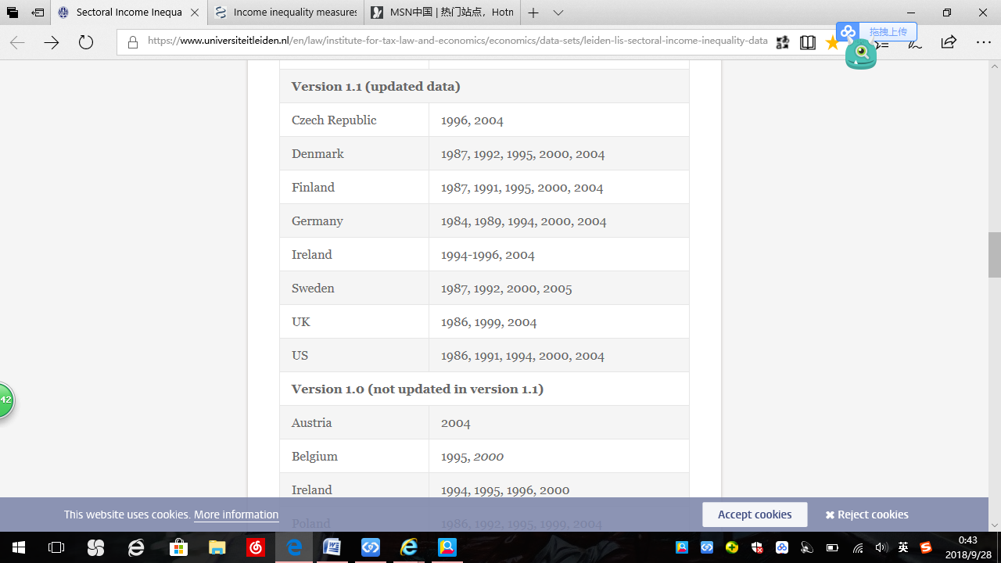

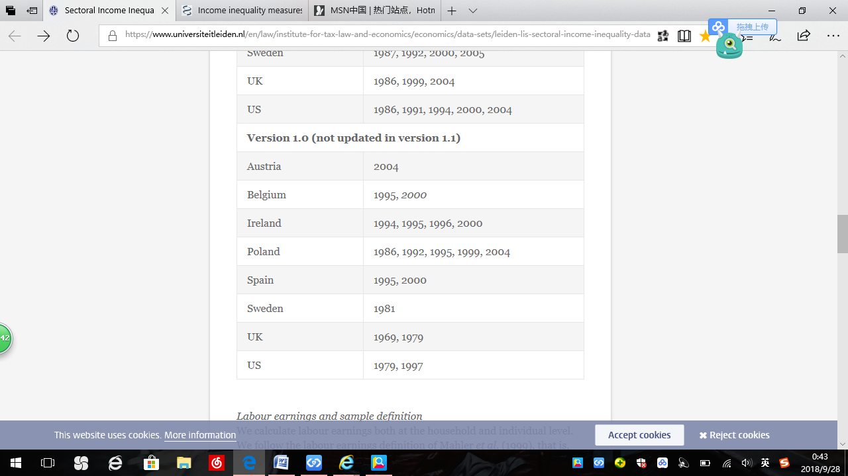  
劳动收入：We calculate labour earnings both at the household and individual level. We follow the labour earnings definition of Mahler et al. (1999), that is, we only include income from wages and salaries or self-employment. Income from other sources, such as interest and rent, is excluded. Also excluded are public benefits and income taxes.（劳动收入中不包含利息、租金、公共福利和所得税） For three waves (Belgium 2000, Ireland 2000, Spain 2000) only net earnings are available. For all calculations we apply standard LIS top- and bottom coding conventions.  
  
样本群体：We restrict our sample to ‘prime age workers’, people aged between 25 and 54 with nonzero earnings. This group probably has the strongest labour market attachment as their earnings are less affected by retirement and schooling decisions. （样本都是适龄工人，25-54岁的有收入群体）

Based on this sample, we calculate the earnings inequality using household information (following Mahler et al., 1999) and using individual information for three sample definitions.

For household earnings, we attribute the household earnings to the sector in which the household head is working.

For our calculations based on individual earnings, we attribute the individual earnings to the sector in which the specific individual is working.

We distinguish between three groups of individuals where we again only include people aged between 25 and 54 with nonzero earnings: only household heads, household heads and spouses, and all household members. （又把个人分为三类群体：只有户主、户主和配偶以及所有家庭成员）

国家与部门层面的衡量指标The dataset contains information both at the country and at the sectoral level.

1.At the country level it provides information on the (weighted) number of households and individuals pooled across all sectors. Also the Gini index for household earnings, and the Gini index and mean log deviation（平均对数偏差） for individual earnings are shown at the country level for the same sample used in the sectoral analyses. For the inequality indicators based on household earnings we correct for differences in household size using the square root equivalence scale.（对于基于家庭收入的不平等指标，使用平方根等值量表对家庭规模的差异进行修正）  
2.At the sectoral level, we provide multiple inequality indicators.（多重不平等指标） For the calculations based on household information, the Gini index, the P90/P10 ratio P90/P10比？, the mean log deviation, the Theil index泰尔指数, and the Atkinson index with inequality aversion parameter ε = 0.5 are included ε=0.5的阿特金森指数. We also include bootstrapped standard errors引导标准错误 for the Gini index. To correct for possible underestimation of the level of inequality at the sectoral level in small sectors 为纠正对小型部门的不平等程度的低估，we also provide the first order corrected一级修正的Gini index based on Deltas (2003). For the sectoral calculations based on individual data, the dataset contains the (first order corrected) Gini index and the mean log deviation for the three sample definitions.，   
  
数据集中包括As a measure of inequality between sectors the dataset comprises the ratio of median earnings in a certain sector as a proportion of the median earnings in a country of the same wave, both for household and individual information.1.某一部门的收入的中位数占同年国家家庭和个人信息中收入中位数的比例In addition, the dataset encompasses the relative employment sizes of sectors2.部门的相对就业规模, defined as the number of households or individuals working in a sector compared to the total number of households or individuals.即在某一部门工作的家庭或个人人数与其总数的比较

基于这个数据集的文献：

* S. Thewissen, O. van Vliet and C. Wang (2017), ‘[Taking the Sector Seriously: Data, Developments and Drivers of Intrasectoral Earnings Inequality](https://www.universiteitleiden.nl/binaries/content/assets/rechtsgeleerdheid/fiscaal-en-economische-vakken/economie/taking-the-sector-seriously_data-developments-and-drivers-of-intrasectoral-earnings-inequality.pdf)’, Social Indicators Research, DOI: 10.1007/s11205-017-1677-2.
* S. Thewissen and O. van Vliet (2014), ‘[Competing with the Dragon: Employment and Wage Effects of Chinese Trade Competition in 17 Sectors Across 18 OECD Countries](http://papers.ssrn.com/sol3/papers.cfm?abstract_id=2531299)’, LIS Working Paper Series No. 623.
* S. Thewissen, C. Wang, and O. van Vliet (2013), '[Sectoral trends in earnings inequality and employment: International trade, skill-biased technological change, or labour market institutions?](http://www.lisdatacenter.org/wps/liswps/595.pdf) ', LIS Working Paper Series 595.
* S. Thewissen, O. van Vliet, and C. Wang (2013), ‘[Sectorale loonongelijkheid en werkgelegenheid in internationaal perspectief tussen 1985-2005](https://www.tpedigitaal.nl/sites/default/files/bestand/sectorale_loonongelijkheid_en_werkgelegenheid_in_internationaal_perspectief_tussen_1985-2005.pdf)’, TPEdigitaal 7(3), pp. 139-160.