A general scaling law reveals why the largest animals are not the fastest

Shirley Jennifer Serrano Rojas1

30 November, 2021

Speed is the fundamental constraint on animal movement, yet there is no general consensus on the determinants of maximum speed itself. Here, we provide a general scaling model of maximum speed with body mass, which holds across locomotion modes, ecosystem types and taxonomic groups. In contrast to traditional power-law scaling, we predict a hump-shaped relationship resulting from a finite acceleration time for animals, which explains why the largest animals are not the fastest. This model is strongly supported by extensive empirical data (474 species, with body masses ranging from 30 μg to 100 tonnes) from terrestrial as well as aquatic ecosystems. Our approach unravels a fundamental constraint on the upper limit of animal movement, thus enabling a better understanding of realized movement patterns in nature and their multifold ecological consequences.

1 Stanford University

Keywords: Speed ; animal movement; body mass

Highlights: This approach may act as a simple and powerful tool for predicting the natural boundaries of animal movement and help in gaining a more unified understanding of the currently assessed movement data across taxa and ecosystems

# 1 Introduction

This is a replication of figure 2A from1

(Fig. 4.1)

# 2 Background

# 3 Methods

# 4 Results

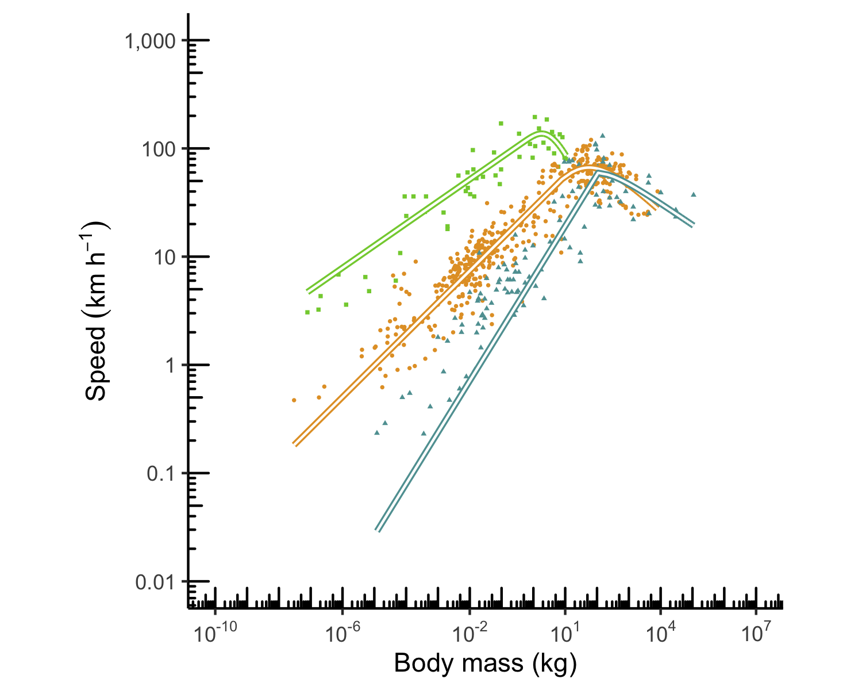

Figure 4.1: Replication of figure 2a from1

# 5 Discussion

# 6 Conclusion

# 7 Acknowledgements

# 8 References

1. Hirt, M. R., Jetz, W., Rall, B. C. & Brose, U. A general scaling law reveals why the largest animals are not the fastest. *Nature Ecology & Evolution* **1**, 1116–1122 (2017).

### 8.0.1 Colophon

This report was generated on 2021-11-30 10:36:33 using the following computational environment and dependencies:

#> ─ Session info 🇨🇿 🧜🏾 🤘🏽 ─────────────────────────────────────────────────  
#> hash: flag: Czechia, merperson: medium-dark skin tone, sign of the horns: medium skin tone  
#>   
#> setting value  
#> version R version 4.1.1 (2021-08-10)  
#> os macOS Big Sur 10.16  
#> system x86_64, darwin17.0  
#> ui X11  
#> language (EN)  
#> collate en_US.UTF-8  
#> ctype en_US.UTF-8  
#> tz America/Los_Angeles  
#> date 2021-11-30  
#> pandoc 2.14.0.3 @ /private/var/folders/st/128v8p7s5w7f9jbqv8xwb2r80000gq/T/AppTranslocation/D35053A6-E3FC-477D-B061-B6632AA40EBB/d/RStudio.app/Contents/MacOS/pandoc/ (via rmarkdown)  
#>   
#> ─ Packages ───────────────────────────────────────────────────────────────────  
#> package * version date (UTC) lib source  
#> assertthat 0.2.1 2019-03-21 [1] CRAN (R 4.1.0)  
#> bookdown 0.24 2021-09-02 [1] CRAN (R 4.1.0)  
#> cachem 1.0.6 2021-08-19 [1] CRAN (R 4.1.0)  
#> callr 3.7.0 2021-04-20 [1] CRAN (R 4.1.0)  
#> cli 3.1.0 2021-10-27 [1] CRAN (R 4.1.0)  
#> colorspace 2.0-2 2021-06-24 [1] CRAN (R 4.1.0)  
#> crayon 1.4.2 2021-10-29 [1] CRAN (R 4.1.0)  
#> DBI 1.1.1 2021-01-15 [1] CRAN (R 4.1.0)  
#> desc 1.4.0 2021-09-28 [1] CRAN (R 4.1.0)  
#> devtools 2.4.2 2021-06-07 [1] CRAN (R 4.1.0)  
#> digest 0.6.28 2021-09-23 [1] CRAN (R 4.1.0)  
#> dplyr * 1.0.7 2021-06-18 [1] CRAN (R 4.1.0)  
#> ellipsis 0.3.2 2021-04-29 [1] CRAN (R 4.1.0)  
#> evaluate 0.14 2019-05-28 [1] CRAN (R 4.1.0)  
#> fansi 0.5.0 2021-05-25 [1] CRAN (R 4.1.0)  
#> farver 2.1.0 2021-02-28 [1] CRAN (R 4.1.0)  
#> fastmap 1.1.0 2021-01-25 [1] CRAN (R 4.1.0)  
#> fs 1.5.0 2020-07-31 [1] CRAN (R 4.1.0)  
#> generics 0.1.1 2021-10-25 [1] CRAN (R 4.1.0)  
#> ggplot2 * 3.3.5 2021-06-25 [1] CRAN (R 4.1.0)  
#> glue 1.5.0 2021-11-07 [1] CRAN (R 4.1.0)  
#> gtable 0.3.0 2019-03-25 [1] CRAN (R 4.1.0)  
#> highr 0.9 2021-04-16 [1] CRAN (R 4.1.0)  
#> htmltools 0.5.2 2021-08-25 [1] CRAN (R 4.1.0)  
#> knitr 1.36 2021-09-29 [1] CRAN (R 4.1.0)  
#> lifecycle 1.0.1 2021-09-24 [1] CRAN (R 4.1.0)  
#> magrittr 2.0.1 2020-11-17 [1] CRAN (R 4.1.0)  
#> maxspeed * 0.0.0.9000 2021-11-30 [1] local  
#> memoise 2.0.1 2021-11-26 [1] CRAN (R 4.1.0)  
#> munsell 0.5.0 2018-06-12 [1] CRAN (R 4.1.0)  
#> pillar 1.6.4 2021-10-18 [1] CRAN (R 4.1.0)  
#> pkgbuild 1.2.0 2020-12-15 [1] CRAN (R 4.1.0)  
#> pkgconfig 2.0.3 2019-09-22 [1] CRAN (R 4.1.0)  
#> pkgload 1.2.3 2021-10-13 [1] CRAN (R 4.1.0)  
#> prettyunits 1.1.1 2020-01-24 [1] CRAN (R 4.1.0)  
#> processx 3.5.2 2021-04-30 [1] CRAN (R 4.1.0)  
#> ps 1.6.0 2021-02-28 [1] CRAN (R 4.1.0)  
#> purrr 0.3.4 2020-04-17 [1] CRAN (R 4.1.0)  
#> R6 2.5.1 2021-08-19 [1] CRAN (R 4.1.0)  
#> remotes 2.4.1 2021-09-29 [1] CRAN (R 4.1.0)  
#> rlang 0.4.12 2021-10-18 [1] CRAN (R 4.1.0)  
#> rmarkdown 2.11 2021-09-14 [1] CRAN (R 4.1.0)  
#> rprojroot 2.0.2 2020-11-15 [1] CRAN (R 4.1.0)  
#> rstudioapi 0.13 2020-11-12 [1] CRAN (R 4.1.0)  
#> scales 1.1.1 2020-05-11 [1] CRAN (R 4.1.0)  
#> sessioninfo 1.2.1 2021-11-02 [1] CRAN (R 4.1.0)  
#> stringi 1.7.6 2021-11-29 [1] CRAN (R 4.1.1)  
#> stringr 1.4.0 2019-02-10 [1] CRAN (R 4.1.0)  
#> testthat 3.1.0 2021-10-04 [1] CRAN (R 4.1.0)  
#> tibble 3.1.6 2021-11-07 [1] CRAN (R 4.1.1)  
#> tidyselect 1.1.1 2021-04-30 [1] CRAN (R 4.1.0)  
#> usethis 2.1.3 2021-10-27 [1] CRAN (R 4.1.0)  
#> utf8 1.2.2 2021-07-24 [1] CRAN (R 4.1.0)  
#> vctrs 0.3.8 2021-04-29 [1] CRAN (R 4.1.0)  
#> withr 2.4.2 2021-04-18 [1] CRAN (R 4.1.0)  
#> xfun 0.28 2021-11-04 [1] CRAN (R 4.1.0)  
#> yaml 2.2.1 2020-02-01 [1] CRAN (R 4.1.0)  
#>   
#> [1] /Library/Frameworks/R.framework/Versions/4.1/Resources/library  
#>   
#> ──────────────────────────────────────────────────────────────────────────────

The current Git commit details are:

#> Local: main /Users/serranoj/Desktop/Important Disc D Mac/Stanford University/Courses/maxspeed  
#> Remote: main @ origin (https://github.com/ShirleyJenniferSerranoRojas/maxspeed.git)  
#> Head: [d88f819] 2021-11-30: cross-reference-figure