Gender Recognition using Voice

Kexian Wu

CWID: 10408805

kwu5@stevens.edu

Yingfei Li

CWID: 10429076

yli224@stevens.edu

# **PROBLEM DESCRIPTION**

The speech signal processing has a wide range of applications in most of technical fields. In speech processing, gender identification plays an important role.

A human ear can easily distinguish between a male and female voice. What if a machine want to do the same? What features of a voice would be required for a machine to classify voices by gender?

The voice of an adult male can range between 85 to 180 Hz and that of adult female ranges between 165 to 255 Hz. From figure 1, we can observe that the fundamental frequencies exhibited by male voices are much lower than those exhibited by females.

Although the frequency ranges quite differently, there is a mid range where the voice frequencies seem to overlay. This is why differentiating voices only on the basis of voice frequency is not adequate, it does require additional feature detections.

Our goal for this project is to learn different models to classify voice samples as male or female based on the gender of the person.

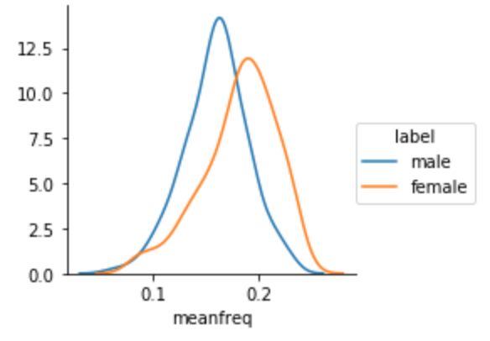

Figure 1: Data Visualization of voice frequencies by genders.

# **RELATED WORK**

## **Dataset**

Acoustic analysis of the voice depends upon parameter settings specific to sample characteristics such as intensity, duration, frequency and filtering. The acoustic properties of the voice and speech can be used to detect the gender of speaker. For the sake of learning and practicing, we plan to collect 460 recorded voice samples from VoxForge, speech corpus. Exactly half of records will be labeled as male and the other half will be labeled as female.

Each voice sample format is a .WAV file. The .WAV format files will be pre-processed for acoustic analysis using using the seewave and tuneR packages. Also, we will use 80% of the original data for training and the rest for testing.

## **Models**

We propose to train the conventional modes to learn the task of classifying male and female voice samples. The models we chose are as following:

1) Decision tree

2) K Nearest Neighbors

3) Logistic Regression

4) Naive Bayes

5) Random Forest Neural Network

7) Neural Network

8) SVM

## **Techniques**

1) Full Feature Set

We will train all the models mentioned above on the dataset containing all the 20 features.

2) PCA

We will reduce the dimension of our data set to fewer dimensions and then trained all the models to observe the changes in accuracy.

3) Voting

We will conduct voting on all the models and use the mode of all results as our prediction to reduce bias.

# **PROJECT MILESTONES**

Projected Project Milestones are given in the Chart 1. The most of the work for our project will be training the conventional models to learn the task of classifying male and female voice samples we collected. We will implement various classifiers in Python 3.

Projected Project Milestones are given in the Chart 1. The most of the work for our project will be training the conventional models and deep learning models to learn the task. After obtaining a solid understanding of the machine learning algorithms, we will write our own functions for most of the machine learning methods we used for this process and compared our results to the one obtained by using Sklearn/Keras package. After using 8 models to get the initial accuracies, we will then propose some techniques like PCA algorithm to reduce the variance by reducing the dimensionality and improve classification accuracy.

|  |  |
| --- | --- |
| 2018/03/27 | Finish project proposal and contact TA |
| 2018/04/03 | Finalize Project Goals |
| 2018/04/10 | Collect data and extract features from audio samples. Build 8 conventional and deep learning models for gender classification |
| 2018/04/17 | Continue working on our conventional models and deep learning models |
| 2018/04/24 | Use feature extraction techniques such as PCA to reduce dimensionality and improve the accuracies |
| 2018/05/01 | Finalize Project |
| 2018/05/08 | Finalize report and project submission |

Chart 1: Tentative Project Milestones

# **REFERENCES**

1. Kory Becker, Gender Recognition by Voice and Speech Analysis, http://www.kaggle.com.
2. Vox Forge Speech Corpu[s](http://www.repository.voxforge1.org/downloads/SpeechCorpus/Trunk/Audio/Main/8kHz_16bit/), Retrieved from

http://www.repository.voxforge1.org/downloads/SpeechCorpus/Tr unk/Audio/Main/8kHz_16bit/

1. L. Breiman, “Random forests”, Machine Learning, Springer US, 45:5– 32, 2001.
2. M. Abadi, A. Agarwal, TensorFlow: Large-scale machine learning on heterogeneous systems, 2015. Software available from tensorflow.org.