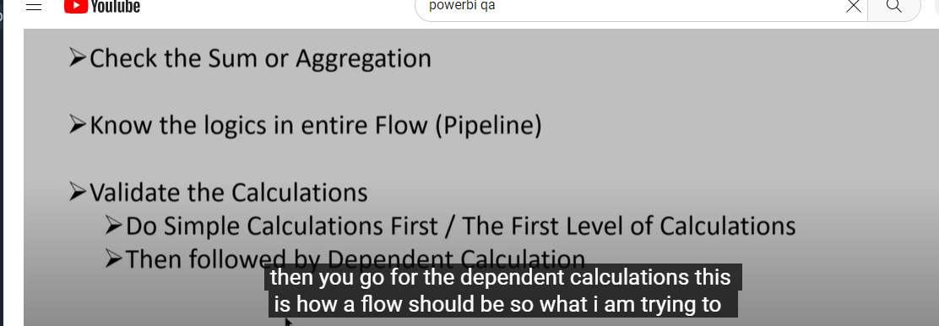

<https://www.youtube.com/watch?v=JjTrBvKUhHI>

BI Validator