The robot initial state is (0, 0, 0), if you need it to go to another goal, change the “m_goal” inside the main file.

state[0] refers to tag id, if you want it to go from tag 0 to tag 3, let m_goal[0] = 3;

state[1] refers to direction, I have assigned 0, 1, 2, 3 to the direction like follwing:



state[2] refers to height, I have assigned 0, 1, 2, 3, 4 to the 5 level of A-rack, the distance between each level is 0.45m. Level 0 is at the following state:

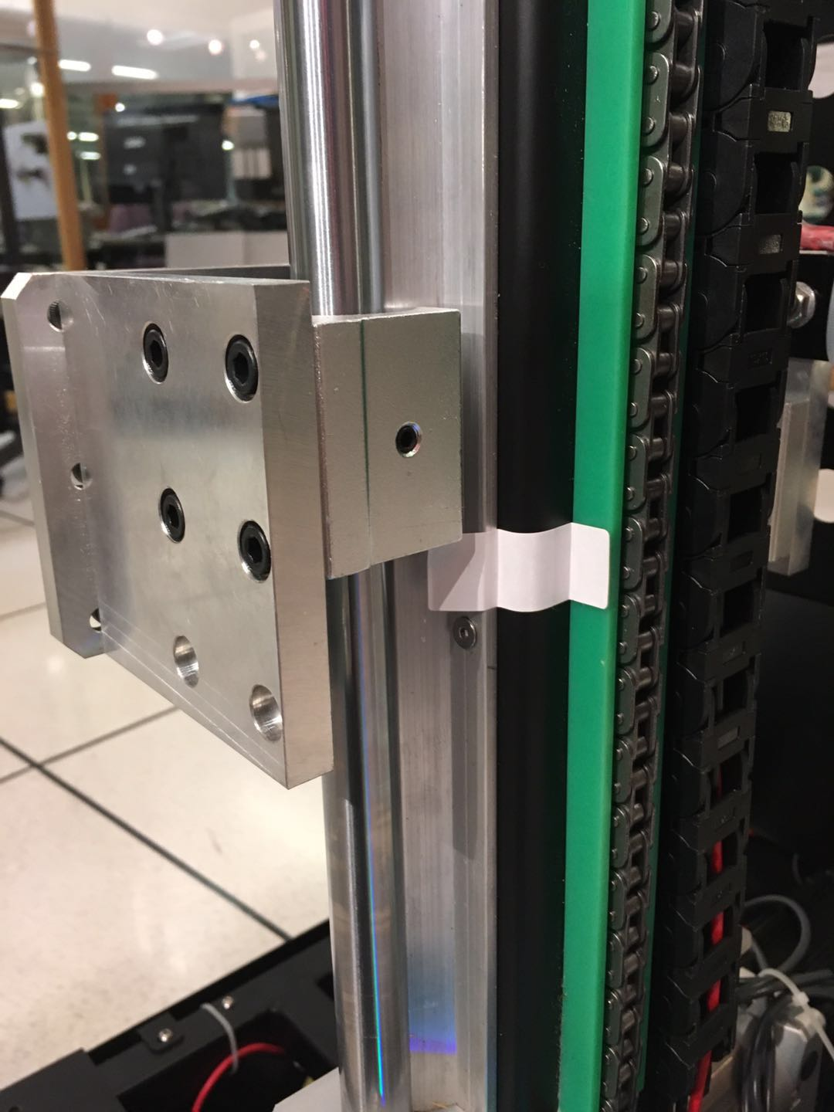

The positive direction of DMcode comparing to robot is:



You can move the code back and forward to see the change of x, y, z output by the “tag_detections”.