There are two folders in the “Code” file.

Use the following steps to run the first “src” file.

Before setup the code, plug these USBs into your PC one by one: Walking motor, Lifting motor and finally camera.

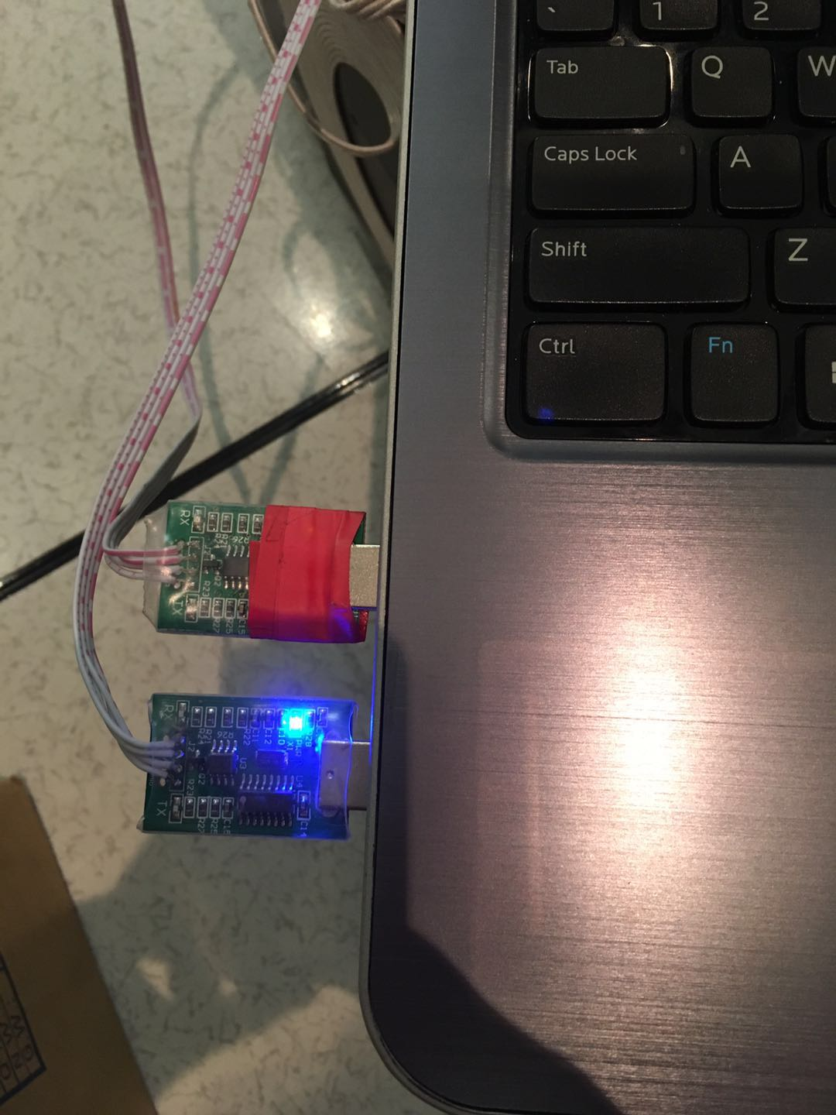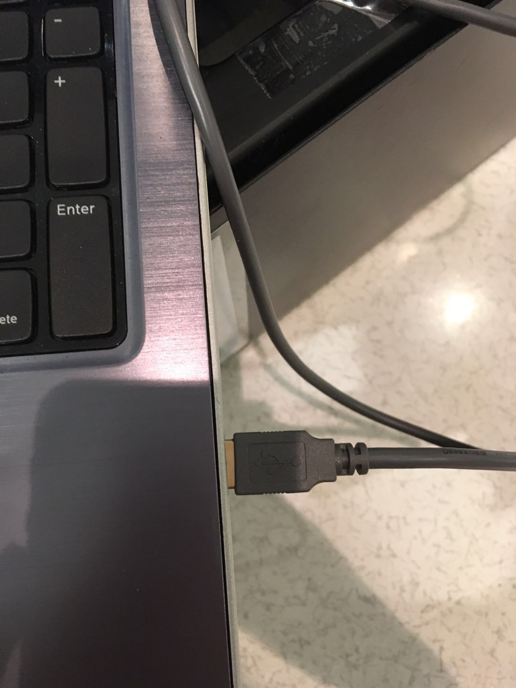

1. Download and put tha file under your workspace. My path is

-Home ->catkin_ws->build

->devel

->src

2. Open a terminal.

>>cd catkin_ws

>>catkin_make

If this step is finished successfully, you will see new node build in the devel/lib path.

3. Open a terminal

>>roscore

4. Open a new terminal

>>cd catkin_ws

>>rosrun ht_vision_node ht_vision_node

5. Put one dm code under the camera, make sure the red light seems to be blinking.

Open a new terminal

>>rostopic echo tag_detections

If success, you will be ablet o see the information of dm code

6. Open a new terminal

>>cd catkin_ws

>>rosrun ht_vision_node tag_correction_node

Move the dmcode, and robot will move to align with the dm code.

The first file is just one I used to show you the functions. The second one has implemented with PID control and more detailed correction function. But deal to the time limitation and broken hardware, I don’t have enough time to debug it. Sorry for the trouble caused and you may need to spend some time on debugging that.