1. If the lift reached the highest or lowest position, the limit switch will be triggered. Follow the steps to release it.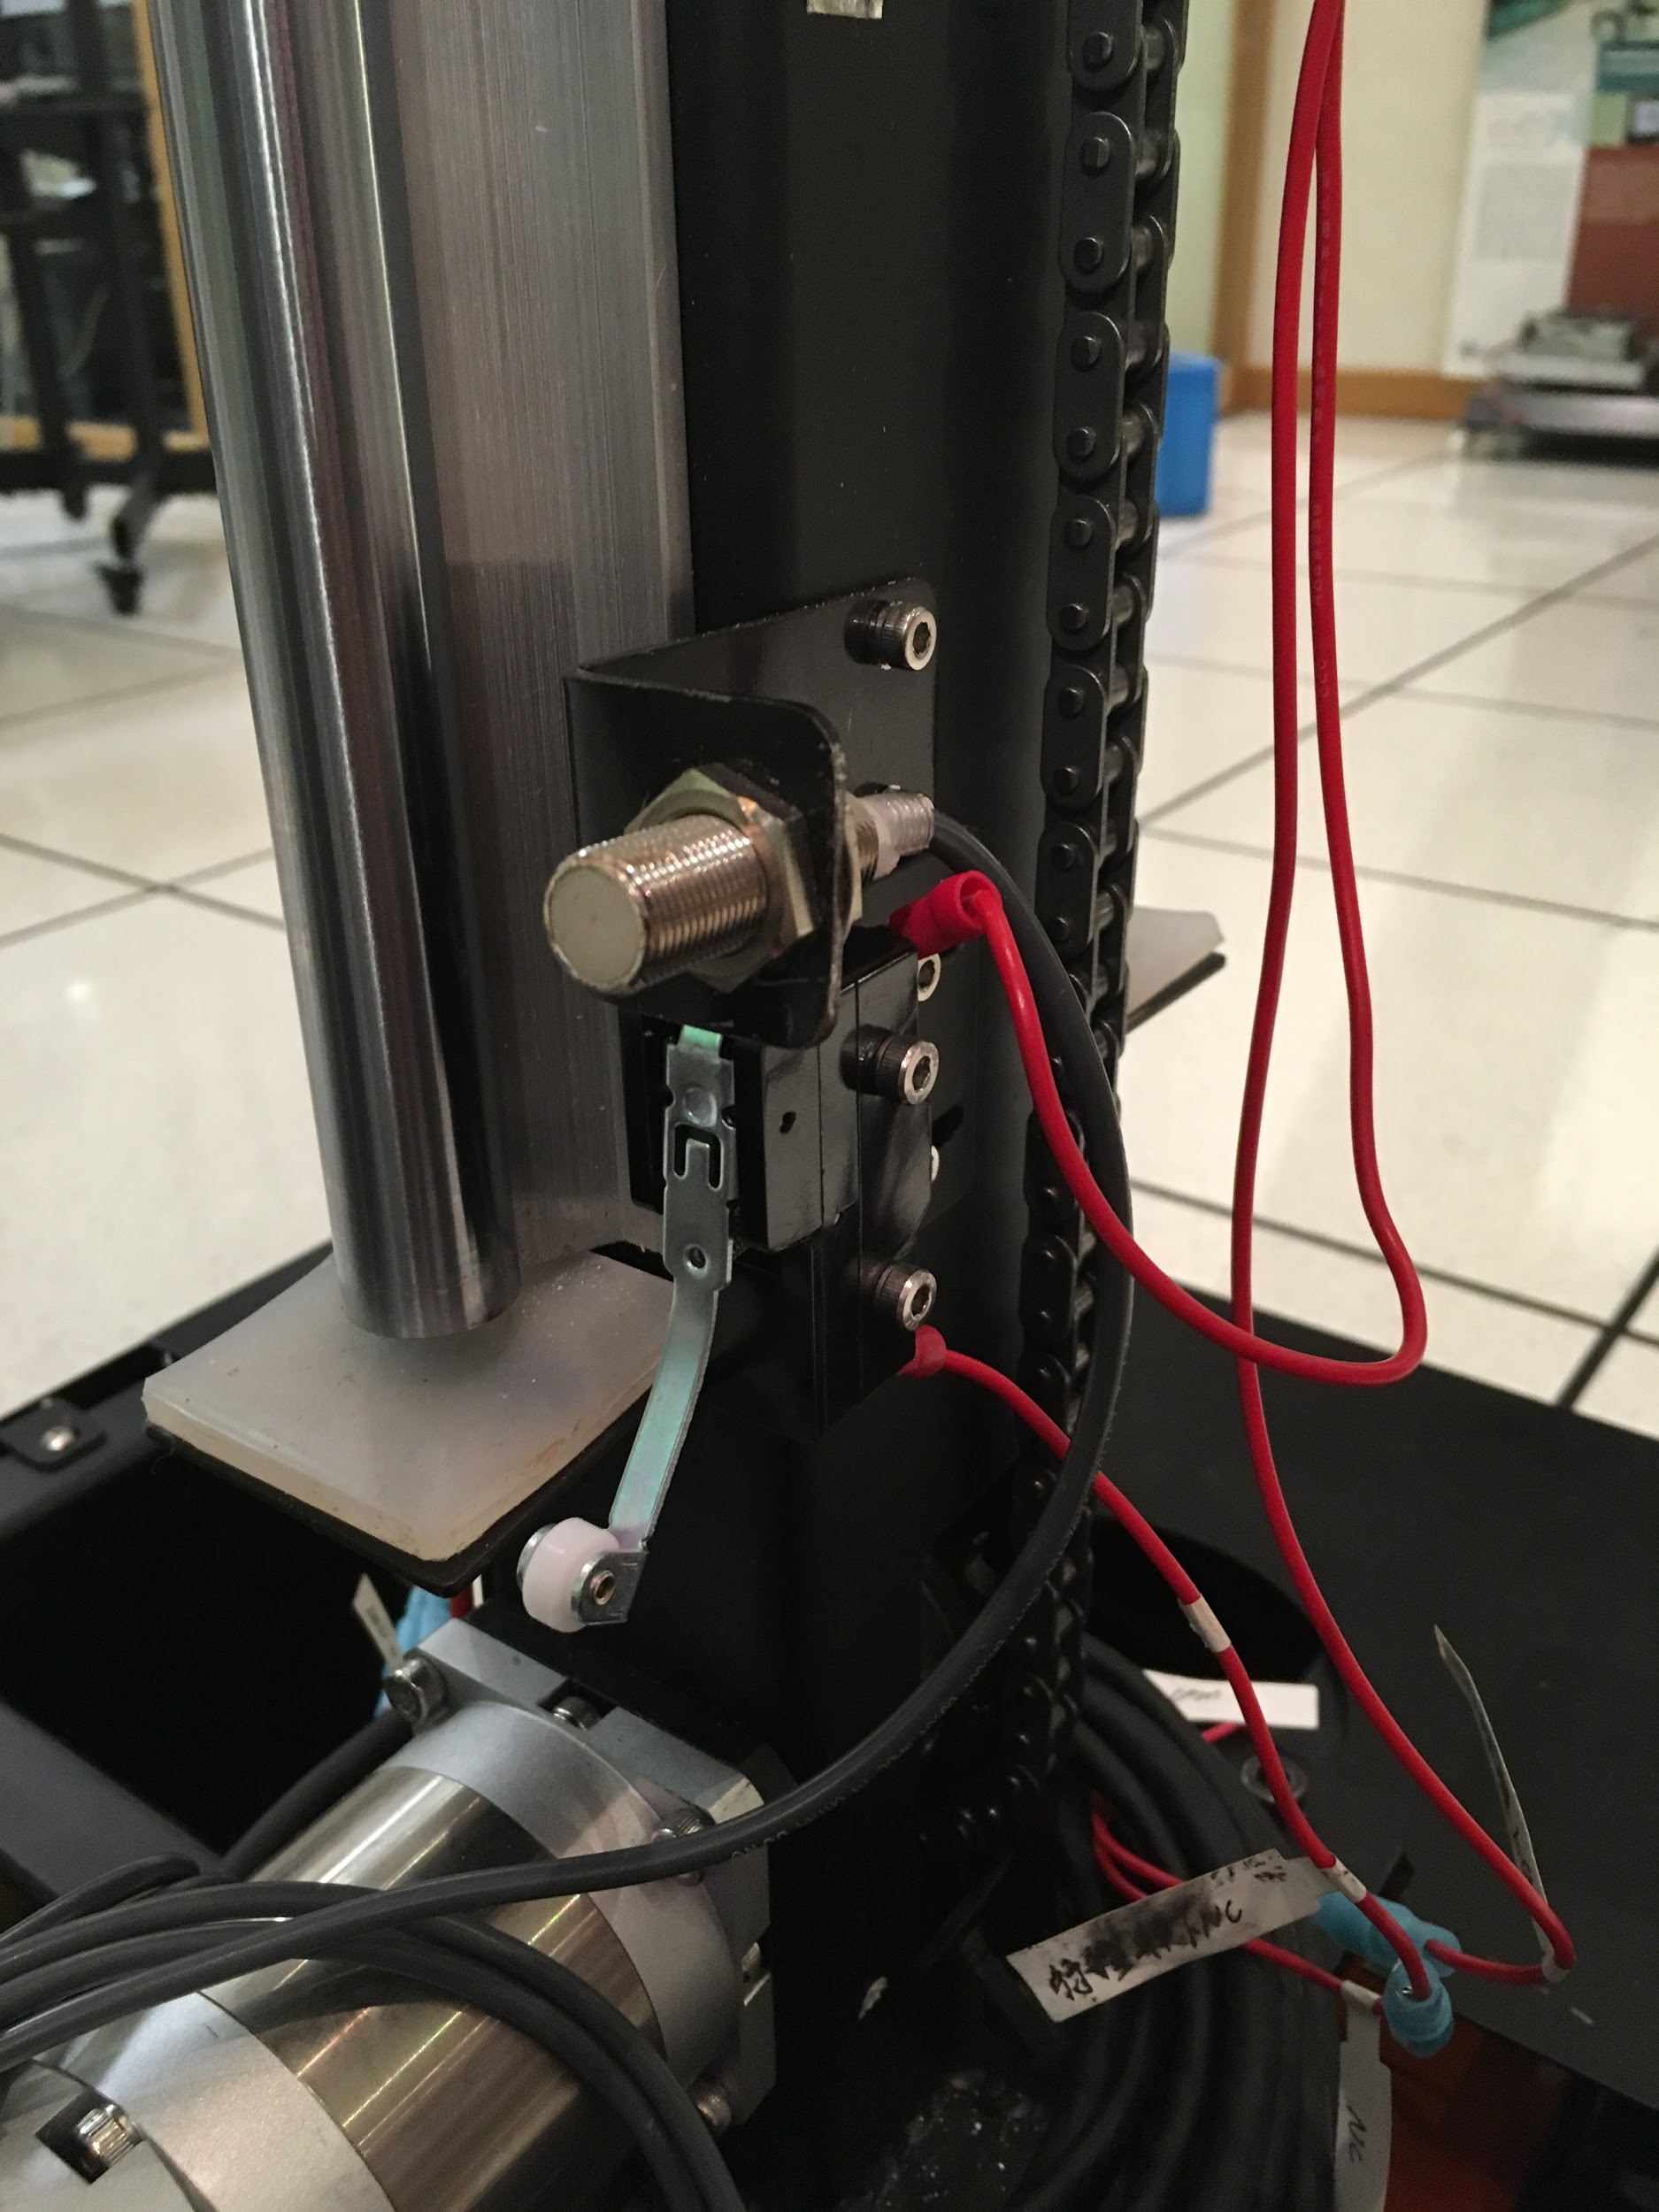

1. Keep the power on, use one wire to short the two blue ports: COM and NC. You will hear “TICK” sound after you did that.
2. Pull up the power supply for lifting motor.
3. At this status, you will be able to move the lifting panel to its safe place.
4. Plug in the power line for lifting motor again to continue your operation.

2. If the robot is out of control and you need to give it a sharp stop.

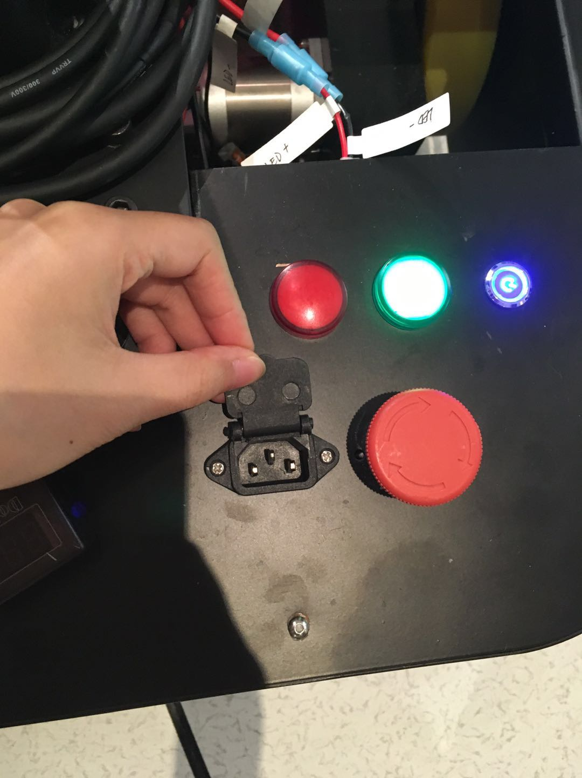

Press the red button.

Release by rotating the button.

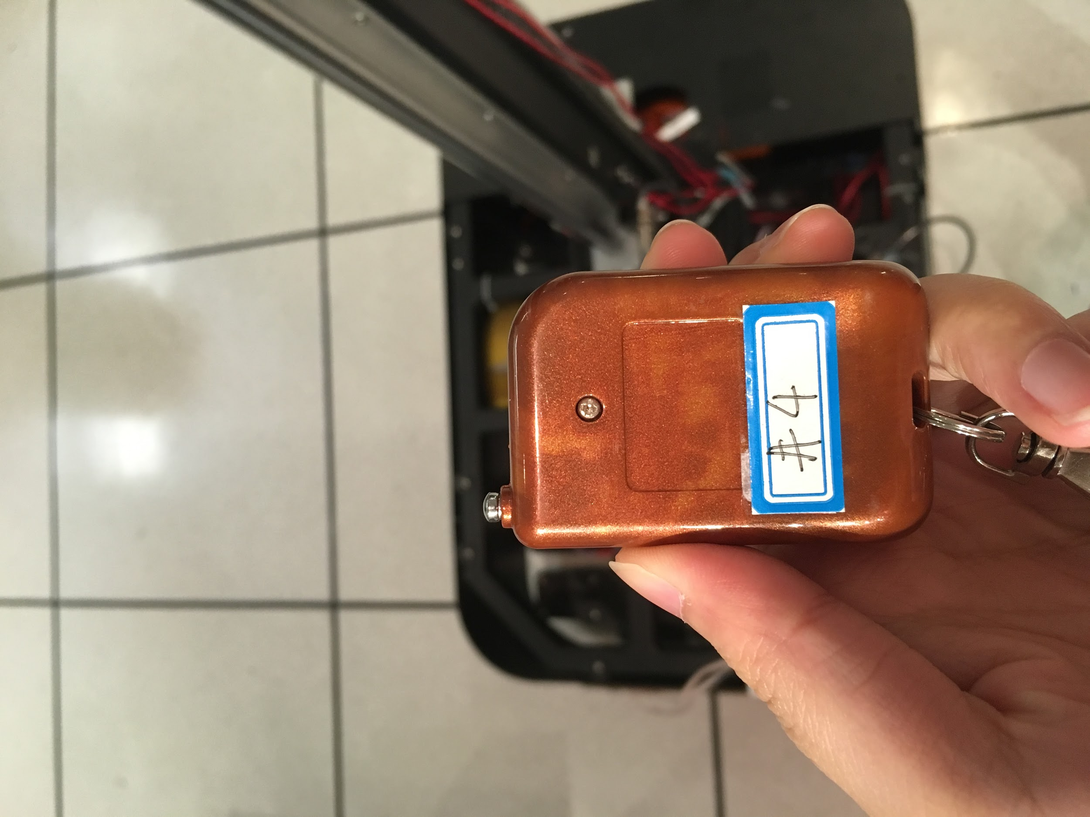

Press the red button at the back.

You can use this one for remote control, the sensing distance is 5m.