### 【Reference】HTML标签快速分类查找

Source1: <http://www.w3school.com.cn/html/html_quick.asp>

Source2: https://www.w3schools.com/tags/ref_byfunc.asp

HTML Basic Document

<html>

<head>

<title>Document name goes here</title>

</head>

<body>

Visible text goes here

</body>

</html>

Text Element

</>This is a paragraph</p>

<br>(line break)

<hr>(horizontal rule)

<pre>This text is preformatted</pre>

Logical Styles

<em>This text is emphasized</em>

<strong>This text is strong</strong>

<code>This is some computer code</code>

Physical Styles

<b>This text is bold</b>

<i>This Text is italic</i>

Links, Anchors, and image Elements

<a href=”http://www.example.com/”>This is a Link</a>

<a href=”http.example.com”><img src=”URL”

alt=”Alternate Text”></a>

<a href=”mailto:webmaster@example.com”>Send e-mail</a>

A named anchor:

<a name=”tips”>Useful Tips Section</a>

<a href=”#tips”>Jump to the Useful Tips Section</a>

Unordered List

<ul>

<li>First item</li>

<li>Next item</li>

</ul>

Ordered list

<ol>

<li>First item</li>

<li>Next item</li>

</ol>

Definition List

<dl>

<dt>First term</dt>

<dd>Definition</dd>

<dt>Next term</dt>

<dd>Definition</dd>

</dl>

Tables(<table><tr><td>)

<table border=”1”>

<tr>

<th>someheader</th>

<th>someheader</th>

</tr>

<tr>

<td>sometext</td>

<td>sometext</td>

</tr>

</table>

Frames

<frameset cols=”25%,75%”>

<frame src=”page1.htm”>

<frame src=”page2.htm”>

</frameset>

Forms

<form action=”http://www.example.com/test.asp” method=”post/get”>

<input type=”text” name=”lastname”

value=”Nixon” size=”30” maxlength=”50”>

<input type=”password”>

<input type=”checkbox” checked=”checked”>

<input type=”radio” checked=”checked”>

<input type=”submit”>

<input type=”reset”>

<input type=”hidden”>

<select>

<option>Apples

<option selected>Bananas

<option>Cherries

</select>

<textarea name=”Comment” rows=”60”

cols=”20”></textarea>

</form>

Entities

&lt; is the same as <

&gt; is the same as >

&#169; is the same as ©

Other Elements

<!-- This is a comment -->

<blockquote>

Text quoted from some source.

<blockquote>

<address>

Address 1<br>

Address 2<br>

City<br>

</address>

### 属性

属性总是以名称/值对的形式出现，比如：name="value"。

属性总是在 HTML 元素的**开始标签**中规定。

e.g. 超链接<a>标签中，链接的地址在href属性中指定：

<a href="http://www.google.com">This is a link</a>

### 水平线

<hr />

折行（不产生新段落）：

<br />

注：不要用<p></p>去插入空行！

### style属性

用于改变HTML元素的**样式**

* 不赞成使用的标签和属性：

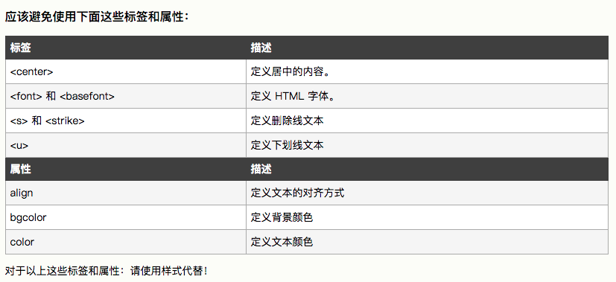

### 文本格式化标签

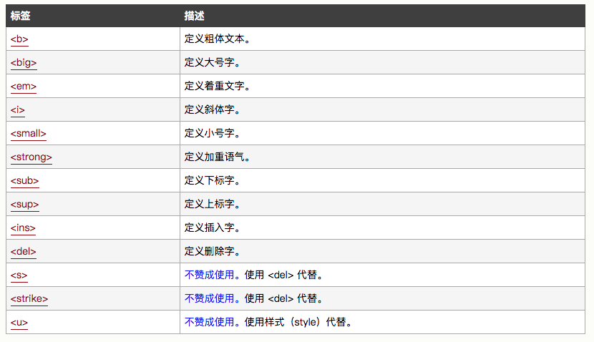

练习：

<html>

<body>

<b>This text is bold</b>

<br />

<strong>This text is strong</strong>

<br />

<big>This text is big</big>

<br />

<em>This text is emphasized</em>

<br />

<i>This text is italic</i>

<br />

<small>This text is small</small>

<br />

This text contains <sub>subscript</sub>

<br />

This text contains <sup>superscript</sup>

</body>

</html>

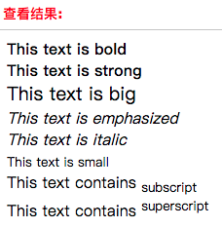

### <pre>标签（预格式文本）

作用：保留空格和换行。

很适合显示计算机代码。

练习：

<pre>

For i = 1 to 10

Print i

Next i

</pre>

显示结果：

